Software Design Document
Veritas Claims Analytics
Architecture, Modules, Data Model & Deployment
Document Version 1.0
Prepared for Engineering & Architecture Review

1. High-Level Architecture
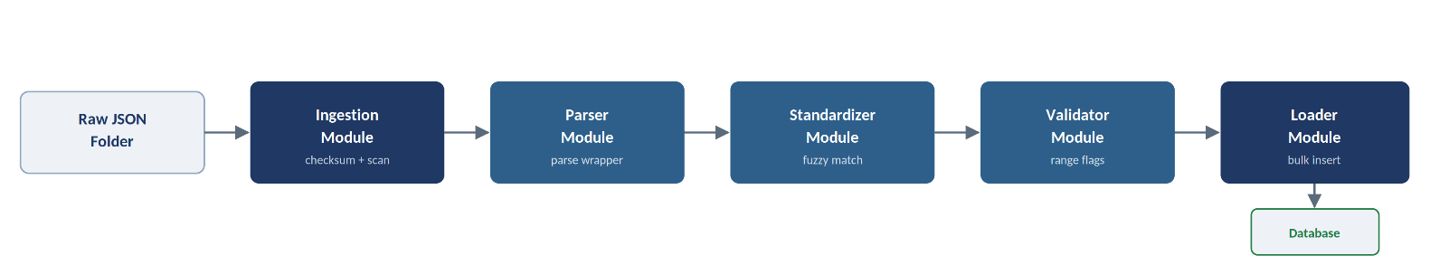
The Veritas Claims Analytics pipeline operates on a decoupled micro-architecture where files are ingested, parsed into flat structures, normalized using fuzzy token logic, checked for reference boundary flags, and stored in a relational database.

Figure 1.1 — High-level pipeline architecture

2. Low-Level Architecture & Modules

2.1 src/ingestion/ingestion.py
Reads raw JSON files. Validates that the file structure matches the Veritas wrapper. Extracts top-level tracking metadata and computes MD5 checksums of raw file contents.
Extracted fields: traceId, documentId, correlationId, metaDetails.

2.2 src/parser/parser.py
Extracts internal document data based on the classifier type:
- Lab Reports — Extracts patient demographics (patient_name, age, gender, uhid, lab_or_hospital_name, reports_date) and iterates through the report_details list.
- Discharge Summaries — Extracts discharge header fields and loops through the dischargeMedications list.

2.3 src/standardizer/standardizer.py
Performs nomenclature mapping. Connects to test_mapping.json (canonical test library). For each test name:
- Performs an exact match check.
- Falls back to a token-sort fuzzy match score via RapidFuzz.
- Performs unit conversion mapping.

2.4 src/validator/validator.py
Compares result_value with range_low and range_high. Identifies anomalies:
- Values > range_high + 3x range width → Outlier.
- Values > range_high → Above Range.
- Values < range_low → Below Range.

2.5 src/loader/loader.py
Manages database loading. Generates unique hashes for deduplication and runs bulk inserts inside database transactions.

3. Database Design (ER Diagram)
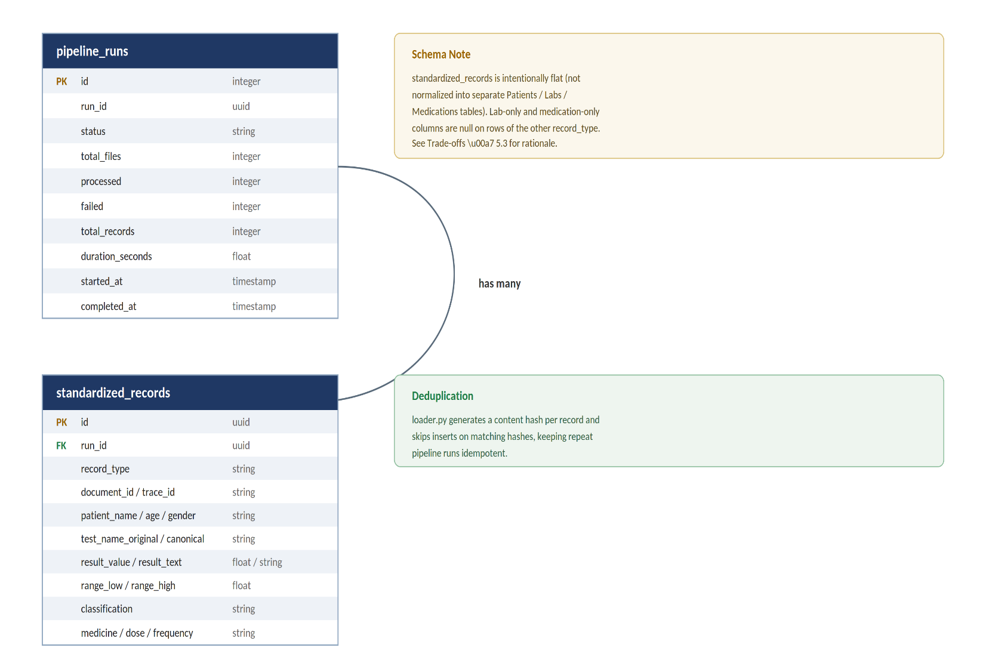
The relational schema maps to the SQLAlchemy ORM models.

Figure 3.1 — Entity-relationship diagram

4. Processing Pipeline Flow
The sequence diagram demonstrates the flow of a single batch execution:
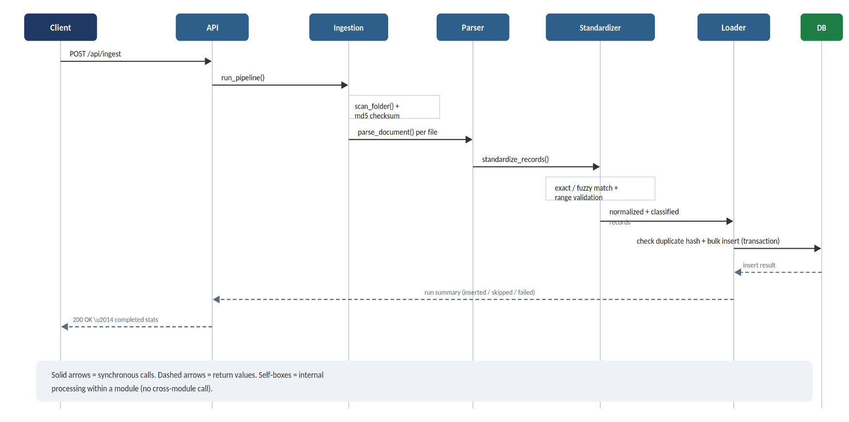
Figure 4.1 — Batch execution sequence diagram

5. Configuration Strategy
Configurations are loaded dynamically and cached in memory using LRU caching:
File | Purpose
test_mapping.json | Defines canonical names and spelling aliases.
unit_mapping.json | Defines normalization rules for lab units.
medicine_mapping.json | Handles drug nomenclature mappings.
reference_ranges.json | Baseline lab reference metrics.

6. Deployment Design
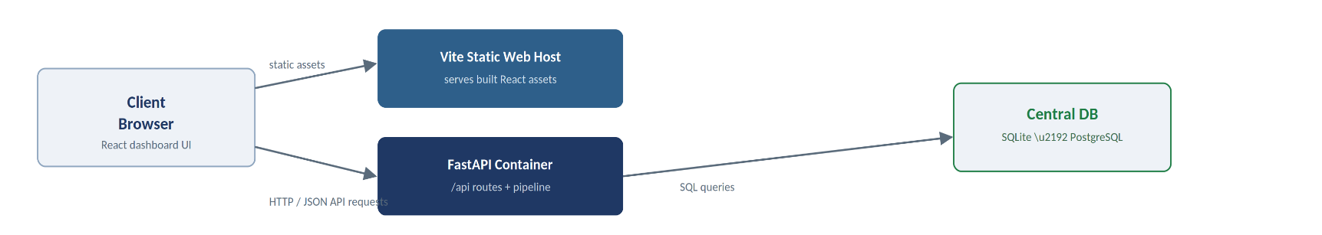
The application runs locally as a decoupled system but is designed for cloud-ready containerization:

Figure 6.1 — Deployment topology

6.1 Production Scaling
- Replace SQLite with PostgreSQL.
- Add Celery / Redis worker queues for batch file processing to support large-scale ingestion (200k+ records/day).

