# Stock Price Prediction with Social Media and Financial News

Gold Team

## Team Members

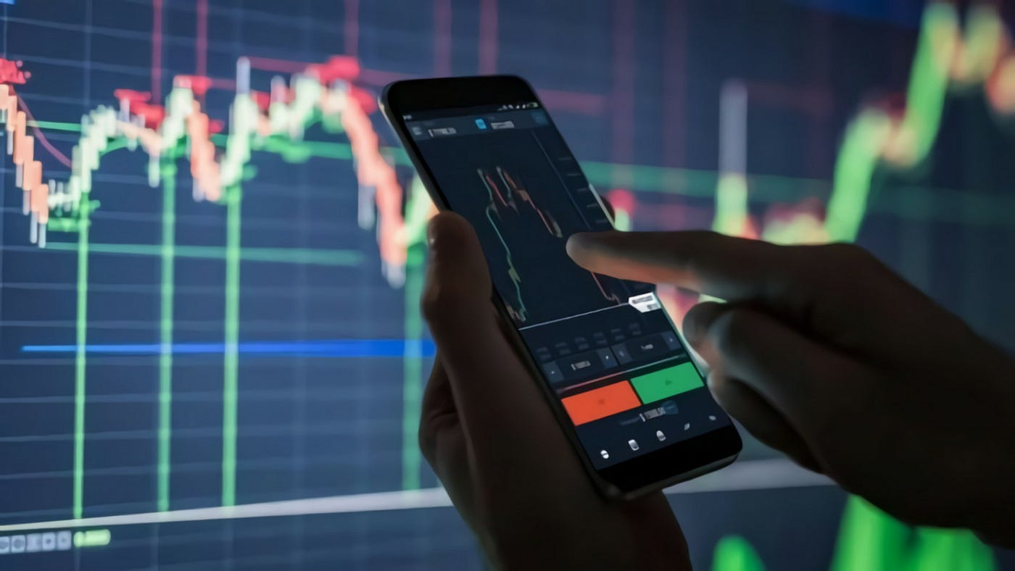

1. **Odai Athamneh**

Role: ML engineer

GitHub: <https://github.com/heyodai>

1. **Devin Cline**

Role: Product architect

GitHub: <https://github.com/devin-cline>

1. **Semir Hot**

Role: Team leader

GitHub: <https://github.com/SemirHot>

1. **Namuun Lkhagvadorj**

Role: Financial analyst

GitHub:<https://github.com/Nami1217>

## Problem statement

In today's digital age, where information is abundant and easily accessible, financial markets have grown increasingly interconnected and complex. Traditional financial analysis methods often struggle to fully capture this intricate market behavior, highlighting the need for a more advanced, multidimensional approach. Leveraging modern technology to extract actionable insights from the vast array of financial data has become essential. Predicting the stock market has important applications for managing investments as well as larger scale sociopolitical implications. Analyzing historical data and incorporating social media and financial news can help provide important information in prediction

## Brief Objectives

* Use a machine learning model to make stock market predictions using previous stock market data, leveraging variables like theta, gamma, and implied volatility to predict stock movements.
* Utilize social media data to help inform the model.
* Utilize financial news data to help inform the model.

## Project Pipeline

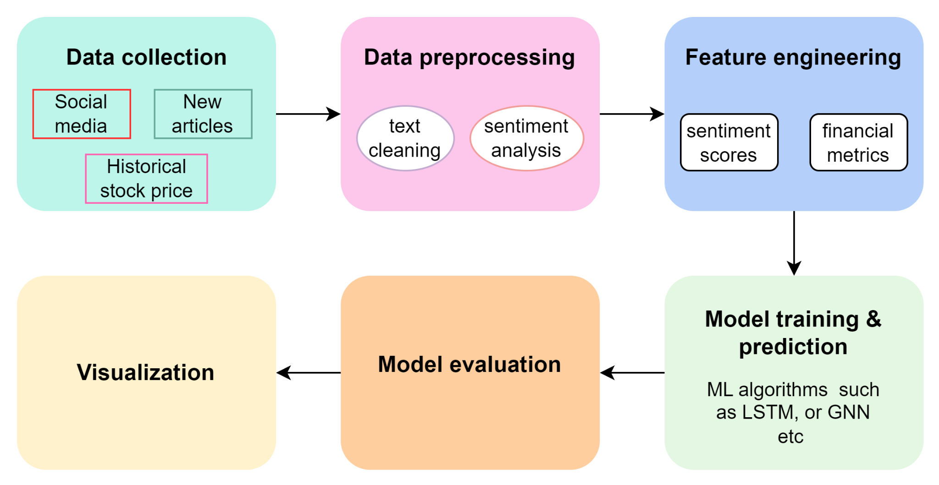

**Figure 1. Project Pipeline**

1. **Integrate multiple data sources**

Collect and preprocess data from various social media platforms, financial news websites, and historical stock prices to create a comprehensive dataset for analysis.

1. **Sentiment analysis**

Develop a sentiment analysis model to assess the tone and sentiment of social media posts and financial news articles, determining their potential impact on stock prices.

1. **Feature engineering**

Extract relevant features from the sentiment data, financial news, and stock market data to build a robust feature set for the prediction model.

1. **Stock price prediction model**

Implement and train machine learning models, such as LSTM (Long Short-Term Memory) networks or other relevant algorithms, to predict stock prices based on the integrated data.

1. **Model evaluation**

Evaluate the performance of the prediction models using appropriate metrics (e.g., RMSE, MAE) to ensure the accuracy and reliability of the predictions.

1. **Integration of real-time data**

Design a system that can update predictions in real-time as new social media posts, news articles, and stock prices become available.

1. **Visualization and reporting**

Create visualizations and reports on the web app to present the stock price predictions and insights effectively to the users

## Datasets

1. Historical labeled sentiment data for financial news:
   1. <https://www.kaggle.com/datasets/ankurzing/sentiment-analysis-for-financial-news>
2. Historical stock market dataset
   1. <https://www.kaggle.com/datasets/paultimothymooney/stock-market-data>
3. Stock data with yfinance library / yahoo API
   1. <https://pypi.org/project/yfinance/>
4. Real-time stock data with Alpha Vantage API
   1. <https://www.alphavantage.co/>
5. News data with NewsApi
   1. <https://newsapi.org/>
6. Financial news data headlines
   1. <https://www.kaggle.com/datasets/miguelaenlle/massive-stock-news-analysis-db-for-nlpbacktests?select=raw_analyst_ratings.csv>
      1. This source contains three .csv’s
         1. raw_partner_headlines.csv has headlines, dates, tickers, publishers
         2. raw_analyst_ratings.csv has headlines, URLs, authors (publisher is benzinga), publication timestamps, tickers
         3. analyst_ratings_processed.csv is the same as raw_analyst_headlines but has timestamps that are to the minute

## Existing Projects/Applications

* Stock market analysis with news sentiment analysis
  + <https://github.com/gandalf1819/Stock-Market-Sentiment-Analysis>
* Stock market analysis with twitter sentiment analysis
  + <https://github.com/sardarosama/Stock-Market-Trend-Prediction-Using-Sentiment-Analysis>
* Chat GPT-informed GNN
  + <https://github.com/ZihanChen1995/ChatGPT-GNN-StockPredict>
* Stock Price Prediction Using Financial News Articles <https://ieeexplore.ieee.org/stamp/stamp.jsp?tp=&arnumber=5609404>
* Forecasting stock prices using LLMs with financial news
  + <https://community.wolfram.com/groups/-/m/t/2959055> [[WSS23] Forecasting stock prices using LLMs with financial news - Online Technical Discussion Groups—Wolfram Community](https://community.wolfram.com/groups/-/m/t/2959055)

This research explores the hypothesis that integrating news articles with stock price history can effectively predict market movements. Using large language models like GPT-2 and BERT, they developed classifiers that utilize news headlines and stock prices as inputs. Their findings show that incorporating financial news improves prediction accuracy, with the model combining GPT-2 embeddings and stock price history achieving the best results.

## Individual Contributions

[Instructions:

Please include a section in the Statement of Work that details the specific contributions of each team member. In your individual submission, describe your role, responsibilities, and contributions to the project, including your involvement in researching, drafting, and preparing the Ignite Talk and the Statement of Work**. Focus on three key aspects: 1) what you have completed so far, 2) what you plan to accomplish in this project, and 3) any changes or improvements you are considering.**]

* + - 1. Odai Athamneh
         1. **Contribution:** Developed the Ignite Talk presentation and set up the GitHub repo.
         2. **What you plan to accomplish:** Given my professional experience in ML engineering, I plan to handle data extraction, cleaning, transformation, and loading into systems.
         3. **Changes/improvements considering:** Use of PCA or similar approaches to extract key vectors without the need to store entire raw datasets.
      2. Devin Cline
         1. **Contribution:** Researched project ideas, datasets, and existing projects/ applications. Helped draft documents for submission.
         2. **What you plan to accomplish:** I plan on helping with coding, meeting deadlines, producing deliverables.
         3. **Changes/improvements considering:** I am considering changing / improving
      3. Semir Hot
         1. **Contribution:** Kicked off the initial project idea and helped with initial brainstorming for direction
         2. **What you plan to accomplish:** Will hope to lead the coding aspect of this project and create a clear roadmap for this project. Will be taking on the role of a PM and Engineer in this given project
         3. **Changes/improvements considering:** Wanting to broaden my understanding of how LLM’s can be used in every day issues and project such as this one.
      4. Namuun Lkhagvadorj
         1. **Contribution:** Helped with researching existing projects and research papers related to our project. Created the project pipeline.
         2. **What you plan to accomplish:** I am planning to explore more on how to collect the news article and social media dataset. Because news articles and social media posts are generated continuously and in large volumes. The sheer number of sources, such as different news websites, blogs, Twitter, Facebook, etc., can make it difficult to collect a comprehensive dataset. So we might focus on key sources and platforms that are most relevant to our project and implement a strategy for selecting high-impact sources or use APIs that aggregate data from multiple sources.
         3. **Changes/improvements considering:** I am considering we might need to improve following things:
* Enhancing the sentiment analysis model by exploring more advanced natural language processing techniques, such as transformers, to improve the accuracy of sentiment predictions.
* Integrating additional data sources, such as alternative social media platforms or financial blogs, to enrich the dataset and provide more comprehensive inputs to the prediction model.
* Implementing more sophisticated feature engineering techniques, including time-series analysis and incorporating external economic indicators, to better capture market trends and improve the prediction model's performance.