V––
📊 Data Analysis
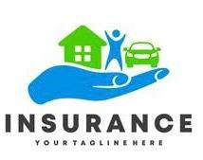
🤖 Machine Learning


i
Opp. GIDC, Ahmedabad-Mehsana Highway, AT & PO-Saij, Kalol, Gujarat 382721
2025-2026
📅 Academic Year
DEGREE ENGINEERIN
IN
Information Technology
Semester VII

🏫 Department
OM GANPATBHAI PATEL
Enrollment No. SUK230504IT025
👨‍🎓 Submitted By

Insurance Charges Prediction
Using Machine Learning

MINI PROJECT REPORT

SWAMINARYAN UNIVERSITY

ii
This is to certify that Mr. Om Ganpatbhai Patel, a student of Bachelor of Engineering (Information Technology), Semester IV, at Swaminarayan University, has successfully completed the mini project titled “Insurance Charges Prediction Using Machine Learning” during the academic year 2025–2026.

This project is submitted in partial fulfilment of the requirements for the award of the Bachelor of Engineering degree. The work presented in this report is the original work carried out by the student.
Date: __________
HOD Signature

CERTIFICATE
iii
I would like to express my sincere gratitude to Swaminarayan University and the Department of Information Technology for providing me with the opportunity to complete this mini project.

I am thankful to my project guide and faculty members for their valuable guidance, encouragement, and support throughout the project. Their suggestions helped me understand the concepts of machine learning and successfully complete this work.

I also thank my parents and friends for their continuous motivation and support during the development of this project.

Finally, I would like to thank everyone who directly or indirectly contributed to the successful completion of this project.

Om Ganpatbhai Patel

ACKNOWLEDGEMENT

IV
ABSTRACT
The Insurance Charges Prediction Using Machine Learning project aims to predict medical insurance charges based on customer information such as age, gender, Body Mass Index (BMI), number of children, smoking status, and residential region. Accurate prediction of insurance charges helps insurance companies estimate medical costs and make better business decisions.

In this project, the insurance dataset was collected and analysed using Python. Data preprocessing techniques were applied to clean and prepare the dataset for machine learning. Exploratory Data Analysis (EDA) was performed using various visualization techniques, including histograms, box plots, count plots, and a correlation heatmap, to understand the relationships between different features.

Multiple regression models were trained and evaluated using performance metrics. The best-performing model was selected and saved using the Pickle library. Finally, a Streamlit web application was developed to provide a user-friendly interface where users can enter customer details and receive predicted insurance charges.

This project demonstrates the practical application of machine learning in solving real-world insurance prediction problems and provides valuable experience in data analysis, model development, and deployment.
TABLE OF CONTENTS
Sr. No. | Contents | Page No.
1 | Cover Page | i
2 | Certificate | ii
3 | Acknowledgement | iii
4 | Abstract | Iv
5 | Table of Contents | V
6 | Day 1 – Project Selection and Planning | 1
7 | Day 2 – Dataset Collection and Import Libraries | 2
8 | Day 3 – Dataset Loading and Understanding | 3
9 | Day 4 – Data Preprocessing | 4
10 | Day 5 – Exploratory Data Analysis (EDA) | 5
11 | Day 6 – Data Visualization | 6
12 | Day 7 – Feature Engineering & Data Splitting | 7
13 | Day 8 – Model Training | 8
14 | Day 9 – Model Evaluation | 9
15 | Day 10 – Prediction Analysis | 10
16 | Day 11 – Model Saving | 11
17 | Day 12 – Model Prediction | 12
18 | Day 13 – Streamlit Application Development | 13
19 | Day 14 – Testing and Documentation | 14
20 | Day 15 – Final Report and Presentation | 15
21 | Conclusion | 16
22 | Future Scope | 17
23 | References | 18

V

DAY 1 – Project Selection and Planning
1

Objective
To select the project topic and understand the problem statement.

Work Done
On the first day, I selected the project "Insurance Charges Prediction using Machine Learning." I studied the project requirements and understood how machine learning can be used to predict insurance charges based on customer information. I identified the project objectives, selected Python as the programming language, and planned to use Jupyter Notebook for development and Streamlit for deployment. I also prepared a workflow to complete the project in a systematic manner.

Learning Outcome
- Understood the project objective.
- Planned the complete machine learning workflow.

Objective
To collect the dataset and prepare the development environment.

Work Done
On the second day, I collected the Medical Insurance Charges dataset and created a new Jupyter Notebook. I imported the required Python libraries including Pandas, NumPy, Matplotlib, Seaborn, Scikit-learn, and Pickle. These libraries are essential for data preprocessing, visualization, machine learning model development, evaluation, and saving the trained model. After importing all the libraries successfully, I verified that the project environment was ready.

Learning Outcome
- Successfully prepared the project environment.
- Imported all required libraries.

Screenshots
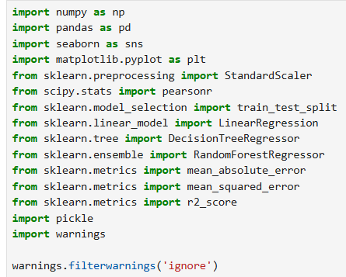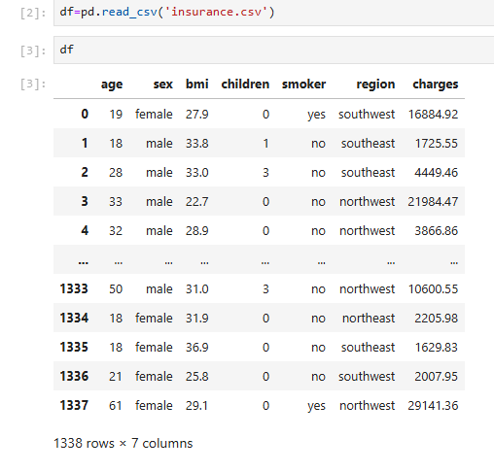
Figure 2.1: Importing required Figure 2.2: Project environment Python libraries. created in Jupyter Notebook.

2
DAY 2 – Dataset Collection and Import Libraries

DAY 3 – Dataset Loading and Understanding
3
Objective
To load and understand the dataset.

Work Done
On the third day, I loaded the insurance dataset into Jupyter Notebook using Pandas. I displayed the first five rows using df.head() to understand the dataset structure. I checked the number of rows and columns using shape() and generated summary statistics using describe(). This helped me understand the data distribution and identify the available features for model development.

Learning Outcome
- Understood the dataset structure.
- Reviewed statistical information.

Screenshots
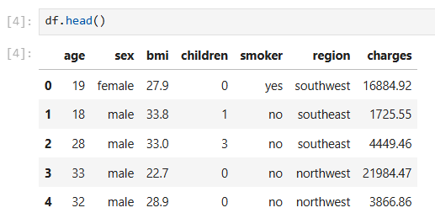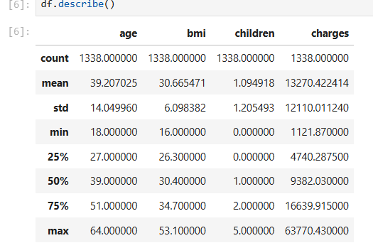
Figure 3.1: First five records of the dataset. Figure 3.2: Statistical summary of the dataset.

DAY 4 – Data Preprocessing

4
Objective
To clean and prepare the dataset for analysis.

Work Done
On the fourth day, I performed data preprocessing. I checked for missing values and duplicate records to ensure data quality. I converted categorical features such as gender, smoking status, and region into numerical values using encoding techniques. These preprocessing steps made the dataset suitable for machine learning algorithms and improved the quality of the input data.

Learning Outcome
- Cleaned and prepared the dataset.
- Converted categorical data into numerical format.

Screenshots
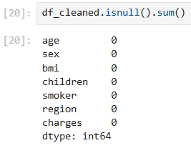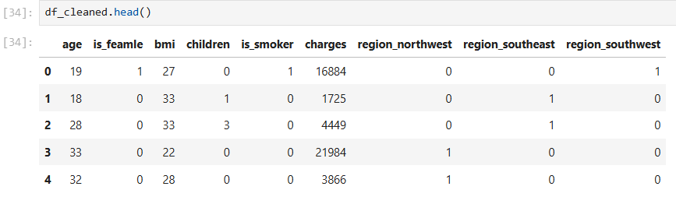
Figure 4.1: Checking for missing values. Figure 4.2: Converting categorical data into numerical values.

DAY 5 – Exploratory Data Analysis (EDA)
5
Objective
To explore the dataset using visualizations.

Work Done
On the fifth day, I performed Exploratory Data Analysis (EDA) to understand the distribution of data and relationships between variables. I generated histograms to study feature distributions and count plots to analyze categorical variables. These visualizations helped identify trends and provided useful insights before training the machine learning model.

Learning Outcome
- Understood feature distributions.
- Identified patterns using visualizations.

Screenshots
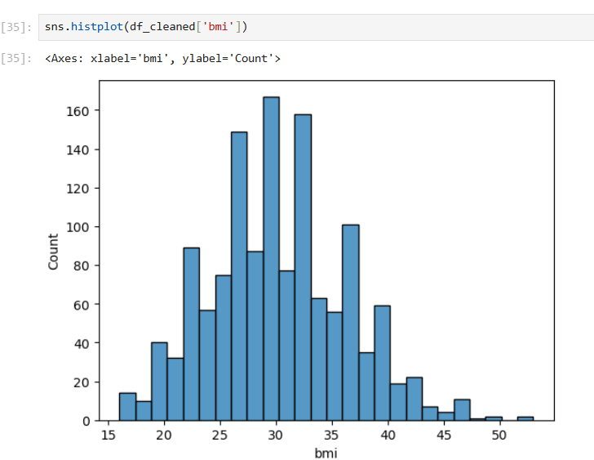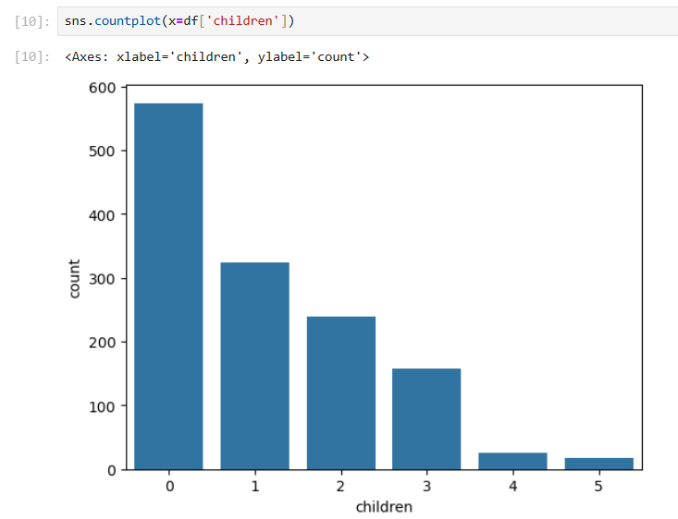
Figure 5.1: Distribution of numerical features. Figure 5.2: Distribution of categorical features.

DAY 6 – Data Visualization
6
Objective
To analyze the relationships between features using visualizations.

Work Done
On the sixth day, I created different visualization graphs to better understand the dataset. I generated box plots to identify outliers and used a correlation heatmap to measure the relationship between different variables. These visualizations helped in understanding how each feature influences the insurance charges and supported better feature selection for model training.

Learning Outcome
- Identified outliers in the dataset.
- Understood feature relationships using correlation analysis.

Screenshots
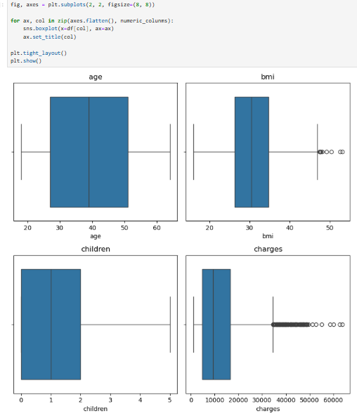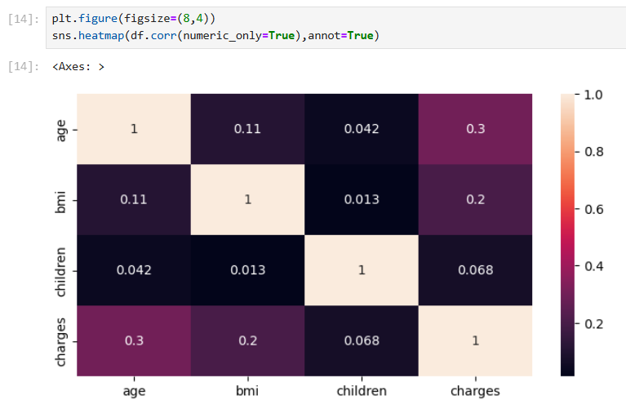
Figure 6.1: Box plot showing outliers in numerical features. .Figure 6.2: Correlation matrix of dataset features.

DAY 7 – Feature Engineering & Data Splitting
7
Objective
To prepare the final dataset for machine learning.

Work Done
On the seventh day, I selected the input features and target variable for the prediction model. After preparing the dataset, I divided it into training and testing datasets using the train_test_split() function. This step helps evaluate the model on unseen data and prevents overfitting.

Learning Outcome
- Selected features for model training.
- Successfully split the dataset into training and testing sets.

Screenshots
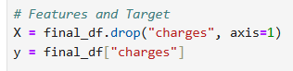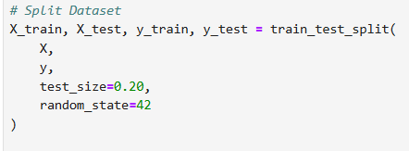
Figure 7.1: Selecting input and target variables. Figure 7.2: Selecting input and target variables.

DAY 8 – Model Training

8
Objective
To train machine learning models.

Work Done
On the eighth day, I trained different machine learning regression models using the prepared dataset. The models learned patterns from the training data to predict insurance charges based on customer details. After training, I verified that the models were working correctly and ready for performance evaluation.

Learning Outcome
- Successfully trained machine learning models.
- Prepared models for evaluation and comparison.

Screenshots
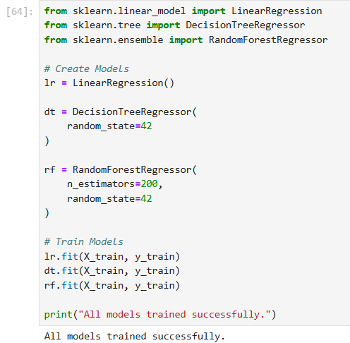
Figure 8.1: Training the machine learning model & Model training completed successful.

DAY 9 – Model Evaluation

Objective
To compare the performance of trained models.

Work Done
On the ninth day, I evaluated the trained models using different performance metrics such as R² Score, MAE, MSE, and RMSE. I compared the results of all models and selected the model that provided the highest prediction accuracy. This helped in choosing the best model for deployment.

Learning Outcome
- Compared the performance of multiple models.
- Selected the best-performing model.

Screenshots
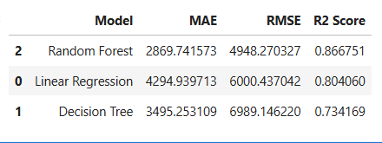
Figure 9.1: Performance comparison of machine learning models with Evaluation
metrics of the selected model..
.

9
DAY 10 – Prediction Analysis
10
Objective
To verify prediction results using the trained model.

Work Done
On the tenth day, I tested the trained model using sample customer input values. The model successfully predicted insurance charges based on the provided information. I verified that the prediction results were reasonable and confirmed that the selected model was suitable for deployment.

Learning Outcome
- Verified prediction accuracy.
- Confirmed the model is ready for deployment.

Screenshots
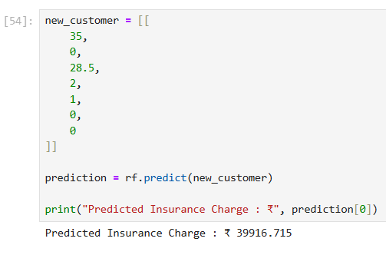
Figure 10.1: Predicting insurance charges using the trained model. & Sample
prediction generated by the model.

DAY 11 – Model Saving

11
Objective
To save the trained machine learning model for future use.

Work Done
On the eleventh day, I saved the final trained machine learning model using the Pickle library. Saving the model allows it to be reused without retraining every time. I verified that the model file was created successfully and could be loaded later for prediction. This step is important for deployment because the saved model will be connected with the Streamlit web application.

Learning Outcome
- Learned how to save a trained model using Pickle.
- Verified the saved model for future predictions.

Screenshots
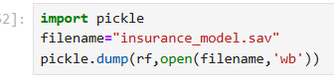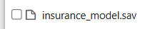
Figure 11.1: Saving the trained model using Pickle. Figure 11 .2: Saved machine learning model file..

Model Prediction
DAY 12 – Model Prediction
12
Objective
To test the trained model using sample inputs.

Work Done
On the twelfth day, I loaded the saved model and tested it with sample customer information such as age, BMI, gender, smoking status, number of children, and region. The model successfully predicted the expected insurance charges. I verified that the prediction process was working correctly before deployment.

Learning Outcome
- Successfully tested the trained model.
- Verified prediction results using sample data.

Screenshots
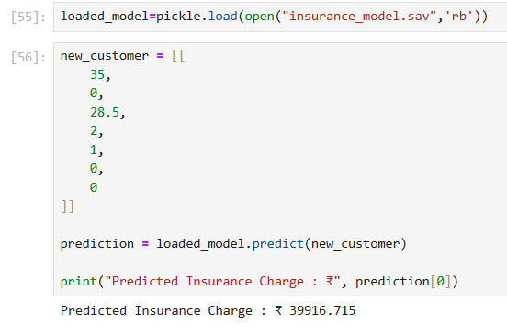
Figure 12.1: Loading the model and making predictions. with Predicted insurance charges.

DAY 13 – Streamlit Application Development
13
Objective
To develop a simple web application for prediction.

Work Done
On the thirteenth day, I created the Streamlit application using Python. The application allows users to enter customer details such as age, gender, BMI, smoking status, number of children, and region. These values are passed to the trained machine learning model, which predicts the insurance charges instantly. The application provides a simple and user-friendly interface.

Learning Outcome
- Developed a basic Streamlit application.
- Connected the trained model with the user interface.

Screenshots
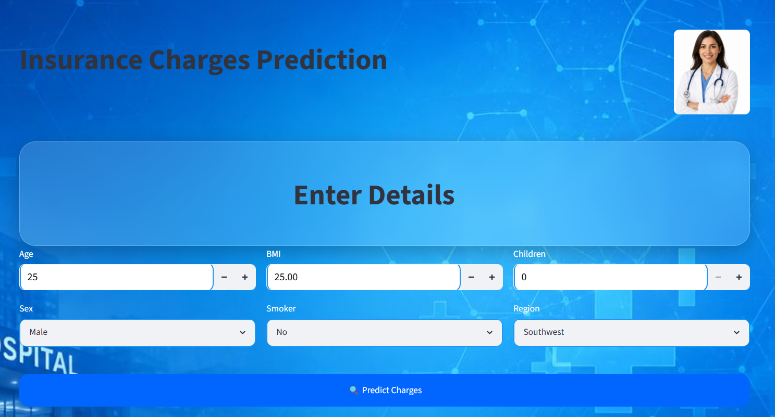
Figure 13 .1: User input section of the application.

DAY 14 – Testing and Documentation
14
Objective
To verify the complete project and prepare documentation.

Work Done
On the fourteenth day, I tested the entire project to ensure each step worked correctly. I checked the prediction output, verified the saved model, and reviewed the application code. I also collected important code snippets, graphs, and outputs to include in the final project report and presentation. Finally, I organized all project files for submission.

Learning Outcome
- Successfully tested the complete project.
- Prepared project documentation and screenshots.

Screenshots
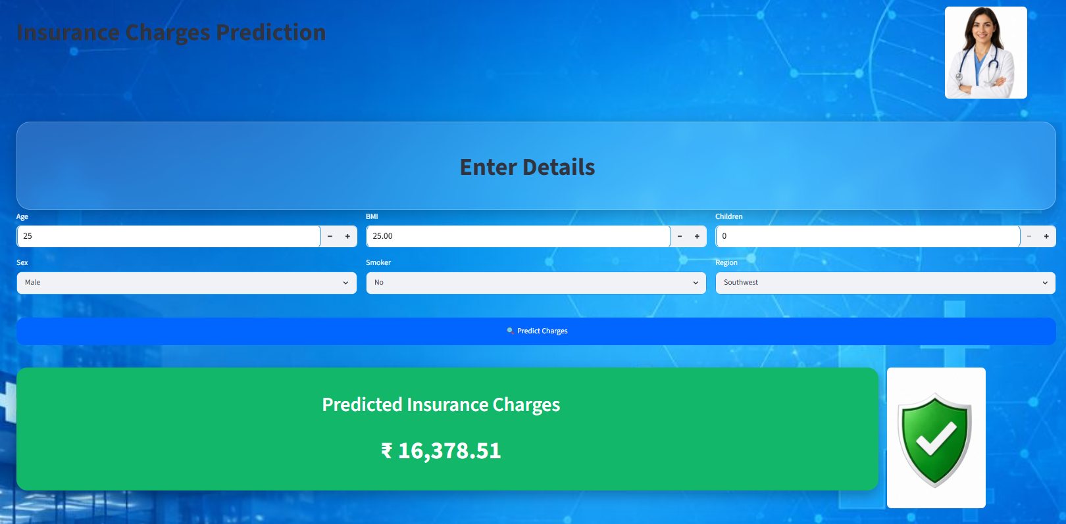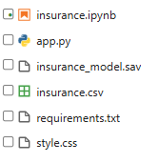
Figure 14.1: Final verification of the project. Figure 14.2: Project files and folders.

DAY 15 – Final Report and Presentation
15
Objective
To complete the project and prepare it for submission.

Work Done
On the final day, I prepared the complete project report and PowerPoint presentation. I reviewed all code, results, graphs, and screenshots to ensure the report was accurate and well organized. I added the conclusion, business recommendations, and future scope of the project. Finally, I checked the project files and prepared them for university submission.

Learning Outcome
- Completed the project documentation.
- Prepared the project for final submission.

Screenshots
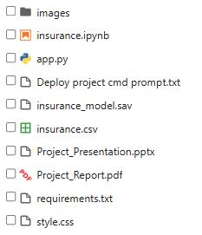
Figure 15.1: Final project files ready for submission.

CONCLUSION
16
The Insurance Charges Prediction Using Machine Learning project was successfully completed by following a structured machine learning pipeline. The project involved data collection, preprocessing, exploratory data analysis (EDA), feature engineering, model training, evaluation, and deployment.
Different machine learning regression models were trained and compared using performance metrics. The best-performing model was selected and saved using the Pickle library. A user-friendly Streamlit web application was also developed to predict insurance charges based on customer information such as age, gender, BMI, number of children, smoking status, and region.
This project helped me gain practical knowledge of Python programming, data preprocessing, data visualization, machine learning algorithms, model evaluation, and web application deployment. It also demonstrated how machine learning can be applied to solve real-world business problems in the insurance industry.
Overall, the project was completed successfully and achieved its objective of predicting insurance charges with satisfactory accuracy.

FUTURE SCOPE
17
The project can be further improved by implementing the following enhancements:
- Increase the dataset size to improve prediction accuracy.
- Train advanced machine learning models such as XGBoost, LightGBM, or CatBoost.
- Perform hyperparameter tuning to optimize model performance.
- Deploy the application on cloud platforms such as Streamlit Community Cloud, Render, or Heroku.
- Add user authentication and login functionality.
- Store prediction history in a database for future reference.
- Develop a responsive mobile-friendly interface.
- Integrate real-time healthcare or insurance data for more accurate predictions.
- Improve the user interface by adding interactive charts and visual reports.
- Convert the web application into an Android or iOS mobile application.
These improvements can make the project more accurate, scalable, and suitable for practical use in the insurance industry.

REFERENCES
18
- Python Software Foundation. Python Documentation. Available at: https://docs.python.org/
- Pandas Development Team. Pandas Documentation. Available at: https://pandas.pydata.org/docs/
- Scikit-learn Developers. Scikit-learn Documentation. Available at: https://scikit-learn.org/stable/
- Streamlit Inc. Streamlit Documentation. Available at: https://docs.streamlit.io/
- NumPy Developers. NumPy Documentation. Available at: https://numpy.org/doc/
- Matplotlib Developers. Matplotlib Documentation. Available at: https://matplotlib.org/
- Seaborn Developers. Seaborn Documentation. Available at: https://seaborn.pydata.org/
- Kaggle. Medical Cost Personal Dataset. Available at: https://www.kaggle.com/datasets/mirichoi0218/insurance
- Jupyter Project. Jupyter Notebook Documentation. Available at: https://jupyter.org/
- Géron, Aurélien. Hands-On Machine Learning with Scikit-Learn, Keras & TensorFlow. O'Reilly Media.

