**erd**

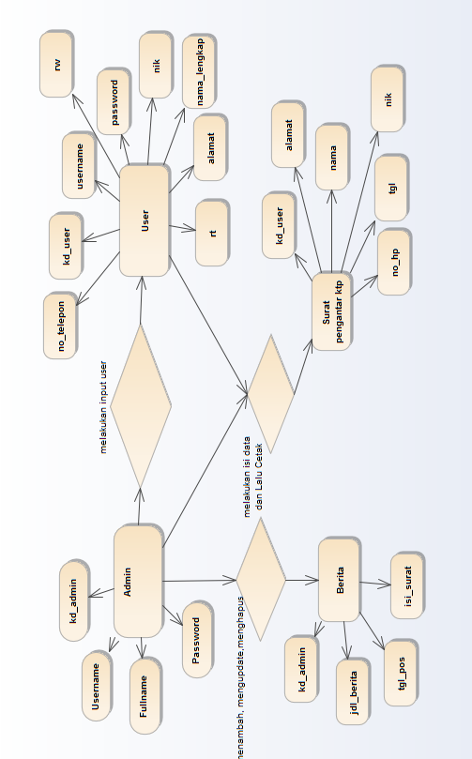

LRS

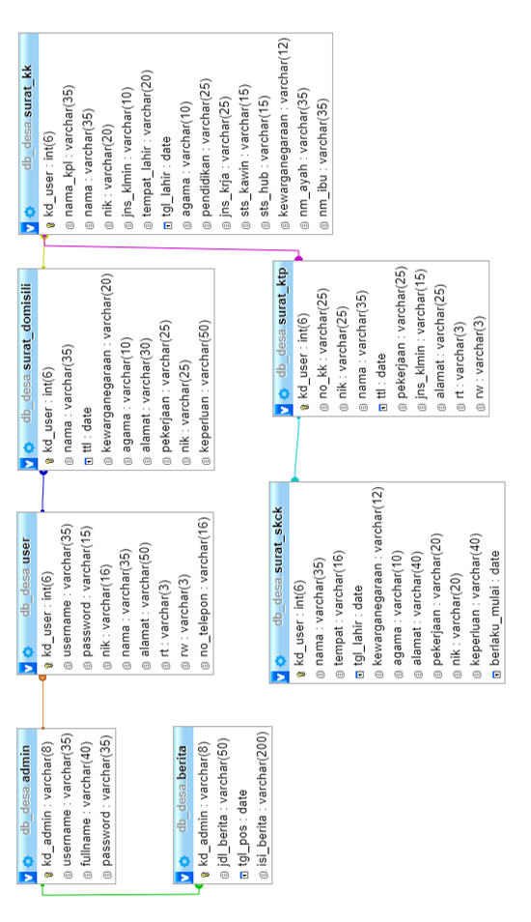

DATA BASE PHPMYADMIN

**admin**

|  |  |  |  |  |  |
| --- | --- | --- | --- | --- | --- |
| **Column** | **Type** | **Null** | **Default** | **Comments** | **MIME** |
| id_admin | int(20) | No |  |  |  |
| nik | varchar(25) | No |  |  |  |
| nama | varchar(60) | Yes | *NULL* |  |  |
| jenis_kelamin | varchar(15) | Yes | *NULL* |  |  |
| tempat_lahir | varchar(40) | Yes | *NULL* |  |  |
| tanggal_lahir | datetime | Yes | *NULL* |  |  |
| agama | varchar(20) | Yes | *NULL* |  |  |
| pekerjaan | varchar(40) | Yes | *NULL* |  |  |
| nama_anak | varchar(40) | Yes | *NULL* |  |  |
| nama_ibu | varchar(40) | Yes | *NULL* |  |  |
| nama_bapa | varchar(40) | Yes | *NULL* |  |  |
| nokk | varchar(40) | Yes | *NULL* |  |  |
| alamat | varchar(40) | Yes | *NULL* |  |  |
| rw | varchar(5) | Yes | *NULL* |  |  |
| rt | varchar(5) | Yes | *NULL* |  |  |
| level | varchar(20) | Yes | *NULL* |  |  |
| logo | varchar(20) | Yes | *NULL* |  |  |
| password | varchar(15) | No |  |  |  |

**Indexes**

| **Keyname** | **Type** | **Unique** | **Packed** | **Column** | **Cardinality** | **Collation** | **Null** | **Comment** |
| --- | --- | --- | --- | --- | --- | --- | --- | --- |
| PRIMARY | BTREE | Yes | No | id_admin | 18 | A | No |  |

**rt**

|  |  |  |  |  |  |
| --- | --- | --- | --- | --- | --- |
| **Column** | **Type** | **Null** | **Default** | **Comments** | **MIME** |
| id_rt | int(20) | No |  |  |  |
| nik | varchar(25) | No |  |  |  |
| nama | varchar(40) | Yes | *NULL* |  |  |
| jenis_kelamin | varchar(15) | Yes | *NULL* |  |  |
| tempat_lahir | varchar(60) | Yes | *NULL* |  |  |
| tanggal_lahir | datetime | Yes | *NULL* |  |  |
| agama | varchar(20) | Yes | *NULL* |  |  |
| pekerjaan | varchar(35) | Yes | *NULL* |  |  |
| nama_anak | varchar(40) | Yes | *NULL* |  |  |
| nama_ibu | varchar(60) | Yes | *NULL* |  |  |
| nama_bapa | varchar(60) | Yes | *NULL* |  |  |
| nokk | varchar(20) | Yes | *NULL* |  |  |
| alamat | varchar(60) | Yes | *NULL* |  |  |
| rw | varchar(4) | Yes | *NULL* |  |  |
| rt | varchar(4) | Yes | *NULL* |  |  |
| level | varchar(20) | Yes | *NULL* |  |  |
| logo | varchar(20) | Yes | *NULL* |  |  |
| password | varchar(20) | No |  |  |  |

**Indexes**

| **Keyname** | **Type** | **Unique** | **Packed** | **Column** | **Cardinality** | **Collation** | **Null** | **Comment** |
| --- | --- | --- | --- | --- | --- | --- | --- | --- |
| PRIMARY | BTREE | Yes | No | id_rt | 17 | A | No |  |

**suratketerangandatang**

|  |  |  |  |  |  |
| --- | --- | --- | --- | --- | --- |
| **Column** | **Type** | **Null** | **Default** | **Comments** | **MIME** |
| id_suketdatang | int(20) | No |  |  |  |
| kd_suketdatang | varchar(10) | No |  |  |  |
| nik | varchar(25) | No |  |  |  |
| nokk | varchar(25) | No |  |  |  |
| nama | varchar(35) | No |  |  |  |
| alamat | varchar(40) | No |  |  |  |
| tempat | varchar(40) | No |  |  |  |
| tanggal_lahir | varchar(5) | No |  |  |  |
| jenis_kelamin | varchar(15) | No |  |  |  |
| agama | varchar(15) | No |  |  |  |
| pekerjaan | varchar(20) | No |  |  |  |
| warganegara | varchar(20) | No |  |  |  |
| rt | varchar(5) | No |  |  |  |
| rw | varchar(5) | No |  |  |  |
| keterangan | varchar(50) | Yes | *NULL* |  |  |
| tanggal | timestamp | No | CURRENT_TIMESTAMP |  |  |
| jml | varchar(10) | No |  |  |  |
| nikpemohon | varchar(20) | No |  |  |  |
| namapemohon | varchar(40) | No |  |  |  |
| statuskkpindah | varchar(35) | No |  |  |  |
| alamatpindah | varchar(40) | No |  |  |  |
| nikkk | varchar(20) | No |  |  |  |
| namakepalakeluarga | varchar(40) | No |  |  |  |
| tanggaldatang | date | No |  |  |  |

**Indexes**

| **Keyname** | **Type** | **Unique** | **Packed** | **Column** | **Cardinality** | **Collation** | **Null** | **Comment** |
| --- | --- | --- | --- | --- | --- | --- | --- | --- |
| PRIMARY | BTREE | Yes | No | id_suketdatang | 5 | A | No |  |

**suratketerangankelahiran**

|  |  |  |  |  |  |
| --- | --- | --- | --- | --- | --- |
| **Column** | **Type** | **Null** | **Default** | **Comments** | **MIME** |
| id_suketkelahiran | int(10) | No |  |  |  |
| kd_suketkelahiran | varchar(10) | No |  |  |  |
| nik | varchar(20) | No |  |  |  |
| nik_ayah | varchar(20) | No |  |  |  |
| nama_bapa | varchar(40) | No |  |  |  |
| tanggal_lahir_bapa | date | No |  |  |  |
| tempat_lahir_bapa | varchar(40) | No |  |  |  |
| pekerjaan_bapa | varchar(40) | No |  |  |  |
| alamat_bapa | varchar(40) | No |  |  |  |
| warganegara_bapa | varchar(30) | No |  |  |  |
| kebangsaan_bapa | varchar(30) | No |  |  |  |
| nik_ibu | varchar(20) | No |  |  |  |
| nama_ibu | varchar(40) | No |  |  |  |
| tmpt_lahir_ibu | varchar(40) | No |  |  |  |
| tgl_lahir_ibu | varchar(10) | No |  |  |  |
| pekerjaan_ibu | varchar(40) | No |  |  |  |
| alamat_ibu | varchar(40) | No |  |  |  |
| warganegara_ibu | varchar(30) | No |  |  |  |
| kebangsaan_ibu | varchar(30) | No |  |  |  |
| nama_anak | varchar(40) | No |  |  |  |
| tempat_lahir | varchar(40) | No |  |  |  |
| tanggal_lahir | date | No |  |  |  |
| nobukunikah | varchar(40) | No |  |  |  |
| tmpt_dilahirkan | varchar(40) | No |  |  |  |
| hari_tgl_lahir | varchar(15) | No |  |  |  |
| jam | varchar(15) | No |  |  |  |
| jeniskelahiran | varchar(20) | No |  |  |  |
| anake | varchar(20) | No |  |  |  |
| tenaga_kesehatan | varchar(15) | No |  |  |  |
| berat_bayi | varchar(10) | No |  |  |  |
| panjang_bayi | varchar(15) | No |  |  |  |
| nama | varchar(40) | No |  |  |  |
| alamat | varchar(40) | No |  |  |  |
| tgllahir | date | No |  |  |  |
| tmplahir | varchar(40) | No |  |  |  |
| jk | varchar(15) | No |  |  |  |
| jenis_kelamin | varchar(15) | No |  |  |  |
| rt | varchar(5) | No |  |  |  |
| rw | varchar(5) | No |  |  |  |
| keterangan | varchar(50) | Yes | *NULL* |  |  |
| tanggal | timestamp | No | CURRENT_TIMESTAMP |  |  |
| jml | varchar(30) | No |  |  |  |
| pekerjaan_pelapor | varchar(40) | No |  |  |  |
| niksaksi1 | varchar(20) | No |  |  |  |
| namasaksi1 | varchar(40) | No |  |  |  |
| alamatsaksi1 | varchar(40) | No |  |  |  |
| tanggal_lahirsaksi1 | date | No |  |  |  |
| tempat_lahirsaksi1 | varchar(40) | No |  |  |  |
| jenis_kelaminsaksi1 | varchar(15) | No |  |  |  |
| pekerjaan_pelaporsaksi1 | varchar(40) | No |  |  |  |
| niksaksi2 | varchar(20) | No |  |  |  |
| namasaksi2 | varchar(40) | No |  |  |  |
| alamatsaksi2 | varchar(40) | No |  |  |  |
| tanggal_lahirsaksi2 | date | No |  |  |  |
| tempat_lahirsaksi2 | varchar(40) | No |  |  |  |
| jenis_kelaminsaksi2 | varchar(15) | No |  |  |  |
| pekerjaan_pelaporsaksi2 | varchar(40) | No |  |  |  |

**Indexes**

| **Keyname** | **Type** | **Unique** | **Packed** | **Column** | **Cardinality** | **Collation** | **Null** | **Comment** |
| --- | --- | --- | --- | --- | --- | --- | --- | --- |
| PRIMARY | BTREE | Yes | No | id_suketkelahiran | 3 | A | No |  |

**suratketerangankematian**

|  |  |  |  |  |  |
| --- | --- | --- | --- | --- | --- |
| **Column** | **Type** | **Null** | **Default** | **Comments** | **MIME** |
| id_suketkematian | int(20) | No |  |  |  |
| kd_suketkematian | varchar(10) | No |  |  |  |
| nik | varchar(20) | No |  |  |  |
| nikkematian | varchar(20) | No |  |  |  |
| nokk | varchar(25) | No |  |  |  |
| nama | varchar(40) | No |  |  |  |
| tempat_lahir | varchar(40) | No |  |  |  |
| tanggal_lahir | varchar(20) | No |  |  |  |
| alamat | varchar(40) | No |  |  |  |
| jenis_kelamin | varchar(15) | No |  |  |  |
| wafat_tanggal | varchar(20) | No |  |  |  |
| rt | varchar(5) | No |  |  |  |
| rw | varchar(5) | No |  |  |  |
| tanggal | timestamp | No | CURRENT_TIMESTAMP |  |  |
| jml | varchar(30) | No |  |  |  |
| agama | varchar(30) | No |  |  |  |
| pekerjaan | varchar(40) | No |  |  |  |
| anake | varchar(30) | No |  |  |  |
| sebab | varchar(35) | No |  |  |  |
| tanggalmati | varchar(20) | No |  |  |  |
| tmptmati | varchar(40) | No |  |  |  |
| tenagakesehatan | varchar(35) | No |  |  |  |
| nik_bapa | varchar(25) | No |  |  |  |
| nik_ibu | varchar(25) | No |  |  |  |
| nama_bapa | varchar(40) | No |  |  |  |
| nama_ibu | varchar(40) | No |  |  |  |
| tempat_lahir_bapa | varchar(40) | No |  |  |  |
| tmpt_lahir_ibu | varchar(40) | No |  |  |  |
| tanggal_lahir_bapa | date | No |  |  |  |
| tgl_lahir_ibu | date | No |  |  |  |
| pekerjaan_bapa | varchar(40) | No |  |  |  |
| pekerjaan_ibu | varchar(40) | No |  |  |  |
| alamat_bapa | varchar(40) | No |  |  |  |
| alamat_ibu | varchar(40) | No |  |  |  |
| warganegara_bapa | varchar(30) | No |  |  |  |
| warganegara_ibu | varchar(30) | No |  |  |  |
| kebangsaan_bapa | varchar(30) | No |  |  |  |
| kebangsaan_ibu | varchar(30) | No |  |  |  |
| namapelapor | varchar(40) | No |  |  |  |
| alamatpelapor | varchar(225) | No |  |  |  |
| tanggal_lahir_pelapor | varchar(30) | No |  |  |  |
| tempat_lahir_pelapor | varchar(45) | No |  |  |  |
| jeniskelaminpelapor | varchar(15) | No |  |  |  |
| pekerjaan_pelapor | varchar(45) | No |  |  |  |
| keterangan | varchar(50) | Yes | *NULL* |  |  |

**Indexes**

| **Keyname** | **Type** | **Unique** | **Packed** | **Column** | **Cardinality** | **Collation** | **Null** | **Comment** |
| --- | --- | --- | --- | --- | --- | --- | --- | --- |
| PRIMARY | BTREE | Yes | No | id_suketkematian | 2 | A | No |  |

**suratketeranganpindah**

|  |  |  |  |  |  |
| --- | --- | --- | --- | --- | --- |
| **Column** | **Type** | **Null** | **Default** | **Comments** | **MIME** |
| id_suketpindah | int(20) | No |  |  |  |
| kd_suketpindah | varchar(20) | No |  |  |  |
| nik | varchar(25) | No |  |  |  |
| nokk | varchar(25) | No |  |  |  |
| nama | varchar(45) | No |  |  |  |
| alamat | varchar(45) | No |  |  |  |
| tempat_lahir | varchar(45) | No |  |  |  |
| tanggal_lahir | varchar(20) | No |  |  |  |
| jenis_kelamin | varchar(15) | No |  |  |  |
| agama | varchar(30) | No |  |  |  |
| pekerjaan | varchar(45) | No |  |  |  |
| warganegara | varchar(30) | No |  |  |  |
| rt | varchar(5) | No |  |  |  |
| rw | varchar(5) | No |  |  |  |
| keterangan | varchar(50) | Yes | *NULL* |  |  |
| tanggal | timestamp | No | CURRENT_TIMESTAMP |  |  |
| jml | varchar(25) | No |  |  |  |
| nikpemohon | varchar(25) | No |  |  |  |
| namapemohon | varchar(45) | No |  |  |  |
| alasanpindah | varchar(50) | No |  |  |  |
| alamatpindah | varchar(45) | No |  |  |  |
| jeniskepindahan | varchar(35) | No |  |  |  |
| statuskktidakpindah | varchar(40) | No |  |  |  |
| statuskkpindah | varchar(40) | No |  |  |  |

**Indexes**

| **Keyname** | **Type** | **Unique** | **Packed** | **Column** | **Cardinality** | **Collation** | **Null** | **Comment** |
| --- | --- | --- | --- | --- | --- | --- | --- | --- |
| PRIMARY | BTREE | Yes | No | id_suketpindah | 2 | A | No |  |

**suratpermohonanktp**

|  |  |  |  |  |  |
| --- | --- | --- | --- | --- | --- |
| **Column** | **Type** | **Null** | **Default** | **Comments** | **MIME** |
| id_ktp | int(20) | No |  |  |  |
| nik | varchar(25) | No |  |  |  |
| nama_pemohon | varchar(45) | No |  |  |  |
| alamat_pemohon | varchar(45) | No |  |  |  |
| jenis_kelamin_pemohon | varchar(15) | No |  |  |  |
| pekerjaan_pemohon | varchar(40) | No |  |  |  |
| tanggal_lahir_pemohon | varchar(20) | No |  |  |  |
| tempat_lahir_pemohon | varchar(45) | No |  |  |  |
| rt | varchar(5) | No |  |  |  |
| rw_pemohon | varchar(5) | No |  |  |  |
| kd_ktp | varchar(20) | No |  |  |  |
| jml | varchar(25) | No |  |  |  |
| keterangan | varchar(50) | Yes | *NULL* |  |  |
| logo | varchar(50) | No |  |  |  |

**Indexes**

| **Keyname** | **Type** | **Unique** | **Packed** | **Column** | **Cardinality** | **Collation** | **Null** | **Comment** |
| --- | --- | --- | --- | --- | --- | --- | --- | --- |
| PRIMARY | BTREE | Yes | No | id_ktp | 1 | A | No |  |

**user**

|  |  |  |  |  |  |
| --- | --- | --- | --- | --- | --- |
| **Column** | **Type** | **Null** | **Default** | **Comments** | **MIME** |
| id_user | int(20) | No |  |  |  |
| nik | varchar(25) | No |  |  |  |
| nama | varchar(40) | Yes | *NULL* |  |  |
| jenis_kelamin | varchar(15) | Yes | *NULL* |  |  |
| tempat_lahir | varchar(40) | Yes | *NULL* |  |  |
| tanggal_lahir | datetime | Yes | *NULL* |  |  |
| agama | varchar(20) | Yes | *NULL* |  |  |
| pekerjaan | varchar(35) | Yes | *NULL* |  |  |
| nama_anak | varchar(40) | Yes | *NULL* |  |  |
| nama_ibu | varchar(40) | Yes | *NULL* |  |  |
| nama_bapa | varchar(40) | Yes | *NULL* |  |  |
| nokk | varchar(20) | Yes | *NULL* |  |  |
| alamat | varchar(40) | Yes | *NULL* |  |  |
| rw | varchar(5) | Yes | *NULL* |  |  |
| rt | varchar(5) | Yes | *NULL* |  |  |
| level | varchar(20) | Yes | *NULL* |  |  |
| logo | varchar(20) | Yes | *NULL* |  |  |
| password | varchar(15) | No |  |  |  |

**Indexes**

| **Keyname** | **Type** | **Unique** | **Packed** | **Column** | **Cardinality** | **Collation** | **Null** | **Comment** |
| --- | --- | --- | --- | --- | --- | --- | --- | --- |
| PRIMARY | BTREE | Yes | No | id_user | 17 | A | No |  |

[Open new phpMyAdmin window](http://localhost/phpmyadmin/db_datadict.php?db=sisteminformasipelayanandesa&table=user&server=1&target=&token=de37d33bea3bd2061403d0d198a6c765)