## Responsive:-

* Viewing in the mobile size of 360x640 there is a drop option where it is not necessary.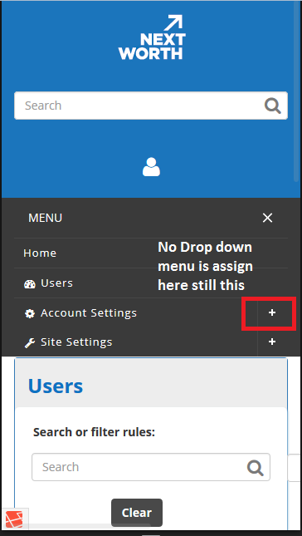
* The logout option is under the search button. It should be near search button

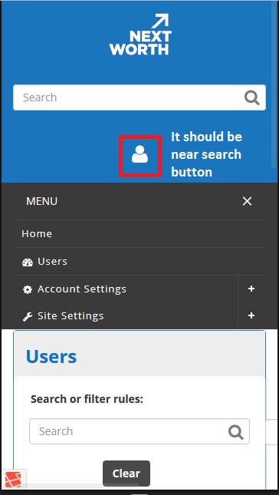

* There should be space below the buttons  
    
   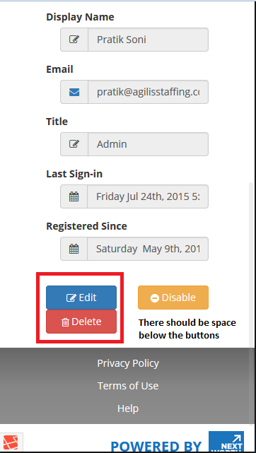
* The select button for selecting the group shown under the user details should have the selection button and primary grp button have to be in same line  
  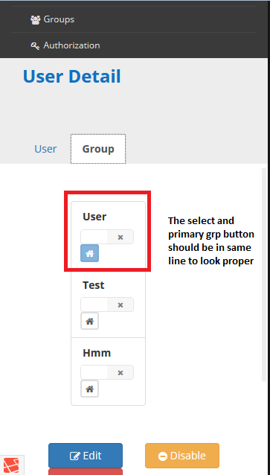
* The search button goes on top at the resolution size of 768x1024  
  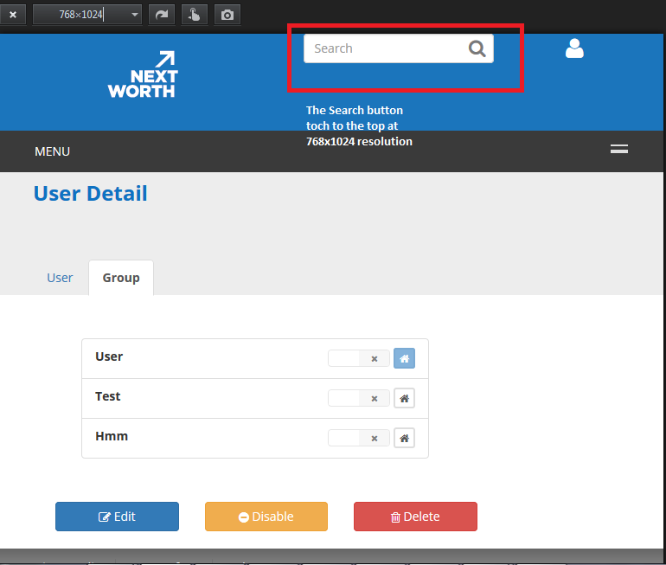
* Box are not as per the width of the screen. Little more width can be provided to them.

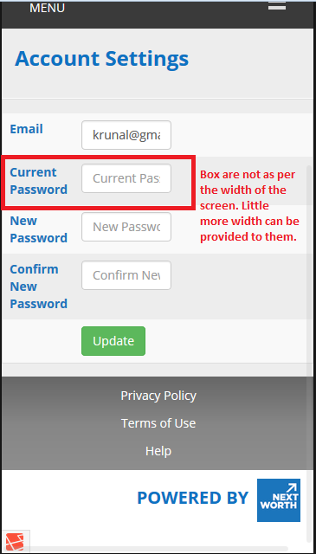

* The footer links must be in same line  
     
   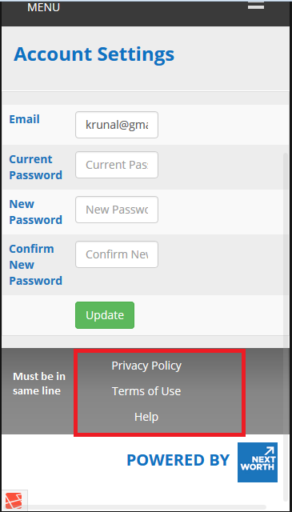
* On clicking on the option near to the search button the menu options are no in same align  
   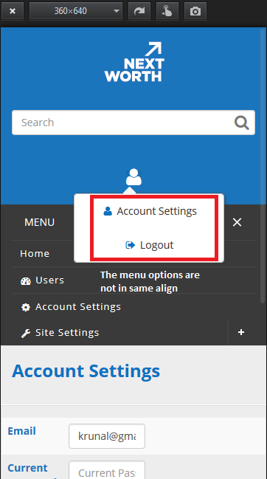
* The filter option cannot be seen in mobile view  
    
   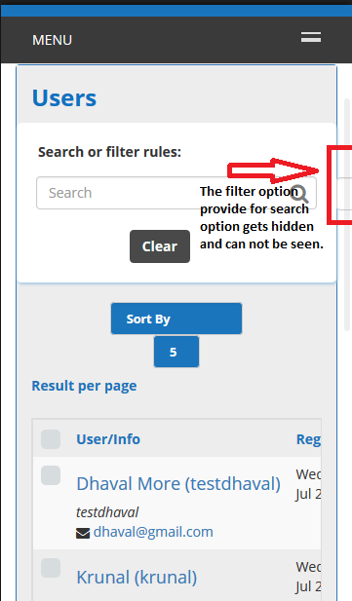  
    
   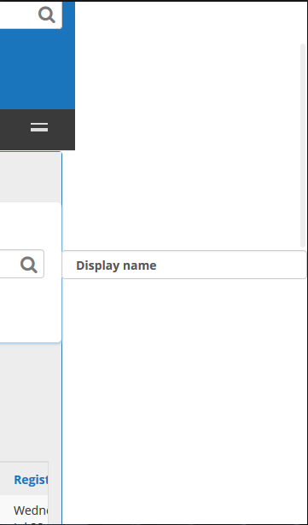
* Dasd
* As
* Das