[www.TipCastle.com](http://www.TipCastle.com)

Tipper Interface

# Overview

This app enabled guests in hotels to electronically leave a tip for the housekeeper. Hotel management can use a web interface to review tip info and other service ratings and notes from the guests.

There are 2 types of users of the app and both have separate interfaces.

**Tipper interface has 6 app pages.**

Login

Sign up

Landing page (list of historical tips)

Tip entry

Tip fee confirmation

Print

**Hotel Management has 4 pages and one export feature**

Landing page (list of historical tips and service rating info)

Tip detail view and edit (allowing association of tips to housekeeper)

Export feature (export tip data to Excel)

Hotel Signup

OS’s for Tipper interface app

Iphone using HTML instead IOS

Android

Hotel management for web browser. I don’t think it needs an App just yet.

# Tipper Login

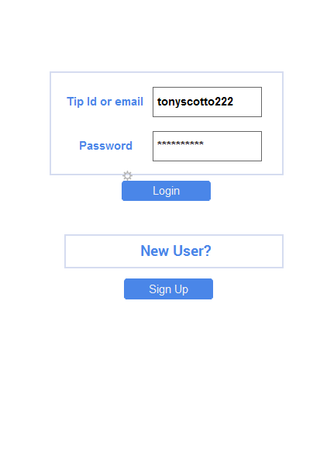

## Sign Up

I don’t know much about storing CC info in an app, but perhaps we should have an option for the user to select to store CC info, perhaps multiple cards. Also, I will need to sign up with a processing company. I’d like to pick one that’s easy to work with from a dev standpoint so please suggest.

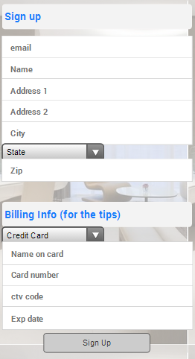

## Login Landing Page or landing page for signing up

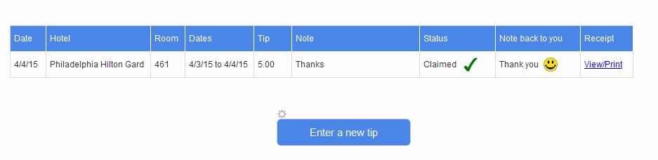

## Tip Entry

Would like to use location services or even Wifi info as you mentioned which will get me closer to identify the hotel and select it. I am pretty sure there’s a way using Google Places API to get to the hotel to save the customer the bother of selecting.

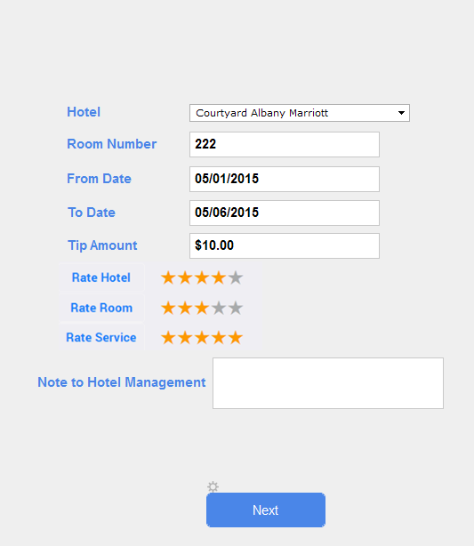

## Confirmation

The fee is % based. 10%

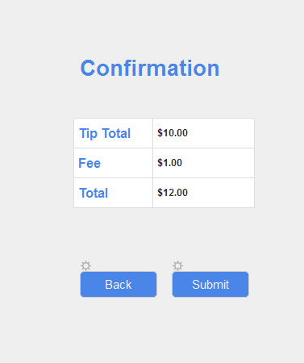

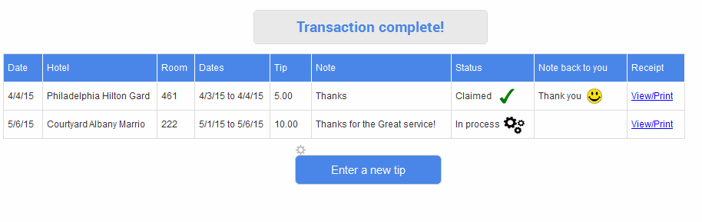

# View/Print

This should be viewable in a phone size view so that someone could take a screen shot and use that as a receipt.

|  |  |
| --- | --- |
| Housekeeping gratuity Receipt  Marriott Courtyard Albany  134 Main St.  Albany, 11223 | Joe Customer  123 Broad St  Anytown, PA, 19047 |

|  |  |  |  |
| --- | --- | --- | --- |
| Date | Item | Stay | Amount |
| 5/6/15 | Housekeeping | 5/1/15 to 5/6/15 | $10.00 |
| 5/6/15 | Service fee |  | $1.00 |
| Total | Paid in full |  | $11.00 |
|  |  |  |  |



TipCastle.com

Hotel Manager Interface

# Hotel Manager Login

Hotel Manager Login

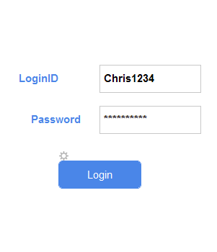

## Landing Page

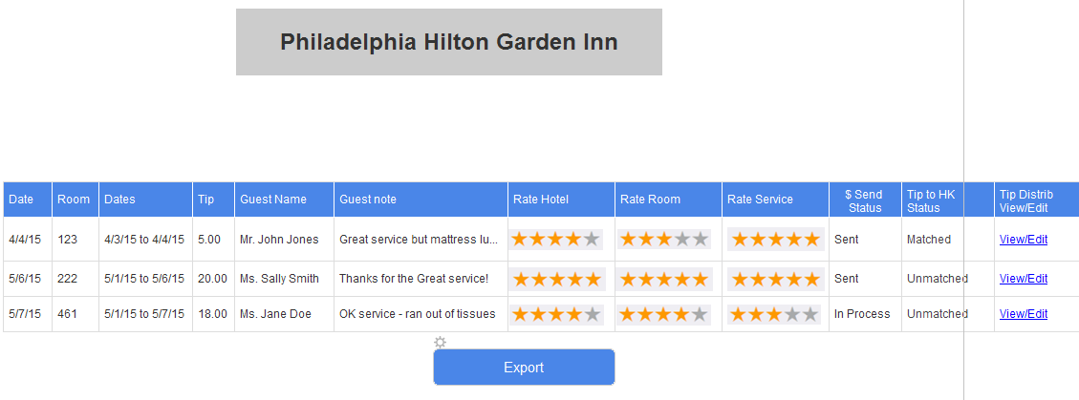

## View/Edit

The idea behind this page is to allow the manager to see all the tips per day and optionally Match/associate the housekeeper to the tip to make it easier to print out and use for distribution. It will also allow him/her to more easily see the service ratings associated to the housekeeper. At some future date it would probably be nice to make it allow for range entry like adding Mary to all this week for rooms 100-115.

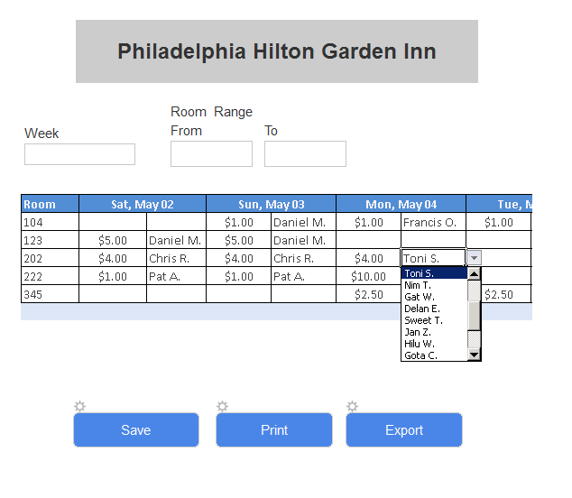

Type in new values here. Existing can be selected.

## Export

Will Export will create Excel or CSV with all details including related guest and rating info. Database info to follow later in document.

## Hotel Sign up

I am not sure how hotels would best like to receive tip money so my first stab is to just get enough to send a check along with date, room and guest details.

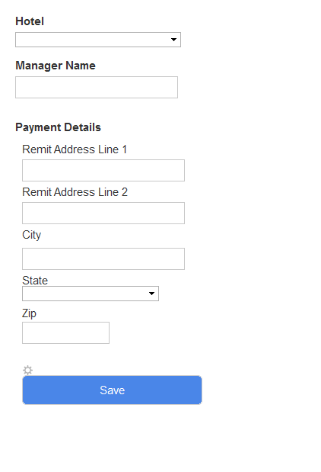

# Database

## Tables

Guest

Hotel

HotelLogin

HouseKeeper

CCInfo

GuestTipEntry

TipByDay

### Guest

GuestID – Globally UniqueId (GUID)

GuestName

Email

### Hotel

HotelID - Globally UniqueId (GUID)

Hotel Name

ManagerName

ManagerEmail

ManagerPhone

HotelPhone

Address1

Address2

City

State

Zip

LongLat? – (not sure about this one)

### HotelLogin

HotelID (foreign Key)

Name

Email

### HouseKeeper

HouseKeeperID - Globally UniqueId (GUID)

HotelID (foreign Key)

Name

### CCInfo

CCInfoID - Globally UniqueId (GUID)

GuestID (foreign Key)

NameOnCard

CCNumber (encrypted)

CTV

ExpDate

### GuestTipEntry

GuestTipEntryID - Globally UniqueId (GUID)

GuestID (foreign Key)

HotelID (foreign Key)

RoomNumber

FromDate

ToDate

TimAmount

RateHotel (number from 1-5)

RateRoom (number from 1-5)

RateService (number from 1-5)

NoteToHotel – Text 255

### TipByDay – automatically filled in from GuestTipEntry on Submit

TipByDayID - Globally UniqueId (GUID)

GuestTipEntryID (foreign Key)

TipDate

TipAmount

HouseKeeperID (foreign Key)