Tipper/Guest Phone App Design

# Overview

This app enabled guests in hotels to electronically leave a tip for the housekeeper. Hotel management can use a web interface to review tip info and other service ratings and notes from the guests.

There are 2 types of users of the app and both have separate interfaces.

# Tipper/Guest Tip App for Iphone and Android – No web app required at this time.

**Tipper interface has 6 app screens.**

Login

Sign up

Landing page (list of last 10 tips)

Tip entry

Tip fee confirmation (credit card capture)

View/Print

# Tipper Login

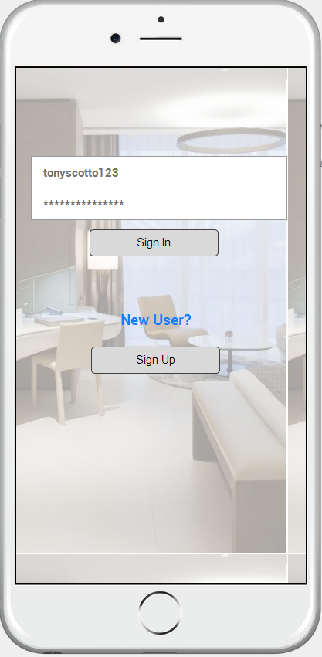

## Sign Up

Easy sign up with just email

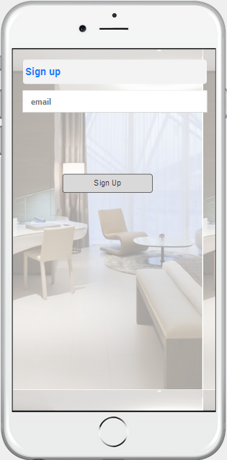

## Login Landing Page or landing page for signing up

**\*If there are more than 10 tips, we need a NEXT and PREV list function**

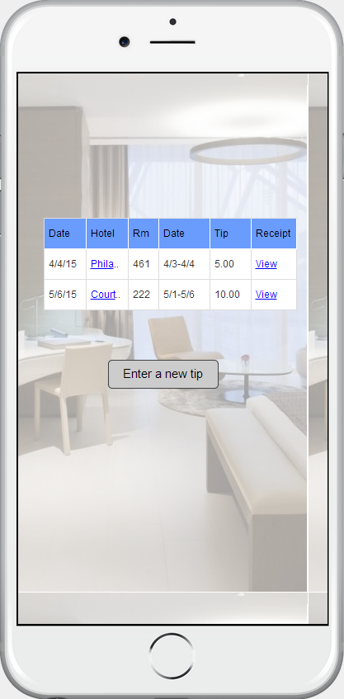

## Tip Entry

Would like to use location services or even Wifi info as you mentioned which will get me closer to identify the hotel and select it. I am pretty sure there’s a way using Google Places API to get to the hotel to save the customer the bother of selecting.

**\*If Tipper decides to leave ZERO $0.00 tip, then skip the next page and just allow the user to submit the rating and note to the hotel.**

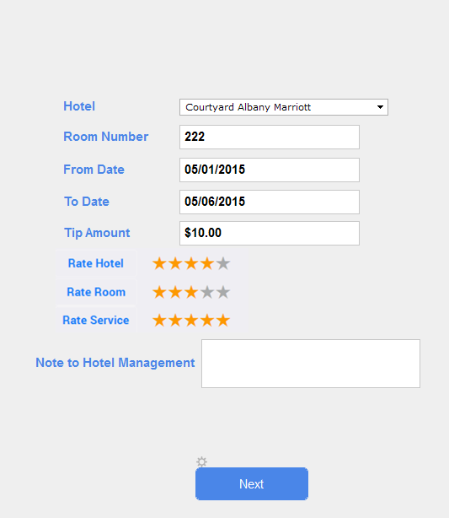

## Confirmation

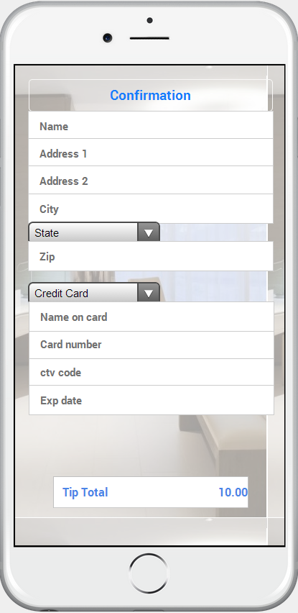

## Transaction Complete

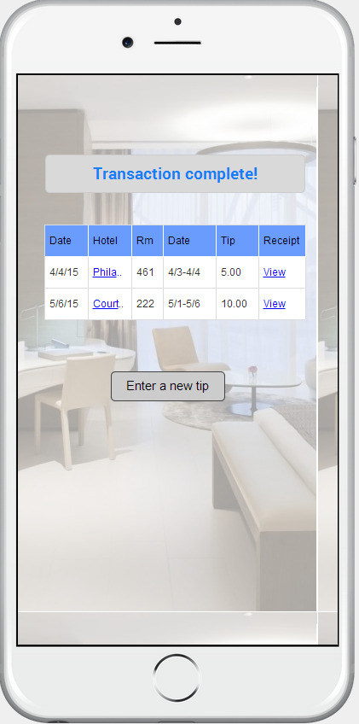

# View/Print

This should be viewable in a phone size view so that someone could take a screen shot and use that as a receipt.

