Selbi Nuryyeva

Prof. Serdal Kırmızıaltın

April 23, 2015

Computational Chemistry

**Homework Assignment 4**

**Question 1**

1. *Parameters (xyz coordinates, angle and bond length):*

O -2.10730 1.97533 -0.04557

H -1.14844 2.03072 -0.28665

H -2.54298 1.59113 -0.84755

HOH 104.51 degrees

O-H 0.990254 Angstrom

*Energy – calculated using UFF method*

5.38772e-13 kJ/mol = 1.2877e-13 kcal/mol,

*Dipole*

0.245 D

|  |  |  |  |
| --- | --- | --- | --- |
|  | Energy (Hartree) | Energy (kcal/mol) | Dipole (Debye) |
| Avogadro | n/a | 1.29e-13 | 0.245 |
| PM3 | -0.085 | -53.35 | 1.7386 |
| RHF/STO-3G | -74.966 | -47041.82 | 1.7093 |
| RHF/6-31G(d,p) | -76.024 | -47705.55 | 2.1478 |
| Experimental | n/a | n/a | 1.85[1]-1.86[2] |

***b)***

Avogadro’s prediction of the lowest energy state is higher than all the ones predicted theoretically using semi-empirical (PM3) and ab-initio (RHF) methods. As the difference between Avogadro’s predictions and of the computational is large, it can be concluded that Avogadro’s predictions are not accurate and cannot be fully trusted.

The lowest energy is reported by Ab-initio method: RHF/6-31G(d,p). As ab-initio methods are more accurate than semi-empirical method (PM3), it is not surprising that ab-initio methods give the lowest energy. 6-31G found a lower energy than STO-3G, perhaps because it takes into account the d and p orbitals. However, it is important to note that even if ab-initio methods found lower energy, they cannot always be implemented as they have limit on number of particles (and can take ages to calculate).

However, for dipole calculations, semi-empirical method, PM3, showed the closest value of dipole to experimental one. While ab-initio methods showed a close value to experimental one as well, Avogadro predictions showed to be way off the experimental value.

***c)*** *Infrared spectra*

PM3

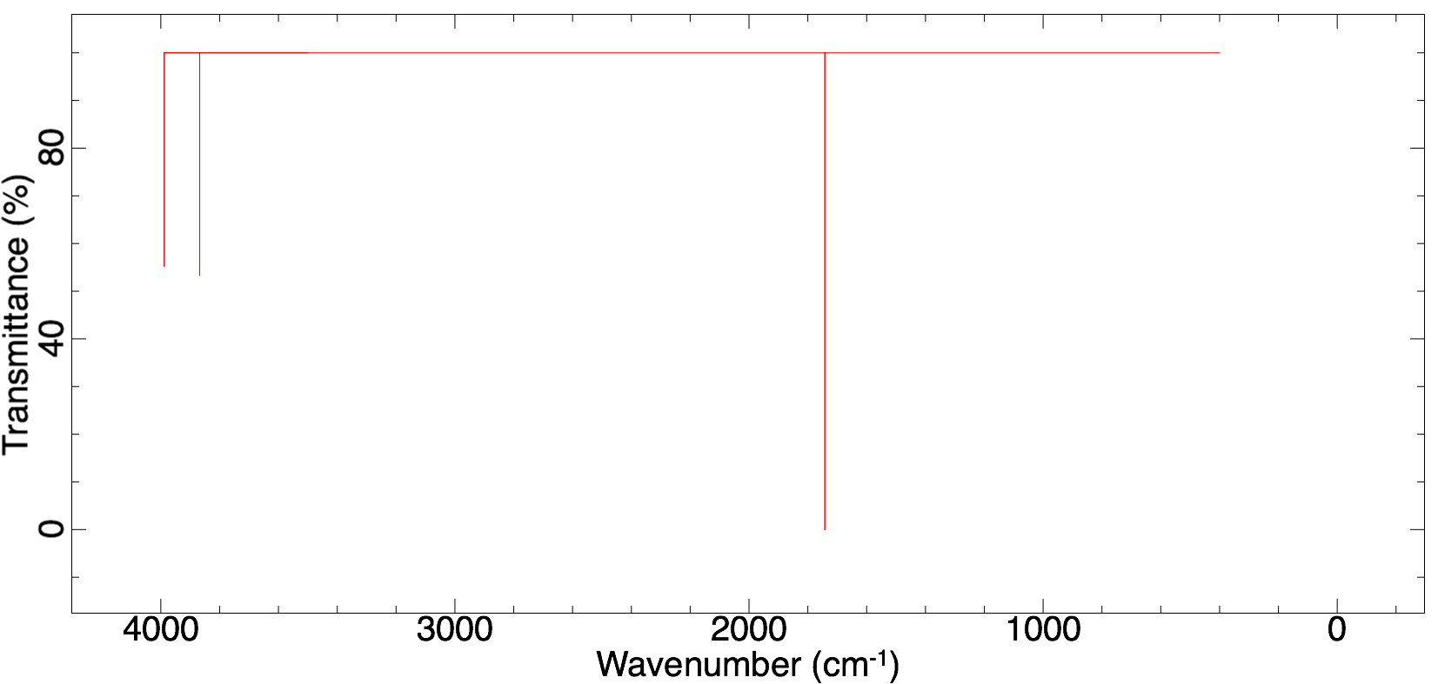

RHF/STO-3G

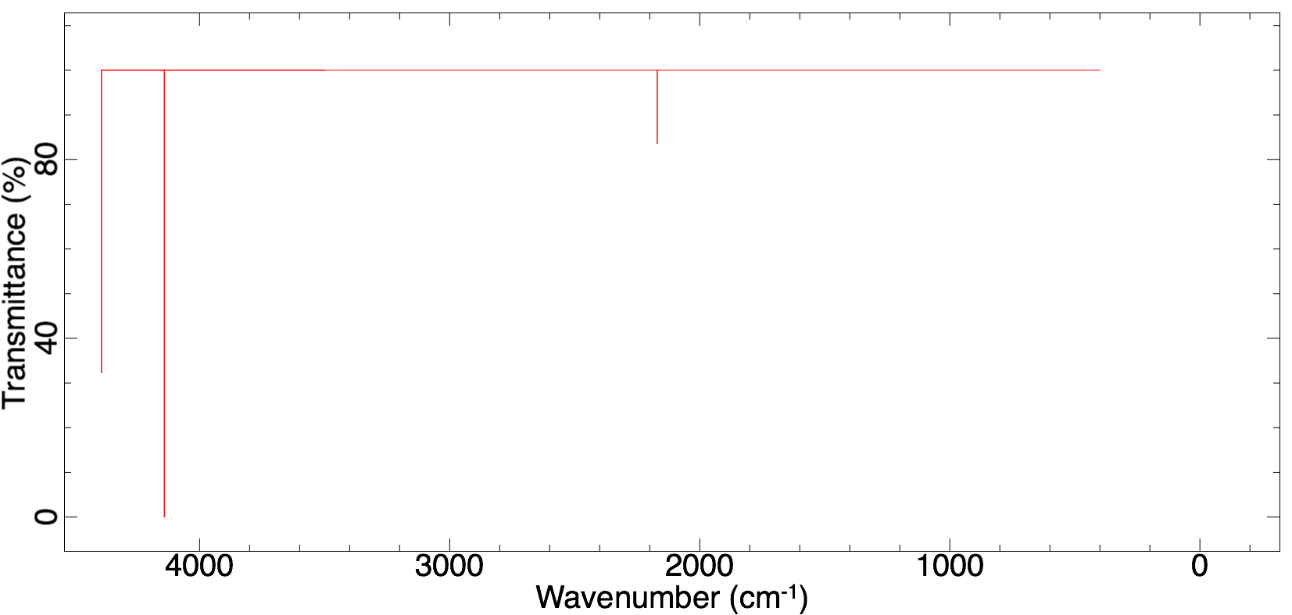

RHF/6-31G(d,p)

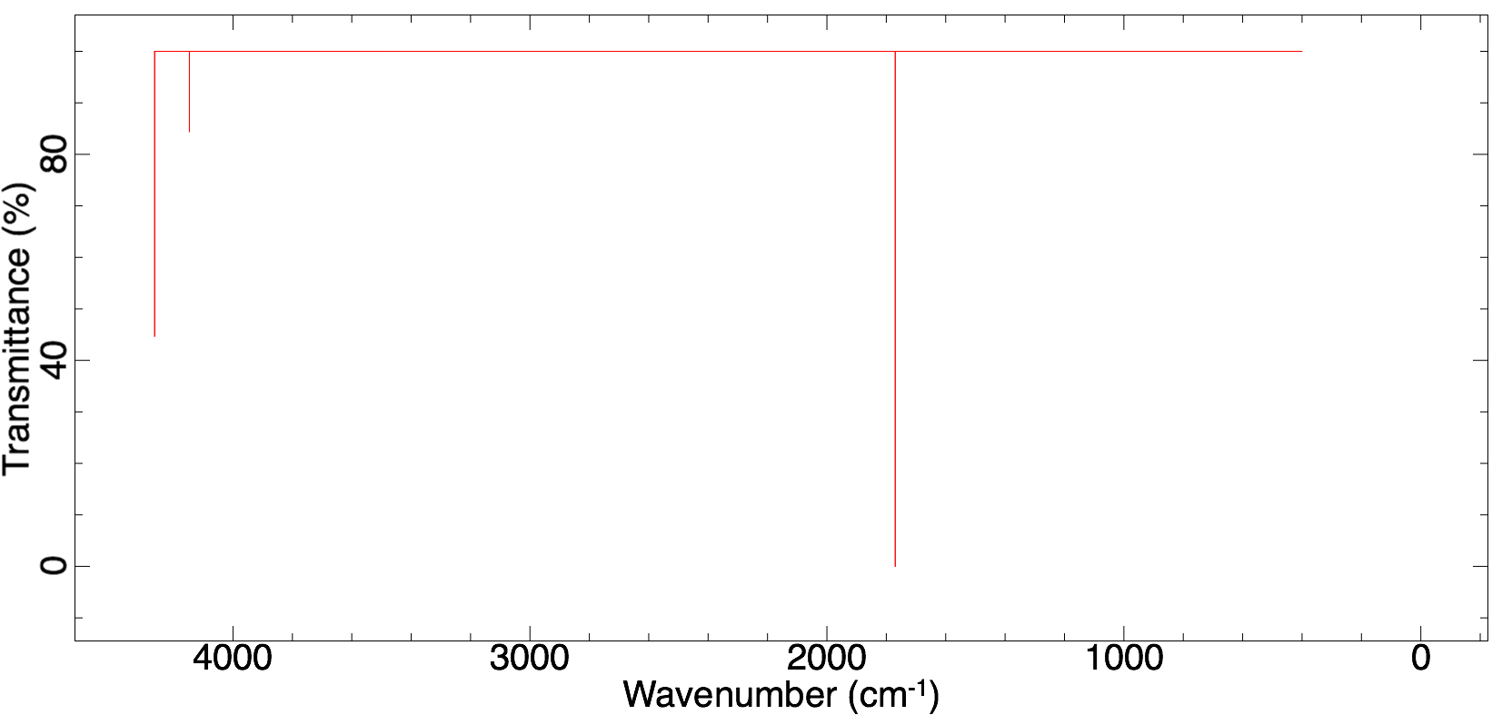

*Comparison of frequency*

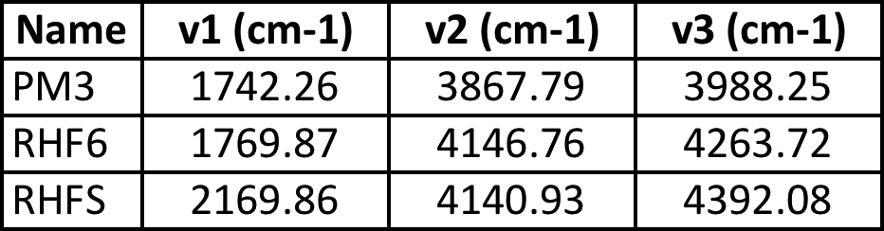

According to IR spectra of all three methods, there are three modes observed. Even though, all three predict three modes, all of them give different values for the frequency of modes, especially when PM3 and RHF are compared. RHF6 and RHFS seem to be closer in predictions of mode 2 and 3 frequencies, however, for mode 1 PM3 and RHF6 give similar predictions.

From the above spectra the intensity-differences should be noted as well. While RHF6 and PM3 intensify the first mode intensity, RHFS has dramatically lower intensity for the first mode.

*Vibrational modes*

PM3 – v1, v2 and v3, respectively

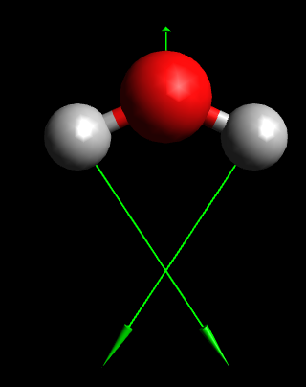 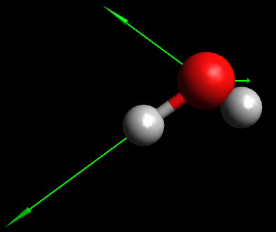 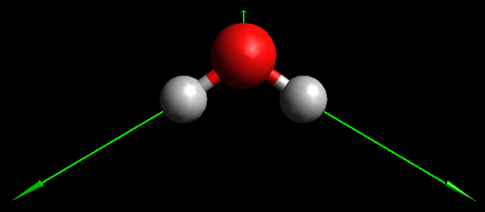

RHF/6-31G(d,p) – v1, v2 and v3, respectively

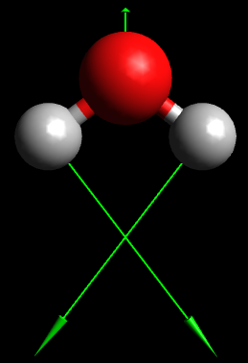 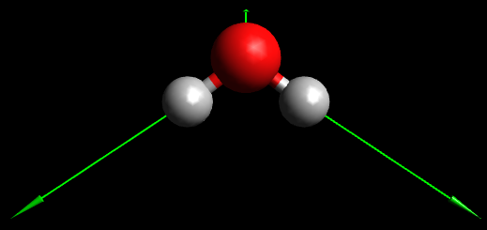 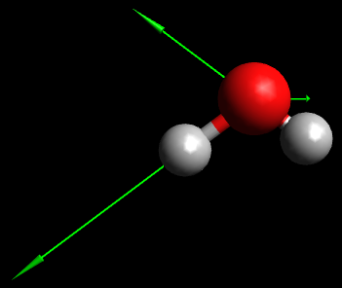

*Let’s say, first picture is mode 1, second is mode 2 and third is mode 3.

RHF/STO-3G – v1, v2 and v3, respectively

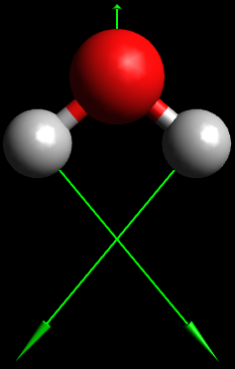 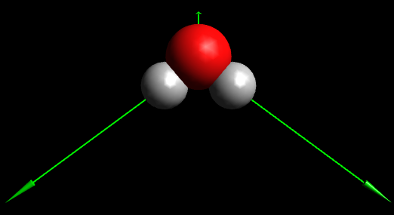 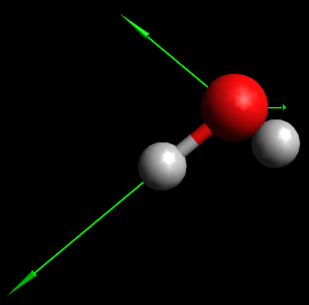

All three methods show the same vibrations. The only difference was noted with PM3 method, it switched the mode 2 with mode 3. In other words, in RHF mode 2 is in the middle of mode 1 and mode 2 (please see above), while in PM3, mode 2 comes at a frequency higher than mode 1 and mode 3.

**Question 2**

***a)*** *Energies using MMFF94s in Avogadro:*

Reactant = 31.4064 kJ/mol

Intermediate 1 = 9.91438 kJ/mol

Intermediate 2 = 5.23681 kJ/mol

Product 1= 30.0454 kJ/mol

Product 2= 9.05649 kJ/mol

***b)*** *SCF energies using RHF/6-31G(d,p)*

Intermediate 1 = -156.4565501 Hartree = -410776.61 kJ/mol

Intermediate 2 = -156.4126803 Hartree = -410661.43 kJ/mol

Intermediate 1 is more likely to happen as it has a lower energy.

***c)*** *Intermediate 1*

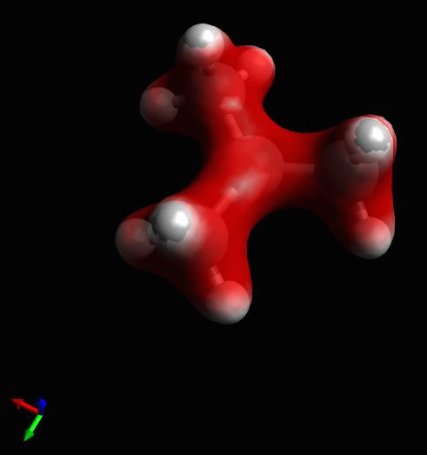

Mulliken charges:

1 C -0.421632 CH3

2 C 0.251799 Central carbon

3 H 0.217905

4 H 0.235166

5 H 0.217961

6 C -0.421632 CH3

7 H 0.217903

8 H 0.217964

9 H 0.235166

10 C -0.421631 CH2

11 H 0.217962

12 H 0.217904

13 H 0.235166

Sum of Mulliken charges = 1.00000

*Intermediate 2*

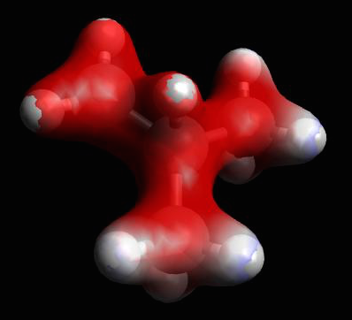 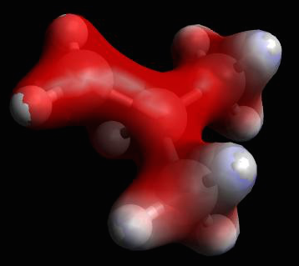

Mulliken charges:

1 C -0.143789 Central Carbon (CH)

2 C -0.346346 CH3

3 H 0.204196

4 H 0.170403

5 H 0.194929

6 C -0.346336 CH3

7 H 0.194925

8 H 0.170405

9 H 0.204201

10 C -0.076766 CH2

11 H 0.237421

12 H 0.268378

13 H 0.268378

Sum of Mulliken charges = 1.00000

Carbon to be attacked on *Intermediate 1* has a point charge of 0.251799, and the one on *Intermediate 2* has a point charge of -0.076766. As Chlorine is negatively charged, it is most likely to attack the carbon that has the most positive charge. As a carbon on *Intermediate 1* has a more positive charge than of the *Intermediate 2*, Chlorine is more likely to attack the *Intermediate 1.*

***d)***

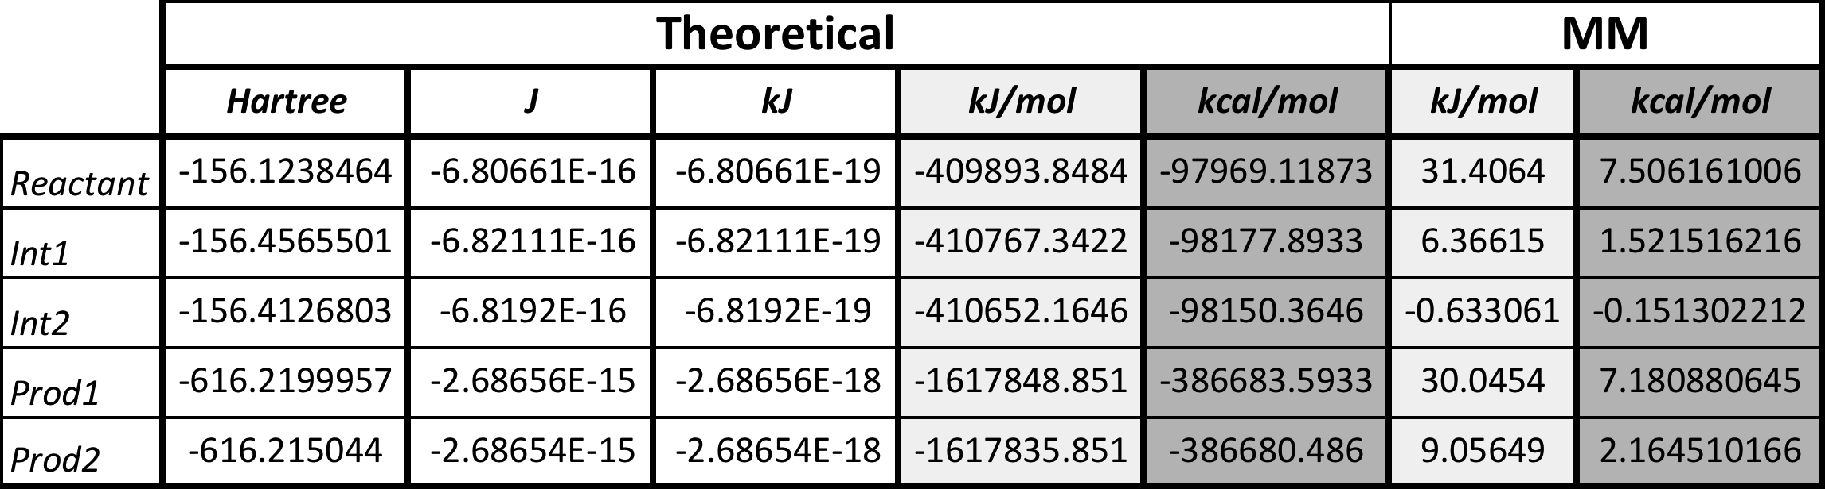

For energies of all of them (reactant, intermediates and products), Theoretical calculations yielded a much lower energy, while MM showed almost exclusively positive energies. Out of all, according to *theoretical calculations*, Product 1 is shown to be the most stable, followed by Product 2. The least stable one (the one with the highest energy) surprisingly is the reactant. However, the order is different according to *MM calculations*, the most stable one is the intermediate 1 and the least stable one is the reactant.

*Energy population of Product 1*

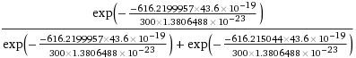

= 

*Energy population of Product 2*

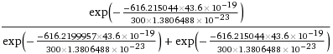

= 

*Energy pop-n of Product 1/Product 2*

= 181.53

***e)***

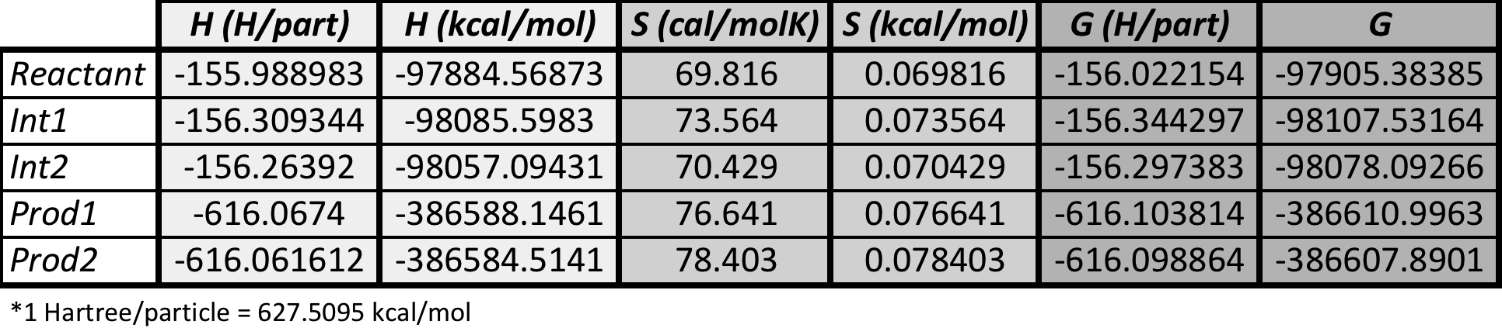

***f)*** k1/k2 = exp(-Ea1/RT)/exp(-Ea2/RT)

Ea1 = E(int1) – E(react) = -98177.8933 – (-97969.11873) = -208.7745661 kcal/mol

Ea2 = E(int2) – E(react) = -98150.3646 – (-97969.11873) = -181.2458718 kcal/mol

*Note: weirdly enough, my activation energies are negative.

T = 300 K

R = 1.9872041e-3 kcal/molK

Therefore, k1/k2 = 1.3302e20.

***g)*** k = kBT/cnh * exp(-deltaG/RT)

kB = 1.3806488e-23 J/K

T = 300 K

c = 1 mol/L

n = 2

h = 6.62606957e-34 J/s

R = 1.9872041e-3 kcal/molK

deltaG1 = G(int1) – G(react) = -98107.53164 – (-97905.38385) = -202.1477929 kcal/mol

deltaG2 = G(int2) – G(react) = -98078.09266 – (-97905.38385) = -172.7088122 kcal/mol

k1 =  = 1.14175e160 sM2 (sL2/mol2)

k2 =  = 4.08995e138 sM2 (sL2/mol2)

k1 is much faster than k2. Therefore, it can be predicted that path 1 would be much more favored than path 2. It agrees with Markovnikov rule, where acid hydrogen (from HCl) attaches to the carbon with fewer substituents (ie. CH2 end of (CH3)3 C=CH2) and the halide (Cl-) attaches to the carbon with more alkyl substituents (ie. C+ on Intermediate 1).

**Question 3**

***a)*** *Minimum energy value:* 164.664 kJ/mol

*Dihedral angle:* 53.9

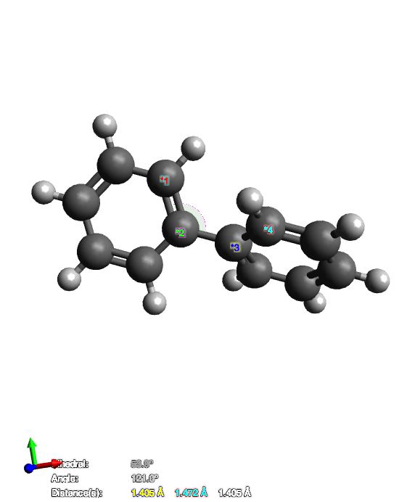

***b)*** *Minimum energy value:* -460.2718448 Hartree = -288824.73 kcal/mol = -1.21e6 kJ/mol

*Dihedral angle:* 45.5

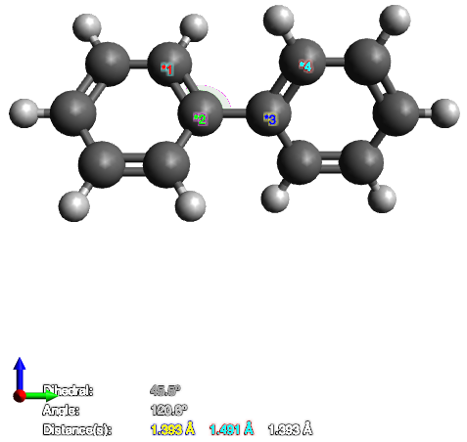

***c)***

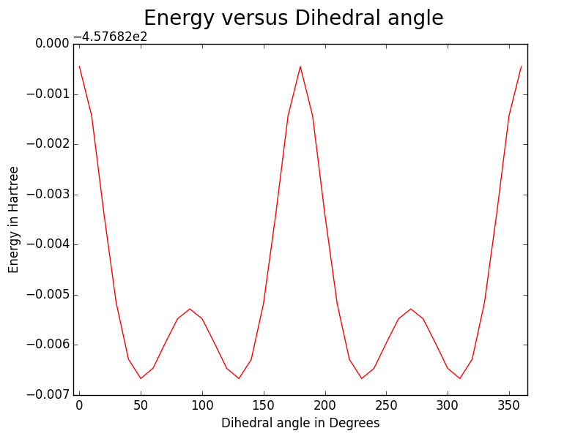

Most stable when dihedral degree is 45.5, 134.5, 225.5 and 314.5. Most unstable when 0, 180 and 360.

***d) and e)*** Professor, please find the code attached. Unfortunately, python could not calculate such high values. Energy of each angle is about -457.68 Hartree, kb is 3.1668e-6 Hartree/K, and temperatures vary. For example, below I tried computing the energy of the first state (ie. Energy of angle 0).

, where E equals to the energy of angle 0, kb as indicated above and K is 270 K. It results in . Python cannot read such information, and writes it as infinity resulting in no graph. Therefore, it becomes impossible to calculate the Q on python with such extremely low values of Energies.

*Energy values are attached in a text.

1. R. D. Nelson Jr., D. R. Lide, A. A. Maryott "Selected Values of electric dipole moments for molecules in the gas phase" NSRDS-NBS10, 1967
2. P. L. Silvestrelli and M. Parrinello, *Physical Review Letters*, 1999, **82**, 3308-3311.