Selbi Nuryyeva

Prof. Serdal Kırmızıaltın

April 23, 2015

Computational Chemistry

**Homework Assignment 4**

**Question 3**

***d)***

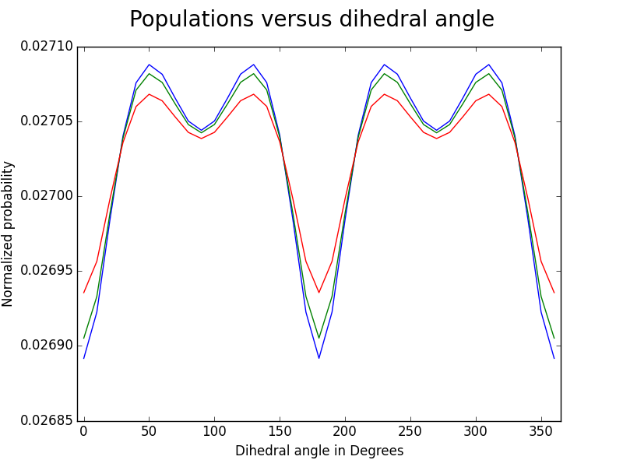Blue = 270 K, Green = 300 K, Red = 400 K.

As temperature gets higher, probability of each angle becomes more evenly distributed (ie. curve slightly flattens). This is probably because with higher temperature, more vibrations, translations etc happen that increase the probability of different angles (increase stability of states of different angles).

***e)***

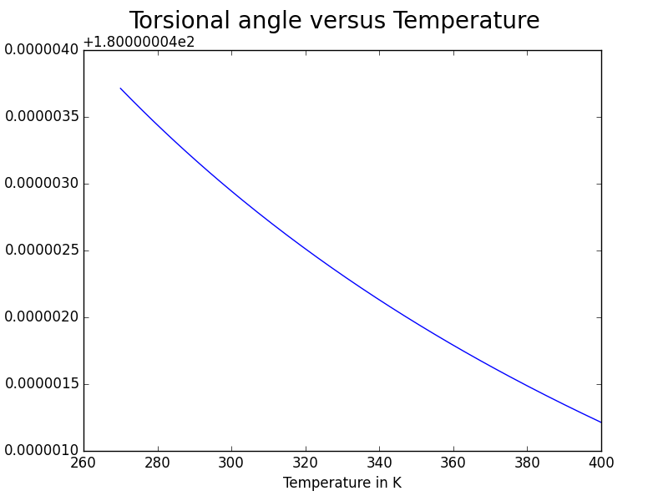*Average torsional angle versus temperature

My result for 300 K is around 180 degrees, which makes sense. If we look at question 3c, there are four highest peaks, and the average of them is 180 degrees:

 = 180. From this we can say that roughly the average torsional angle is 180 degrees.

my minimized structure, the torsional angle is 45.52 degrees. The average is way far off from this value, because biphenyl has 4 different ways of having the degree of 45.52, thus, having an average angle of 180. Experimental 44.4 degrees[1], which is very close to what Gaussian has predicted in minimized structure, but is still far off the average value for the same reason.

1. Mikael P. Johansson and Jeppe Olsen (2008). "Torsional Barriers and Equilibrium Angle of Biphenyl: Reconciling Theory with Experiment". *J. Chem. Theory Comput.* **4** (9): 1460.