Spring+SpringMVC+MyBatis框架搭建
SSM框架搭建 1
1、 准备 1
1.1 所用框架 1
1.2 开发环境 1
2、 搭建 3
2.1 项目结构 3
2.2 创建Maven项目 4
2.3 Maven引入需要的JAR包 7
2.4 spring与MyBatis整合 11
2.4.1 建立JDBC配置文件 11
2.4.2 建立spring-mybatis.xml配置文件 12
2.4.3 Log4j配置文件 log4j.properties 13
2.4.4 创建测试用表 14
2.4.5 使用MyBatis Generator自动创建数据库映射文件实体类等，参考链接： 14
http://blog.csdn.net/zhshulin/article/details/23912615 14
2.4.6 建立service接口和实现类 14
2.4.7 建立测试类 14
2.5 整合SpringMVC 15
2.5.1 配置spring-mvc.xml 15
2.5.2 配置web.xml文件 16
2.6 测试 18
2.6.1 创建jsp页面 18
2.6.2 建立UserController类 18
2.7 部署项目 19

准备

1.1 所用框架
Spring 4.0.2 RELEASE
Spring MVC 4.0.2 RELEASE
MyBatis 3.2.6

1.2 开发环境
Eclipse
apache-maven-3.3.9
JDK 1.7
Tomcat8
mysql-5.7.9-winx64
Maven安装eclipse配置参考：
http://jingyan.baidu.com/article/295430f136e8e00c7e0050b9.html

搭建

2.1 项目结构
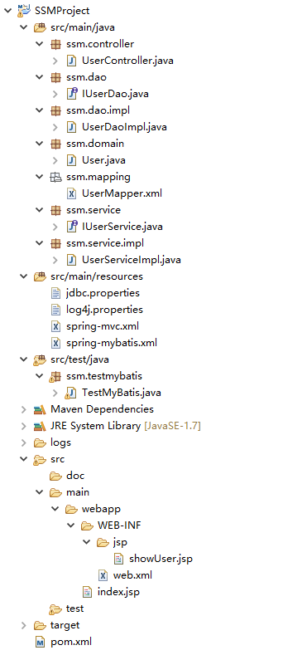

2.2 创建Maven项目

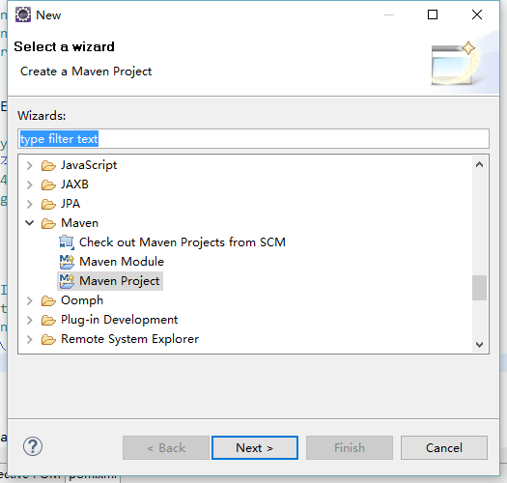
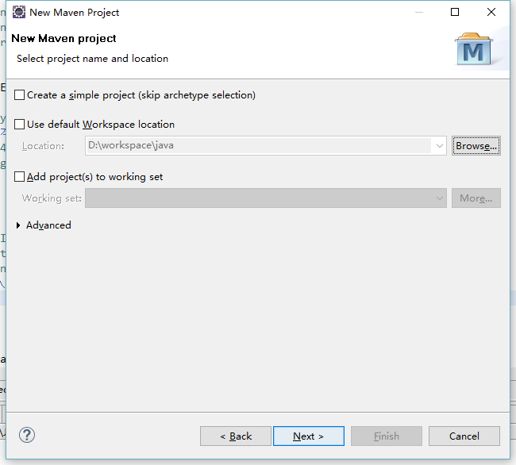
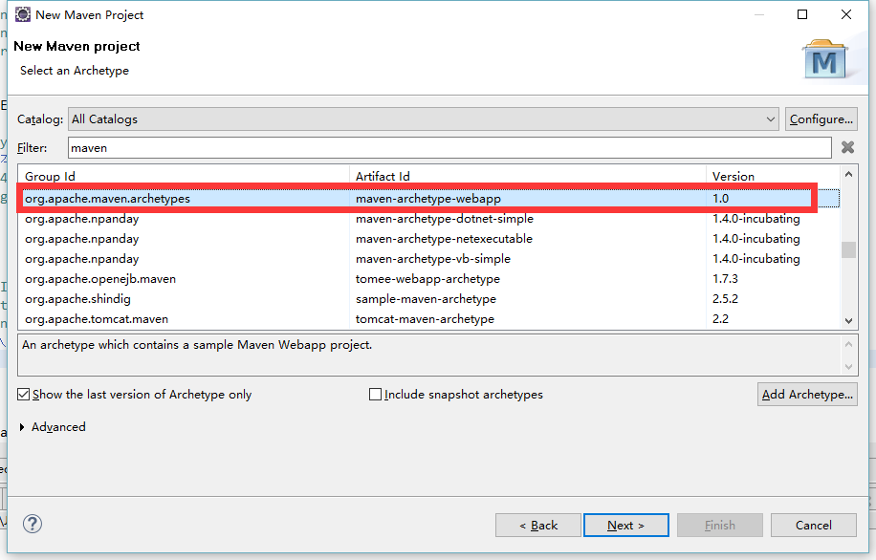
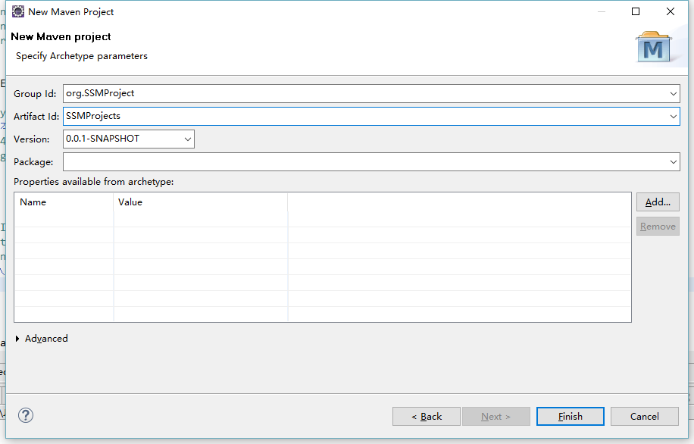
创建完成后右键项目更改项目属性如下：
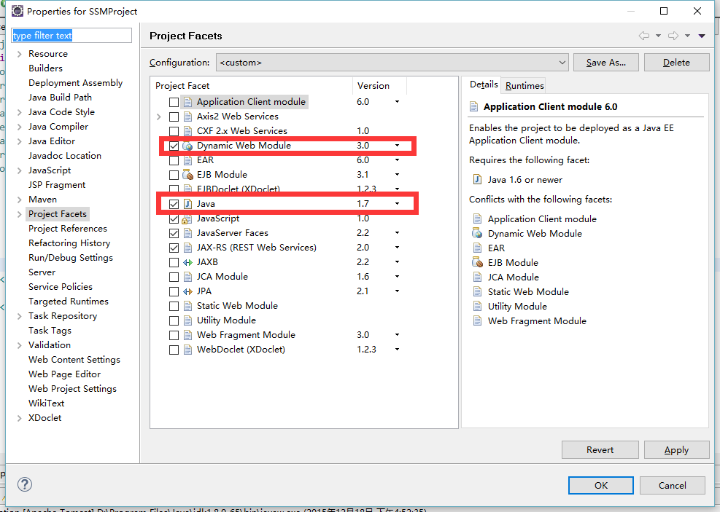
如果更改Dynamic web module提示失败，打开.setting目录下的org.eclipse.wst.common.project.facet.core.xml将文件修改如下：

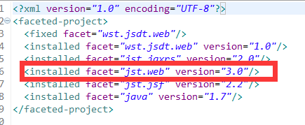

2.3 Maven引入需要的JAR包
一次引入接下来用的的所有jar包：pom.xml
<project xmlns="http://maven.apache.org/POM/4.0.0" xmlns:xsi="http://www.w3.org/2001/XMLSchema-instance"
xsi:schemaLocation="http://maven.apache.org/POM/4.0.0 http://maven.apache.org/maven-v4_0_0.xsd">
<modelVersion>4.0.0</modelVersion>
<groupId>org.SSMProject</groupId>
<artifactId>SSMProject</artifactId>
<packaging>war</packaging>
<version>0.0.1-SNAPSHOT</version>
<name>SSMProject Maven Webapp</name>
<url>http://maven.apache.org</url>
<properties>
<!-- spring版本号 -->
<spring.version>4.0.2.RELEASE</spring.version>
<!-- mybatis版本号 -->
<mybatis.version>3.2.6</mybatis.version>
<!-- log4j日志文件管理包版本 -->
<slf4j.version>1.7.7</slf4j.version>
<log4j.version>1.2.17</log4j.version>
</properties>

<dependencies>
<dependency>
<groupId>junit</groupId>
<artifactId>junit</artifactId>
<version>4.11</version>
<!-- 表示开发的时候引入，发布的时候不会加载此包 -->
<scope>test</scope>
</dependency>
<!-- spring核心包 -->
<dependency>
<groupId>org.springframework</groupId>
<artifactId>spring-core</artifactId>
<version>${spring.version}</version>
</dependency>

<dependency>
<groupId>org.springframework</groupId>
<artifactId>spring-web</artifactId>
<version>${spring.version}</version>
</dependency>
<dependency>
<groupId>org.springframework</groupId>
<artifactId>spring-oxm</artifactId>
<version>${spring.version}</version>
</dependency>
<dependency>
<groupId>org.springframework</groupId>
<artifactId>spring-tx</artifactId>
<version>${spring.version}</version>
</dependency>

<dependency>
<groupId>org.springframework</groupId>
<artifactId>spring-jdbc</artifactId>
<version>${spring.version}</version>
</dependency>

<dependency>
<groupId>org.springframework</groupId>
<artifactId>spring-webmvc</artifactId>
<version>${spring.version}</version>
</dependency>
<dependency>
<groupId>org.springframework</groupId>
<artifactId>spring-aop</artifactId>
<version>${spring.version}</version>
</dependency>

<dependency>
<groupId>org.springframework</groupId>
<artifactId>spring-context-support</artifactId>
<version>${spring.version}</version>
</dependency>

<dependency>
<groupId>org.springframework</groupId>
<artifactId>spring-test</artifactId>
<version>${spring.version}</version>
</dependency>
<!-- mybatis核心包 -->
<dependency>
<groupId>org.mybatis</groupId>
<artifactId>mybatis</artifactId>
<version>${mybatis.version}</version>
</dependency>
<!-- mybatis/spring包 -->
<dependency>
<groupId>org.mybatis</groupId>
<artifactId>mybatis-spring</artifactId>
<version>1.2.2</version>
</dependency>
<!-- 导入java ee jar 包 -->
<dependency>
<groupId>javax</groupId>
<artifactId>javaee-api</artifactId>
<version>7.0</version>
</dependency>
<!-- 导入Mysql数据库链接jar包 -->
<dependency>
<groupId>mysql</groupId>
<artifactId>mysql-connector-java</artifactId>
<version>5.1.30</version>
</dependency>
<!-- 导入dbcp的jar包，用来在applicationContext.xml中配置数据库 -->
<dependency>
<groupId>commons-dbcp</groupId>
<artifactId>commons-dbcp</artifactId>
<version>1.2.2</version>
</dependency>
<!-- JSTL标签类 -->
<dependency>
<groupId>jstl</groupId>
<artifactId>jstl</artifactId>
<version>1.2</version>
</dependency>
<!-- 日志文件管理包 -->
<!-- log start -->
<dependency>
<groupId>log4j</groupId>
<artifactId>log4j</artifactId>
<version>${log4j.version}</version>
</dependency>

<!-- 格式化对象，方便输出日志 -->
<dependency>
<groupId>com.alibaba</groupId>
<artifactId>fastjson</artifactId>
<version>1.1.41</version>
</dependency>

<dependency>
<groupId>org.slf4j</groupId>
<artifactId>slf4j-api</artifactId>
<version>${slf4j.version}</version>
</dependency>

<dependency>
<groupId>org.slf4j</groupId>
<artifactId>slf4j-log4j12</artifactId>
<version>${slf4j.version}</version>
</dependency>
<!-- log end -->
<!-- 映入JSON -->
<dependency>
<groupId>org.codehaus.jackson</groupId>
<artifactId>jackson-mapper-asl</artifactId>
<version>1.9.13</version>
</dependency>
<!-- 上传组件包 -->
<dependency>
<groupId>commons-fileupload</groupId>
<artifactId>commons-fileupload</artifactId>
<version>1.3.1</version>
</dependency>
<dependency>
<groupId>commons-io</groupId>
<artifactId>commons-io</artifactId>
<version>2.4</version>
</dependency>
<dependency>
<groupId>commons-codec</groupId>
<artifactId>commons-codec</artifactId>
<version>1.9</version>
</dependency>
</dependencies>
<build>
<finalName>SSMProject</finalName>
<plugins>
<plugin>
<groupId>org.apache.maven.plugins</groupId>
<artifactId>maven-compiler-plugin</artifactId>
<version>3.1</version>
<configuration>
<source>1.7</source>
<target>1.7</target>
</configuration>
</plugin>
</plugins>
</build>
</project>

2.4 spring与MyBatis整合

2.4.1 建立JDBC配置文件 jdbc.properties
driver=com.mysql.jdbc.Driver
url=jdbc:mysql://127.0.0.1:3306/db_ssm
username=root
password=root
#定义初始连接数
initialSize=0
#定义最大连接数
maxActive=20
#定义最大空闲
maxIdle=20
#定义最小空闲
minIdle=1
#定义最长等待时间
maxWait=60000

2.4.2 建立spring-mybatis.xml配置文件
<?xml version="1.0" encoding="UTF-8"?>
<beans xmlns="http://www.springframework.org/schema/beans"
xmlns:xsi="http://www.w3.org/2001/XMLSchema-instance" xmlns:p="http://www.springframework.org/schema/p"
xmlns:context="http://www.springframework.org/schema/context"
xmlns:mvc="http://www.springframework.org/schema/mvc"
xsi:schemaLocation="http://www.springframework.org/schema/beans
http://www.springframework.org/schema/beans/spring-beans-3.1.xsd
http://www.springframework.org/schema/context
http://www.springframework.org/schema/context/spring-context-3.1.xsd
http://www.springframework.org/schema/mvc
http://www.springframework.org/schema/mvc/spring-mvc-4.0.xsd">
<!-- 自动扫描 -->
<context:component-scan base-package="ssm" />
<!-- 引入配置文件 -->
<bean id="propertyConfigurer"
class="org.springframework.beans.factory.config.PropertyPlaceholderConfigurer">
<property name="location" value="classpath:jdbc.properties" />
</bean>

<bean id="dataSource" class="org.apache.commons.dbcp.BasicDataSource"
destroy-method="close">
<property name="driverClassName" value="${driver}" />
<property name="url" value="${url}" />
<property name="username" value="${username}" />
<property name="password" value="${password}" />
<!-- 初始化连接大小 -->
<property name="initialSize" value="${initialSize}"></property>
<!-- 连接池最大数量 -->
<property name="maxActive" value="${maxActive}"></property>
<!-- 连接池最大空闲 -->
<property name="maxIdle" value="${maxIdle}"></property>
<!-- 连接池最小空闲 -->
<property name="minIdle" value="${minIdle}"></property>
<!-- 获取连接最大等待时间 -->
<property name="maxWait" value="${maxWait}"></property>
</bean>

<!-- spring和MyBatis完美整合，不需要mybatis的配置映射文件 -->
<bean id="sqlSessionFactory" class="org.mybatis.spring.SqlSessionFactoryBean">
<property name="dataSource" ref="dataSource" />
<!-- 自动扫描mapping.xml文件 -->
<property name="mapperLocations" value="classpath:ssm/mapping/*.xml"></property>
</bean>

<!-- DAO接口所在包名，Spring会自动查找其下的类 -->
<bean class="org.mybatis.spring.mapper.MapperScannerConfigurer">
<property name="basePackage" value="ssm.dao" />
<property name="sqlSessionFactoryBeanName" value="sqlSessionFactory"></property>
</bean>

<!-- (事务管理)transaction manager, use JtaTransactionManager for global tx -->
<bean id="transactionManager"
class="org.springframework.jdbc.datasource.DataSourceTransactionManager">
<property name="dataSource" ref="dataSource" />
</bean>

</beans>

2.4.3 Log4j配置文件 log4j.properties
log4j.rootLogger=INFO,Console,File
#定义日志输出目的地为控制台
log4j.appender.Console=org.apache.log4j.ConsoleAppender
log4j.appender.Console.Target=System.out
#可以灵活地指定日志输出格式，下面一行是指定具体的格式
log4j.appender.Console.layout = org.apache.log4j.PatternLayout
log4j.appender.Console.layout.ConversionPattern=[%c] - %m%n

#文件大小到达指定尺寸的时候产生一个新的文件
log4j.appender.File = org.apache.log4j.RollingFileAppender
#指定输出目录
log4j.appender.File.File = logs/ssm.log
#定义文件最大大小
log4j.appender.File.MaxFileSize = 10MB
# 输出所以日志，如果换成DEBUG表示输出DEBUG以上级别日志
log4j.appender.File.Threshold = ALL
log4j.appender.File.layout = org.apache.log4j.PatternLayout
log4j.appender.File.layout.ConversionPattern =[%p] [%d{yyyy-MM-dd HH\:mm\:ss}][%c]%m%n

2.4.4 创建测试用表
DROP TABLE IF EXISTS `user_t`;
CREATE TABLE `user_t` (
`id` int(10) NOT NULL,
`user_name` varchar(40) DEFAULT NULL,
`password` varchar(255) DEFAULT NULL,
`age` int(24) DEFAULT NULL,
PRIMARY KEY (`id`)
) ENGINE=InnoDB DEFAULT CHARSET=utf8;

INSERT INTO `user_t` VALUES ('1', 'admin', '123456', '24');

2.4.5 使用MyBatis Generator自动创建数据库映射文件实体类等，参考链接：

http://blog.csdn.net/zhshulin/article/details/23912615

2.4.6 建立service接口和实现类
IUserService.java
UserServiceImpl.java

2.4.7 建立测试类
TestMyBatis.java
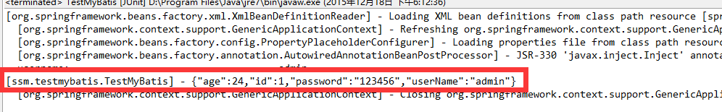

如果运行成功，证明spring与MyBatis已经整合成功

2.5 整合SpringMVC

2.5.1 配置spring-mvc.xml
<?xml version="1.0" encoding="UTF-8"?>
<beans xmlns="http://www.springframework.org/schema/beans"
xmlns:xsi="http://www.w3.org/2001/XMLSchema-instance" xmlns:p="http://www.springframework.org/schema/p"
xmlns:context="http://www.springframework.org/schema/context"
xmlns:mvc="http://www.springframework.org/schema/mvc"
xsi:schemaLocation="http://www.springframework.org/schema/beans
http://www.springframework.org/schema/beans/spring-beans-3.1.xsd
http://www.springframework.org/schema/context
http://www.springframework.org/schema/context/spring-context-3.1.xsd
http://www.springframework.org/schema/mvc
http://www.springframework.org/schema/mvc/spring-mvc-4.0.xsd">
<!-- 自动扫描该包，使SpringMVC认为包下用了@controller注解的类是控制器 -->
<context:component-scan base-package="ssm.controller" />
<!--避免IE执行AJAX时，返回JSON出现下载文件 -->
<bean id="mappingJacksonHttpMessageConverter"
class="org.springframework.http.converter.json.MappingJacksonHttpMessageConverter">
<property name="supportedMediaTypes">
<list>
<value>text/html;charset=UTF-8</value>
</list>
</property>
</bean>
<!-- 启动SpringMVC的注解功能，完成请求和注解POJO的映射 -->
<bean
class="org.springframework.web.servlet.mvc.annotation.AnnotationMethodHandlerAdapter">
<property name="messageConverters">
<list>
<ref bean="mappingJacksonHttpMessageConverter" /> <!-- JSON转换器 -->
</list>
</property>
</bean>
<!-- 定义跳转的文件的前后缀 ，视图模式配置-->
<bean class="org.springframework.web.servlet.view.InternalResourceViewResolver">
<!-- 这里的配置我的理解是自动给后面action的方法return的字符串加上前缀和后缀，变成一个 可用的url地址 -->
<property name="prefix" value="/WEB-INF/jsp/" />
<property name="suffix" value=".jsp" />
</bean>

<!-- 配置文件上传，如果没有使用文件上传可以不用配置，当然如果不配，那么配置文件中也不必引入上传组件包 -->
<bean id="multipartResolver"
class="org.springframework.web.multipart.commons.CommonsMultipartResolver">
<!-- 默认编码 -->
<property name="defaultEncoding" value="utf-8" />
<!-- 文件大小最大值 -->
<property name="maxUploadSize" value="10485760000" />
<!-- 内存中的最大值 -->
<property name="maxInMemorySize" value="40960" />
</bean>

</beans>

2.5.2 配置web.xml文件
<?xml version="1.0" encoding="UTF-8"?>
<web-app xmlns:xsi="http://www.w3.org/2001/XMLSchema-instance"
xmlns="http://java.sun.com/xml/ns/javaee"
xsi:schemaLocation="http://java.sun.com/xml/ns/javaee http://java.sun.com/xml/ns/javaee/web-app_3_0.xsd"
version="3.0">
<display-name>Archetype Created Web Application</display-name>
<!-- Spring和mybatis的配置文件 -->
<context-param>
<param-name>contextConfigLocation</param-name>
<param-value>classpath:spring-mybatis.xml</param-value>
</context-param>
<!-- 编码过滤器 -->
<filter>
<filter-name>encodingFilter</filter-name>
<filter-class>org.springframework.web.filter.CharacterEncodingFilter</filter-class>
<async-supported>true</async-supported>
<init-param>
<param-name>encoding</param-name>
<param-value>UTF-8</param-value>
</init-param>
</filter>
<filter-mapping>
<filter-name>encodingFilter</filter-name>
<url-pattern>/*</url-pattern>
</filter-mapping>
<!-- Spring监听器 -->
<listener>
<listener-class>org.springframework.web.context.ContextLoaderListener</listener-class>
</listener>
<!-- 防止Spring内存溢出监听器 -->
<listener>
<listener-class>org.springframework.web.util.IntrospectorCleanupListener</listener-class>
</listener>

<!-- Spring MVC servlet -->
<servlet>
<servlet-name>SpringMVC</servlet-name>
<servlet-class>org.springframework.web.servlet.DispatcherServlet</servlet-class>
<init-param>
<param-name>contextConfigLocation</param-name>
<param-value>classpath:spring-mvc.xml</param-value>
</init-param>
<load-on-startup>1</load-on-startup>
<async-supported>true</async-supported>
</servlet>
<servlet-mapping>
<servlet-name>SpringMVC</servlet-name>
<!-- 此处可以可以配置成*.do，对应struts的后缀习惯 -->
<url-pattern>/</url-pattern>
</servlet-mapping>
<welcome-file-list>
<welcome-file>/index.jsp</welcome-file>
</welcome-file-list>

</web-app>

2.6 测试

2.6.1 创建jsp页面
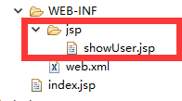

<%@ page language="java" import="java.util.*" pageEncoding="utf-8"%>
<!DOCTYPE HTML PUBLIC "-//W3C//DTD HTML 4.01 Transitional//EN">
<html>
<head>
<title>测试</title>
</head>

<body>
${user.userName}
</body>
</html>

2.6.2 建立UserController类
package ssm.controller;

import javax.annotation.Resource;
import javax.servlet.http.HttpServletRequest;

import org.springframework.stereotype.Controller;
import org.springframework.ui.Model;
import org.springframework.web.bind.annotation.RequestMapping;

import ssm.domain.User;
import ssm.service.IUserService;

@Controller
@RequestMapping("/user")
public class UserController {
@Resource
private IUserService userService;

@RequestMapping("/showUser")
public String toIndex(HttpServletRequest request,Model model){
int userId = Integer.parseInt(request.getParameter("id"));
User user = this.userService.getUserById(userId);
model.addAttribute("user", user);
return "showUser";
}

}

2.7 部署项目
访问地址：http://localhost:8080/SSMProject/user/showUser?id=1

