|<

Maintenance Information
Control system
Interface protocols
Sorter CSC Item Recognition Interface

Journal: 0000.doc
Date: Jan, 4. 2024
Revision: 8_0
Pages: 23
Initials: akr

© BEUMER Group 2024
This document and all data contained herein are the exclusive intellectual property rights of BEUMER Group and are supplied in strictest confidence under the express condition that any reproduction, transmission, transcription etc., or storing in any retrieval system/form, or any kind of supply to others is strictly forbidden without express prior written consent. The receiver guarantees that any disclosed material shall not be used in any way detrimental to the interest of BEUMER Group.

Contents
Page
1. Versions 3
2. Acronyms and abreviations 4
3. Introduction 5
4. References and Related Documents 6
5. Concept 7
5.1 Transport protocol 7
5.2 Keep alive 7
5.3 CSC –Scanner communication 7
5.3.1 Normal telegram flow chart 8
5.4 Acknowledgement strategy 9
6. Data Formats 10
6.1 SCANNER -> CSC Telegrams 10
6.1.1 HEARTBEAT 10
6.1.2 IMAGE_RESULT 10
7. Appendix A – telegram format low-level description 17
7.1 telegram binary description 17
7.2 Content of XML_buffer 18
7.3 Example 18
7.3.1 Examples of IMAGE_RESULT 18
8. APPENDIX B - Barcode type list 20
9. Appendix C – XML Schema 21

Versions

Version | Date | Init. | Description
1 | 19 Aug 2015 | HOS | Based on product version.
2 | 18 Dec 2015 | HOS | Added Camera name to the heartbeat telegram
3 | 09 Jun 2016 | HOS | Added new parameter "OtherInfo"  to Image result telegram.
4 | 07 Dec 2016 | HOS | Added note for using AIM code type standard, corrected the telegram length, and buffer length values in telegram example (section 7.3).
5 | 25 Feb 2020 | MTV | Added p18+ parameters from 12124 DHL Singapore Hub
6 | 26 Feb 2020 | MTV | Updated document with review comments from OLS and JFF.
7 | 21 Dec 2023 | OLS | Added note that volume and weight are optional fields. Hereby this document replaces the P18_Protocol-CSC-Scanner document.  Removed reference to P17.
8 | 3 Jan 2024 | AKR | Updated tag1 in otherInfo to 'isCuboidal'
9 | 1 Oct 2025 | AKR | Updated tag2 in otherInfo to 'isSideBySide'

Acronyms and abreviations
CSC | Crisplant System Controller.
CMC | The CMC is responsible for handling, communication and supervision of all physical parts of the sorter. The CMC is connected to the CSC via an Ethernet connection. In this document CMC cover both the Conveyor and Sorter Machine controls.

Introduction
This document describes the scanner protocol for the CSC5 sorter controller.
The purpose of this protocol is to specify a telegram sent from the scanner to the CSC to contain barcodes information received from the camera(s).

The concept involves 3 different interfaces:
- CMC –Scanner interface see [CMC]
- CMC -CSC interface see [Routing]
- CSC –Scanner interface. This is the protocol described in this document.

To be able to verify the information credibility send to the CSC, the scanner must send info which can be validated by a XSD (XML Schema Definition)
See Appendix C for the actual XML schema.
If the telegram cannot be validated by the schema, the xml file will be discarded.

References and Related Documents
[Routing] Crisplant a/s
CMC Product release 3.0
Routing Interface
Journal: p3_Protocol-CMC-Routing

[Schema] Crisplant a/s
CSC5 Product
CSC-ScannerProtocol.xsd
Journal: p18_Protocol-CSC-Scanner-schema.xsd

[CMC] CMC5 Product
CMC Camera Interface RS422
Journal: p10a_Camera_RS422.doc

[XML] Extensible Markup Language (XML) 1.0 (Third Edition) -
W3C Recommendation, 04 February 2004 -
http://www.w3.org/TR/2004/REC-xml-20040204

[XML-Schema] XML Schema Part 1 : Structures / Part 2 : Data Types (Second Edition)
W3C Recommendations, 28 October 2004
http://www.w3.org/TR/2004/REC-xmlschema-1-20041028
http://www.w3.org/TR/2004/REC-xmlschema-2-20041028

Concept
The communication concept with this protocol is:
- The CMC is connected to the scanner using the [CMC] interface, once the read signals goes down the scanner will return a "code telegram" on the [CMC] interface containing a barcode equal to the GID it received by the CMC.
- The scanner will on its other interface (This protocol) send an Image_Result Tlg to the CSC, containing GID, status and barcode information to the CSC. The identification of the item is based on the GID sent by CMC to scanner along with the cmcIndex.
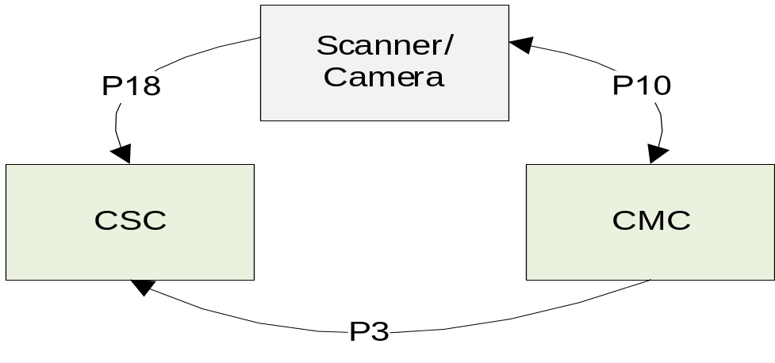

Transport protocol
The application data being described in this protocol is communicated using a TCP/IP socket
The CSC is set to be the client, and the Scanner is the server.

Keep alive
The Scanner send a Heartbeat telegram every 4 seconds, if no other telegrams are send. A reply must be received within 4 seconds, if not the connection is considered to be dead. This is handled by disconnecting the connection to the Scanner and an alarm will be presented on the CSC. The CSC must then try to reconnect to the Scanner.

CSC –Scanner communication
The figure below illustrates the communication between the CSC and the Scanner. All real-time control data is communicated via the CMC using digital signals. This CMC interface is described in a separate document [CMC].
The barcode results (Image_ReadyTlg) are routed from Scanner directly to the CSC using the TCP/IP connection bypassing the CMC.

Normal telegram flow chart
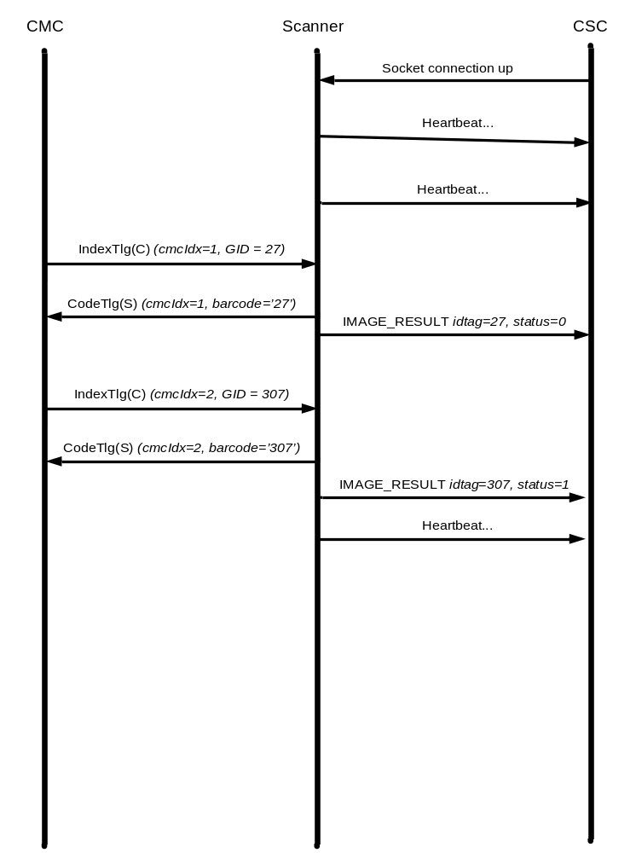

The chart illustrates the telegram flow of 2 items, with cmcidx/GID (1, and 2).
1. First the connection is established between the CSC and the scanner.
2. Then we see heartbeat telegrams from the Scanner to the CSC.
3. An item is about to pass the scanner and the CMC send and IndexTlg with cmcidx and GID to the scanner and will set a read signal to the scanner to read an item.
4. Once the item has passed the camera the read signal goes low, and the scanner will return a CodeTlg containing the GID received in the IndexTlg as a barcode to the CMC.
5. scanner will send an IMAGE_RESULT telegram to the CSC, containing a idTag = GID, status and the barcodes captured.
6. Step 3..5 are now repeated for another item.

Acknowledgement strategy
In general there is no application acknowledgement. When the image result message received from the scanner no acknowledgement will be replied to the scanner.
After reception of code telegram from the scanner (to CMC), the CSC waits for image result message from the scanner, if no image result received within the configured timeout, the item will be handled as No_Read .

Data Formats
All telegrams are xml-encoded, and the different data types, ranges etc. are all described the schema file that supports this protocol. The schema file is used to verify the telegram layout and contents, of any telegram within this protocol.

SCANNER -> CSC Telegrams
From scanner to CSC.

HEARTBEAT
A telegram sent from the scanner indicating that the scanner and the connection is alive.
Action: The CSC will reset it's timer.
Reply: none

CameraName | The name of camera/scanner
Status | 0: OK
Status messages indicating errors will not be sent in the heartbeat telegram, but sent via the CMC using the P10a protocol [CMC].

IMAGE_RESULT
This telegram contains the results of the coding of an item. It is sent to the CSC once the result is available.
The volume and weight sections are optional (i.e. only used if there are volume and/or scales on the equipment)
If the telegram is not sent to the CSC within a configurable time, the CSC will timeout, and the item will be handled as No-Read item.
Action: The CSC will send the result to the Tier 1
Reply: none

idTag | Unique identification equal to the GID that the scanner has received on the [CMC] interface.  The GID has the range [0..2.147.483.647]
status | 0 = Coding OK  1 = No read  2 = General scanner error, no data available
noOfCode | Number of codes
codes | code: List of barcode/types
  codeType | The barcode type - see XML scema
  barcode | The barcode
  codeType
  barcode
  codeType
  barcode

volume | Volume Information
  resultStatus | The status of the result of volume scanning (possible values below)
  result | Real volume in cm3
  height | Item height in mm
  width | Item width in mm
  length | Item length in mm
  rawData | The raw telegram from the volume scanner.  This field is optional and only used if there are project specific reasons
weight | Weight information
  resultStatus | The status of the result of weighing the item (possible values below)
  result | Weight of the item in grams
  rawData | The raw telegram from the weight scale according to the used scale protocol.  This field is optional and only used if there are project specific reasons

otherInfo | Code: List of special label (key/value)
  tagName 1: isCuboidal
  tagValue 1: 0 or 1(isCuboidal )
  tagName 2: isSideBySide
  tagValue 2: 0 or 1(isSideBySide)
  tagName 3:
  tagValue 3:
  tagName n
  tagValue n

The RawData information is optional and is only used of data needs to be forwarded to the BEUMER Group Alibi system.
If it is used, it contains the raw data from the volume and/or scale telegrams (according to the used protocol). As the raw data can be in binary format, the sent value must be encoded as base64 (see https://en.wikipedia.org/wiki/Base64).

See example of image result format in appendix A.

Note: The AIM standard is used for code types (C0, C1, A1).

Volume Information – ResultStatus:

ss | General
0 | OK.
01..n | Error
 | Volume results using Sick volume scanners
1 | No index telegram received within read signal
2 | Multiple Indexes received within read signal
3 | Index already in use
4 | Index telegram error detected. (framing/parity or length/context)
5 | Still measuring item when read signal was lowered
6 | More than one item in scanner field – volume for first item included
9 | Internal Error which prevents scanning (Reason sent in error telegram)
10 | Warm-up mode – volume data may be outside tolerances
11 | Item too small to be measured under the OIML-restriction (item is smaller than the tolerances of the system)
12 | Item too short to be measured (related to length)
13 | Item too low to be measured (related to height)
14 | Item too narrow to be measured (related to width)
15 | Item to long to be measured (related to length)
16 | Item to high to be measured (related to height)
17 | Item to wide to be measured (related to width)
18 | Item outside measuring area
20 | Remission to low
21 | Remission to high
30 | Reserved by RVSS
31 | Reserved by RVSS
32 | Reserved by RVSS
33 | Reserved by RVSS

Weight Information – ResultStatus:

s | Scale Status using [SCALE-B020] protocol
0 | OK.
1 | Negative weight value.
2 | Overweight item. Item is heavier than the protocol maximum weight.
3 | Zero error. Scale is unable to zero.
4 | No WEIGH_NOW signal detected. There is no weight value present for this index, because the scale has not seen a transition of the WEIGH_NOW signal.
5 | Measuring not finished. There is no weight value present for this index.
6 | Weight calculation not finished. There is no weight value present for this index.
7 | Scale is in calibration-mode or test-mode. Scale has to be in normal mode in order to weigh.
8 | Item too long.
9 | More than one item on the scale belt. This error is returned when an item cannot be weighed because an item has been seen in the PEC while another parcel is being weighed. This error can only be returned when the scale is configured to weigh single parcels, i.e. not allowing more than one item on the scale-belt at the same time (weighing single parcels).
10 | Underweight item detected. The item is below the protocol minimum weight.
11 | Reserved.
12 | Calibration constant(s) or specific gravity is invalid – The scale has lost its calibration or has never been calibrated before. A deficient battery in the scale can cause this.
13 | Load cell error. One or more load cells are not connected correctly or are deficient.
14 | Weight buffer error. The weight values needed to calculate the weight were not present in the scale's internal weight buffer.
15 | Power up error. This status code signals that the scale has one or more power-up errors. Most likely the number of load cells or the presence of an accelerometer is configured wrong. Also the power up zeroing range could have been exceeded during power up, so the scale did not zero during power-up.
16 | Weight integration period too short. This error is returned when the calculated weighing time for an item is lower than the set minimum weighing time.
17 | Item missing. This status code indicates that an item did not arrive in PEC 2 in the calculated time window. This status code is only returned when the scale is configured to use 2 PEC's.
18 | Too many items detected in PEC. This error is returned when an item cannot be weighed because three or more items have been seen in the PEC and all 3 items are still present on the weighing plate (therefore the middle item can not be weighed). This error can only be returned when the scale is configured to allow more than one item on the scale-belt at the same time (weighing multiple/several parcels).
19 | Unknown index. The scale has been requested for data for an index not present in its buffer.
20 | Warm-up delay. This error code signals that power has been applied to the scale recently and the scale is not yet ready to make correct weighing.
21 | Item outside weighing belt. This error code signals that the parcel is not placed correctly on the weighing belt.
 | Scale Status using [SCALE] protocol
 | Priority 1 Errors
40 | Scale is in warm-up condition.
41 | Not finished with initialization (Init not received or not finished executing init).
42 | Spare
43 | Spare
44 | Spare
45 | Spare
46 | Spare
47 | Spare
 | Priority 2 Errors
48 | No index telegram received before weighing.
49 | Multiple indexes received before detective an item in the “Weigh_now” photocell.
50 | Index already in use.
51 | Index telegram error detected. (framing/parity or length/ context).
52 | Index buffer overflow.
53 | Spare
54 | Spare
55 | Spare
 | Priority 3 Errors
56 | Unable to zero, the gross weight too small.
57 | Unable to zero, the gross weight too large.
58 | Invalid measurement  (Intern over- or under load while measured)
59 | Out of weighing range
60 | Spare
61 | Spare
62 | Spare
63 | Internal scale error. (*1. See remark).
 | Priority 4 Errors
64 | Overweight parcel detected. The parcel is above the maximum weight (range 2).
65 | Overweight parcel detected. The parcel is above the maximum weight (range 1).
66 | Parcel too long.
67 | More than one parcel on the weighing belt. This error is returned when a parcel cannot be weighed because the distance to the subsequent parcel is too short.
68 | No WEIGH_NOW signal detected. There is no weight value present for this index, because the Scale has not seen a transition of the WEIGH_NOW signal. The parcel is maybe too low.
69 | Spare
70 | Spare
71 | Spare
 | Priority 5 Errors
72 | Weight integration period too short. This error is returned when the calculated weighing time for a parcel is lower than the minimum weighing time set.
73 | Too many parcels detected in PEC. This error is returned when a parcel cannot be weighed because three or more parcels have been seen in the PEC (therefore the middle parcel can not be weighed).
74 | Unknown parcel detected (stray item). This error code indicates that a parcel was not seen in the inlet PEC only in the outlet PEC.
75 | Parcel missing. This error code indicates that a parcel did not arrive at the outlet PEC.
76 | Parcel outside weighing belt. This error code signals that the parcel is not placed correctly on the weighing belt (nonautomatic weighing only).
77 | Spare
78 | Spare
79 | Spare
 | Priority 6 Errors
80 | Underweight parcel detected. The parcel is below the minimum weight.
81 | Spare
82 | Spare
83 | Spare
84 | Spare
85 | Spare
86 | Scale is in calibration/test mode. Scale has to be in normal mode in order to weigh.
87 | Scale is not sealed
0 | No error
88-127 | Spare
>128 | Are not defined.

Appendix A – telegram format low-level description

telegram binary description
All telegram are composed of a telegram length followed by the message body. The telegram length gives the number of bytes of the telegram body (i.e. ‘telegram length’ does not include itself).
The telegram structure is described by a four-column table below:
- The first column gives the field position measured in bytes with respect to the telegram body,
- The second column gives the type of field (see below).
- The third column gives the size of field (in bytes).
- The last column gives the meaning of the field and the possible values, if applicable.

The data can be of the following types:
- INT32 for a 32-bit word, in standard network-order (i.e. big-endian convention, with the Most Significant Byte sent first).
- CHAR[] for a null-terminated character string.
- BYTE[] for an array of bytes, whose length is dynamically given by a preceding field.
- BYTE[4] for an array of 4 bytes;
- BYTE[0..3] for 0 to 3 padding bytes needed to align the next structure.

Offset | Type | Size | Description
0 | INT32 | 4 | Telegram length
4 | INT32 | 4 | XML Buffer length including XML_TAG field.
8 | BYTE[4] | 4 | XML_TAG: tag identifying that the next field is the XML string buffer. This tag is equal to #x58 #x4D #x4C #x20  (i.e. ‘XML’ with an added space character for padding).
12 | CHAR[] | Telegram length - 4 (xml-tag) | XML Buffer

This structure applies to all telegrams.
The XML_BUFFER must be parsed to get and check the protocol version and the message type, but this information are not needed to read the structure.

Content of XML_buffer
XML_BUFFER is the XML transcription of the telegram
[Schema] contains the XML-Schema associated with this protocol
It is recommended to use a concise XML-transcription:
XML_BUFFER should contain only the message, using UTF-8 encoding, without the prolog part (i.e. without XML-declaration, DTD, Processing-instruction …).

The sender is not allowed to send several XML-messages in the same binary message.

Example
The following table gives the binary content of a <STATUS_REQUST/> message. In this table, the last column contains value of each byte, in hexadecimal notation.
Offset | Type | Size | Value
0 | INT32 | 4 | #x00 #x00 #x00 #x5282 expressed as big-endian.
4 | INT32 | 4 | #x00 #x00 #x00 #x4e  78 expressed as big-endian.
8 | BYTE[4] | 4 | #x58 #x4D #x4C #x20  ‘XML ‘
12 | CHAR[] | 74 bytes | <HEARTBEAT>  <CameraName>camera 1</CameraName>  <Status>0</Status>  </HEARTBEAT>

Examples of IMAGE_RESULT
<IMAGE_RESULT>
<idTag>234</idTag>
<status>0</status>
<noOfCode>2</noOfCode>
<codes>
<code>
<codeType>C0</codeType>
<barcode>JJD014600003766110995</barcode>
</code>
<code>
<codeType>A1</codeType>
<barcode>115717560</barcode>
</code>
</codes>
<volume>
<resultStatus>0</resultStatus>
<result>6000</result>
<height>100</height>
<width>200</width>
<length>300</length>
<rawData>MDAyNTAwMDEwMDAwNjAwMDAwMDAwMTAwMDIwMDAzMDAwMDAwMDEwMjMzMTIzNDU2</rawData>
</volume>
<weight>
<resultStatus>80</resultStatus>
<result>100</result>
<rawData></rawData>
</weight>
<otherInfo>
<element>
<tagName>Class 1</tagName >
<tagValue>flameable</tagValue >
</element>
<element>
<tagName>Class 2</tagName>
<tagValue>Biological Substance</tagValue>
</element>
</otherInfo>
</IMAGE_RESULT>

APPENDIX B - Barcode type list
All industry standard barcodes must be supported.

Appendix C – XML Schema
<?xml version="1.0" encoding="UTF-8"?>
<xs:schema xmlns:xs="http://www.w3.org/2001/XMLSchema">

<xs:annotation>
<xs:documentation>
'Reading and Coding Backbone - BEUMER'
This XML-schema describes the following interface:
'DL Scanner interface' as specified in P18_Plus_Protocol-CSC-Scanner.doc
</xs:documentation>
</xs:annotation>

<!-- ======================================= -->
<!-- MESSAGES EXCHANGED ON ALL INTERFACES -->
<!-- ======================================= -->

<!-- ======================================= -->
<!-- MESSAGES SEND FROM SCANNER TO CSC -->
<!-- ======================================= -->
<xs:element name="HEARTBEAT">
<xs:complexType>
<xs:sequence>
<xs:element name="CameraName" type="xs:string"/>
<xs:element name="Status">
<xs:simpleType>
<xs:restriction base="xs:integer">
<xs:minInclusive value="0"/>
<xs:maxInclusive value="1"/>
</xs:restriction>
</xs:simpleType>
</xs:element>
</xs:sequence>
</xs:complexType>
</xs:element>

<xs:element name="IMAGE_RESULT">
<xs:complexType>
<xs:sequence>
<xs:element type="xs:string" name="idTag"/>
<xs:element name="status">
<xs:simpleType>
<xs:restriction base="xs:integer">
<xs:minInclusive value="0"/>
</xs:restriction>
</xs:simpleType>
</xs:element>
<xs:element type="xs:short" name="noOfCode"/>
<xs:element name="codes">
<xs:complexType>
<xs:sequence>
<xs:element name="code" maxOccurs="unbounded" minOccurs="0">
<xs:complexType>
<xs:sequence>
<xs:element type="xs:string" name="codeType"/>
<xs:element type="xs:string" name="barcode"/>
</xs:sequence>
</xs:complexType>
</xs:element>
</xs:sequence>
</xs:complexType>
</xs:element>
<xs:element name="volume" minOccurs="0">
<xs:complexType>
<xs:sequence>
<xs:element type="xs:integer" name="resultStatus"/>
<xs:element type="xs:integer" name="result"/>
<xs:element type="xs:integer" name="height"/>
<xs:element type="xs:integer" name="width"/>
<xs:element type="xs:integer" name="length"/>
<xs:element type="xs:base64Binary" name="rawData" minOccurs="0"/>
</xs:sequence>
</xs:complexType>
</xs:element>
<xs:element name="weight" minOccurs="0">
<xs:complexType>
<xs:sequence>
<xs:element type="xs:integer" name="resultStatus"/>
<xs:element type="xs:integer" name="result"/>
<xs:element type="xs:base64Binary" name="rawData" minOccurs="0"/>
</xs:sequence>
</xs:complexType>
</xs:element>
<xs:element name="otherInfo">
<xs:complexType>
<xs:sequence>
<xs:element name="element" maxOccurs="unbounded" minOccurs="0">
<xs:complexType>
<xs:sequence>
<xs:element type="xs:string" name="tagName"/>
<xs:element type="xs:string" name="tagValue"/>
</xs:sequence>
</xs:complexType>
</xs:element>
</xs:sequence>
</xs:complexType>
</xs:element>
</xs:sequence>
</xs:complexType>
</xs:element>
</xs:schema>

