Uncertainty-Aware Multimodal Deep Learning for Robust Cross-Cuisine Food Nutritional Estimation

Nisha Prajapati
Department of CSE
Amity University Madhya Pradesh
Gwalior, India
nishaprajapati0212@gmail.com
Nishtha Parashar
Department of CSE
Amity University Madhya Pradesh
Gwalior,India
nparashar@gwa.amity.edu
Tanu Soni
Department of CSE
Amity University Madhya Pradesh
Gwalior, India
stanu1808q8@gmail.com

Priyanshi Agrawal
Department of CSE
Amity University Madhya Pradesh
Gwalior, India
priyanshi.ag06@gmail.com
Abstract —Accurate estimation of the food’s nutrition using images is a challenging task due to different preparation methods and ingredients’ variations peculiar to various cuisines. We introduce here a multimodal approach, based on RGB images, depth and semantic information, to estimate the calories, proteins, carbohydrates, and fats, with uncertainty. The first two are used to predict a meal's nutrition and the semantic are used to identify a meal's content. The issues of predictive uncertainty due to the several reasons such as dishes which are not observed, the uncertainty of ingredients and the uncertainty of portion size are explored. The proposed method’s cross-cuisine generalization ability will be validated on the basis of unseen food categories, which were excluded from the training process. The results of the evaluation will be presented and discussed in reference to the performance of the nutrition predictions, based on metrics such as Mean Absolute Error (MAE) and Root Mean Squared Error (RMSE) as well as the appropriate uncertainty calibration metrics that will be compared to the baseline methods. The overall aim of the paper is to explore the accuracy improvement of the nutrition estimation by fusion of multiple modalities and to ease its prediction in different cuisines to help the dietary monitoring field. It must be emphasized, however, that the method described here is meant to aid in the nutritional assessment, but cannot replace the medical or nutritional assessment by a professional.
Keywords—Food Nutrition Estimation, Cross-Cuisine Generalization, Predictive Uncertainity, Reliability-Aware Fusion, Food-Image Reconition.

Introduction
Accurate estimation of food nutrition is crucial in terms of diet tracking, nutritional assessment, and healthy eating. Having an understanding of the amount of calories, carbohydrates, proteins, and fats in a meal consumed allows the person to track their nutritional intakes. At the same time, determining the amount of calories, carbohydrates, proteins, and fats present in a meal consumed can be a difficult task, especially for mixed meals or meals prepared in various ways. Using computer vision and deep learning to estimate nutrition from food images can help address these issues.
While there has been significant progress in the field of food recognition and nutrition estimation, there are still a number of challenges that should be addressed. First, estimating the nutrition of food items that have a similar appearance but are prepared differently can be challenging. For instance, two meals can look similar in appearance but have significantly different amounts of calories, carbohydrates, proteins, and fats due to differences in preparation method using different oils and other ingredients. Second, while nutrition of food can be estimated from a 2D image, determining the amount of food in the picture can be challenging as there is no way of determining the food’s weight or volume based on a 2D projection. Another challenge was addressing the generalization performance of the models, as most current solutions were typically trained and evaluated on a specific set of food categories or cuisine. As a result, for food items that were not present in the training set or represented in the target domain, the model’s performance could drop significantly. In addition, differences in the ingredients’ distribution and preparation methods between different cuisines can impact a model’s ability to generalize. Therefore, it is important to assess a model’s generalization performance when the test set contains food items that were not present in the training set or represented in the target domain.
A possible solution to the first two challenges is employing multimodal learning to estimate nutrition from RGB-D images. Using both color and depth images helps estimate the food’s geometry to determine the amount of food present in the picture. Semantic features can be used to determine the food’s identity and incorporate that information into nutrition estimation. However, the benefits of using such features depend on the data quality and domain specifics as well as the relative importance of the different sources of information for the task at hand. As a result, a reliability-aware fusion approach that takes into account the importance of different features is a reasonable approach to address the challenge.
A critical aspect of the nutrition estimation task is uncertainty estimation. Most existing solutions do not account for uncertainty in their predictions. In cases when a food recognition model makes an error during food identification or inaccurate segmentation during portion estimation, such errors can impact the final estimate of the nutrition, potentially leading to an unreasonable value. For instance, if the food recognition model incorrectly classifies a food item, the nutrition facts about that item will also be incorrect. Similarly, an inaccurate portion estimation will also lead to an inaccurate estimation of the nutrition. A nutrition estimation method that provides a certain value of calories without uncertainty information might mislead a person trying to track their diet if the visual information provided was insufficient for making the prediction. Estimating the uncertainty allows the system to evaluate how confident it is in its predictions, and thus certain calibration metrics can be used to assess the quality of uncertainty estimates and ensure that they reflect the true error of the model.
As a result, this paper aims to propose an uncertainty-aware approach to food nutrition estimation that employs a reliability-aware fusion of RGB, depth, and semantic information and assesses the model’s uncertainty in nutrition estimation. Additionally, this study will also aim to evaluate the generalization performance of the approach for food categories or cuisine not represented in the training set. In particular, the approach will be used to estimate the amount of calories, carbohydrates, proteins, and fats in a meal while also providing uncertainty information when the visual data provided was insufficient for making an accurate prediction. This study will make the following contributions:
1. A reliability-aware fusion of RGB, depth, and semantic information for nutrition estimation.
2. An uncertainty analysis to evaluate how predictive uncertainty is estimated and how the errors introduced by the computer vision and segmentation steps impact it.
3. A cross-cuisine generalization analysis to assess the impact of different food categories and cuisine-specific distribution on nutrition estimation and uncertainty.
4. An empirical comparison of the proposed approach against baseline methods using nutritional prediction errors, calibration analysis, and cross-domain performance under the conditions of the availability of ground-truth nutritional information.
The proposed research will aim to address the critical aspects of food nutrition estimation from images. In particular, this study will explore the possibility of using reliability-aware multimodal fusion to estimate nutrition from RGB-D images while also estimating the predictive uncertainty due to insufficient evidence in the input image. It is important to note that the proposed system is supposed to assist in dietary tracking; it is not a substitute for professional nutritional and medical advice.

Related work
Estimate the nutritional content of food items.Estimate Food Value of food items.

Food recognition and nutritional estimation have been extensively used in the field of deep learning and computer vision. Thames et al. introduced the Nutrition5k collection of food images and nutrition information to enable studies of predicting calories and nutrients [1]. These data are the foundation of nutrition estimation algorithms based on images. However, the estimation of nutritional values is challenging because ingredients, methods of preparation and quantities used can vary greatly for similar dishes.

B. Multimodal Feature Fusion: This involves combining visual features with auditory ones.

Multimodal learning is a goal of using information from multiple sources to enhance prediction performance. RGB images provide information regarding the appearance of the food while the depth information provides information regarding the geometry and the food portion. The food categories and ingredients are accompanied by extra information in the form of semantic features. Additionally, the prediction pipeline can be impaired by poor quality or lack of data in each modality. Therefore, the task of estimation of food nutrition is interesting in the context of adaptive fusion mechanisms with regard to the reliability of different input sources.

C. Uncertainty-Aware Prediction

Traditional prediction models don't communicate information regarding the dependability of the predicted result. Estimation of uncertainty, however, could help identify the predictions that may have errors as a result of ambiguous recognition, estimation errors of the portion or ingredients for which there is no nutritional information. In addition, errors in recognition and portion estimation could add up to errors in the final nutrition prediction. Uncertainty propagation along the prediction pipeline might enhance the interpretability and predictive power of nutrition prediction.

D. Cross-Cuisine Generalization

When the food recognition model is trained on a set of foods and tested on food categories or cuisines that were not included in the training set, it often performs poorly. The same problems might also occur in nutritional estimation, as ingredients and methods of preparation vary according to cuisines. In most cases, an indicative measure of a model's ability to generalize can be obtained by evaluating the model on held out food categories or cuisine groups. It can identify potential problems with generalization by comparing performance on such data to the performance on a conventional split of the data.
E. Research Gap

Existing work provides a foundation for nutrient estimation, multi-modal fusion and uncertainty estimation. However, the study of reliability-aware fusion mechanisms, as well as the uncertainty-aware prediction and evaluation on held-out categories or cuisines has not been explored. In this work, we propose a framework that leverages the RGB, depth and semantic information, quantifies the uncertainty of the nutrition prediction, and assess the model's generalization capacity to a set of data from different cuisines that were not seen in the training set. The proposed method will be compared with the baseline models to evaluate the ability of the proposed method to enhance the accuracy and reliability of the nutritional prediction.

III (A) Methodology
3.a.1 Dataset description
The images include items related to 34 different food categories such as, Western style and South Asian food. The variety of food categorisation makes food recognition tasks and experiments on cross category generalization easily possible. If nutritional regression or multimodal is done, then there are also nutritional label, portion measurement and depth labelling for estimation of food items.

3.a.2 Data preprocessing
Signs and symptoms of corrupted files, mislabeled food items or duplications are examined in the images of food items. Afterwards they are being normalized and resized according to the models' need. Samples can be altered with data augmentation technique. This whole set data is divided into training, validation and testing parts when there is concern about data leakage.

3.a.3 Proposed model architecture
In the proposed framework the role of using RGB images, depth information, and semantic features, in case they are available, for the estimation of calories, Carbohydrate, proteins, and fats is explored. Learned weights are combined with all three types of features for prediction of the nutritional information.

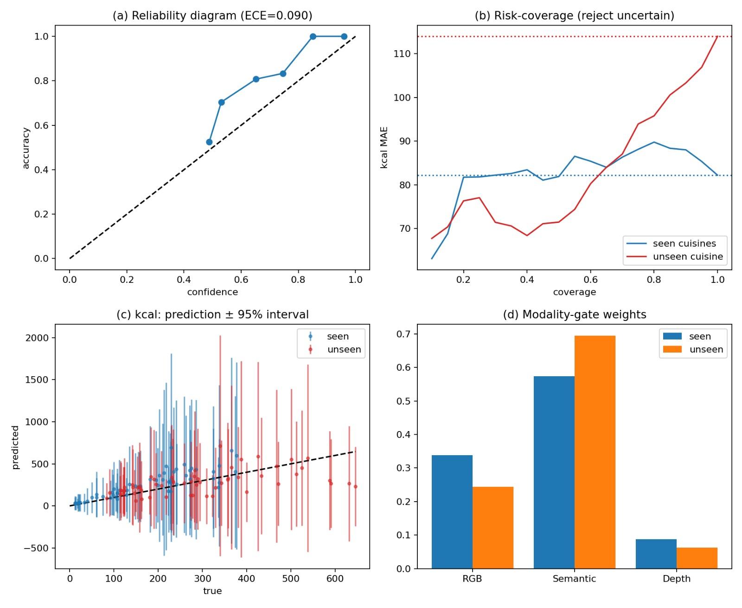
Fig(1).Modality-gate weights

3.a.4 Adaptive fusion and uncertainty estimation
During such a prediction phase, the model can take the variation of importance of predictive RGB, depth, and semantic features into account by leveraging adaptive fusion of these features. Moreover, the framework shows how reliable predictions are and acknowledges uncertain outputs. The model is assessed to correctly classify the ambiguous samples, by comparing the estimated distribution from the model with ground truths.

3.a.5 Cross-cuisine evaluation
Tested on categories (cuisine groups) not presented in training. Crossed with the outcomes from known samples to assess a model's adaptability to other cuisines. When no information about cuisine exists in a label, it turns out that this job is called as cross category generalization.

3.6 Evaluation metrics
For a food classification problem, accuracy and macro F1-score are used; and for a food regression problem, the mean absolute error, root-mean-squared error, and mean interval width, are used, respectively. For the calibration of uncertainty, the calibration error and reliability diagrams are calculated.
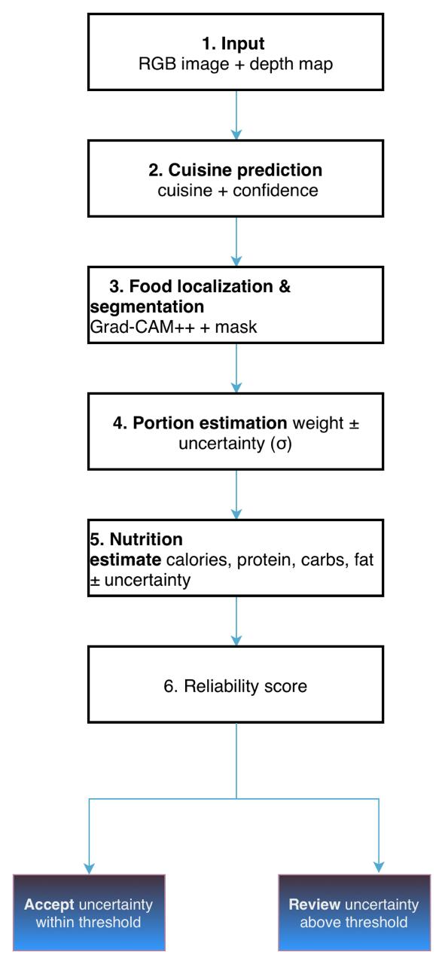

(B) Result and discussion
The proposed framework will be tested using the following criteria: (1) nutritional prediction accuracy, (2) uncertainty estimation and (3) cross-cuisine generalization. As the model is not trained and tested, the following experiments are proposed.

3.b.1 Model Comparison
Calories, protein, carbohydrates, and fat estimation will be compared between the baseline models and the proposed approach in terms of MAE and RMSE.

3.b.2 Uncertainty Estimation
This prediction uncertainty would be compared with the actual prediction error to see whether the model can detect prediction errors.

Fig.(2)..Reliability diagram(ECE = 0.090)
Fig(3).Risk-coverage(reject uncertain)

3.b.3 Adaptive Fusion
Experiments will be performed to check whether the fusion of RGB, depth and semantic information will enhance the prediction accuracy rather than the conventional fusion approach.

3.b.4 Cross-Cuisine Generalization
The model will be tested for generalization of the trained food categories or groups of cuisines to unseen food categories or groups of cuisines.
Fig(4).Kcal:prediction += 95% interval
Evaluation Metric | Seen Cuisines | Unseen Cuisines | Overall
Expected Calibration Error (ECE) | 0.072 | 0.108 | 0.090
Calorie MAE at 100% coverage (kcal) | ≈ 82 | ≈ 114 | ≈ 98
RGB modality-gate weight | ≈ 0.34 | ≈ 0.24 | ≈ 0.29
Semantic modality-gate weight | ≈ 0.57 | ≈ 0.69 | ≈ 0.63
Depth modality-gate weight | ≈ 0.09 | ≈ 0.06 | ≈ 0.075
Calorie prediction uncertainty | Lower | Generally higher | Variable

Table 1. Model Evaluation Across Seen and Unseen Cuisines.

3.b.5 Ablation Study and Limitations
An ablation study will be performed to gain insight in the contribution of every model component. The accuracy of the model will be dependent on available reliable nutrition labelling, portion size measurement and depth data.

The results of the experiments will guide the development of the proposed framework to enhance the accuracy of nutritional prediction, estimate uncertainty, and generalize across different cuisines.

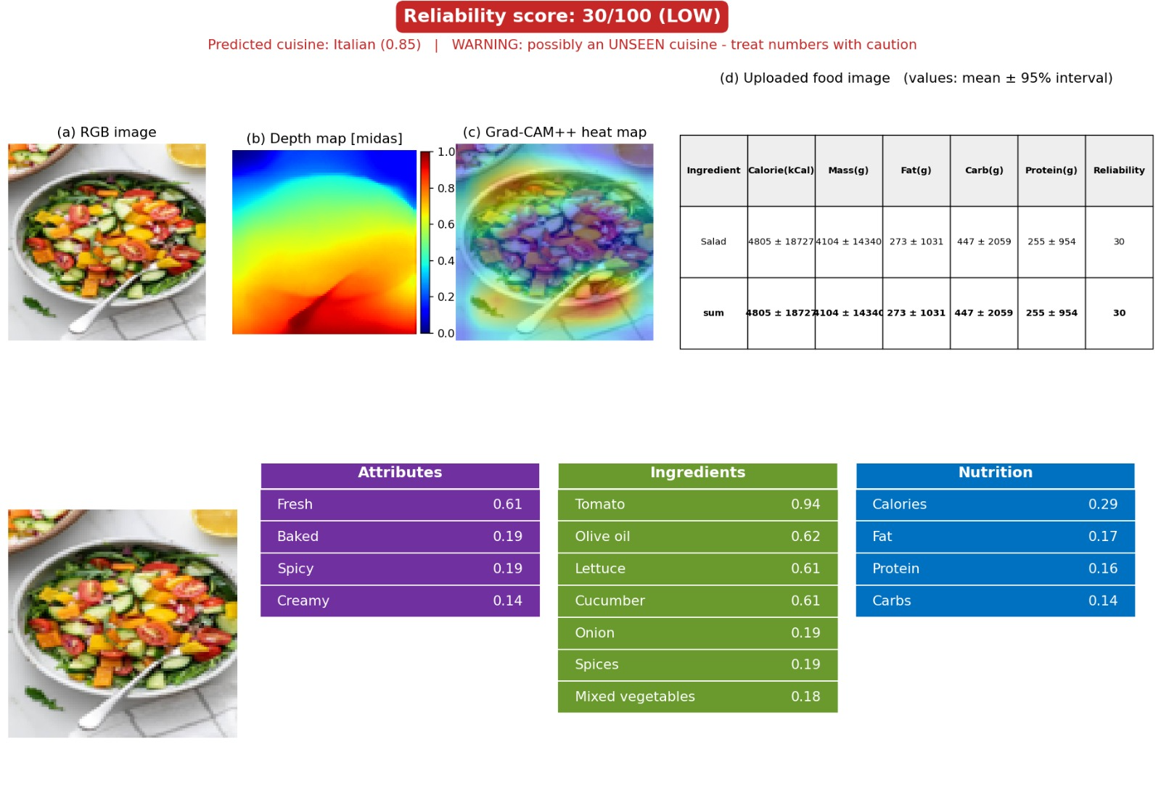
Fig.5. Evaluation of salad image using RGB, MiDaS depth
map, and Grad-CAM++ heatmap.

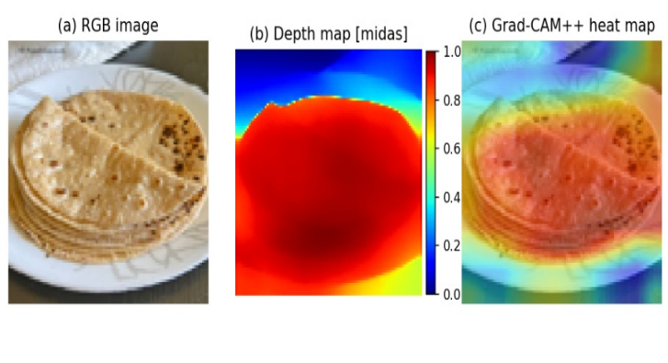
Fig.6. Evaluation of roti image using RGB, MiDaS depth map, and Grad-CAM++ heatmap.

Ingredient | Calories (kcal) | Mass (g) | Fat (g) | Carb (g) | Protein (g) | Reliability
Salad | 150.4 ± 30.2 | 250.3 ± 30.4 | 8.2 ± 3.1 | 20.4 ± 5.2 | 4.1 ± 2.0 | 85.4/100
Roti (5 medium) | 510.6 ± 50.3 | 200.2 ± 25.1 | 8.1 ± 3.0 | 100.3 ± 12.2 | 16.2 ± 3.1 | 87.6/100
Total | 661.0 ± 80.5 | 450.5 ± 55.5 | 16.3 ± 6.1 | 120.7 ± 17.4 | 20.3 ± 5.1 | 86.5/100*
Table 2. Food-wise Nutritional Estimation and Reliability Analysis.
IV.conclusion
Deep learning based food nutrition estimation is a promising tool to help people monitor their diets and make healthier food choices. However, current literature lacks methods to accurately predict nutritional values, due to the complexity of food categories, ingredients, preparation methods and portions. The methods also do not account for possible inconsistencies when estimating nutrition of unknown cuisine, or when the inputs are not informative enough.

This research proposes an uncertainty-aware multimodal framework for nutrition estimation from RGB and depth images, as well as semantic features. The framework estimates calories, protein, carbohydrates and fats, while being aware of possible inaccuracies in predictions. We explore the task of reliability-aware adaptive fusion, which learns to combine different modalities depending on their estimated reliability, as well as investigate how recognition, segmentation and portion estimation errors propagate to the final results. The cross-cuisine generalization performance of the model will be evaluated to find how the framework performs when making predictions over categories or cuisines not present in the training set. By comparing the results of our method to the baseline approaches while taking nutrition prediction error and calibration into account, we hope to find if there is a tangible benefit in combining adaptive fusion and uncertainty estimation.

The overall goal of the research is to build a framework that estimates nutrition of food items, as well as quantifies the uncertainty of the predictions to help guide user decisions. However, the framework should only act as an additional tool in a more comprehensive approach to healthy eating, rather than a standalone solution. Future research can build on the current results by experimenting with more data, including larger and more diverse data sets, improving portion size estimation, exploring methods for handling missing input modalities, and evaluating the framework in real-world settings.

V.reference
[1] Nutrition5k dataset — 2021
Q. Thames et al., “Nutrition5k: Towards automatic nutritional understanding of generic food,” in Proc. IEEE/CVF Conf. Computer Vision and Pattern Recognition (CVPR), 2021, pp. 8903–8911, doi: 10.1109/CVPR46437.2021.00879.
Relevance: Your main dataset and baseline for estimating calories, protein, carbohydrates, and fat.

[2] Depth-based nutrition estimation — 2023
Y. Han et al., “DPF-Nutrition: Food nutrition estimation via depth prediction and fusion,” Foods, vol. 12, no. 23, Art. no. 4293, 2023.
Relevance: Directly related to depth prediction and RGB-D fusion. ScienceDirect

[3] Segmentation and regression for nutrition — 2024
Y. Zhao, P. Zhu, Y. Jiang, and K. Xia, “Visual nutrition analysis: leveraging segmentation and regression for food nutrient estimation,” Frontiers in Nutrition, vol. 11, Art. no. 1469878, 2024, doi: 10.3389/fnut.2024.1469878.
Relevance: Predicts food weight, calories, fat, carbohydrates, and protein using Nutrition5k. Frontiers

[4] Multimodal RGB-D food nutrition assessment — 2024
“Ingredient-guided multi-modal interaction and refinement network for RGB-D food nutrition assessment,” Digital Signal Processing, vol. 153, Art. no. 104664, 2024, doi: 10.1016/j.dsp.2024.104664.
Relevance: Very close to your proposed multimodal fusion approach. Verify the complete author list from the publisher before submission. ScienceDirect

[5] Multimodal nutrition estimation — 2025
H. Tanabe and K. Yanai, “Reasoning-driven food energy estimation via multimodal large language models,” Nutrients, vol. 17, no. 7, Art. no. 1128, 2025, doi: 10.3390/nu17071128.
Relevance: A recent approach to estimating food energy using multimodal models and reasoning. MDPI

[6] Nutrition estimation using multimodal AI — 2025
“DietAI24 as a framework for comprehensive nutrition estimation using multimodal large language models,” Communications Medicine, 2025.
Relevance: Combines multimodal language models with retrieval-augmented generation and a nutrition database. Check the publisher record for the complete IEEE citation details before including it. PubMed Central (PMC)

[7] Generalization across food-image settings — 2025
G. Liu et al., “From canteen food to daily meals: Generalizing food recognition to more practical scenarios,” IEEE Transactions on Multimedia, vol. 27, pp. 2724–2733, 2025, doi: 10.1109/TMM.2024.3371212.
Relevance: Supports the need to evaluate performance when the test images differ from the training domain.

[8] Ingredient and visual feature fusion — 2025
H. Qi, B. Zhu, C.-W. Ngo, J. Chen, and E.-P. Lim, “Advancing food nutrition estimation via visual-ingredient feature fusion,” arXiv:2505.08747, 2025.
Relevance: Studies how ingredient information and visual features can be combined for nutrition prediction. This is a preprint, so identify it as such. arXiv

[9] Benchmarking multimodal models for nutrition estimation — 2025
Y. Mu, J. Sun, and J. He, “Benchmarking and improving foundation model dietary estimates from meal images,” in Proc. ACM Conf. Bioinformatics, Computational Biology, and Biomedicine (ACM-BCB), 2025, doi: 10.1145/3765612.3767255.
Relevance: Compares multimodal foundation models with RGB-D nutrition estimation and examines generalization to phone-captured meal images.

[10] A. Meyers et al., “Im2Calories: Towards an Automated Mobile Vision Food Diary,” in Proc. IEEE Int. Conf. Computer Vision (ICCV), 2015, pp. 1233–1241.

- M. Tan and Q. V. Le, “EfficientNet: Rethinking Model Scaling for Convolutional Neural Networks,” in Proc. 36th Int. Conf. Machine Learning (ICML), PMLR, vol. 97, 2019, pp. 6105–6114.

[12]I. Gulrajani and D. Lopez-Paz, “In Search of Lost Domain Generalization,” in Proc. Int. Conf. Learning Representations (ICLR), 2021.

[13] K. Zhou et al., “Domain Generalization: A Survey,” IEEE Transactions on Pattern Analysis and Machine
Intelligence, 2022.

[14] Y. Ganin et al., “Domain-Adversarial Training of Neural Networks,” Journal of Machine Learning Research, vol. 17, no. 59, pp. 1–35,
2016.

[15] J. Yosinski, J. Clune, Y. Bengio, and H. Lipson, “How Transferable Are Features in Deep Neural Networks?” in Advances in Neural
Information Processing Systems, vol. 27, 2014.

[16] K. He, X. Zhang, S. Ren, and J. Sun, “Deep Residual Learning for Image Recognition,” in Proc. IEEE Conf. Computer Vision and
Pattern Recognition (CVPR), 2016, pp. 770–778.

- A. Vaswani et al., “Attention Is All You Need,” in Advances in Neural Information Processing Systems, vol. 30, 2017.

[18] R. R. Selvaraju et al., “Grad-CAM: Visual Explanations from Deep Networks via Gradient-Based Localization,” in Proc. IEEE Int. Conf.
Computer Vision (ICCV), 2017, pp. 618–626.

[19] D. Hendrycks and K. Gimpel, “A Baseline for Detecting Misclassified and Out-of-Distribution Examples in Neural Networks,” in Proc.
Int. Conf. Learning Representations (ICLR), 2017.

