DwaTrack
Business Tracking System
System Diagrams Documentation
Project Report — Technical Appendix

Table of Contents
1. System Context Diagram
2. Entity Relationship Diagram (ERD)
3. System Flowchart
4. Data Flow Diagram (DFD) — Level 1
5. Use Case Diagram

1. System Context Diagram
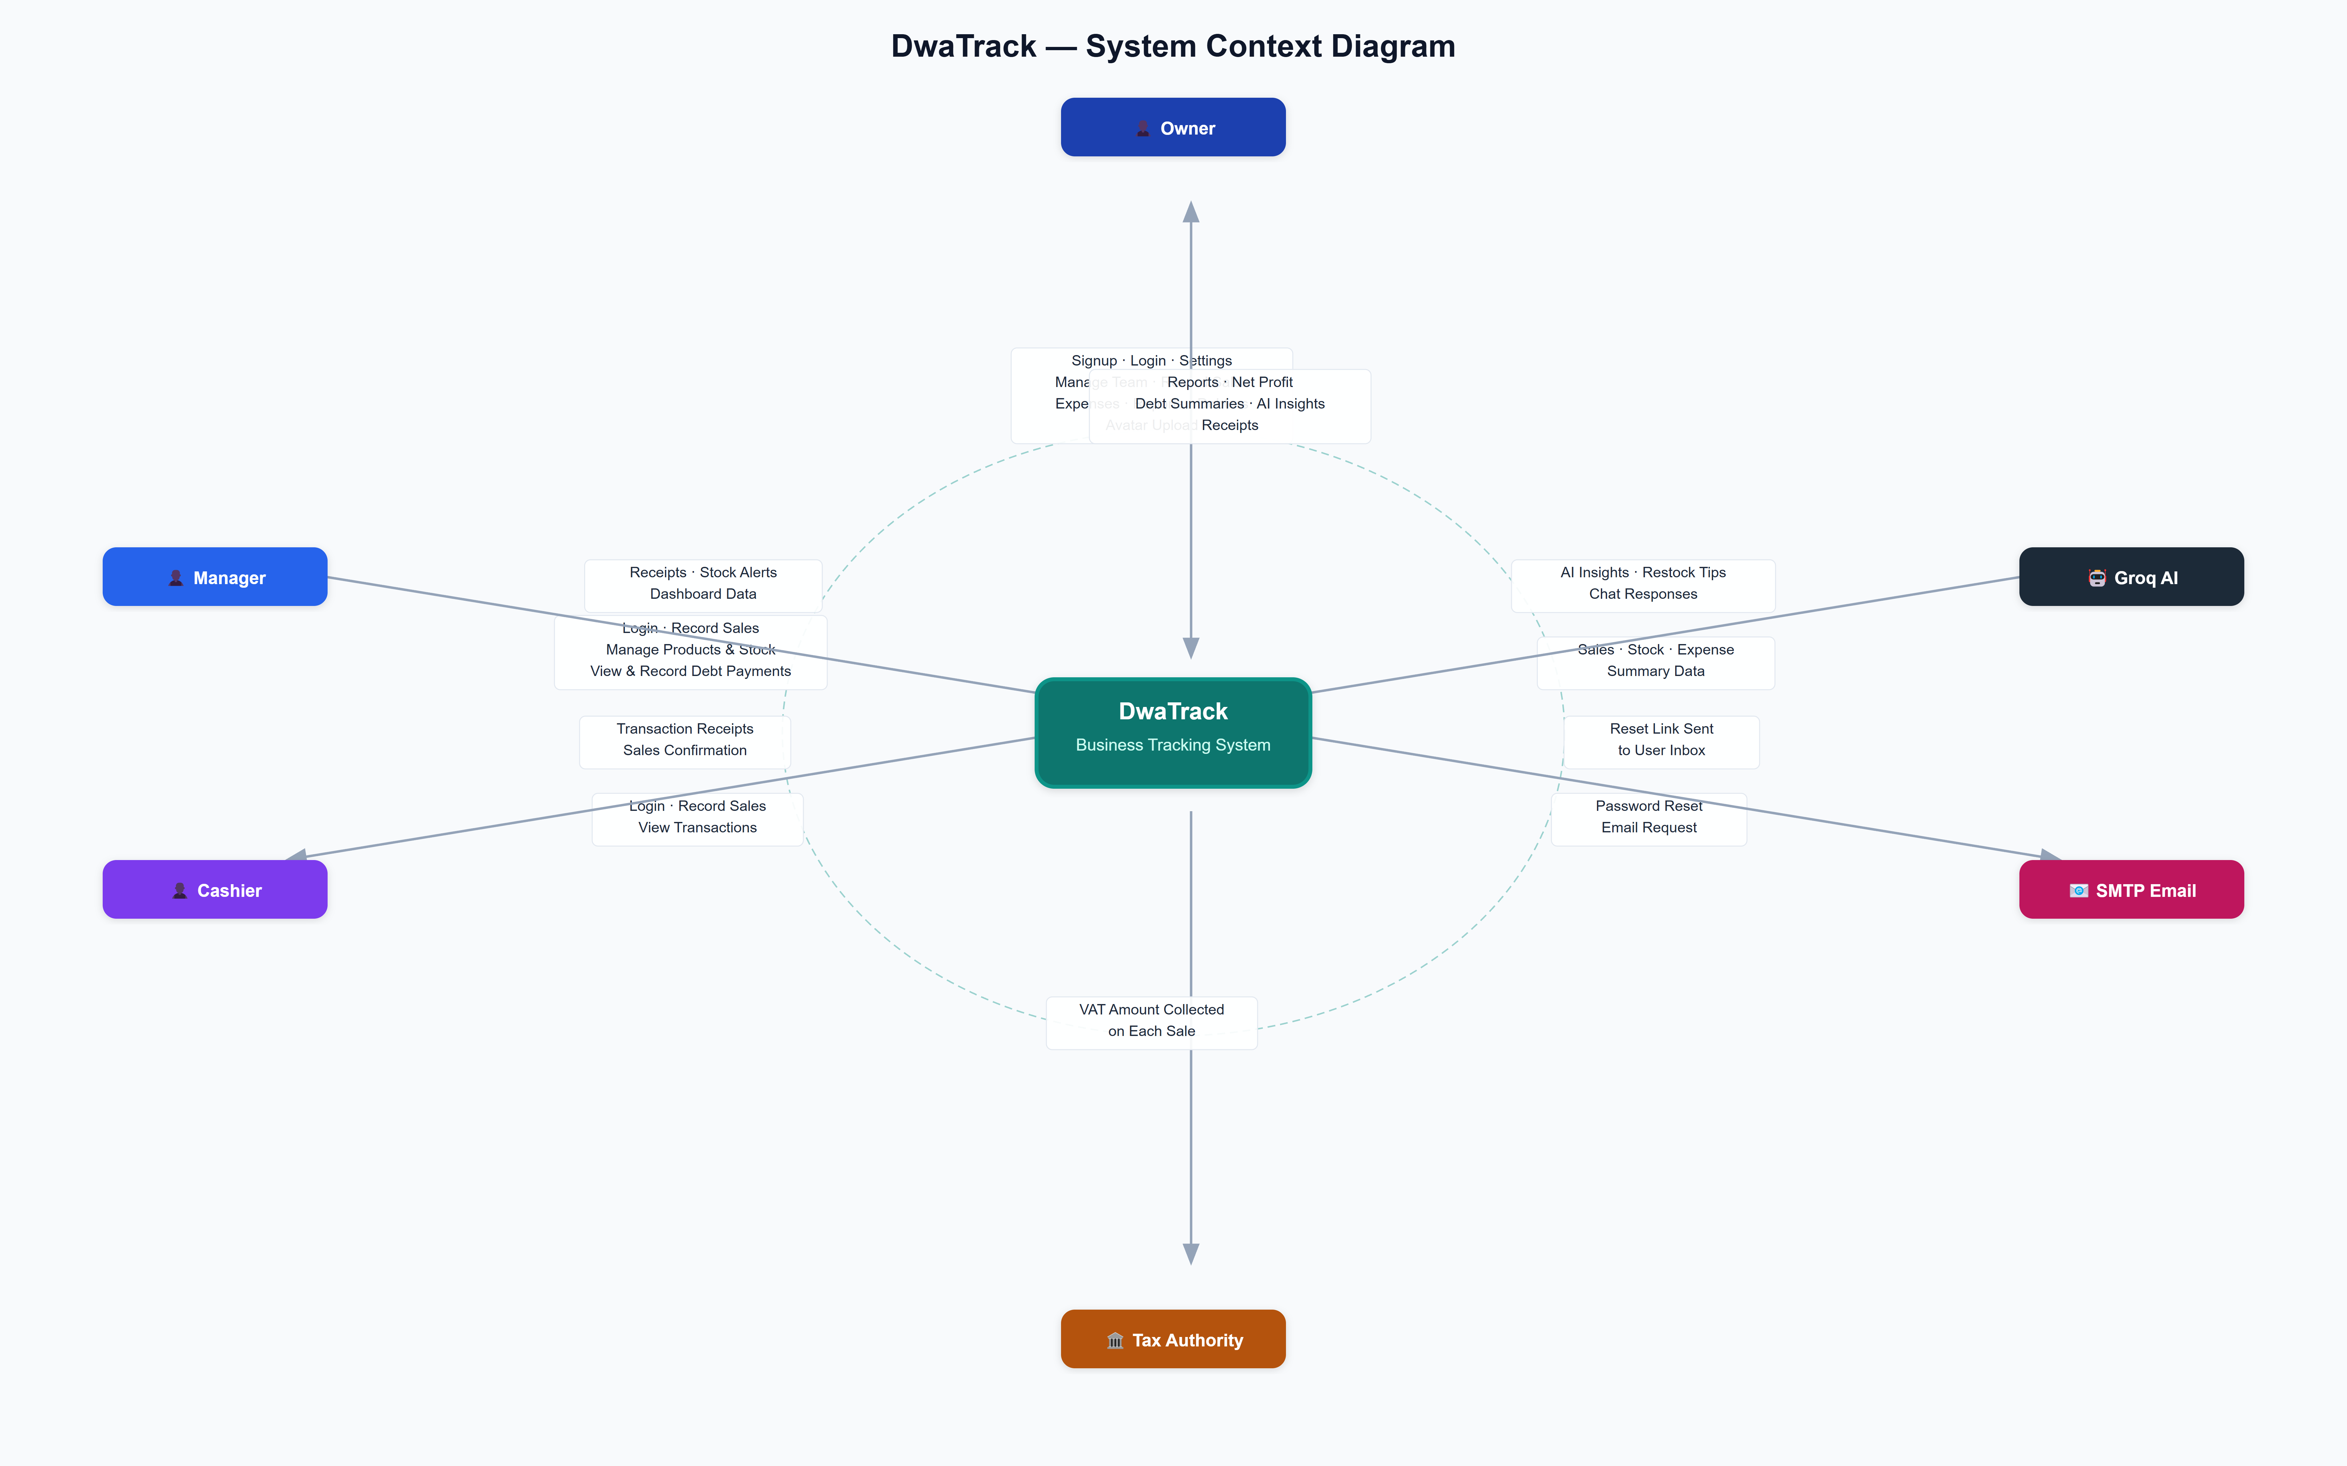

Overview
The System Context Diagram provides a high-level view of DwaTrack and its interactions with external entities. It defines the system boundary — showing what is inside DwaTrack and who or what communicates with it from the outside. It does not describe internal processes; its purpose is to establish the scope of the system and all external dependencies.

External Entities

Owner
The primary user who registers and owns a DwaTrack account. The Owner has full access to all system features including team management, financial reports, the AI assistant, and all settings.

Manager
A team member assigned the Manager role by the Owner. Managers can record sales, manage products and stock, and view and record debt payments on behalf of the business.

Cashier
A team member assigned the Cashier role by the Owner. Cashiers have the most restricted access — they can record sales and view their own transactions only.

Tax Authority
Represents the government tax body (for example, the Ghana Revenue Authority). DwaTrack calculates VAT collected on each sale, which may be submitted to this authority by the Owner.

Groq AI
A third-party artificial intelligence service. DwaTrack sends summarised business data to Groq and receives AI-generated insights, restock recommendations, and chat responses in return.

SMTP Email Service
An external email delivery provider configured via SMTP (for example, Gmail). DwaTrack uses this service exclusively for sending time-limited password reset links to users who have forgotten their passwords.

Data Flows

From | To | Data Exchanged
Owner | DwaTrack | Signup details, credentials, sale data, expenses, settings, team management, debtor payments, avatar
DwaTrack | Owner | Financial reports, net profit, receipts, debt summaries, AI insights
Manager | DwaTrack | Login credentials, sale items, product and stock updates, debt payments
DwaTrack | Manager | Transaction receipts, stock alerts, dashboard data
Cashier | DwaTrack | Login credentials, sale items
DwaTrack | Cashier | Transaction receipts, sales confirmation
DwaTrack | Tax Authority | VAT amount collected per sale
DwaTrack | Groq AI | Summarised sales, stock, and expense data
Groq AI | DwaTrack | AI insights, restock tips, chat responses
DwaTrack | SMTP Email Service | Password reset email request
SMTP Email Service | Owner / Manager / Cashier | Password reset link delivered to user inbox

Key Design Notes
- The PostgreSQL database is not shown as an external entity because it is part of DwaTrack's internal infrastructure, not an outside party.
- A Geolocation API was considered during design but is not used in the final system. Currency is set manually during signup based on the user's country selection.

2. Entity Relationship Diagram (ERD)
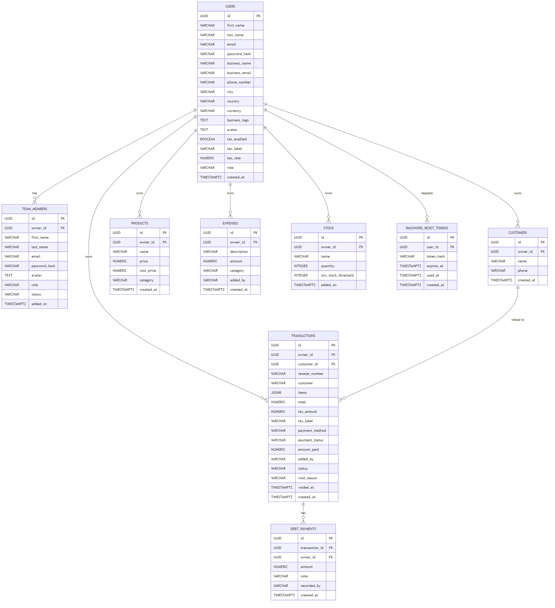

Overview
The Entity Relationship Diagram describes the logical structure of DwaTrack's PostgreSQL database. It shows all nine tables, their columns, data types, primary and foreign keys, and the relationships between tables. The ERD reflects the schema used in the live production database.

Entities and Attributes

USERS
Stores account information for business owners who register on DwaTrack.

Column | Type | Description
id | UUID (PK) | Unique identifier for the owner
first_name | VARCHAR | Owner's first name
last_name | VARCHAR | Owner's last name
email | VARCHAR | Owner's login email address (unique)
password_hash | VARCHAR | Bcrypt-hashed password
business_name | VARCHAR | Name of the business
business_email | VARCHAR | Business contact email
phone_number | VARCHAR | Business phone number
city | VARCHAR | Business city or address
country | VARCHAR | Country of operation
currency | VARCHAR | Currency symbol (e.g. GH₵)
business_logo | TEXT | Base64-encoded business logo image
avatar | TEXT | Base64-encoded profile photo
tax_enabled | BOOLEAN | Whether tax is applied on receipts
tax_label | VARCHAR | Tax label shown on receipts (e.g. VAT)
tax_rate | NUMERIC | Tax rate as a percentage
role | VARCHAR | Always 'owner' for records in this table
created_at | TIMESTAMPTZ | Account creation timestamp

TEAM_MEMBERS
Stores managers and cashiers added by the Owner.

Column | Type | Description
id | UUID (PK) | Unique identifier for the team member
owner_id | UUID (FK → USERS) | The owner who added this member
first_name | VARCHAR | Member's first name
last_name | VARCHAR | Member's last name
email | VARCHAR | Member's login email address
password_hash | VARCHAR | Bcrypt-hashed password
avatar | TEXT | Base64-encoded profile photo
role | VARCHAR | Either 'manager' or 'cashier'
status | VARCHAR | Either 'active' or 'inactive'
added_on | TIMESTAMPTZ | Timestamp when the member was added

CUSTOMERS
Stores named customers associated with credit sales.

Column | Type | Description
id | UUID (PK) | Unique identifier for the customer
owner_id | UUID (FK → USERS) | The owner this customer belongs to
name | VARCHAR | Customer's full name
phone | VARCHAR | Customer's phone number
created_at | TIMESTAMPTZ | Record creation timestamp

TRANSACTIONS
Records every sale — cash, mobile money, card, partial payment, and credit sales.

Column | Type | Description
id | UUID (PK) | Unique identifier for the transaction
owner_id | UUID (FK → USERS) | The owner this transaction belongs to
customer_id | UUID (FK → CUSTOMERS) | Linked customer (for credit sales)
receipt_number | VARCHAR | Auto-generated receipt reference (e.g. RCP-20240411-1234)
customer | VARCHAR | Customer display name (defaults to 'Walk-in Customer')
items | JSONB | JSON array of sold items with name, quantity, and price
total | NUMERIC | Total sale amount including tax
tax_amount | NUMERIC | Tax portion of the total
tax_label | VARCHAR | Tax label at the time of the sale
payment_method | VARCHAR | Payment method (cash, momo, card, or credit)
payment_status | VARCHAR | 'paid', 'partial', or 'credit'
amount_paid | NUMERIC | Amount paid upfront (for partial and credit sales)
added_by | VARCHAR | Name of the staff who recorded the sale
status | VARCHAR | 'completed' or 'voided'
void_reason | VARCHAR | Reason provided when a transaction is voided
voided_at | TIMESTAMPTZ | Timestamp when the transaction was voided
created_at | TIMESTAMPTZ | When the transaction was recorded

DEBT_PAYMENTS
Records individual repayments made against a credit or partial-payment transaction.

Column | Type | Description
id | UUID (PK) | Unique identifier for the payment
transaction_id | UUID (FK → TRANSACTIONS) | The transaction being paid off
owner_id | UUID (FK → USERS) | The owner this payment belongs to
amount | NUMERIC | Amount paid in this instalment
note | VARCHAR | Optional note about the payment
recorded_by | VARCHAR | Name of the staff who recorded it
created_at | TIMESTAMPTZ | Payment timestamp

PRODUCTS
Stores products available for sale.

Column | Type | Description
id | UUID (PK) | Unique identifier for the product
owner_id | UUID (FK → USERS) | The owner this product belongs to
name | VARCHAR | Product name
price | NUMERIC | Selling price
cost_price | NUMERIC | Purchase/cost price (for profit calculation)
category | VARCHAR | Product category
created_at | TIMESTAMPTZ | When the product was added

EXPENSES
Records business expenses such as rent, utilities, and supplies.

Column | Type | Description
id | UUID (PK) | Unique identifier for the expense
owner_id | UUID (FK → USERS) | The owner this expense belongs to
description | VARCHAR | Description of the expense
amount | NUMERIC | Expense amount
category | VARCHAR | Expense category (e.g. Rent, Utilities, Supplies)
added_by | VARCHAR | Name of the staff who recorded it
created_at | TIMESTAMPTZ | When the expense was recorded

STOCK
Tracks inventory item quantities and low-stock alert thresholds.

Column | Type | Description
id | UUID (PK) | Unique identifier for the stock item
owner_id | UUID (FK → USERS) | The owner this stock item belongs to
name | VARCHAR | Item name
quantity | INTEGER | Current quantity in stock
low_stock_threshold | INTEGER | Quantity at which a low-stock alert is triggered
added_on | TIMESTAMPTZ | When the item was added

PASSWORD_RESET_TOKENS
Stores secure, time-limited tokens used to authenticate password reset requests.

Column | Type | Description
id | UUID (PK) | Unique identifier for the token
user_id | UUID (FK → USERS) | The user who requested the reset
token_hash | VARCHAR | SHA-256 hash of the reset token (raw token only sent via email, never stored)
expires_at | TIMESTAMPTZ | Token expiry time (1 hour from creation)
used_at | TIMESTAMPTZ | Timestamp when the token was consumed
created_at | TIMESTAMPTZ | When the token was generated

Relationships

Relationship | Cardinality | Description
USERS → TEAM_MEMBERS | One-to-Many | An owner can have many team members
USERS → CUSTOMERS | One-to-Many | An owner can have many customers
USERS → TRANSACTIONS | One-to-Many | An owner owns many transactions
USERS → PRODUCTS | One-to-Many | An owner owns many products
USERS → EXPENSES | One-to-Many | An owner owns many expense records
USERS → STOCK | One-to-Many | An owner manages many stock items
USERS → PASSWORD_RESET_TOKENS | One-to-Many | An owner can have multiple reset tokens over time
CUSTOMERS → TRANSACTIONS | One-to-Many | A customer can be linked to many credit transactions
TRANSACTIONS → DEBT_PAYMENTS | One-to-Many | A credit transaction can have many debt payments recorded against it

3. System Flowchart


Overview
The System Flowchart describes the complete operational flow of DwaTrack from the moment a user visits the application. It covers account creation, authentication including password reset, role-based access, all core business workflows, and automatic session timeout. The diagram uses subgraphs to distinguish the distinct experience of each user role.

Entry and Authentication
A user who does not yet have an account proceeds to sign up by providing their name, email address, password, and country. The system checks for duplicate email addresses and automatically assigns a currency based on the selected country. If the user already has an account, they proceed directly to the login screen.
On the login screen, a user who has forgotten their password can enter their email address to receive a time-limited password reset link. After clicking the link and setting a new password, they are redirected back to the login screen. Valid credentials grant access and the system routes the user to the dashboard appropriate for their role.

Owner — Full Access
Upon login, the Owner reaches a dashboard that includes an overview of today's sales, outstanding debt balances, and AI-powered business insights. From the dashboard, the Owner can perform the following actions:
- Record Sales — Add transactions using any payment method.
- View, Void, and Delete Transactions — Full transaction management with reason entry for voided sales.
- Manage Products — Add, edit, and remove products from the catalogue.
- Manage Stock — Track inventory quantities and receive alerts for low-stock items.
- Manage Expenses — Record and delete business expenditures.
- View Reports — Access revenue summaries, expense breakdowns, payment method analysis, and the monthly sales activity heatmap.
- AI Assistant — Submit natural language queries for sales summaries, restock recommendations, and business advice.
- Manage Debtors — View outstanding customer debts and record repayments.
- Settings — Update shop information, configure tax, manage team members, and upload a profile avatar.

Manager — Limited Access
Managers can record sales, view and void transactions, manage products and stock, view outstanding debts, and record debt payments. Managers cannot delete transactions, manage expenses, or access financial reports.

Cashier — Basic Access
Cashiers can record sales and view their own transactions only. They cannot void or delete transactions, manage products or stock, manage expenses, or access the reports section.

Record Sale Flow (All Roles)
All three roles follow the same sale recording process:
- Products and quantities are selected from the product catalogue.
- An optional discount is applied to the order total.
- The system calculates the subtotal, tax (if enabled), and the final total automatically.
- The user selects a payment method. For Cash, Mobile Money, or Card payments, the transaction is marked as Paid. For Credit sales, a customer must be selected. If a deposit is entered, the status is set to Partial. If no deposit is provided, the status is set to Credit.
- The transaction is submitted, stock quantities are automatically deducted, and a receipt is generated. The user may optionally print the receipt.

Debtors Flow (Owner and Manager)
- The user views a list of all customers with outstanding balances, including urgency indicators for overdue accounts.
- A specific customer is selected to reveal their open credit transactions and full payment history.
- A repayment amount is recorded against a chosen transaction.
- If the payment clears the full outstanding balance, the transaction status automatically updates to Paid. Otherwise, the status becomes Partial.

Stock Management Flow (Owner and Manager)
Stock management allows users to add new items with a defined low-stock threshold, restock existing items when supplies arrive, and view a list of items that have fallen below their threshold.

Session Inactivity Timeout (All Roles)
All authenticated users are subject to a 15-minute inactivity timeout. After 15 minutes of no user interaction, a warning modal appears with a 60-second countdown. If the user acknowledges the warning, the timer resets and the session continues. If the countdown expires or the user clicks logout, the session is closed and the user is redirected to the login page.

4. Data Flow Diagram (DFD) — Level 1
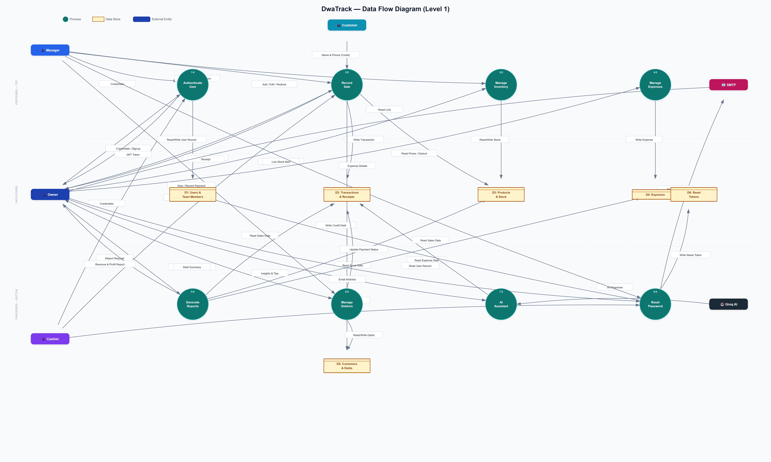

Overview
The Level 1 Data Flow Diagram decomposes DwaTrack into its eight core processes and illustrates how data moves between external entities, internal processes, and data stores. Unlike the System Flowchart, which describes the sequence of user actions and decisions, the DFD focuses exclusively on the movement and transformation of data within and around the system.

Notation
- Circles represent Processes — named operations that receive, transform, or produce data.
- Open-ended rectangles represent Data Stores — the persistent storage locations (database tables) where data is held at rest.
- Rounded rectangles represent External Entities — the people or systems outside DwaTrack's boundary that supply or consume data.

External Entities

Entity | Description
Owner | Provides credentials, sale data, and management instructions; receives reports, receipts, and insights
Manager | Provides credentials and sale or stock data; receives receipts and stock alerts
Cashier | Provides credentials and sale data; receives receipts
Customer | Provides name and phone number when a credit sale is being recorded
Groq AI | Receives summarised business data; returns AI-generated insights and responses
SMTP Service | Receives email dispatch requests; delivers password reset links to users

Data Stores

Store | Contents
D1: Users & Team Members | Owner and team member account records, hashed credentials, and avatar images
D2: Transactions & Receipts | All sales records including payment status, itemised products, totals, and void information
D3: Products & Stock | Product catalogue with selling prices, cost prices, categories, and current stock quantities
D4: Expenses | Business expense records with amounts, categories, and timestamps
D5: Customers & Debts | Customer profiles and all debt payment records linked to credit transactions
D6: Reset Tokens | SHA-256 hashed, time-limited tokens used for password reset verification

Processes

1.0 — Authenticate User
Receives login credentials from Owners, Managers, and Cashiers, or a new account signup from an Owner. Reads user records from D1 to verify identity. On success, issues a signed JWT session token to the requesting user.

2.0 — Record Sale
Receives sale items, quantities, discounts, payment method, and optional customer details from any authenticated user. Reads product prices from D3. Writes the completed transaction to D2. Deducts sold quantities from D3. Writes a credit debt entry to D5 when the payment method is credit. Returns a receipt to the recording user.

3.0 — Manage Inventory
Receives add, edit, and restock instructions from Owners and Managers. Reads and writes product and stock data in D3. Returns low-stock alerts when item quantities fall below their configured thresholds.

4.0 — Manage Expenses
Receives expense details including description, amount, and category from the Owner. Writes the expense record to D4.

5.0 — Generate Reports
Receives a report request from the Owner. Reads sales data from D2, stock data from D3, and expense data from D4. Returns compiled revenue, profit, and expense reports to the Owner.

6.0 — Manage Debtors
Receives debt-viewing and payment-recording instructions from Owners and Managers. Reads and updates debt records in D5. Updates the payment status of the relevant transaction in D2 when a payment is recorded. Returns a debt summary to the requesting user.

7.0 — AI Assistant
Receives a natural language query from the Owner. Reads relevant sales data from D2. Sends summarised data to the Groq AI external service. Receives the AI-generated response and returns insights to the Owner.

8.0 — Reset Password
Receives an email address from any user requesting a password reset. Reads the corresponding user account from D1. Writes a hashed, time-limited token to D6. Sends a password reset email request to the SMTP service. When the user subsequently submits a new password, validates the token from D6 and writes the new password hash to D1.

5. Use Case Diagram


Overview
The Use Case Diagram identifies all the functional capabilities of DwaTrack and maps them to the actors who can perform them. Each use case represents a discrete action a user can initiate within the system boundary. The diagram is organised into eight functional groups, and access control differences between the three user roles are clearly represented.

Actors

Owner
The business owner with full system access. Can perform every use case available in the system.

Manager
A staff member with intermediate access. Can record sales, manage inventory, view and record debts, and update their profile avatar. Cannot manage expenses, access reports, or administer the team.

Cashier
A staff member with basic access. Can record sales, view their own transactions, and update their profile avatar only.

Groq AI
An external AI service that participates as a secondary actor in all AI Assistant use cases.

SMTP Service
An external email service that participates as a secondary actor in the Forgot Password and Reset Password use cases.

Use Cases by Group

Authentication
Use Case | Owner | Manager | Cashier | External Participant
Sign Up | ✓ | — | — | —
Log In | ✓ | ✓ | ✓ | —
Log Out | ✓ | ✓ | ✓ | —
Forgot Password | ✓ | ✓ | ✓ | SMTP Service
Reset Password | ✓ | ✓ | ✓ | SMTP Service
Auto Session Timeout | ✓ | ✓ | ✓ | —

Account & Settings
Use Case | Owner | Manager | Cashier
Update Shop Info | ✓ | — | —
Configure Tax | ✓ | — | —
Upload Avatar | ✓ | ✓ | ✓
Add Team Member | ✓ | — | —
Deactivate Team Member | ✓ | — | —

Sales & Transactions
Use Case | Owner | Manager | Cashier
Record Cash Sale | ✓ | ✓ | ✓
Record Credit Sale | ✓ | ✓ | ✓
Apply Discount | ✓ | ✓ | ✓
Print Receipt | ✓ | ✓ | ✓
Void Transaction | ✓ | ✓ | —
Delete Transaction | ✓ | — | —
Search Transactions | ✓ | ✓ | ✓

Products & Stock
Use Case | Owner | Manager | Cashier
Add / Edit Product | ✓ | ✓ | —
Delete Product | ✓ | — | —
Add Stock Item | ✓ | ✓ | —
Restock Item | ✓ | ✓ | —
View Low Stock Alerts | ✓ | ✓ | —

Expenses
Use Case | Owner | Manager | Cashier
Record Expense | ✓ | — | —
Delete Expense | ✓ | — | —

Debtors
Use Case | Owner | Manager | Cashier
View Outstanding Debts | ✓ | ✓ | —
Record Debt Payment | ✓ | ✓ | —
View Payment History | ✓ | ✓ | —

Reports & Analytics
Use Case | Owner | Manager | Cashier
View Revenue Report | ✓ | — | —
View Expense Breakdown | ✓ | — | —
View Sales Activity Heatmap | ✓ | — | —
View Product Analysis | ✓ | — | —

AI Assistant
Use Case | Owner | Manager | Cashier | External Participant
Get Sales Summary | ✓ | — | — | Groq AI
Get Restock Tips | ✓ | — | — | Groq AI
Chat with Assistant | ✓ | — | — | Groq AI

Role Permission Summary

Feature Area | Owner | Manager | Cashier
Authentication & Account | Full | Partial | Basic
Sales Recording | Full | Full | Full
Transaction Management | Full | Partial | None
Products & Stock | Full | Partial | None
Expenses | Full | None | None
Debtors | Full | Full | None
Reports & Analytics | Full | None | None
AI Assistant | Full | None | None
Team Management | Full | None | None

Documentation prepared for the DwaTrack Business Tracking System project report.

