A Database Connection Program for Feasibility Study

--User Guide

Hui Guo

This is a guide of the installation of the program.

**1. MySQL installation**

Download and install MySQL

http://dev.mysql.com/downloads/installer/

You may need to set up a password in the middle of the process.

* For Ubuntu users you can also run:

sudo apt-get install mysql-server

in terminal.

If you want to use NetBeans for JAVA programming, download it from here:

http://netbeans.org/downloads/

You may need a connector to work with MySQL:

http://dev.mysql.com/downloads/connector/j/5.0.html

**2. Database setup**

Open a MySQL command line client, enter password then run:

mysql> create database MTMS;

mysql> use MTMS

mysql> source C:/MTMS.sql

This puts three tables in the database: Type, People, Reports.

*For the last one, enter the address where MTMS.sql is located.

*For Linux user, type

mysql -r root –p

in the terminal to enter sql.

*If you're already under the same folder as the sql file, use

mysql> source MTMS.sql

for the last command.

Or in the terminal, run

mysql -r root -p MTMS<MTMS.sql

if you already have a database named MTMS in MySQL.

**3. JDK installation**

You need JDK to run the program:

http://www.oracle.com/technetwork/java/javase/downloads/jdk7-downloads-1880260.html

Or on Ubuntu:

sudo add-apt-repository ppa:webupd8team/java

sudo apt-get update

sudo apt-get install oracle-java7-installer

**4. Run the program**

Run MTMS/dist/MTMS.jar(by clicking it in Windows).

On linux, in ternimal, type:

java -jar /MTMS/dist/MTMS.jar

Please make sure MySQL is running.

Table People from MySQL:

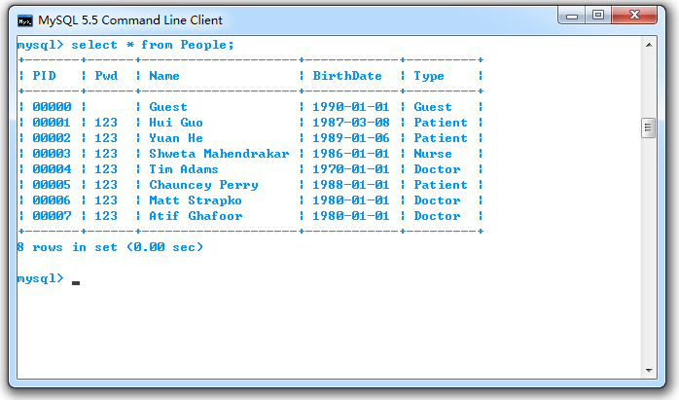

The running of the program:

