|  |  |
| --- | --- |
| Vidya  एक कोशिश | Abstract  VIDYA is to handle donations and connect the donators with the nearest/appropriate needy person through a social mobile application. The application handles different services such as the reviews of the searched needy person and displays their contacts and their location the application allows users to create a profile for themselves and the information about the needy. This profile will be shown to donators who are looking for someone to donate. |

**BY: VIDYA ~ एक कोशिश**

GitHub: <https://github.com/heyvishu/VIDYA>

**SUBMITTED TO:**

Dr. DURGANSH SHARMA

Assistant Professor (SS) Department of Computer Application

**Group Members:**

|  |  |  |  |  |
| --- | --- | --- | --- | --- |
| **Name** | **SAP-ID** | **ROLL NO** | **CONTACT NO** | **EMAIL** |
| Vishvendra Singh | 500067077 | R174218072 | +919460919564 | i.emvishu@gmail.com |
| Ayush Soni | 500071420 | R174218077 | +919053399999 | ayus.soni@gmail.com |
| Saumya Agrawal | 500070815 | R174218049 | +919169581306 | sm.agrwal@gmail.com |



Contents

**INTRODUCTION** 3

**MANIFESTO** 4

**PRINCIPLES** 5

**PROBLEM STATEMENT** 6

**SYSTEM MODULES** 7

**METHODOLOGY** 8

**DATA ANALYSIS** 9

**ENTITY RELATIONSHIP DIAGRAM** 12

**DATA FLOW DIAGRAM** 13

• **DFD LEVEL – 0** 13

• **DFD LEVEL – 1** 14

**DFD LEVEL – 2** 15

**Program Evaluation and Review Technique** 16

**PERT CHART** 17

# **INTRODUCTION**

The aim of this project is to establish an awareness for an application related to manual idea of sharing thoughts over any fields of education whether it is for competition, academic or any other level.

This application is to convert manual application into online application. Individual can sign up to the application and all they can do is share life experiences, their thoughts, study material basically. Customized data will be used in this application. User have all the right to describe about their personal information on their main profile.

First Step capstone project objective is to handle donations and connect the donators with the nearest/appropriate needy person through a social mobile application. The application handles different services such as the reviews of the searched needy person and displays their contacts and their location

The application allows users to create a profile for themselves and the information about a

certain family that needs help. This profile will be shown to donators who are looking for

someone to donate to. Mainly only information is exchanged. The donators are able to post/see reviews about other people’s profiles.

This application is aimed to help the Moroccan society and create a sense of solidarity through modern techniques. The social implications it will have after being launched will certainly aim at closing the gap in terms of quality of life for the less fortunate citizens.

# 

# **MANIFESTO**

We are uncovering better ways of developing software by doing it and helping others do it. Through this work we have come to value:

* Individuals & interactions over processes and tools.
* Working software over comprehensive documentation.
* Customer collaboration over contract negotiation.
* Responding to change over following a plan.

That is while there is value in the items on the right, we value the items on the left more.

# 

# **PRINCIPLES**

We follow these principles:

* Our highest priority is to satisfy the customer through early & continuous delivery of valuable software.
* Welcome changing requirements, even late in development. Agile processes harness change for the customer’s competitive advantage.
* Deliver working software frequently, from a couple of weeks to couple of months, with preference to the shorter timescale.
* Business people and developers must work together daily throughout the project.
* Build projects around motivated individuals. Give them the environment and support they need and trust them to get the job done.
* The most efficient & effective method of conveying information to & within a development team is face-to-face conversation.
* Working software is the primary measure of progress.
* Agile processes promote sustainable development. The sponsors, developers & users should be able to maintain a constant pace indefinitely.
* Continuous attention to technical excellence & good design enhances agility.
* Simplicity-the art of maximizing the amount of work not done is essential.
* The best architectures, requirements, and designs emerge from self-organizing teams.
* At regular intervals, the team reflects on how to become more effective then tunes and adjusts its behavior accordingly.

# **PROBLEM STATEMENT**

Children living in poverty face many barriers to accessing an education. Some are obvious — like not having a school to go to — while others are more subtle, like the teacher at the school not having had the training needed to help children learn effectively.

Increasing access to education can improve the overall health and longevity of a society, grow economies, and even combat climate change. Yet in many developing countries, children’s access to education can be limited by numerous factors. Language barriers, gender roles, and reliance on child labor can all stall progress to provide quality education. The world’s most vulnerable children from disadvantaged communities, including young girls and children with disabilities, are more likely to miss out on school.

# **SYSTEM MODULES**

Our Project contains the following modules:

1. Profile Module

Profile is an important component to users, which helps users to add the personal details.

i.e. Name, Address, Email ID, Mobile Number.

1. Customer Care

Successful businesses tend to provide a high level of customer service which results in high customer satisfaction.

The potential benefits to the firm from providing a consistently high level of customer service include:

* **Increased sales** – more likely to try out other products/services too
* **Customer loyalty** – more likely to be a source of repeat business and to recommend the business to friends and family
* **Enhanced public image** – helps build a brand and provides protection if there is a slip-up in customer service
* **More effective workforce** – satisfied customers help create a positive working environment

# **METHODOLOGY**

We are using FDD (Feature Driven Development) methodology to develop our project as it is the best fit to develop project with multiple features, following this methodology will allow us to add new features into existing project thus making it more feature rich and increasing its functionalities over time. FDD is a combination of iterative and incremental software development process. The development under FDD is carried out on client valued functionality and client’s perspective.

Development under FDD initiates with a deep understanding of the scope and context of the system and detailed models are created at each level for peer review and all the models are progressively merged into an overall wholesome model.

**Building Features List**

* User can create his/her own new account
* User can get books of his/her own interest
* Donator can apply filters according to their need.

# **DATA ANALYSIS**

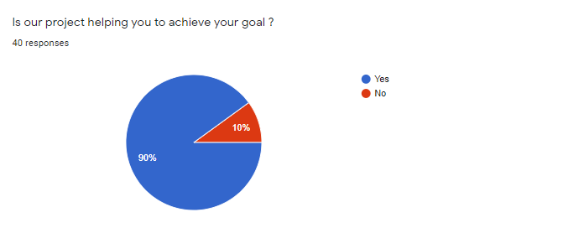

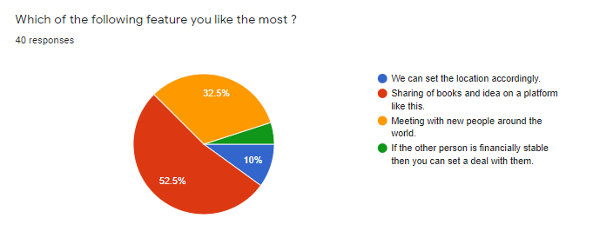

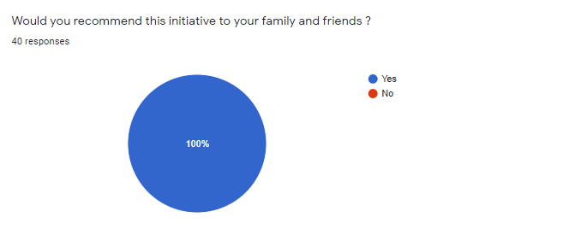

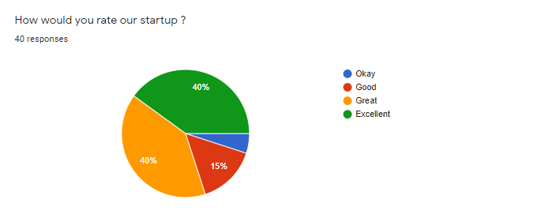

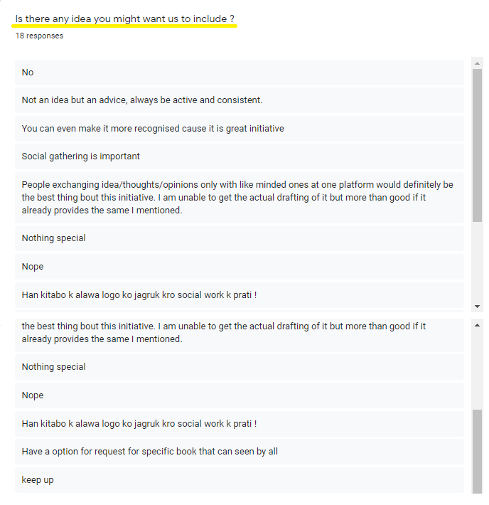

# **ENTITY RELATIONSHIP DIAGRAM**

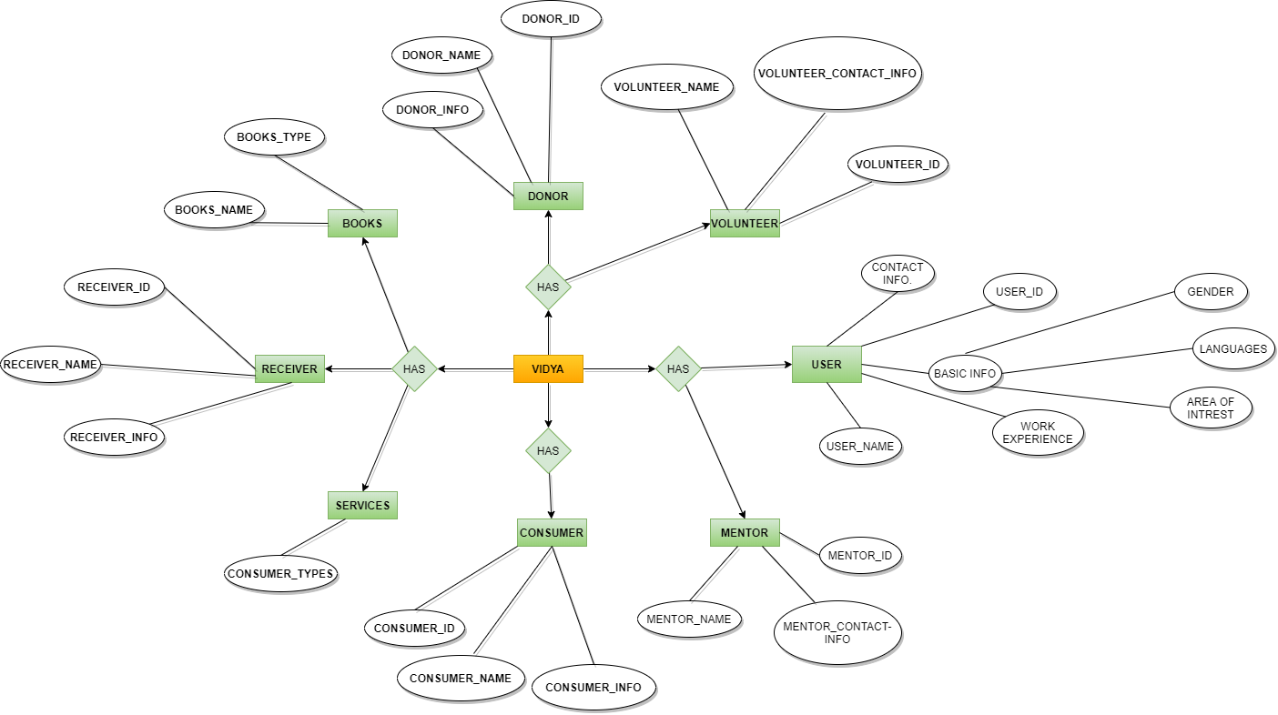

LINK : https://photos.app.goo.gl/CTfUWjGAaL5othrq7

# **DATA FLOW DIAGRAM**

## **DFD LEVEL – 0**

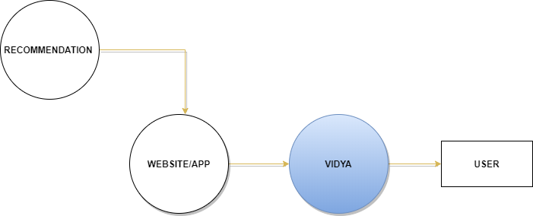

## **DFD LEVEL – 1**

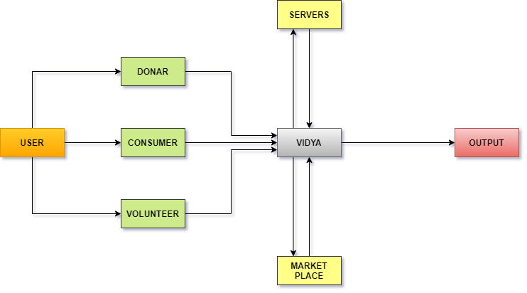

## **DFD LEVEL – 2**

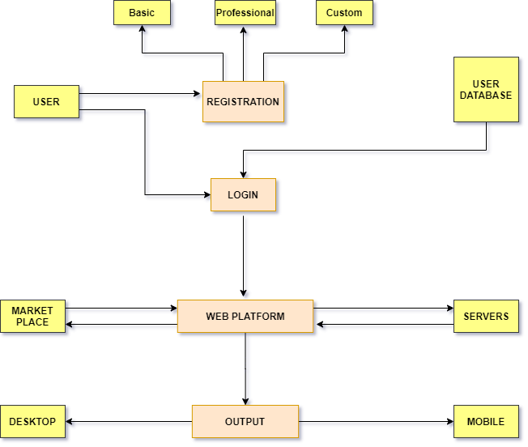

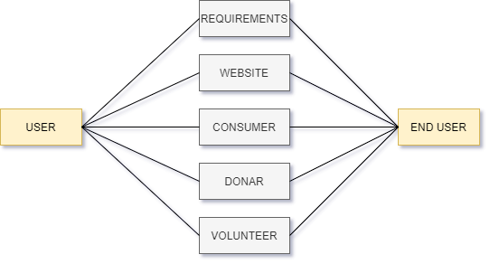

# **PERT CHART**

