Single Cone Classifier Experiment

**Date: April 10, 2025**

**Submitted by:**

*prat (1906)*

# Aim

To study the characteristics of a single cone classifier

# Objectives

1. To determine the separation efficiency for a mixture of coal and sand particles for a different flow rate of water

# Observations

**Density of sand = 1.4 g/cm³  
Density of coal = 0.65 g/cm³**

## Table 1 Observations

|  |  |  |  |  |
| --- | --- | --- | --- | --- |
| **Set No** | **Water flow rate (LPM)** | **Time of collection (min)** | **Coal Size (micron)** | **Weight of coal obtained (g)** |
| 1 | 10 | 10 | 600 | 2 |
| 2 | 15 | 10 | 600 | 3 |
| 3 | 20 | 10 | 600 | 4 |

# Sample Calculations

Efficiency = Weight of coal obtained / Total coal used  
  
For Set 1:  
Efficiency = 2 / 30 = 0.0667

# Results and Discussions

## Table 2 Results

|  |  |  |
| --- | --- | --- |
| **Set No** | **Water flow rate (LPM)** | **Separation Efficiency** |
| 1.0 | 10.0 | 0.06666666666666667 |
| 2.0 | 15.0 | 0.1 |
| 3.0 | 20.0 | 0.13333333333333333 |

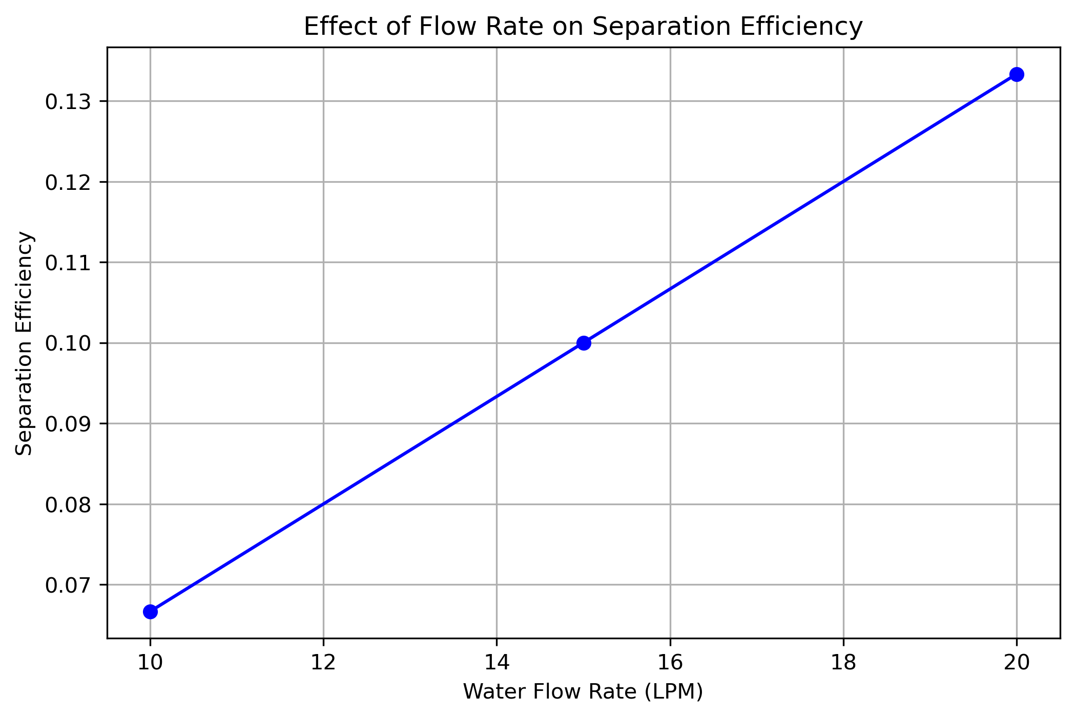

Figure 1

# Discussion

From the graph, it can be seen that with increase in flow rate the separation efficiency increases, which means that at higher flow rates it is easy to separate the two components of the mixture at higher flow rates.

At higher flow rates the settling velocity of sand particles decreases, however, the coal particles are carried by the flow faster thus enabling better separation.

# Conclusion

The separation efficiency is a good measure of the performance of cone classifier. The separation efficiency increases with an increase in the flow rate of water.