# GUI Online Survey: Comparing GUI and Non-GUI Members

193 entries (GUI: 104, non-GUI: 89)

## Internal Consistency

All scales of psychological measures used in the online survey have good Cronbach’s alpha, ranging from .72 to .91 (good internal consistency). Therefore, we will proceed to include all the questions in the respective scales.

vars

scales

Cronbachs

1

Social Cohesion

0.83

2

Sense of Community

0.91

3

Connection to Nature

0.89

4

Self Esteem

0.71

5

Self Efficacy

0.91

## Descriptive statistics

Descriptive Statistics of Major Variables (GUI and Non GUI Members)

vars

scales

n

mean

sd

median

trimmed

mad

min

max

range

skew

kurtosis

se

1

Age

193

37.52

12.10

36.00

36.88

13.34

18.0

72.0

54.00

0.46

−0.44

0.87

2

Social Cohesion

193

5.23

1.14

5.20

5.25

1.48

2.8

7.0

4.20

−0.06

−0.99

0.08

3

Sense of Community

193

4.84

1.10

4.88

4.86

1.30

1.0

7.0

6.00

−0.24

0.04

0.08

4

Connection to Nature

193

5.35

0.96

5.40

5.36

1.04

2.6

7.0

4.40

−0.11

−0.74

0.07

5

Self Esteem

193

4.95

1.06

5.00

4.96

1.11

1.0

7.0

6.00

−0.24

0.13

0.08

6

Self Efficacy

193

5.29

0.92

5.38

5.31

0.74

1.0

7.0

6.00

−0.66

1.79

0.07

Descriptive Statistics of Major Variables (Only GUI Members)

vars

scales

n

mean

sd

median

trimmed

mad

min

max

range

skew

kurtosis

se

1

Age

104

37.86

13.00

35.50

37.13

12.60

18.0

72.0

54.00

0.50

−0.41

1.27

2

Social Cohesion

104

5.92

0.87

6.00

5.98

1.19

4.0

7.0

3.00

−0.42

−0.96

0.09

3

Sense of Community

104

5.19

1.04

5.12

5.21

1.11

2.9

7.0

4.12

−0.07

−0.76

0.10

4

Connection to Nature

104

5.55

0.92

5.60

5.57

0.89

3.5

7.0

3.50

−0.21

−0.87

0.09

5

Self Esteem

104

5.06

1.10

5.00

5.07

1.48

1.0

7.0

6.00

−0.33

0.37

0.11

6

Self Efficacy

104

5.35

0.91

5.38

5.36

0.74

1.0

7.0

6.00

−0.87

3.39

0.09

Descriptive Statistics of Major Variables (Only non-GUI Members)

vars

scales

n

mean

sd

median

trimmed

mad

min

max

range

skew

kurtosis

se

1

Age

89

37.12

11.01

36.00

36.62

14.83

18.0

61.0

43.00

0.31

−0.87

1.17

2

Social Cohesion

89

4.42

0.83

4.40

4.41

0.89

2.8

6.6

3.80

0.20

−0.43

0.09

3

Sense of Community

89

4.43

1.04

4.38

4.47

0.93

1.0

6.1

5.12

−0.51

0.30

0.11

4

Connection to Nature

89

5.13

0.97

5.10

5.12

1.04

2.6

7.0

4.40

0.04

−0.60

0.10

5

Self Esteem

89

4.81

1.01

4.75

4.83

1.11

2.2

7.0

4.75

−0.18

−0.24

0.11

6

Self Efficacy

89

5.22

0.92

5.25

5.25

0.93

2.5

7.0

4.50

−0.41

0.06

0.10

## Normality Check

All the variables below excepts Sense of Community do not follow the normal distribution.

variables

shapiro_test

Age

p <.001

Social Cohesion

p <.001

Sense of Community

0.098*

Connection to Nature

0.003

Self Esteem

0.005

Self Efficacy

p <.001

*Sense of community follows the normal distribution

## Correlation Analysis

* **Sense of Community (SOC)** and **Social Cohesion (SoCoh)** show the **moderate to strong significant correlation**. It’s interesting to note that **Connection to Nature** shows **small to moderate significant correlations** with all the **psychological measurements**. This will be examined further with the only GUI dataset.

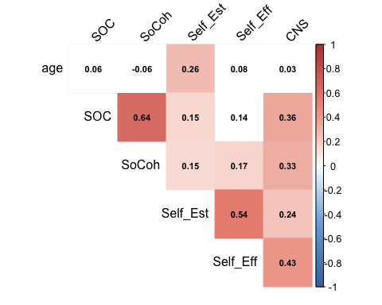

## Significant test (t-test and Wilcoxon Test)

* As preliminary analyses, we assessed whether there were **any differences between GUI and non-GUI group in terms of the respective psychological measures** such as sense of community, nature connection, self-efficacy, and self-esteem.
* We conducted **the Welch Two Sample t-test** on **Sense of Community** and **Wilcoxon Signed-rank test** on the rest of the scales. **Statistically significant differences** were observed in **the Nature Connection** between **GUI members and non-GUI members** (Table 6). Cohen’s d was estimated at **0.2**, which is **a small effect** based on the Cohen’s guidelines (1992).
* Although the effect is small, this study identified that **those who engaged in GUI programs more than three months** in the last two years have **a stronger sense of connection to nature**.
* While **social cohesion** and **a sense of community** were **significantly higher** among the GUI members, responses from non-GUI members to these scales were about **their neighborhood rather than about GUI**. Therefore, this study **cannot confirm** that GUI members have a higher sense of community and social cohesion compared to the ones non-GUI group has.

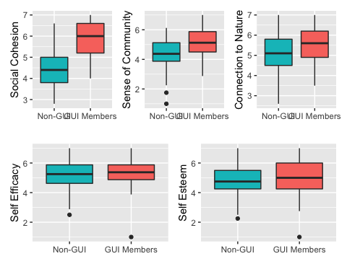

Table 6: Summary of Test Statistics

vars

scales

Cronbachs

shapiro_test

non_GUI_means

GUI_means

test_statistics

effect_size

1

Social Cohesion

0.83

p <.001

4.41

5.92

p < .001**

0.665

2

Sense of Community

0.91

0.098*

4.42

5.19

p < .001**

0.738

3

Connection to Nature

0.89

0.003

5.12

5.54

p < .001**

0.219

4

Self Esteem

0.71

0.005

4.80

5.06

0.12

0.111

5

Self Efficacy

0.91

p <.001

5.22

5.34

0.42

0.057

*t-test for Sense of Community, and Wilcoxon test for the rest of the scales