# GUI Online Survey: Comparing GUI and Non-GUI Members

193 entries (GUI: 104, non-GUI: 89)

## Correlation Analysis

* **Sense of Community (SOC)** and **Social Cohesion (SoCoh)** show the **moderate to strong significant correlation**. It’s interesting to note that **Connection to Nature** shows **small to moderate significant correlations** with all the **psychological measurements**. This will be examined further with the only GUI dataset.

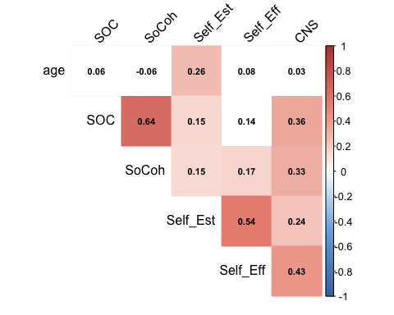

## Significant test (t-test and Wilcoxon Test)

* As preliminary analyses, we assessed whether there were **any differences between GUI and non-GUI group in terms of the respective psychological measures** such as sense of community, nature connection, self-efficacy, and self-esteem.
* We conducted **the Welch Two Sample t-test** on **Sense of Community** and **Wilcoxon Signed-rank test** on the rest of the scales. **Statistically significant differences** were observed in **the Nature Connection** between **GUI members and non-GUI members** (Table 6). Cohen’s d was estimated at **0.2**, which is **a small effect** based on the Cohen’s guidelines (1992).
* Although the effect is small, this study identified that **those who engaged in GUI programs more than three months** in the last two years have **a stronger sense of connection to nature**.
* While **social cohesion** and **a sense of community** were **significantly higher** among the GUI members, responses from non-GUI members to these scales were about **their neighborhood rather than about GUI**. Therefore, this study **cannot confirm** that GUI members have a higher sense of community and social cohesion compared to the ones non-GUI group has.

