# Online Survey: Analysis of Responses from GUI Members

## Internal Consistency

All scales of psychological measures used in the online survey have good Cronbach’s alpha, ranging from .76 to .92 (good internal consistency). Therefore, we will proceed to include all the questions in the respective scales.

vars

scales

Cronbachs_Alpha

1

Social Cohesion

0.76

2

Sense of Community

0.92

3

Connection to Nature

0.89

4

Self Esteem

0.76

5

Self Efficacy

0.91

6

Intrinsic Motivation Inventory

0.78

7

Intrisic Motivation (Enjoyment and Interests)

0.78

8

Perceived Competence

0.45*

9

Perceived Choice

0.41*

* Perceived Competence and Perceived Choice have only two items, respectively

## Descriptive statistics

Descriptive Statistics of Major Variables (only GUI Members)

vars

variables

n

mean

sd

median

trimmed

mad

min

max

range

skew

kurtosis

se

1

Age

104

37.86

13.00

35.50

37.13

12.60

18.0

72.0

54.00

0.50

−0.41

1.27

2

Frequency of Visits (per year)

104

20.39

40.75

5.00

11.54

5.93

1.0

300.0

299.00

4.28

22.77

4.00

3

Total Duration of Commitment (months)

104

25.53

27.97

15.00

20.54

19.27

1.0

136.0

135.00

1.64

2.56

2.74

4

Social Cohesion

104

5.92

0.87

6.00

5.98

1.19

4.0

7.0

3.00

−0.42

−0.96

0.09

5

Sense of Community

104

5.19

1.04

5.12

5.21

1.11

2.9

7.0

4.12

−0.07

−0.76

0.10

6

Connection to Nature

104

5.55

0.92

5.60

5.57

0.89

3.5

7.0

3.50

−0.21

−0.87

0.09

7

Intrinsic Motivation Inventory

104

5.71

0.73

5.75

5.73

0.74

3.9

7.0

3.12

−0.29

−0.45

0.07

8

Intrisic Motivation (Enjoyment and Interests)

104

5.94

0.84

6.00

6.00

1.11

4.0

7.0

3.00

−0.48

−0.71

0.08

9

Perceived Competence

104

5.33

0.98

5.00

5.32

0.74

2.5

7.0

4.50

−0.04

−0.31

0.10

10

Perceived Choice

104

5.63

0.98

5.50

5.69

1.11

3.0

7.0

4.00

−0.43

−0.54

0.10

11

Self Esteem

104

5.06

1.10

5.00

5.07

1.48

1.0

7.0

6.00

−0.33

0.37

0.11

12

Self Efficacy

104

5.35

0.91

5.38

5.36

0.74

1.0

7.0

6.00

−0.87

3.39

0.09

Descriptive Statistics of Major Variables (Only Female Members)

vars

variables

n

mean

sd

median

trimmed

mad

min

max

range

skew

kurtosis

se

1

Age

75

36.75

12.59

36.00

36.44

14.83

18.0

72.0

54.00

0.24

−0.78

1.45

2

Frequency of Visits (per year)

75

17.80

39.34

4.00

9.93

4.45

1.0

300.0

299.00

5.20

32.89

4.54

3

Total Duration of Commitment (months)

75

26.64

27.58

16.00

22.26

20.76

1.0

111.0

110.00

1.33

1.16

3.18

4

Social Cohesion

75

5.96

0.89

6.20

6.02

1.19

4.0

7.0

3.00

−0.41

−1.10

0.10

5

Sense of Community

75

5.20

1.12

5.25

5.22

1.11

2.9

7.0

4.12

−0.08

−0.91

0.13

6

Connection to Nature

75

5.64

0.88

5.70

5.67

1.04

3.5

7.0

3.50

−0.17

−0.85

0.10

7

Intrinsic Motivation Inventory

75

5.75

0.74

5.88

5.77

0.74

3.9

7.0

3.12

−0.33

−0.52

0.09

8

Intrisic Motivation (Enjoyment and Interests)

75

6.01

0.82

6.00

6.08

1.11

4.0

7.0

3.00

−0.53

−0.68

0.10

9

Perceived Competence

75

5.34

1.05

5.00

5.35

0.74

2.5

7.0

4.50

−0.04

−0.41

0.12

10

Perceived Choice

75

5.64

0.98

5.50

5.71

1.48

3.0

7.0

4.00

−0.54

−0.37

0.11

11

Self Esteem

75

5.12

1.14

5.25

5.16

1.11

1.0

7.0

6.00

−0.59

0.68

0.13

12

Self Efficacy

75

5.44

0.91

5.50

5.48

0.74

1.0

7.0

6.00

−1.38

5.88

0.10

Descriptive Statistics of Major Variables (Only Male Members)

vars

variables

n

mean

sd

median

trimmed

mad

min

max

range

skew

kurtosis

se

1

Age

28

41.21

13.81

35.50

40.12

8.15

27.0

70.0

43.00

0.89

−0.72

2.61

2

Frequency of Visits (per year)

28

27.54

44.94

9.00

18.71

11.86

1.0

200.0

199.00

2.41

5.68

8.49

3

Total Duration of Commitment (months)

28

23.00

29.73

10.00

17.63

11.86

1.0

136.0

135.00

2.20

5.20

5.62

4

Social Cohesion

28

5.84

0.85

6.00

5.88

0.74

4.0

7.0

3.00

−0.52

−0.76

0.16

5

Sense of Community

28

5.21

0.82

5.12

5.21

0.93

3.6

6.8

3.12

−0.03

−1.04

0.15

6

Connection to Nature

28

5.35

0.94

5.20

5.37

1.33

3.5

6.8

3.30

−0.24

−1.18

0.18

7

Intrinsic Motivation Inventory

28

5.57

0.72

5.50

5.58

0.56

4.0

7.0

3.00

−0.14

−0.38

0.14

8

Intrisic Motivation (Enjoyment and Interests)

28

5.71

0.87

5.88

5.74

0.93

4.0

7.0

3.00

−0.27

−0.95

0.16

9

Perceived Competence

28

5.30

0.82

5.50

5.29

0.74

4.0

7.0

3.00

−0.16

−0.86

0.16

10

Perceived Choice

28

5.55

0.96

5.50

5.56

0.74

4.0

7.0

3.00

−0.09

−1.07

0.18

11

Self Esteem

28

4.84

0.93

4.50

4.78

0.74

3.2

7.0

3.75

0.60

−0.47

0.18

12

Self Efficacy

28

5.05

0.86

5.00

5.00

1.30

3.9

6.8

2.88

0.37

−1.04

0.16

## Profile of GUI Members in the sample

### Frequency of Visits (per year)

The maximum number of the frequency visits is **300**- there is one member who visits GUI almost everyday. The mean and median values for the frequency of visits are 20.4 and 5, respectively. From the below chart, it’s observed that the frequency of visits is skewed to the left (small numbers of visits)-**30% of respondents** in this study visit GUI on average **once a year**, and **66% of respondents** visit GUI **less than 12 times a year** (on average less than once a month).

Data summary

|  |  |
| --- | --- |
| Name | Piped data |
| Number of rows | 104 |
| Number of columns | 1 |
| _______________________ |  |
| Column type frequency: |  |
| numeric | 1 |
| ________________________ |  |
| Group variables | None |

**Variable type: numeric**

|  |  |  |  |  |  |  |  |  |  |  |
| --- | --- | --- | --- | --- | --- | --- | --- | --- | --- | --- |
| skim_variable | n_missing | complete_rate | mean | sd | p0 | p25 | p50 | p75 | p100 | hist |
| frequency_coded | 0 | 1 | 20.39 | 40.75 | 1 | 1 | 5 | 20 | 300 | ▇▁▁▁▁ |

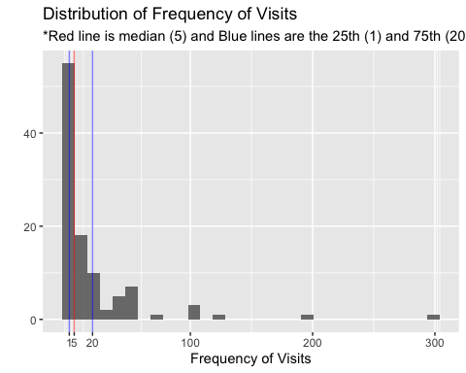

### Total Duration of Commitment (month)

The maximum number of durations of commitment is **136**- there is one respondent who has been visiting GUI **more than 11 years**. The mean and median values for the commitment are 25.5 and 15, respectively. From the below chart, it’s observed that the commitment is also skewed towards the shorter durations of commitment-44% of respondents in this study engaged with GUI less than or equal to 1 year(12 months), and 76% of respondents engaged with GUI less than or equal to 3 years (36 months).

Data summary

|  |  |
| --- | --- |
| Name | Piped data |
| Number of rows | 104 |
| Number of columns | 1 |
| _______________________ |  |
| Column type frequency: |  |
| Date | 1 |
| ________________________ |  |
| Group variables | None |

**Variable type: Date**

Data summary

|  |  |  |  |  |  |  |
| --- | --- | --- | --- | --- | --- | --- |
| skim_variable | n_missing | complete_rate | min | max | median | n_unique |
| month_year | 2 | 0.98 | 2008-08-01 | 2020-03-01 | 2018-09-01 | 50 |

|  |  |
| --- | --- |
| Name | Piped data |
| Number of rows | 104 |
| Number of columns | 1 |
| _______________________ |  |
| Column type frequency: |  |
| numeric | 1 |
| ________________________ |  |
| Group variables | None |

**Variable type: numeric**

|  |  |  |  |  |  |  |  |  |  |  |
| --- | --- | --- | --- | --- | --- | --- | --- | --- | --- | --- |
| skim_variable | n_missing | complete_rate | mean | sd | p0 | p25 | p50 | p75 | p100 | hist |
| commitment_coded | 0 | 1 | 25.53 | 27.97 | 1 | 5 | 15 | 36 | 136 | ▇▃▁▁▁ |

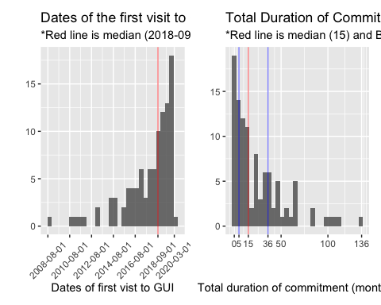

### Frequency and Commitment

The below chart suggests that many of the respondents in this study (36%) are **newer members of GUI (less than or equal to 15 months)** who visit GUI **less than or equal to 5 times per year**. Also, the below chart and the result of the correlation test between the two variables indicate that the correlation between **frequency and commitment is weak** (r=0.235, Pearson): it seems that the longer commitment with GUI does not necessarily lead to a higher frequency of visits.

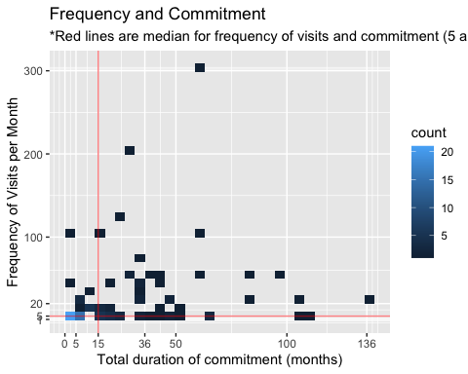

### Genger, Race, and Age

#### Gender and Race

From the below tables, it’s observed that the majority of respondents in this study are female and Chinese. It would be good to check this distribution against the GUI membership directory (if it exists).

gender

count

Female

75

Male

28

Others

1

race

race_type

count

0

NA

1

1

Chinese

92

2

Malay

2

3

Indian

6

4

others

3

#### Age

The age of respondents seems to be well-distributed-it’s slightly skewed to the left (towards the younger age) but there are still 20% of the respondents who are between the age of 50 and 72.

Data summary

|  |  |
| --- | --- |
| Name | Piped data |
| Number of rows | 104 |
| Number of columns | 1 |
| _______________________ |  |
| Column type frequency: |  |
| numeric | 1 |
| ________________________ |  |
| Group variables | None |

**Variable type: numeric**

|  |  |  |  |  |  |  |  |  |  |  |
| --- | --- | --- | --- | --- | --- | --- | --- | --- | --- | --- |
| skim_variable | n_missing | complete_rate | mean | sd | p0 | p25 | p50 | p75 | p100 | hist |
| age | 0 | 1 | 37.86 | 13 | 18 | 28 | 35.5 | 46.25 | 72 | ▆▇▅▃▁ |

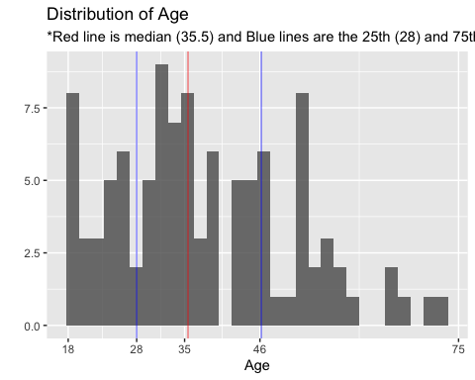

### Types of Programs Engaged

The most popular program attended by the respondents is Balik Kampung followed by Harvesting, Wood Workshop, Corporate programs, and Sketching. Among those who selected others, common programs include Farmer’s Market 2019, Pesta Kampung, and Pizza making.

programs

count

Balik

48

Corporate

14

Sketch

4

Wood

31

Harvesting

32

Others

55

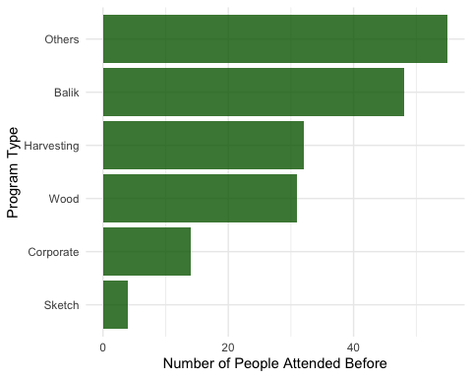

The below chart indicates that **most of the respondents (53%) attended only one of the GUI’s programs**. Those who attended any 2 of GUI’s programs are 28%. The below correlation test and scatterplot show that those who engage with GUI in the longer duration attend more number of program types ( **r=0.464**, Pearson). This means that **the longer the member commits on GUI, the more number of types of programs they attend**.

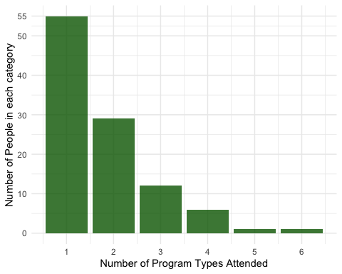

## corrplot 0.84 loaded

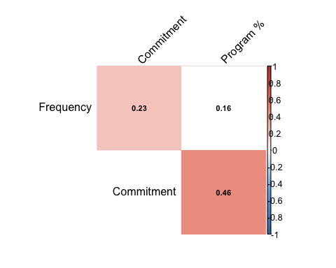

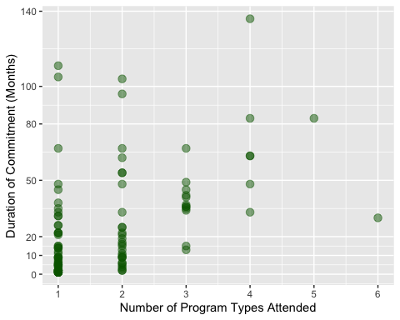

### Reasons to visit GUI

The most common word used to explain reasons to visit GUI is **“Nature”** followed by **support, community, volunteer, people, activities, and farming**. Most of the words listed in the below charts are also mentioned frequently during the focus group discussions.

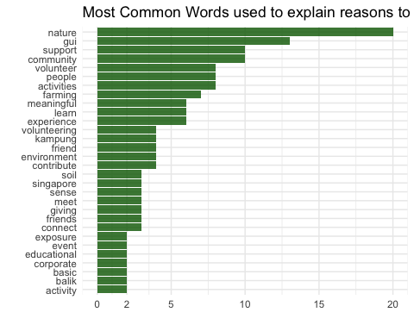

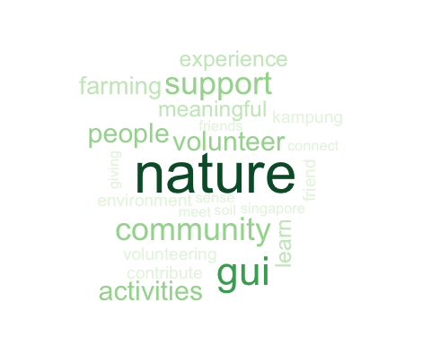

## Normality Check

All the variables below excepts Sense of Community and Intrinsic Motivation do not follow the normal distribution.

variables

shapiro_test

Age

p <.001

Frequency of Visits (per year)

p <.001

Total Duration of Commitment (months)

p <.001

Social Cohesion

p <.001

Sense of Community

0.096*

Connection to Nature

p <.001

Self Esteem

p <.001

Self Efficacy

p <.001

Intrinsic Motivation Inventory

0.118*

Intrisic Motivation (Enjoyment and Interests)

p <.001

Perceived Competence

p <.001

Perceived Choice

p <.001

*Sense of community and Intrinsic Motivation follows the normal distribution

## Gender-wise Analysis

* As the difference in the sample size is large (75 female and 28 male), the median test was conducted to see if there are any significant differences between female and male members in the respective variables.
* Although the difference in the frequency of visits is large (male members visit GUI more than twice as often as female members do), no significant difference was observed.
* **Self-efficacy** is the only variable that shows a significant difference: **female members have a higher sense of self-efficacy**.

Test Statistics: Male vs Female

vars

scales

male_median

female_median

Median_test_p_value

1

Age

35.50

36.00

0.64

2

Frequency

9.00

4.00

0.079

3

Commitment

10.00

16.00

0.30

4

Social Cohesion

6.00

6.20

0.40

5

Sense of Community

5.12

5.25

0.40

6

Connection to Nature

5.20

5.70

0.82

7

Intrinsic Motivation Inventory

5.50

5.88

0.25

8

Intrisic Motivation (Enjoyment and Interests)

5.88

6.00

0.21

9

Perceived Competence

5.50

5.00

0.61

10

Perceived Choice

5.50

5.50

0.72

11

Self Esteem

4.50

5.25

0.09

12

Self Efficacy

5.00

5.50

0.041*

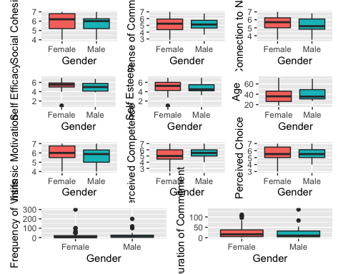

## PCA and Cluster Analysis

* We applied Principal Component Analysis and Cluster Analysis to divide GUI members into several groups based on variables that describe their relationships with GUI, including duration of commitment, frequency of visits, and number of program types attended. Hopefully, this will illustrate profiles of GUI members better.

### Determining the number of plots

Based on the below, elbow plot, we decided to include the first 2 components that explain **82%** of the variance in the three variables.

## # A tibble: 3 x 4  
## PC std.dev percent cumulative  
## <dbl> <dbl> <dbl> <dbl>  
## 1 1 1.26 0.532 0.532  
## 2 2 0.936 0.292 0.824  
## 3 3 0.727 0.176 1

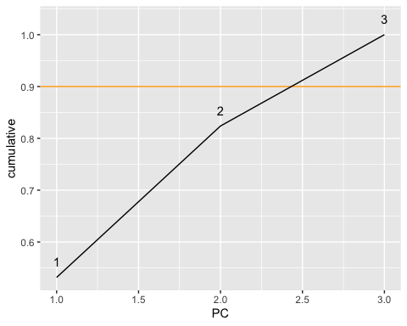

* Component 1 (RC1) has large positive directions in number_programs and commitment_coded.
* Whereas, component 2 (RC2) has more positive direction in frequency_coded and some positive directions in commitment_coded.

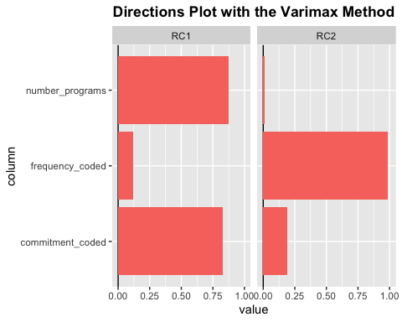

### Determining K

A Hierarchical Cluster Analysis was applied to determine the appropriate number of clusters. Based on the below plots, we decided to take k=4.

hierarchical_clusters <- hclust(dist(cluster_data))  
fviz_dend(hierarchical_clusters, k = 4, cex = 0.4) # K= the number of clusters in the dendogram

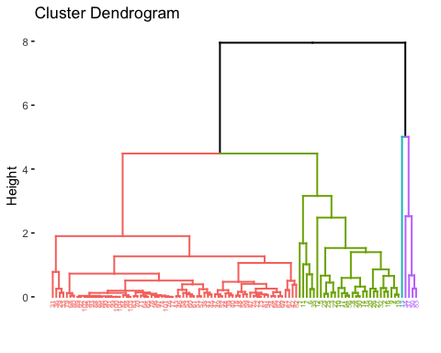

# hierarchical_clusters_k4 <- cutree(hierarchical_clusters, k = 4)  
# fviz_cluster(list(data = cluster_data, cluster = hierarchical_clusters_k4))

### K-mean clustering

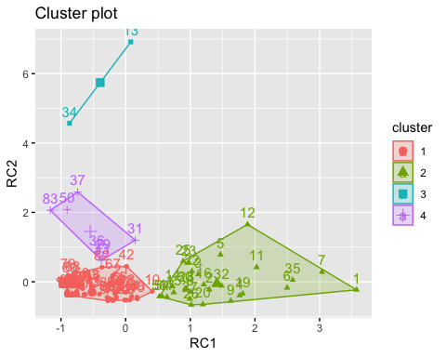

### Preliminary Analysis on the clusters

* To test the validity of the groups identified, a profile analysis was conducted, including running descriptives on each cluster and **ANOVA tests** on clusters for each variable.
* ANOVA test confirmed that these 4 groups are **significantly different** ( *p* <0.001) in terms of the relationships with GUI (commitment_coded, frequency_coded, and number_programs).
* Age is also significantly different among clusters ( *p* <0.05).
* Although the ANOVA test did not show any significant differences in the rest of the variables, the table A and the boxplots seem to show some variances among clusters. For example, **Sense of Community** is very low in the cluster 1.

Table A: Median Values by Groups

clusters.

male

female

members_n

age

frequency_coded

commitment_coded

number_programs

SoCoh

SOC

IMI

IM

PComp

PChoice

CNS

Self_Est

Self_Eff

1

17

49

67

36.0

2

8.0

1.0

6.0

4.88

5.75

6.00

5.00

5.50

5.7

5.00

5.50

2

7

21

28

31.0

20

48.5

3.0

6.2

5.69

5.88

6.12

5.25

5.75

5.5

5.25

5.38

3

1

1

2

51.5

250

46.5

1.5

5.5

5.44

5.38

5.38

5.75

5.00

5.6

4.38

5.44

4

3

4

7

55.0

70

31.0

1.0

6.0

5.25

5.50

6.25

5.00

5.50

5.4

4.50

5.00

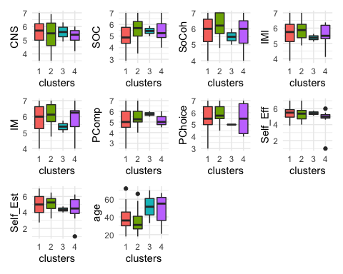

### Interpreting the clusters

* Based on the below directional plot and the Table A, X1 or group 1 can be categorized as **fresh members** of GUI (n=67): those who **recently started coming** to GUI (on average within 8 months), their **frequency of visits is low** (only twice a year), and they haven’t attended many programs yet. Perhaps, these members are still exploring how to engage with GUI.
* X2 or group 2 is the most senior (or experienced) members of GUI ( **long-term members**, n=28): those who committed with GUI for **the longest period** (on average 4 years) and have attended **many different programs (on average 3)**.
* X3 or group 3 can be refered as **everyday visitors** (n=2): their engagement with GUI is relatively long (about 4 years) and they visit GUI almost everyday (more than 20 times a month).
* X4 or group 4 can be interpreted as **committed frequent visitors** (n=7): they are relatively long-term members of GUI (on average 2 and half years) and their frequency of visit is high (on average 70 times a year). They seem keep coming to the same program.
* **Group 3 and Group 4** have much older members and higher frequency of visits, compared to **Group 1 and Group 2**. Therefore, the older members of GUI tend to visit there more frequently.
* The **Connection to Nature** is **highest** in the Group 1, suggesting that GUI tends to attract new members who have a high sense of Nature Connection.

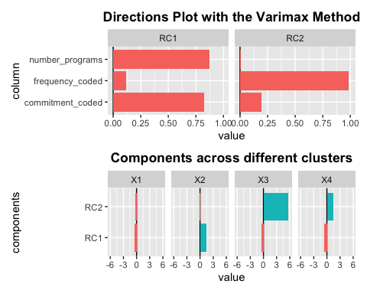

## Median Test: Fresh Members VS Long-term Members

* Although the ANOVA test did not find any sigfnificant differences in the psychometric scales across the groups, the difference in the median of **Sense of Community** between the **fresh_members** and **long term members** is hgih. Hence, we ran the Median Test.
* A **significant** difference ( *p* =0.014) was found in **Sense of Community**: hence, the long-term engagement with GUI seems to enhance a **Sense of Community** of GUI members.
* **Committed frequent visitors** and **Everyday visitors** did not show a significant difference in **Sense of Community** when it’s compared with **fresh_members**. Perhaps, this is due to the small number of group size (7 and 2, respectively).

Median.test(old_new$SOC, old_new$clusters) # Sense of Community is significant. P=0.014  
Median.test(old_new$CNS, old_new$clusters) # CNS is not significant. p=0.374  
Median.test(old_new$IMI, old_new$clusters) # IMI is not significant. p=0.491  
Median.test(old_new$SoCoh, old_new$clusters) # Social Cohesion is not significant. p=0.333  
Median.test(old_new$Self_Est, old_new$clusters) # Self-est is not significant. p=0.433  
Median.test(old_new$Self_Eff, old_new$clusters) # Self-eff is not significant. p=0.494  
Median.test(old_new$IM, old_new$clusters) # IM is not significant. p=0.64  
Median.test(old_new$PComp, old_new$clusters) # PComp is not significant. p=0.947  
Median.test(old_new$PChoice, old_new$clusters) # PChoice is not significant. p=0.739

## Correlation Analysis

* **Correlation Test (Spearman's Rank Test)** shows correlation r by the figures and highlights: towards **shades of blue** mean **negative** and **shades of red** mean **positive correlations**. Those squares with no highlights (white) are non-significant correlations (p> 0.05).
* It’s observed that **Sense of Community (SOC), Social Cohesion (SoCoh), and Intrinsic Motivation Inventry (IMI)** show **significant correlations (moderate to strong)** among them.
* The subset of **Intrinsic Motivation Inventry (IMI)**, including **Intrinsic Motivation (enjoyment/ intetests: IM)**, **Perceived Competence (PComp)** and **Perceived Chocie (PChoice)** also **show significant correlations** with SOC and SoCoh (however, the correlations are weaker compared to the ones with IMI)
* Frequency (frequency_coded) and commitment (commitment_coded) also show moderate to strong correlations (Spearman). However, as discussed earlier, **the correlation test with Pearson** only **showed a weak correlation (r=0.23, Pearson)**.
* **1) those who visit GUI frequently** and **2) those who commit GUI in the long duration** seem to have **a higher sense of community** and **a higher Intrinsic Motivation (IMI)**. Earlier studies from Community Psychology support these findings: **sense of community and intrinsic motivation can be built through frequent interactions over the long term** (Christens & Peterson, 2010; Bidee, 2013; Oostlander et al., 2013).
* It is interesting to note that Perceived Competence (PComp) shows a significant correlation with Frequency, whereas Perceived Choice (PChoice) is significantly correlated with Commitment
* There is **a strong correlation** between **Nature Connection (CNS)** and **Intrinsic Motivation (IMI)** (r=0.465)__, implying that **those who are self-motivated also have a high sense of nature connection.**
* The number of **program types attended** (# of Programs) shows **significant positive correlations** with **Frequency, Commitment, Sense of Community (SOC), Social Cohesion (SoCoh), and Intrinsic Motivation (IMI)**. Hence, **more committed members** with **a higher sense of community** engage in **a variety of programs**. It is also interesting to note that # of Programs shows a significant negative correlation with age: **older GUI members** attend **less variety of GUI programs**.
* This correlation test did not show significant correlations between **1) frequency and commitment, and 2) Social Cohesion (SoCoh)** and **Nature connection (CNS)**. This suggests that **Social Cohesion** and **Nature Connection** can be built among GUI members regardless of their duration of commitment and frequency of visits. As the focus group discussion with GUI volunteers noted, perhaps **GUI members** can gain a sense of Social Cohesion **immediately** through their engagement at GUI. Regarding the Nature Connection, it seems that **those who visit GUI already have a higher sense of nature connection**. Therefore, it doesn’t seem to change so much over time.

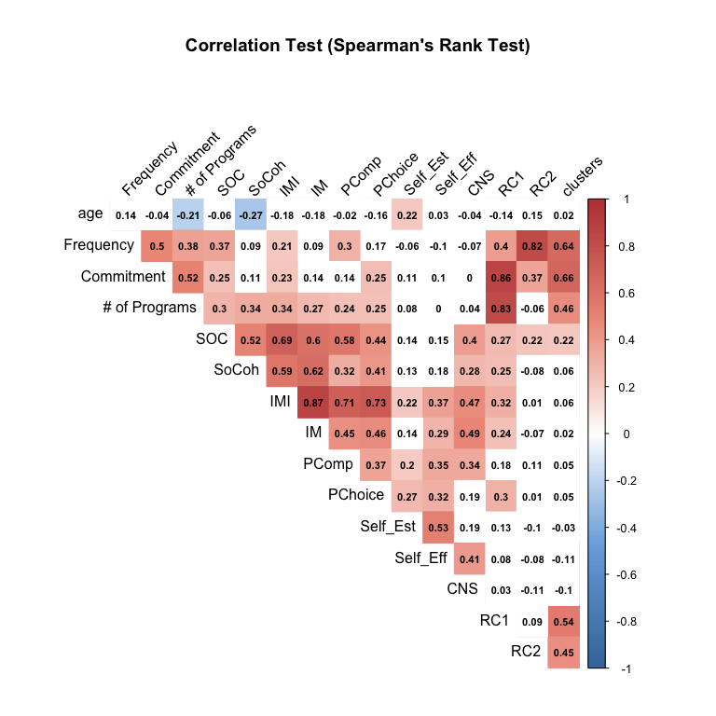

## Regression Analysis

### Frequency, Commitment, and Number of Programs as Inputs

* As significant correlations were found among frequency, commitment, number of programs attended, Sense of Community, and Intrinsic Motivation, this study conducted a regression analysis on these variables.
* Among the several models, the models with SOC, IMI, and Self_Est are the significant models: Higher values in Frequency and # of Programs will lead to higher SOC. Similary, **higher values in # of Programs** will lead to higher **Intrinsic Motivation (IMI)** and **Enjoyments/ interests (IM)**.
* However, these models have **relatively low R-squared (0.10 to 0.164)**: these models **explain 10 to 16% of the outcome variables**. Further investigation is required to examine which are the factors, missed out from this study, may have potential effects on the outcomes.

model_gui_2 <- lm(CNS ~ Commitment, data = model_data)  
summary(model_gui_2) #Not significant

model_gui_3 <- lm(IMI ~ `# of Programs`, data = model_data)  
summary(model_gui_3) # R-squared =0.10. Number of programs is Significant

model_gui_4 <- lm(Self_Est ~ age + Frequency + `# of Programs`, data = model_data)  
summary(model_gui_4) # R-squared =0.11. Age and Frequency are Significant

model_gui_5 <- lm(Self_Eff ~ age + Frequency + `# of Programs`, data = model_data)  
summary(model_gui_5) # Not significant

model_gui_6 <- lm(formula = IM ~ age + Commitment + `# of Programs` + clusters,  
 data = model_data)  
summary(model_gui_6) # R-squared is 0.164. Number of programs and cluster 2 are significant

model_gui_7 <- lm(formula = PComp ~ `# of Programs`,  
 data = model_data)  
summary(model_gui_7) # R-squared is 0.065. Number of programs is significant

model_gui_8 <- lm(formula = PChoice ~ `# of Programs`,  
 data = model_data)  
summary(model_gui_8) # R-squared is 0.039. Number of programs is significant

|  |  |  |  |
| --- | --- | --- | --- |
| Outcome Variables | R-squared | Positive Coefficients | Negative Coefficients |
| Sense of Community | 0.148 | # of Programs, Frequency | NA |
| Nature Connection | Not significant | NA | NA |
| Intrinsic Motivation Inventory | 0.10 | # of Programs | NA |
| Intrinsic Motivation (Enjoyment/ Interests) | 0.164 | # of Programs | Cluster 2 (compared to cluster 1) |
| Perceived Competence | 0.065 | # of Programs | NA |
| Perceived Choice | 0.039 | # of Programs | NA |
| Self Esteem | 0.11 | age | Frequency |
| Self Efficacy | Not significant | NA | NA |

### Other Psychometric Scales as Inputs

* model_gui_9 shows the highest R-squared among all the models. The model **explains 53%** of variance in the Intrinsic Motivation (Enjoyment/ Interests): **Higher SoCoh and SOC** will lead to **higer levels of enjoyment/ interests** among the GUI members.
* model_gui_10 explains **46% of the variance** in the **Self Efficacy (Sef_Eff)**: **higher Perceived Competence (PComp)** and **lower Sense of Community** will lead to higher sense of Self Efficacy.

model_gui_9 <- lm(IM ~ SoCoh + SOC + Self_Eff + PChoice, data = model_data)  
summary(model_gui_9)  
# Significant model. R-squared is 0.528. SOC and SoCoh are significant

model_gui_10 <- lm(Self_Eff ~ SOC + PComp + PChoice, data = model_data)  
summary(model_gui_10)  
# R-squared = 0.459. SOC, Self_Est, and PComp are significant. But SOC is negative

## Comparing The Long-term Members and The General Public

* Results of ANOVA test shows significant differences only in the **Nature Connection (CNS)** (P =0.035)
* Post hoc test shows that the **significance difference** was observed between **cluster 1 (fresh members)** and **cluster 5 (non GUI members)**.
* To see the differences between the **non GUI members** and **Long-term members**, median test was conducted: no significance differences were observed in the CNS, Self_Est, and Self_Eff. It implies that **non GUI members** are **not significantly different** from **Long-term GUI Members** in terms of their sense of nature connection, self-esteem, and self-efficacy.

Median Test Results: Non GUI and Long-term GUI Members

Variables

Median of Non GUI

Median of Long-term GUI

p Value

Nature Connection

5.10

5.50

0.14

Self Esteem

4.75

5.25

0.22

Self Efficacy

5.25

5.36

0.76