# Online Survey: Analysis of Responses from GUI Members

## GUI members: 104 entries

## 1. Profile of GUI Members in the sample

### Frequency of Visits (per year)

The maximum number of the frequency of visits is **300 (times per year)**— there is one member who visits GUI almost everyday. The mean and median values for the frequency of visits are 20.4 and 5, respectively. From the below chart, it’s observed that the frequency of visits is skewed to the left (small numbers of visits)—**30% of respondents** in this study visit GUI on average **once a year**, and **66% of respondents** visit GUI **less than 12 times a year** (on average less than once a month).

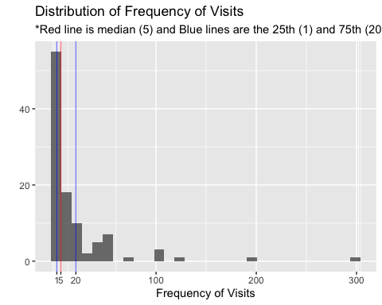

### Total Duration of Commitment (month)

The maximum number of durations of commitment is **136**- there is one respondent who has been visiting GUI **more than 11 years**. The mean and median values for the commitment are 25.5 and 15, respectively. From the below chart, it’s observed that the commitment is also skewed towards the shorter durations of commitment-44% of respondents in this study engaged with GUI less than or equal to 1 year(12 months), and 76% of respondents engaged with GUI less than or equal to 3 years (36 months).

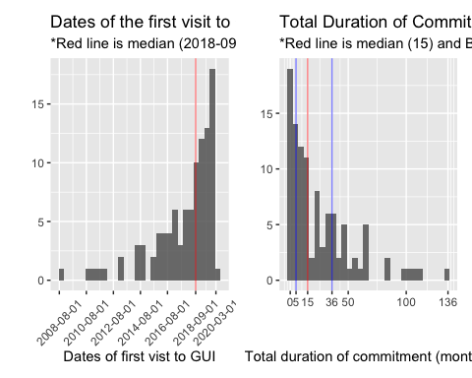

### Frequency and Commitment

The below chart suggests that many of the respondents in this study (36%) are **newer members of GUI (less than or equal to 15 months)** who visit GUI **less than or equal to 5 times per year**. Also, the below chart and the result of the correlation test between the two variables indicate that the correlation between **frequency and commitment is weak** (r=0.235, Pearson): it seems that the longer commitment with GUI does not necessarily lead to a higher frequency of visits.

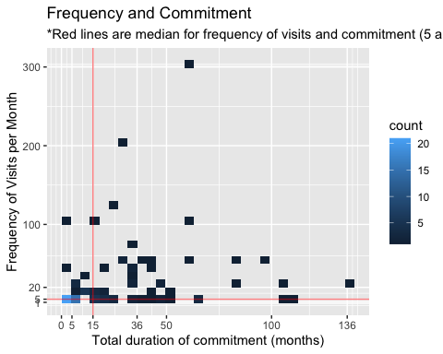

### Gender, Race, and Age

#### Gender and Race

From the below tables, it’s observed that the majority of respondents in this study are female and Chinese.

#### Age

The age of respondents seems to be well-distributed-it’s slightly skewed to the left (towards the younger age) but there are still 20% of the respondents who are between the age of 50 and 72.

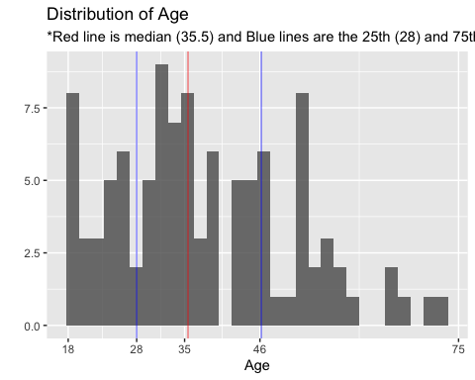

### Types of Programs Engaged

The most popular program attended by the respondents is Balik Kampung followed by Harvesting, Wood Workshop, Corporate programs, and Sketching. Among those who selected others, common programs include Farmer’s Market 2019, Pest Kampung, and Pizza making.

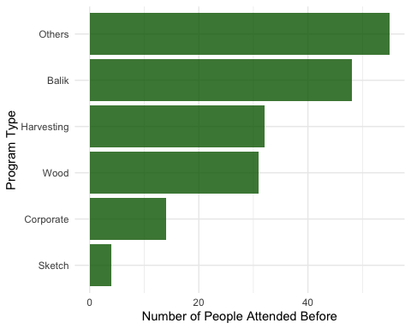

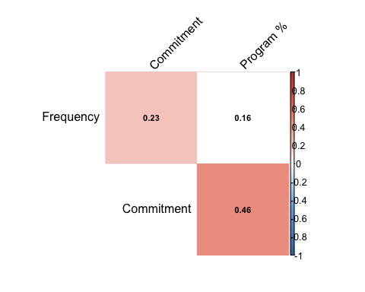The below chart indicates that **most of the respondents (53%) attended only one of the GUI’s programs**. Those who attended any 2 of GUI’s programs are 28%. The below correlation test and scatterplot show that those who engage with GUI in the longer duration attend more number of program types ( **r=0.464**, Pearson). This means that **the longer the member commits on GUI, the more number of types of programs they attend**.

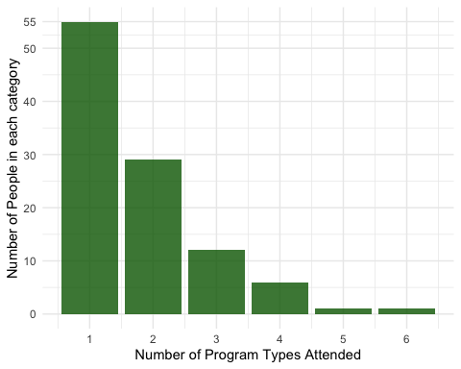

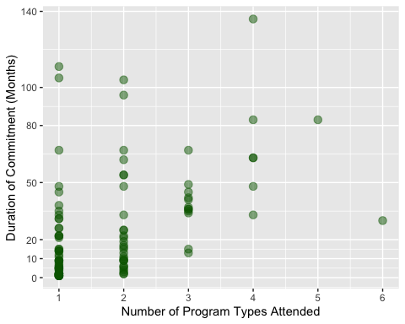

### Reasons to visit GUI

The most common word used to explain reasons to visit GUI is **“Nature”** followed by **support, community, volunteer, people, activities, and farming**. Most of the words listed in the below charts are also mentioned frequently during the focus group discussions.

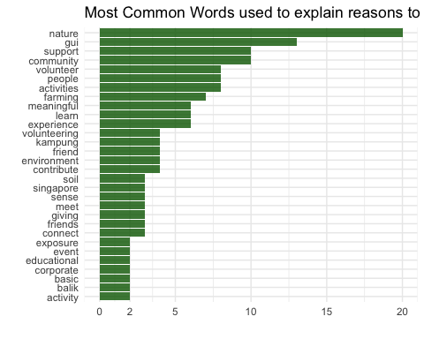

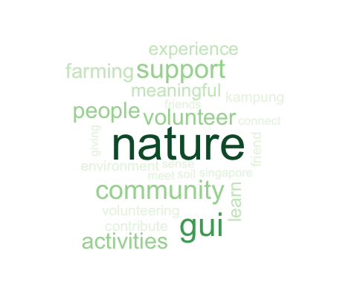

## 2. Gender-wise Analysis

* As the difference in the sample size is large (75 female and 28 male), the median test was conducted to see if there are any significant differences between female and male members in the respective variables.
* Although the difference in the frequency of visits is large (male members visit GUI more than twice as often as female members do), no significant difference was observed.
* A screenshot of a cell phone

  Description automatically generated**Self-efficacy** is the only variable that shows a significant difference: **female members have a higher sense of self-efficacy**.

## 

## 3. Cluster Analysis

* We applied Principal Component Analysis and Cluster Analysis to divide GUI members into several groups based on variables that describe their relationships with GUI, including duration of commitment, frequency of visits, and number of program types attended.

### Interpreting the clusters

* Based on the below plot and the Table A, Group 1 can be categorized as **fresh members** of GUI (n=67): those who **recently started coming** to GUI (on average within 8 months), their **frequency of visits is low** (only twice a year), and they haven’t attended many programs yet. Perhaps, these members are still exploring how to engage with GUI.
* Group 2 is the most senior (or experienced) members of GUI (**long-term members**, n=28): those who committed with GUI for **the longest period** (on average 4 years) and have attended **many different programs (on average 3)**.
* Group 3 can be refered as **everyday visitors** (n=2): their engagement with GUI is relatively long (about 4 years) and they visit GUI almost everyday (more than 20 times a month).
* Group 4 can be interpreted as **committed frequent visitors** (n=7): they are relatively long-term members of GUI (on average 2 and half years) and their frequency of visit is high (on average 70 times a year). They seem keep coming to the same program.
* **Group 3 and Group 4** have much older members and higher frequency of visits, compared to **Group 1 and Group 2**. Therefore, the older members of GUI tend to visit there more frequently.
* A screenshot of a cell phone

  Description automatically generatedA screenshot of a cell phone

  Description automatically generatedThe **Connection to Nature** is **highest** in the Group 1, suggesting that GUI tends to attract new members who have a high sense of Nature Connection.

## A screenshot of a cell phone Description automatically generatedMedian Test: Fresh Members VS Long-term Members

* Although the ANOVA test did not find any sigfnificant differences in the psychometric scales across the groups, the difference in the median of **Sense of Community** between the **fresh_members** and **long term members** is hgih. Hence, we ran the Median Test.
* A **significant** difference (*p* =0.014) was found in **Sense of Community**: hence, the long-term engagement with GUI seems to enhance a **Sense of Community** of GUI members.
* **Committed frequent visitors** and **Everyday visitors** did not show a significant difference in **Sense of Community** when it’s compared with **fresh_members**. Perhaps, this is due to the small number of group size (7 and 2, respectively).

## Comparing The Long-term Members and The General Public

* Results of ANOVA test shows significant differences only in the **Nature Connection (CNS)** (P =0.035)
* Post hoc test shows that the **significance difference** was observed between **cluster 1 (fresh members)** and **cluster 5 (non GUI members)**.
* A screenshot of a cell phone

  Description automatically generatedTo see the differences between the **non GUI members** and **Long-term members**, median test was conducted: no significance differences were observed in the CNS, Self_Est, and Self_Eff. It implies that **non GUI members** are **not significantly different** from **Long-term GUI Members** in terms of their sense of nature connection, self-esteem, and self-efficacy

### 5. Short-Term Effects of attending GUI Program

* We conducted the **Welch Two Sample t-test** on PANAS (Positive Negative Emotions) and **Wilcoxon Signed-rank test** on Restorative Outcome Scale.
* A screenshot of a cell phone

  Description automatically generated**Statistically significant differences** were observed in **both scales**. Cohen’s d was estimated at **0.51 and 1.002**, which are **medium to large effect** based on the Cohen’s guidelines (1992).
* This study identified that **those who engaged in GUI programs** feel **more restored and more positive emotions** right **after attending a program**.

