# Summary of Findings

## Research Question 1

***How nature place-making unfolds when conducted by NGOs***

*Qualitative analysis of Focus Group Discussions will be added.

## Research Question 2

***To what extent the facilitators of nature place-making conducted by NGOs influence the individual’s self-identity and perception of the place***

### Cosine Similarity: Comparison between Core Members and Volunteers

* **Cosine similarity** is a metric used to determine **how similar the documents** are irrespective of their size.
* Mathematically, it measures the cosine of the angle between two vectors projected in a multi-dimensional space. In this context, the two vectors are arrays containing the word counts of two documents.
* When plotted on a multi-dimensional space, where each dimension corresponds to a word in the document, the cosine similarity captures the **orientation (the angle)** of the documents and not the magnitude.
* This method is based on an assumption which is **the document (or sentence) are similar if having common words**.

#### Benefits

* Relatively **high Cosine Similarity** are found among **Restoration, Nature Connection, Sense of Community, and Mindsets (related to 5G)** between GUI Core Members and volunteers.
* It is interesting to note that core members and volunteers seem to use different words to describe **Empowerment, Environmental Awareness, Hands-on Experiences, and Self-Efficacy or Confidence**.

GUI Benefits: Comparison between Core Members and Volunteers

GUI Benefits

Cosine Similarity

Restoration

0.586

Nature Connection

0.629

Sense of Community

0.696

Empowerment

0.271

Environmental Awareness

0.151

Hands-on Experiences

0.13

Mindsets (related to 5G)

0.523

Self-awareness

NA*

Self-Efficacy or Confidence

0.395

*Self-awareness was not found among core members.

#### Values

* Relatively **high Cosine Similarity** are found among **Characteristics of Nature in GUI, Sense of Autonomy and Ownership, Risk-taking but Safe Space, and Connecting people**.
* For __Characteristics of Nature in GUI, Activism, Non hierarchical Structure, and Sense of Place__, core members and volunteers seem to **use different words** to describe them.

GUI Values: Comparison between Core Members and Volunteers

GUI Values

Cosine Similarity

Characteristics of Nature in GUI

0.530

Sense of Autonomy and Ownership

0.548

Risk-taking but Safe Space

0.589

Connecting people

0.502

Activism

0.281

Non hierarchical Structure

0.105

Sense of Place*

0.308

## Research Question 3

***How nature place-making activities impact the subjective sense of well-being of individuals participating in the activities***

### Comparing GUI’s fresh and long-term members

* Although the ANOVA test did not find any sigfnificant differences in the psychometric scales across the groups, the difference in the median of **Sense of Community** between the **fresh_members** and **long term members** is hgih. Hence, we ran the Median Test.
* A **significant** difference ( *p* =0.014) was found in **Sense of Community** between **Fresh Members (1)** and **Long-term GUI Members (2)**: hence, the **long-term engagement with GUI** seems to **enhance a Sense of Community** of GUI members.
* **Committed frequent visitors (3)** and **Everyday visitors (4)** did not show a significant difference in **Sense of Community** when it’s compared with **fresh_members**. Perhaps, this is due to the small number of group size (7 and 2, respectively).
* **Self-esteem (Self_Est), Intrinsic Motivation (IM), Perceived Competence (PComp), Perceived Choice (PChoice), Self Efficacy (Self_Eff), and Self Esteem (Self_Est)** do not seem to be developed through over time and frequent interactions

Table A: Median Values by Groups

clusters.

male

female

members_n

age

frequency_coded

commitment_coded

number_programs

SoCoh

SOC

IMI

IM

PComp

PChoice

CNS

Self_Est

Self_Eff

1

17

49

67

36.0

2

8.0

1.0

6.0

4.88

5.75

6.00

5.00

5.50

5.7

5.00

5.50

2

7

21

28

31.0

20

48.5

3.0

6.2

5.69

5.88

6.12

5.25

5.75

5.5

5.25

5.38

3

1

1

2

51.5

250

46.5

1.5

5.5

5.44

5.38

5.38

5.75

5.00

5.6

4.38

5.44

4

3

4

7

55.0

70

31.0

1.0

6.0

5.25

5.50

6.25

5.00

5.50

5.4

4.50

5.00

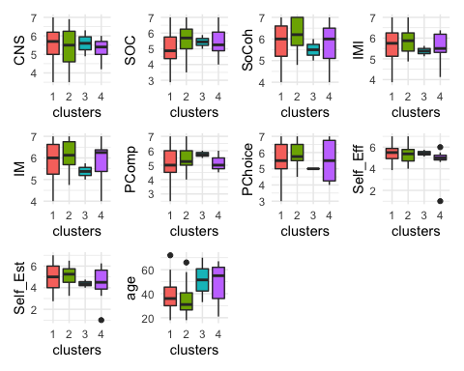

### Short-Term Effects of attending GUI Program

* We conducted the **Welch Two Sample t-test** on PANAS and **Wilcoxon Signed-rank test** on ROS.
* **Statistically significant differences** were observed in **both scales**. Cohen’s d was estimated at **0.51 and 1.002**, which are **medium to large effect** based on the Cohen’s guidelines (1992).
* This study identified that **those who engaged in GUI programs** feel **more restored and more positive emmotions** right **after attending a program**.
* Going forward, **program-wise analysis** needs to be conducted to see if **attending a particular program** shows **different ROS and PANAS** compared to those who attend a different program. For this, we need further data collections (minimum of 20 participants in each program).

Summary of Test Statistics: Pre-and-post Survey

vars

scales

Cronbachs_alpha

shapiro_test

pre_means

post_means

test_statistics

effect_size

1

ROS

0.88

0.018

4.94

5.78

p < 0.01

0.517

2

PANAS

0.90

0.052

5.20

6.10

p < 0.001

1.002

*t-test for PANAS, and Wilcoxon test for ROS

