LIFELONG LOGISTICS
Inward & Outward Transportation Network Analysis
Operations Review · FY 2025–26 · Hub: Farrukhnagar, Haryana
Prepared as an owner-level review of freight movement through the Farrukhnagar hub. It covers the full picture — inbound supply, outbound demand, geographic concentration, carrier and customer mix, fleet and cost implications, risks, and recommended actions. Inbound figures are GRN actuals (goods physically received); outbound figures are delivered quantities on dispatched delivery notes.
1. Executive Summary
The Farrukhnagar hub runs a classic break-bulk operation: it receives goods in a small number of large, near-full loads and ships them out in a very large number of small consignments. Across FY 2025–26 the hub recorded 5,474 inbound trips against 23,170 outbound trips — an outbound-to-inbound ratio of 4.2 to 1 — while moving a comparable volume on each side (58,802 CBM in, 65,570 CBM out). The consequence is a sharp asymmetry in trip economics: the average inbound trip carries 10.7 CBM (effectively a full truck), whereas the average outbound trip carries just 2.8 CBM (a part-load or last-mile drop).
The second defining feature is geography. Inbound supply is short-haul and tightly clustered to the north-west of the hub — the Punjab–Haryana manufacturing belt. Outbound demand, by contrast, is bimodal: a dense hyper-local cluster around the National Capital Region (NCR), and a heavy ultra-long-haul flow to the southern metros. Because inbound and outbound geographies barely overlap on the long-haul lanes, the network carries a structural empty-backhaul cost on its most expensive routes.
Demand is dominated by quick-commerce. BlinkIT, Swiggy, Zepto and BigBasket together account for roughly half of all outbound trips, and their small-drop, tight-SLA replenishment pattern is the main reason outbound trip counts are so high relative to volume. On the supply side, freight is highly carrier-concentrated, with a single transporter handling close to a third of outbound trips.
Four priorities follow from the analysis: (1) exploit backhaul pairing between NW inbound and NCR outbound; (2) restructure the long-haul South flow, which is the largest cost pool; (3) run a deliberate two-fleet model — last-mile for NCR, line-haul for the metros; and (4) close the data gaps that currently obscure cost allocation. These are developed in Section 10.
2. The Network at a Glance
The table below frames the two sides of the operation. The headline is not the volume — inbound and outbound CBM are within 12% of each other — but the trip count and the average load size.
Metric | Inward (receipts) | Outward (deliveries)
Trips | 5,474 | 23,170
Volume moved (CBM) | 58,802 | 65,570
Units handled | 8,096,860 | 8,356,305
Average load per trip (CBM) | 10.7 | 2.8
Distinct locations | 64 supplier cities | 552 destinations
Active partners | 200 suppliers | 19 customer channels
Carriers | — | 18 transporters

Read as an owner: the hub absorbs about 5,474 heavy-vehicle arrivals a year and generates 23,170 dispatches. Every inbound truck is, in effect, broken down into roughly four outbound consignments. Inbound is a heavy-truck, full-load problem; outbound is a fragmentation problem. The two need different vehicles, different rate structures, and different planning logic — a point that recurs throughout this report.
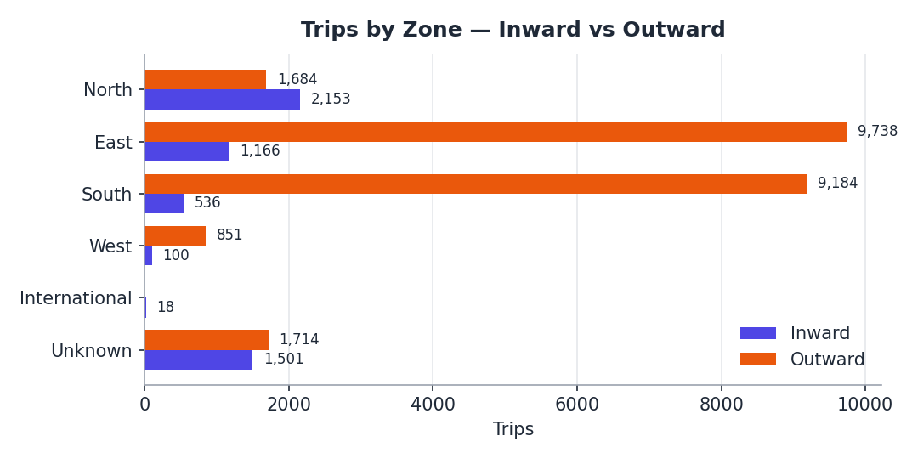
Figure 1 — Trips by directional zone. Inbound leans North; outbound leans East and South.
3. The Inbound Network — Supply Side
Inbound freight is short, dense and predictable. Of the 5,474 receipts, 3,973 are to mapped locations, and 3,519 of those — 89% — originate within 500 km of the hub. There is effectively no inbound activity in the 500–1000 km bands. This is a supplier base sitting on the hub’s doorstep.
The North zone alone contributes 2,153 trips from 53 suppliers, just over half of all mapped inbound movement. Within it, the Punjab–Haryana manufacturing corridor is the clear engine: Sonipat, Jalandhar and Ludhiana together supply close to 1,900 inbound trips. These are repeatable, same-region lanes — ideal candidates for scheduled milk-run consolidation rather than ad-hoc full loads.
Inbound also carries the operation’s biggest data blind spot: 1,501 trips (27% of all receipts) are from suppliers whose address could not be mapped to a zone. Until those are resolved, more than a quarter of inbound cost cannot be allocated to a lane.
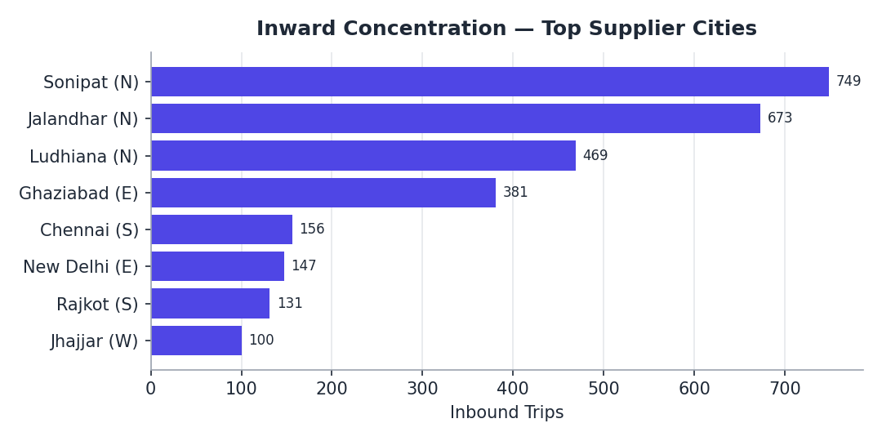
Figure 2 — Inbound concentration. Suppliers cluster in the NW (Punjab–Haryana). Zone shown in brackets.
By product, inbound receipts are led by Sports & Fitness (2,260 trips), Kitchen & Dining (987) and Home Improvements (569) — a profile consistent with a bulky, cube-heavy goods mix, which explains the high CBM per inbound trip.
4. The Outbound Network — Demand Side
Outbound is the opposite of inbound in almost every respect: 23,170 trips spread across 552 destinations, at an average of just 2.8 CBM per trip. The distance profile is distinctly bimodal. Of the mapped outbound trips, roughly 37% are hyper-local moves inside the 0–100 km band (7,847 trips), and roughly 44% are ultra-long-haul moves beyond 1,000 km (9,371 trips). The middle distances are comparatively thin.
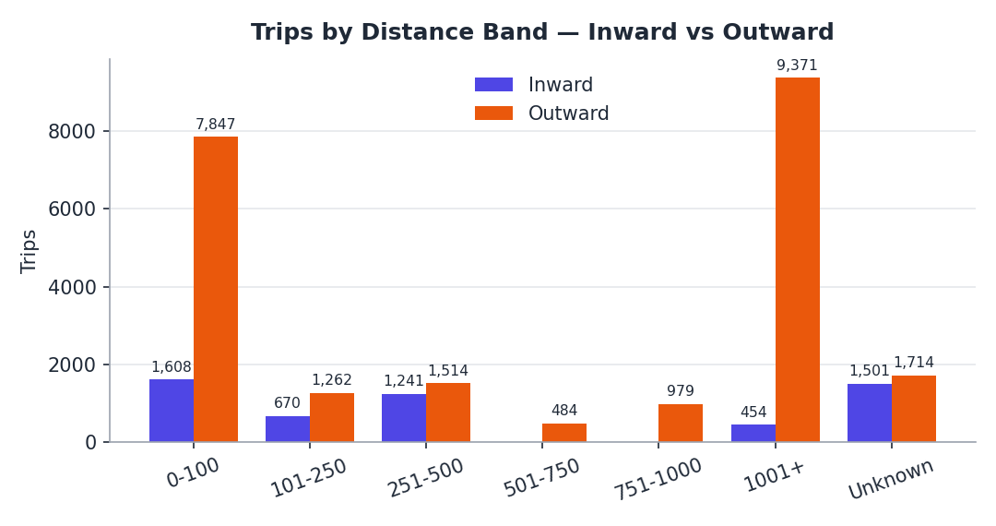
Figure 3 — Trips by distance band. Outbound is bimodal: a hyper-local peak and a long-haul peak.
The hyper-local peak is the NCR quick-commerce cluster — frequent, small replenishment runs to dark stores in and around Gurugram. The long-haul peak is primary freight to the southern metros — Bengaluru, Hyderabad, Mumbai (Bhiwandi) and Pune. The East zone leads on trip count (9,738 trips, almost all short-haul NCR) while the South zone leads on distance and cost (9,184 trips, overwhelmingly 1,000 km-plus).
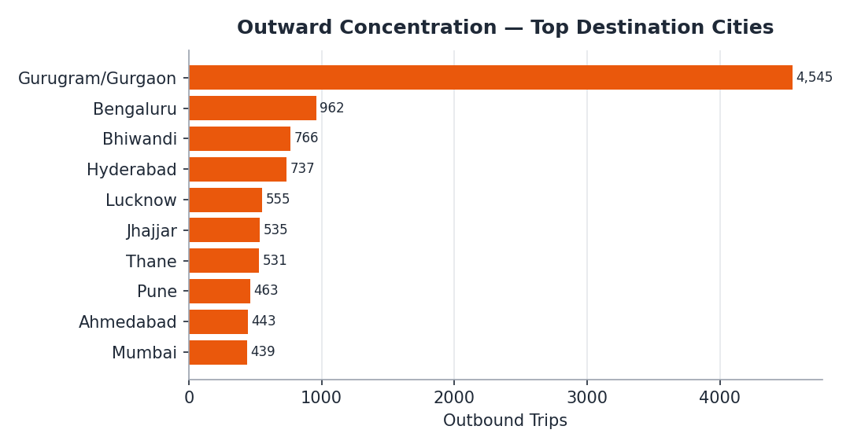
Figure 4 — Outbound concentration. Gurugram/Gurgaon (NCR) dominates; southern metros form the long-haul pole.
A data note worth flagging here: the top destination, the NCR home market, is recorded under two spellings — “Gurugram” and “Gurgaon” — which together represent about 4,545 outbound trips. Treated as one city it is, by a wide margin, the single largest delivery point in the network.
5. Where the Heat Is — Concentration Hotspots
Asked simply — where does the network run hottest? — the answer differs sharply by direction.
Inbound hotspot: the north-west belt
Inbound heat is single-poled and close to home. It sits in the North zone along the Punjab–Haryana axis: Sonipat (749 trips), Jalandhar (673), Ludhiana (469) and Ghaziabad (381) on the NCR fringe. On a map this is one tight, bright cluster within a 0–500 km arc to the north and north-west of Farrukhnagar. It is the easiest part of the network to plan: short lanes, repeat suppliers, consolidatable.
Outbound hotspots: two poles, near and far
Outbound heat is twin-poled. The first and brightest pole is local — the Gurugram/Gurgaon NCR cluster, plus Jhajjar — a hyper-dense 0–100 km zone driven by quick-commerce dark-store replenishment. The second pole is remote: a chain of bright spots over the southern metros — Bengaluru, Hyderabad, Bhiwandi/Mumbai, Pune — each more than 1,000 km away. Between the two poles the map is comparatively cool.
The strategic point is the mismatch. Inbound heat and the near outbound pole both sit around the NCR, so they overlap — a truck running a short outbound NCR drop is geographically close to the NW supplier belt. But the far outbound pole (South) has no inbound heat anywhere near it. A vehicle sent to Bengaluru or Hyderabad has nothing of the company’s own to carry back. That single fact drives much of the cost discussion in Section 8.
The live dashboard (Suppliers_Map.html) renders these concentrations directly: switch the heatmap overlay to Trips, then toggle between Inward and Outward mode to see the single NW pole become the twin NCR-plus-South pattern.
6. Customer Channel Mix
Outbound demand is concentrated in a handful of channels. Quick-commerce platforms — BlinkIT, Swiggy, Zepto and BigBasket — together generate about 12,187 trips, roughly half of all outbound movement. BlinkIT alone is the largest single customer of the transport operation.
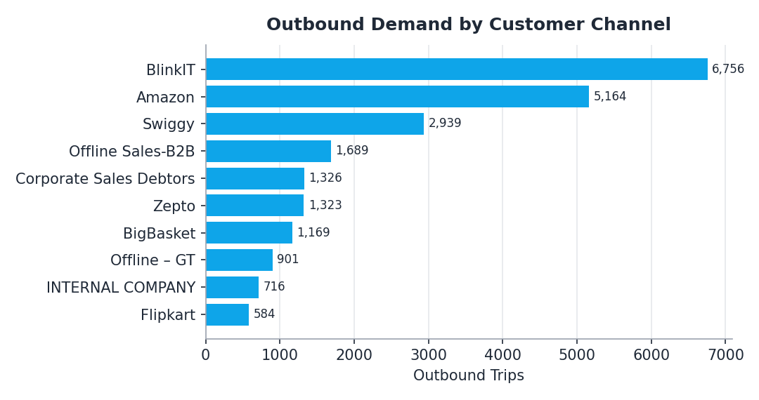
Figure 5 — Outbound trips by customer channel. Quick-commerce dominates trip volume.
Customer channel | Trips | CBM | CBM / trip
BlinkIT | 6,756 | 15,662 | 2.32
Amazon | 5,164 | 18,319 | 3.55
Swiggy | 2,939 | 8,468 | 2.88
Offline Sales-B2B | 1,689 | 2,163 | 1.28
Corporate Sales Debtors | 1,326 | 42 | 0.03
Zepto | 1,323 | 3,472 | 2.62
BigBasket | 1,169 | 1,170 | 1.00
Offline – GT | 901 | 772 | 0.86

The CBM-per-trip column is the operationally important one. Quick-commerce channels move small volumes per trip but at high frequency and under tight delivery windows — that is the structural reason the outbound trip count is four times the inbound. Amazon behaves differently: fewer, bigger drops. Pure-B2B and offline channels are larger still per consignment. An owner pricing this book of business should recognise that quick-commerce trips cost more per CBM to serve and price (or batch) them accordingly.
7. Carrier / Transporter Mix
Outbound freight is highly carrier-concentrated. Loadit Supply Services Pvt Ltd alone handles 6,724 trips — about 29% of outbound movement and an even larger share of outbound CBM. The top three carriers together cover roughly 65% of all outbound trips.
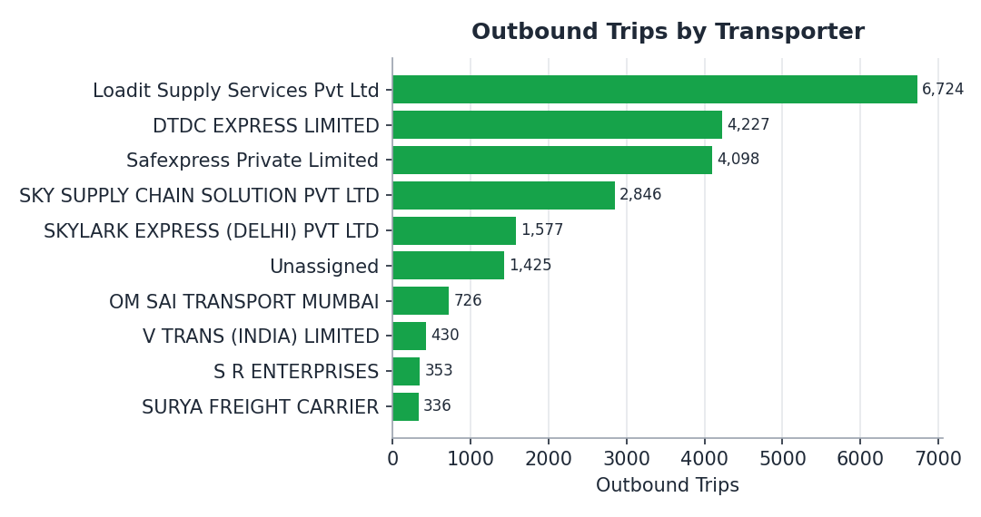
Figure 6 — Outbound trips by transporter. One carrier dominates; “Unassigned” = missing carrier data.
Concentration of this degree is a double-edged sword. It gives volume leverage in rate negotiation, but it also creates a continuity risk: a disruption, capacity squeeze or rate hike from the lead carrier would be difficult to absorb at short notice. The chart also exposes a data gap — a block of outbound trips carry no transporter name at all, which prevents clean carrier performance and cost benchmarking.
8. Cost & Capacity Implications
Two networks, two fleets
Because inbound is a full-load heavy-truck flow and outbound is a fragmented part-load flow, the hub is really running two transport networks at once. The inbound network needs a modest number of large vehicles on predictable NW lanes. The outbound network needs a last-mile / small-commercial fleet for the NCR quick-commerce cluster and a separate line-haul capability for the southern metros. Managing these as one undifferentiated fleet leads to the wrong vehicle on the wrong lane.
The empty-backhaul exposure
The long-haul South corridor — 9,371 outbound trips beyond 1,000 km — is the single largest cost pool in the network. Each of these trips is a 1,500–1,800 km primary move, and because there is no inbound supply anywhere near the southern metros, the company’s own vehicles have nothing to carry on the return leg. The effective cost of these lanes is close to a round trip for a one-way load. By contrast, the short NCR outbound lanes overlap with the NW inbound belt, so backhaul pairing there is genuinely feasible and largely unexploited today.
Trip economics
At 2.8 CBM per outbound trip the network is paying to move a lot of partly-filled vehicles. Even a modest improvement in average outbound fill — through delivery-window batching, minimum drop sizes, or multi-stop routing within the NCR cluster — converts directly into fewer trips for the same volume, and trip count is the primary cost driver on the outbound side.
9. Risks & Data Gaps
- Carrier concentration — a single transporter handles ~29% of outbound trips; no fast substitute exists at that scale.
- Backhaul exposure — the long-haul South corridor is both the costliest lane group and structurally empty on the return leg.
- Unmapped inbound — 1,501 inbound trips (27% of receipts) come from suppliers that could not be mapped to a zone.
- Missing destination / carrier data — 23,937 outbound delivery lines (~1,714 trips) have a blank Place of Supply, and ~1,425 trips carry no transporter name.
- Inconsistent naming — the largest destination is split across “Gurugram” and “Gurgaon”, understating the true #1 lane in any unadjusted report.
- Demand concentration — half of outbound volume depends on quick-commerce platforms, whose SLAs and order patterns the hub does not control.
10. Recommendations
- Exploit the NCR–NW backhaul. Build scheduled milk-runs across the NW supplier belt (Sonipat–Jalandhar–Ludhiana) instead of ad-hoc full loads, and pair short NCR outbound runs with NW inbound pickups to cut empty kilometres on the lanes where geography actually allows it.
- Restructure the long-haul South corridor. For the 1,000 km-plus southern flow, move off per-trip pricing: negotiate dedicated-lane or round-trip rates, and actively source third-party return loads from the South since own-backhaul is unavailable. Evaluate a forward stocking point near Bengaluru or Hyderabad to convert many long primary moves into bulk line-haul plus local distribution.
- Run a deliberate two-fleet model. Plan and contract the NCR last-mile fleet and the metro line-haul fleet separately, with vehicle types and rate cards matched to each. Do not let one fleet pool serve both.
- Raise outbound truck fill. Introduce delivery-window batching, minimum drop sizes and multi-stop routing within the NCR cluster to lift average outbound fill above today’s 2.8 CBM/trip — every point of fill removes trips.
- Diversify the carrier base. Qualify a second and third carrier at meaningful scale to reduce dependence on the lead transporter, and use the volume to benchmark rates.
- Close the data gaps. Make Place of Supply and Transporter mandatory fields on every delivery note, standardise the Gurugram/Gurgaon spelling, and complete address mapping for the 45 unmapped inbound suppliers. Clean data is the precondition for lane-level cost control.
Source data: Inward_Report.xlsx and Outward_Report.xlsx (FY 2025–26). Inbound = GRN actual receipts; outbound = dispatched delivery notes. Figures may include minor rounding. Distance and zone derived from geocoded locations relative to the Farrukhnagar hub.

