**Stage 1A: PLAY/PAUSE implementation**

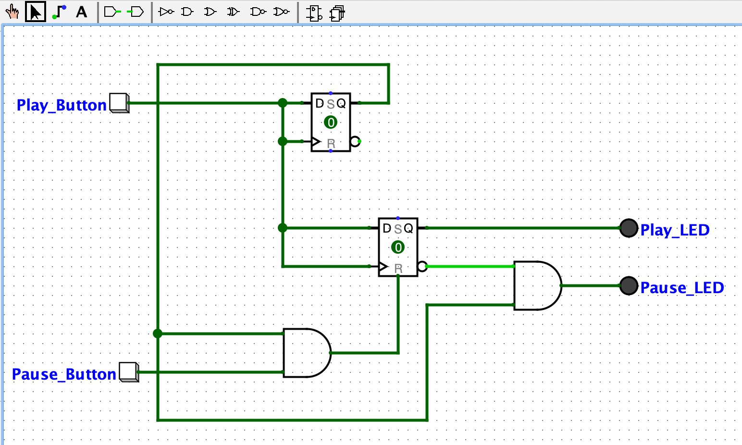

*Figure 1. Play/Pause Implementation*

*(Screen captured from my Mac on October 18th, 2022)*

Components List:

+ Play LED

+ Pause LED

+ Play Button

+ Pause Button

+ D-Flip Flop

**Description**

The circuit has 2 D-Flip Flop with rising edge, and the *Play Button* can be considered as a clock. The first D-Flip Flop, which is linked to the *Play Button*, indicates whether the *Play Button* have been pressed or not. If the *Play Button* is not pressed for the first time, the *Pause Button* will not affect the *Play LED* or the *Pause LED* (The timing diagram below will show the implementation)

*Figure 1.2. Timing Diagram for the Play/Pause Implementation*

*(Screen captured from my Mac on October 18th, 2022)*