**Stage 1B: Implement Pause-To-Play Transition**

*Figure 1. Pause-to-play Implementation*

*(Screen captured from my Mac on October 18th, 2022)*

Components List:

+ Play Button

+ Pause Button

+ Play LED

+ Pause LED

+ D Flip Flop

+ AND gates

**Description**

The circuit upon is upgraded comparing to the previous one in stage 1A. If the play button is not pressed for the first time, the Pause Button will not have any impact on two LEDs. In contrast, if the Play Button is pressed before, the Pause Button will have two functions:

+ If the music player is in PLAY state, pressing Pause Button will turn the music player to PAUSE state.

+ If the music player is in PAUSE state, pressing Pause Button will turn the music player to PLAY state.

The timing diagram below will show the implementation of stage 1B.

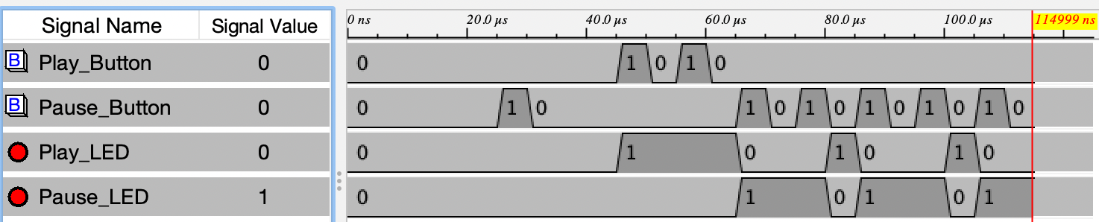

*Figure 1. Pause-to-play Implementation*

*(Screen captured from my Mac on October 20th, 2022)*