#### Stage 2: Implement volume control and display

The implementation is inspired by the 8-deep shift register, the Figure 1 below is the 4-deep shift register, which is the same as 8-deep shift register but with less D-Flip Flop.

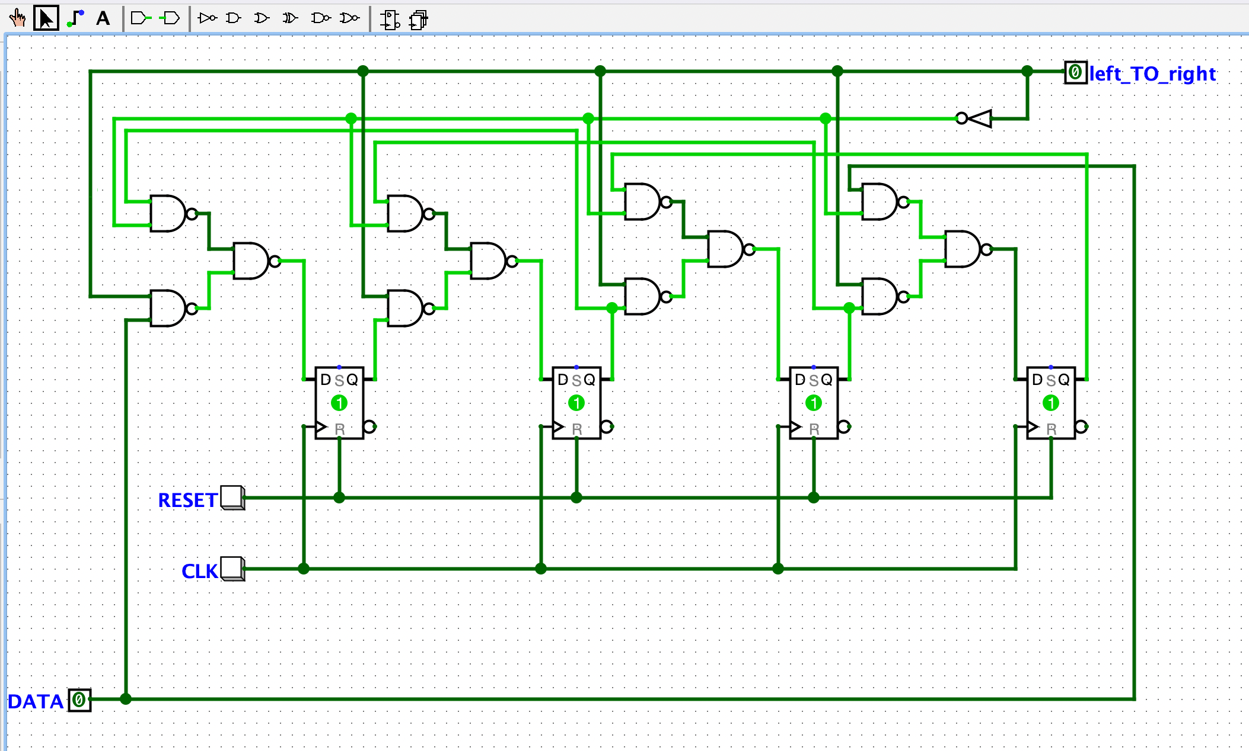

*Figure 1. 4-deep shift register*

*(Screen captured from my Mac on October 20th, 2022)*

**Volume control implementation**

*Figure 2. Volume controlling*

*(Screen captured from my Mac on October 21st, 2022)*

9 D-Flip Flop are used in the circuit. Volume Up or Volume Down is determined by the first D-Flip Flop, and the signal is passed to the next 8 D-Flip Flop via an XNOR gate. I used the XNOR gate to ensure that the output from this gate is always 1 anytime I release the volume up (or volume down) button after pushing that button because the rest rising edge D-Flip Flop control volume levels.