**Synchronous Counter from 0 to 99**

The track skipping is inspired by the synchronous counter from 0 to 99. However, it should be modified to skip the 0’s stage, which means that the counter will count from 1 to 99. The figure 1 below is the implementation of counter counting up 0-99 in electronic circuit.

*Figure 1. Synchronous counter counting from 0 to 99*

*(Screen captured from my Mac on Oct 22nd, 2022)*

**Implementation of Track Skipping**

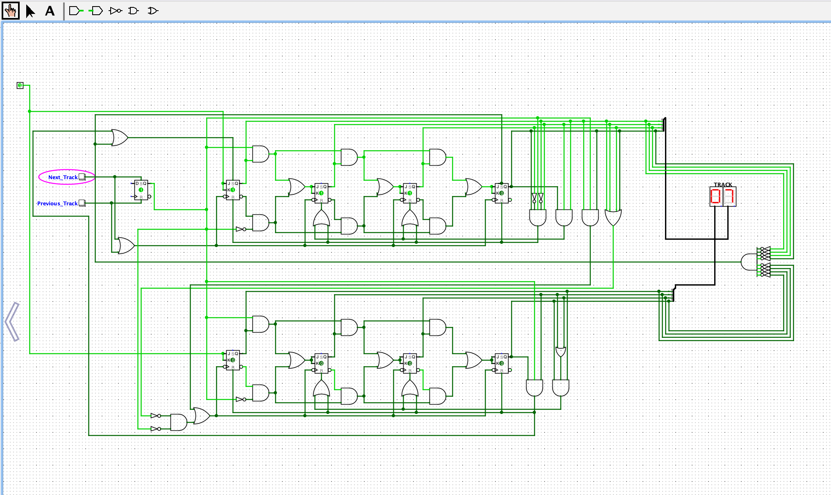

*Figure 2. Track Skipping Implementation*

*(Screen captured from my Mac on Oct 22nd, 2022)*