**Name:** Thanh Tam Vo

**StudentID:** 103487596

**COS10004 - Computer Systems – Lab 2 Submission**

**Part 1**

**Screenshot of the circuit for the first row of the table**

*Figure 1. Circuit for the first-row data*

*Screen captured from my Mac on September 22nd, 2022*

**Truth table**

|  |  |  |
| --- | --- | --- |
| **Input A** | **Input B** | **Output** |
| **0101** | **0000** | **0101** |
| **0101** | **0001** | **0110** |
| **0101** | **0010** | **0111** |
| **0101** | **0011** | **1000** |
| **0101** | **0100** | **1001** |
| **0101** | **0101** | **1010** |
| **0101** | **0110** | **1011** |
| **0101** | **0111** | **1100** |
| **0101** | **1000** | **1101** |
| **0101** | **1001** | **1110** |
| **0101** | **1010** | **1111** |
| **0101** | **1011** | **0000** |
| **0101** | **1100** | **0001** |
| **0101** | **1101** | **0010** |
| **0101** | **1110** | **0011** |
| **0101** | **1111** | **0100** |

**Part 2**

**Screenshot of RS Flip Flop using 2-input NOR gates**

*Figure 2. RS Flip Flop using 2-input NOR gates*

*Screen captured from my Mac on September 22nd, 2022*

**Truth table**

|  |  |  |  |
| --- | --- | --- | --- |
| **Set Reset Q Q’** | | | |
| **1** | **0** | **0** | **1** |
| **0** | **0** | **0** | **1** |
| **0** | **1** | **1** | **0** |
| **1** | **1** | **0** | **0** |

**Description of the behaviors of the circuit above when one of the inputs is 1**

If we open the Set and close the Reset, Q will be 0 and Q’ will be 1.

Similarly, when two inputs are closed, the output will be no different from the previous case.

However, if we open the Reset and close the Set, Q will be 1 and Q’ will be 0.

**If we set both inputs to 1**

Two gates will race each other to feedback their new outputs infinitely and we cannot know which one will win.

**Screenshot of D Flip Flop**

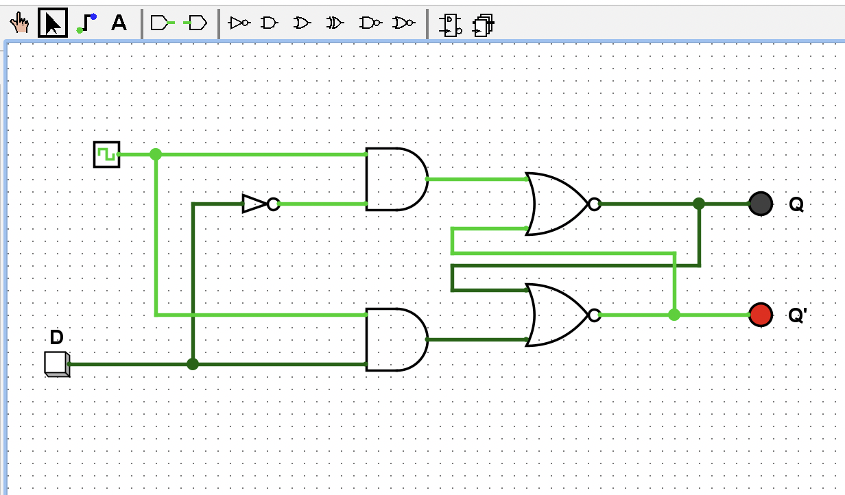

*Figure 3. D Flip Flop*

*Screen captured from my Mac on September 22nd, 2022*

**Truth table for D Flip Flop**

|  |  |  |  |
| --- | --- | --- | --- |
| **Clock Pin Q Q’** | | | |
| **0** | **0** | 0 | 1 |
| **0** | **1** | 0 | 1 |
| **1** | **1** | 1 | 0 |
| **1** | **0** | 0 | 1 |

**Description of the behaviors of D Flip Flop**

This D Flip Flop has only 1 input with the manipulation of the clock, when the input is set to 1,

In case the clock is 1:

* if the input is set to 1, Q will be 1 and Q’ will be 0
* if the input is set to 0, Q will be 0 and Q’ will be 1

In case the clock is 0: we cannot modify Q and Q’ despite changing input D

Leverage: Input D can be considered as an input with two functions: Set and Reset

**Role of the clock and its impact**

The clock impacts the input data and the output not only depends on input data but also clock’s status. It guarantees the synchronization of data input and ensures the predictability.

**Why is it generally preferred over the R-S Flip Flop ?**

Because the D Flip Flop guarantees that there are no indeterminant state with both active inputs in the R-S Flip Flop.

**Screenshot of JK Flip Flop**

*Figure 3. JK Flip Flop*

*Screen captured from my Mac on September 22nd, 2022*

**Truth table for JK Flip Flop**

|  |  |  |  |
| --- | --- | --- | --- |
| **J K Q (when clocked) Q’ (when clocked)** | | | |
| **0** | **0** | No change | No change |
| **1** | **0** | 1 | 0 |
| **0** | **1** | 0 | 1 |
| **1** | **1** | Toggle | Toggle |

**Making JK Flip Flop behave like D Flip Flop**

We can do this by driving the J and K inputs with D input, also, a NOT gate is required for this process.

**J-K Flip Flop be made to behave like a toggle**

When J and K are set to be 1