**Name:** Thanh Tam Vo

**StudentID:** 103487596

**COS10004 - Computer Systems – Lab 3 Submission**

**Screenshot of the 4-bit endian register**

*Figure 1. 4-bit endian register*

*Screen captured from my Mac on September 29th, 2022*

**Test Schedule**

|  |  |  |
| --- | --- | --- |
| **Ox Input Binary Output Binary** | | |
| **0** | **0000** | **0000** |
| **1** | **0001** | **0001** |
| **2** | **0010** | **0010** |
| **3** | **0011** | **0011** |
| **5** | **0101** | **0101** |
| **A** | **1010** | **1010** |
| **B** | **1011** | **1011** |
| **C** | **1100** | **1100** |
| **D** | **1101** | **1101** |
| **E** | **1110** | **1110** |
| **F** | **1111** | **1111** |

­

**Question 7**

**Question 7.1**

*The counter is a circuit that counts the number of a specific event occurring in the processor.*

**Question 7.2**

*An asynchronous counter known as a ripple counter sends ripples of the clock pulses over the circuit. Only the first flip-flop in the circuit is connected to the clock, and it controls the clock input for subsequent flip-flops.*

**Screenshot of big-endian 3-bit ripple counting-up counter**

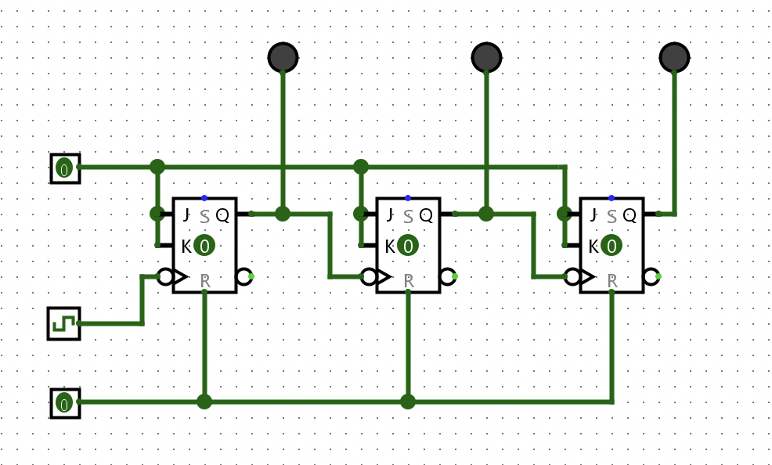

*Figure 2. A big-endian 3-bit ripple counter*

*Screen captured from my Mac on September29th, 2022*

**Screenshot of big-endian 3-bit ripple counting-down counter**

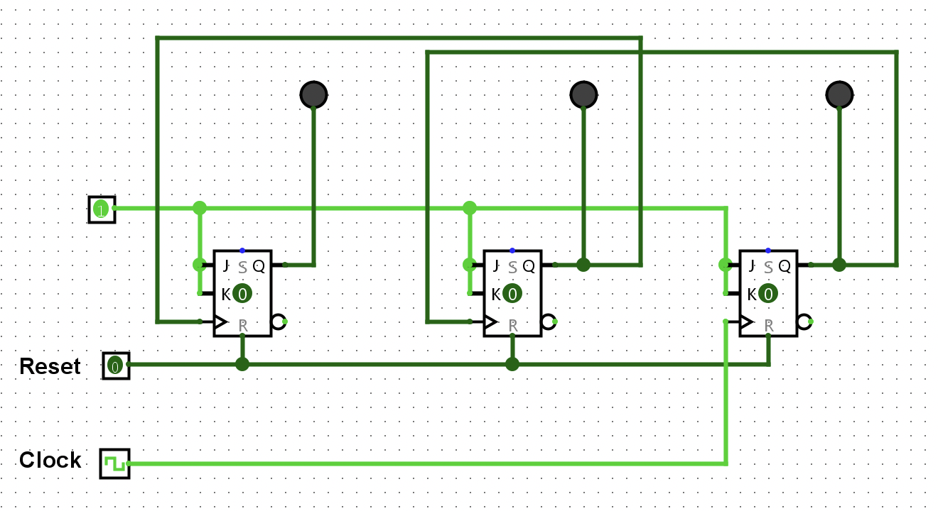

*Figure 3. A big-endian 3-bit ripple counter*

*Screen captured from my Mac on September 29th, 2022*

**Screenshot of common counting-up counter**

*Figure 4. Common counting up clock*

*Screen captured from my Mac on September 29th, 2022*

**Screenshot of HEX Digit Display**

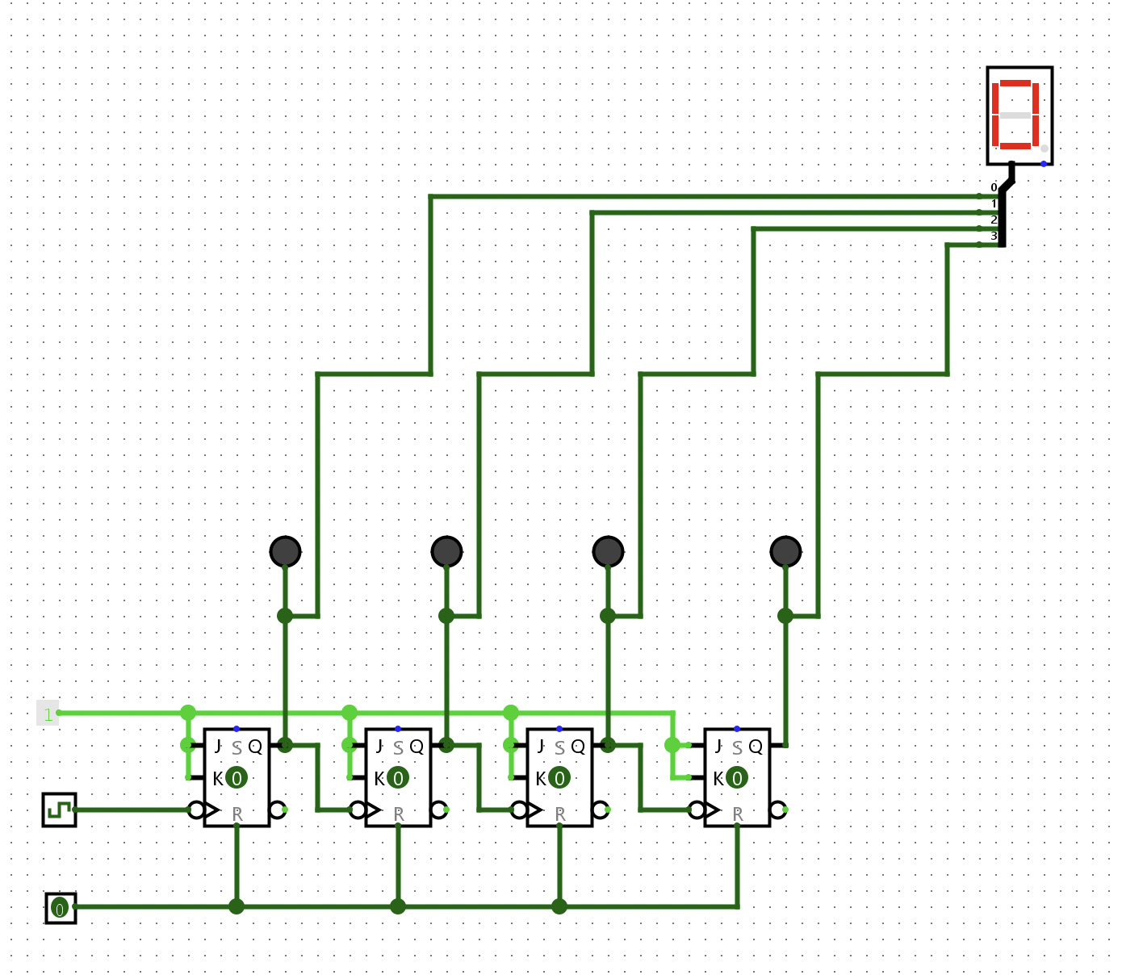

*Figure 5. Common HEX Digit Display*

*Screen captured from my Mac on September 29th, 2022*