Attributing related-view gains in plant image evaluation with single-source and joint replacement controls
Xin Li¹* · Bojian Guo¹ · Asel Kartanova¹
¹ Higher School of Economics and Business, Department of Information Systems in Economics, I. Razzakov Kyrgyz State Technical University, 66 Ch. Aitmatov Ave., Bishkek 720044, Kyrgyz Republic
* Corresponding author: Xin Li; lixin26@kstu.kg
Xin Li: https://orcid.org/0009-0005-0670-5006; Bojian Guo: https://orcid.org/0009-0005-8353-2436; Asel Kartanova: https://orcid.org/0000-0003-1479-0747

Abstract
Related test views can benefit from shared-source training images, but ordinary training-sample replacement also changes predictions. We separate these responses using matched deletions followed by either related views or unrelated same-class sources. The study combines joint replacement with a single-source intervention that holds every other training observation fixed. Two public archives provide 481 audited onion components and 538 author-identified potato leaves. Five fixed classifiers include ResNet18 and DINOv2 representations, colour features and nearest-neighbour controls. Across ten predetermined splits, single-source replacement improved class-balanced target correctness by 25.19 percentage points for ResNet18 logistic regression and 18.49 points for DINOv2 in onion, compared with 2.48 and 2.83 points in potato. Restricting evaluation weight to onion classes with at least 30 sources reduced the corresponding contrasts to 13.59 and 11.32 points; the original fits and all prediction records were retained. Joint replacement across 30 splits also showed a larger local advantage in onion. However, never-exposed predictions changed under both policies, and single-versus-joint contrasts on identical targets varied in sign across splits. The evidence supports a local advantage conditional on the fitted representation and archive, while prediction turnover alone does not specifically identify shared-source exposure. Matched single-source controls strengthen attribution without establishing a universal leakage magnitude, whole-network memorization or field diagnostic validity.
Keywords: related images; data leakage; training-sample replacement; prediction stability; grouped evaluation; plant image classification

1 Introduction
Keeping related observations together is an established requirement for credible evaluation. In plant imaging, several files can represent transformations of one photograph or different views of one leaf. A test image may therefore be unseen as a file while its source remains familiar to the fitted model. Random partitions of such files can answer a substantially easier question than recognition beyond the shared source. PlantVillage demonstrated the value of deep representations for curated leaf images, but its authors also distinguished within-collection performance from performance on images acquired elsewhere [1]. Later work has emphasized acquisition diversity and explicit challenge-oriented evaluation [2, 3].
The existence of shared-source leakage is not the unresolved question. Menco-Tovar et al. compared region-level and original-image-controlled evaluation in bacterial microscopy, establishing the importance of keeping derived regions with their original image [4]. Cluster-based analyses characterize how dependence crosses partitions, and contamination studies examine different amounts of overlap [5, 6]. Comparisons based on independently drawn split strategies can change both test composition and training support. Even a fixed-test experiment that replaces unrelated training sources with related views changes two things: test-source familiarity and the training sample itself. A separate unexposed test panel can register that change, but it does not determine whether the resulting instability is specific to shared-source exposure.
This distinction follows from the wider literature on stability and individual predictions. Algorithmic stability concerns how fitted predictions respond to changes in training data [7]. Predictive multiplicity shows that models with similar overall performance can disagree on individual cases [8, 9]. Training-data influence provides another way to study relationships between individual training and test observations [10]. We do not introduce a new stability principle or treat a near-zero mean accuracy change as evidence of unchanged predictions. Our question is whether the observed response to related-view insertion exceeds the response to an explicitly matched insertion of unrelated, same-class sources.
We examine this question with two replacement policies. Both remove exactly the same training sources. One inserts supported views of selected probe sources; the other inserts unused sources with the same original labels. A second panel, called the sentinel panel, never shares a source with training under either policy. The selected probes measure a local policy advantage, while the sentinels measure changes beyond those deliberately exposed sources. The joint policies change several sources together. We therefore add a single-source comparison: only the donor assigned to one probe is replaced, while every other training observation remains identical. This intervention separates the response of that target from changes caused by replacing the rest of the selected sources.
The two tasks supply different provenance and recognition conditions. The onion task uses conservative visual-dependence components reconstructed from an existing augmented archive. The potato task uses original photographs and explicit leaf numbers from the original PlantVillage acquisition records. Its inclusion was fixed from metadata before fitting the new task, and all three potato classes were retained. This archive provides a second provenance structure and capture setting in which to test the specificity of the replacement response. A separate source-locked onion analysis retains the agricultural context without treating the controlled exposure experiment as evidence of pathogen diagnosis or field deployment. The contribution is a controlled reanalysis of attribution: it measures the local response under a fixed training background, tests its sensitivity to joint replacement and class weighting, and compares that response with changes on never-exposed sources. These are evaluation findings, not a new classifier or a claim of improved disease recognition.

2 Materials and methods

2.1 Data and provenance
Table 1 distinguishes files, reconstructed visual components and author-recorded leaves. The units are not interchangeable. The onion images depict bulb onion, Allium cepa, and the potato images depict Solanum tuberosum. We retain the source labels as classification targets and do not infer new diagnoses from image appearance.
The chilli and onion leaf dataset (COLD) supplied 4,502 augmented onion files and a machine-readable raw snapshot containing 815 files [11]. Exact deduplication left 813 raw contents. Although the augmented filenames contained 816 apparent parent prefixes, those prefixes did not separate every shared visual source. In a documented counterexample, eight derivatives in two different prefixes matched the same raw image content. Prefix-only grouping was consequently withdrawn from the present estimates.
The corrected audit tested every augmented member against retrieved raw candidates and added a global candidate search. SIFT descriptor matching followed by a RANSAC homography evaluated normal and horizontally reflected query orientations, accepting either qualifying orientation. At least 15 inliers and an inlier fraction of at least 0.60 defined a positive geometric edge; stricter common-reference support additionally required inlier coverage of at least 5% in each image and median and 95th-percentile residuals no greater than 2 and 4 pixels in the decoded grayscale image coordinates. Known filename links and all positive geometric links formed conservative blocking components. Components connecting different original labels were excluded from the intervention task, rather than relabelled. Within each retained component, the common raw reference supporting the most augmented members was selected without consulting classifier outcomes; ties were resolved by raw-content hash. At least three unique supported views were required. The selected set contained 3,076 eligible files in 481 components. Component counts were 228 healthy, 190 Iris yellow spot virus-labelled, 50 pooled Stemphylium/Colletotrichum leaf-blight-labelled and 13 purple-blotch-labelled. Geometric support establishes related visual content under finite retrieval rules; it does not establish a plant identity or a complete augmentation history. Candidate retrieval, exclusions and thresholds are specified in Online Resource 1.
The independent archive task comprised the complete three-class potato portion with eligible original colour photographs and explicit leaf assignments in PlantVillage [1]. We verified each assignment against the original authors' 2016 records containing File Name and Leaf #. The current leaf map was byte-identical to the historical author repository object. All 2,152 selected photographs also matched their fixed author-repository Git objects. The resulting 538 leaves had four original photographs each: 250 early-blight-labelled, 250 late-blight-labelled and 38 healthy leaves. Grayscale and segmented processing variants were not counted as new observations. All downloaded photographs were pixel-unique, and the complete eligible potato task was retained without outcome-based selection. The leaf identifiers strengthen the sampling-unit definition for this task; they do not identify separate whole plants or provide a new pathological adjudication.
Table 1 Source units and class support in the repeated-view tasks. Onion units are screened dependence components; potato units are author-recorded leaves. Neither count establishes the number of independent plants.
Task and source unit | Original label | Sources | Eligible images
Onion / audited component | Healthy | 228 | 757
Onion / audited component | IYSV-labelled | 190 | 976
Onion / audited component | Pooled leaf-blight-labelled | 50 | 694
Onion / audited component | Purple-blotch-labelled | 13 | 649
Potato / author leaf ID | Healthy | 38 | 152
Potato / author leaf ID | Early-blight-labelled | 250 | 1000
Potato / author leaf ID | Late-blight-labelled | 250 | 1000

2.2 Matched replacement design
Figure 1 shows the controlled contrast. For each original class, a seeded random partition assigned approximately 20% of sources to probes, 10% to sentinels and the remainder to development, using Python's rounding rule. Sources within each class's probe panel were randomly paired. Complementary allocations A and B selected one source from each pair, so every paired probe was selected exactly once. An odd unpaired probe remained unselected. One image from each probe and sentinel was fixed as its evaluation anchor. Every selected training source contributed two fixed images; probe insertion used two images different from its evaluation anchor.
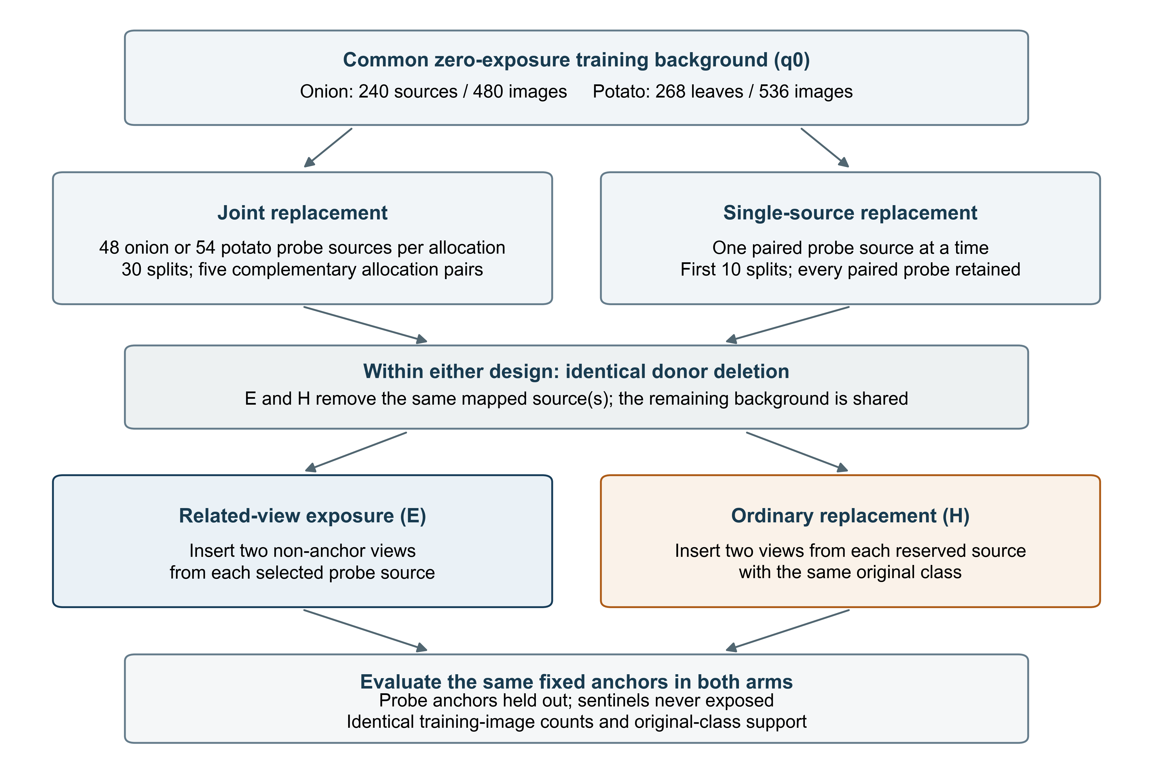
Fig. 1 Matched replacement at two scales. Joint policies replace 48 onion or 54 potato sources in one allocation. Single-source policies replace only the donor assigned to the current target and keep every other training observation identical. Both policies remove the same donor sources and insert two same-class images per source. Test anchors remain fixed and sentinels never share an audited or recorded source with training
For each paired probe, two distinct development sources with the same original label were selected before fitting: a removable donor and an alternative source. The zero-exposure training set contained all development sources except these reserved alternatives. Under the exposure policy, selected removable donors were replaced by the corresponding probes' related views. Under the ordinary-replacement policy, the same donors were removed and the corresponding reserved alternatives were inserted. These alternatives had no audited or author-recorded source link to either test panel; this is the operational meaning of unrelated sources here. We call the latter the sham policy solely to distinguish the experimental arms; it is an actual change to the training data, not an unchanged or ineffective treatment. Within an allocation, the policies preserved the exact test anchors, the deleted sources, the number of inserted sources, original-class training counts and the two-image training budget per source.
Thirty splits, with seeds 20261003–20261032, each used five independently drawn complementary allocation pairs. The onion task had 97 probes, of which 96 were paired, and 48 sentinels; each allocation selected 48 probes, and each fitted model used 240 sources and 480 images. The potato task had 108 paired probes and 54 sentinels, selected 54 probes per allocation, and used 268 training leaves and 536 images. Source intersections were checked from actual training memberships: the exposure arm shared exactly the selected probe sources, while sham and zero-exposure arms shared none with either test panel. Exact image overlap was prohibited in every arm. Sentinels remained source-disjoint throughout. These controls apply to the audited source identifiers; unknown onion dependencies remain possible.
For the single-source intervention, the first ten recorded seeds (20261003–20261012) and every paired probe within them were fixed before new outcomes were available. Starting from that split's zero-exposure set, we removed only the donor assigned to the current target. Exposure inserted that target's two non-anchor views; sham inserted its already assigned reserved alternative. All other training observations, class counts, image counts and evaluation anchors were identical. This produced 960 onion and 1,080 potato target-within-split interventions; repeated occurrences across overlapping splits are not new biological units. The training budgets remained 240 sources/480 files and 268 leaves/536 photographs. Actual memberships and image hashes were checked before fitting. Figure 1 distinguishes this fixed-background comparison from joint replacement.

2.3 Representations and fitting
The reference representation was a frozen ImageNet-pretrained ResNet18 with 512 features [12, 13]. A standardized, class-balanced L2 logistic classifier used fixed regularization C = 0.01, the lbfgs solver and at most 10,000 iterations. Scaling was fitted separately inside each training arm. The modest fitted head avoids training a high-capacity network on a few hundred source units.
Before the new fits, we specified one modern representation sensitivity: the official DINOv2 ViT-S/14 checkpoint [14]. Its final LayerNorm CLS token supplied 384 features after the official short-side 256-pixel bicubic resize, 224-pixel centre crop and ImageNet normalization. The backbone remained frozen. The identical logistic specification was applied to these features; no checkpoint or hyperparameter was selected on either task's outcomes. Checkpoint and source hashes, image-byte checks for all 5,228 files, and exact preprocessing and repeated-extraction checks accompany the outputs. The membership of these archives in DINOv2 pretraining cannot be verified; the experiment controls our fitted heads and training sets, not unknown foundation-model pretraining overlap.
A colour comparator used 189 histogram and summary-statistic features across BGR, HSV and Lab channels with the same logistic specification. Untuned cosine nearest-neighbour comparators used the ResNet18 and DINOv2 representations; deterministic row order resolved ties. All five models used identical sources, selected images and allocations. The original multiclass endpoint was primary. Earlier healthy-versus-other refits of ResNet18, colour and ResNet18 nearest-neighbour models remain secondary analyses; DINOv2 and the single-source experiment were specified for multiclass labels only. Complete records include all retained models, rather than a best-performing subset. Fitting used scikit-learn [15].

2.4 Outcomes and interpretation
Balanced accuracy (BA) gives equal weight to the K endpoint classes. For one allocation, let P_{c} be its selected probe anchors with true class c, and let C_{i}^{E} and C_{i}^{H} indicate a correct prediction under exposure and sham. The selected-probe contrast is
$$Δ_{P}=\frac{1}{K}\sum_{c=1}^{K}{\frac{1}{|P_{c}|}\sum_{i∈P_{c}}{(C_{i}^{E}−C_{i}^{H})}} (1)$$
Equation (1) compares predictions on the same selected anchors. We average the A and B contrasts, then the five allocation pairs within each split. Unselected paired probes, all paired probes and original-class strata are reported as secondary outcomes. The quantity is conditional on the joint replacement policy; other inserted sources differ at the same time, so it should not be called an isolated direct effect.
Sentinel changes use the common zero-exposure prediction as the reference. Let G be the class-balanced fraction changing from an incorrect to a correct prediction, L the fraction changing from correct to incorrect, and W the fraction changing between two incorrect labels. Then
$$ΔBA=G−L, T=G+L, Q=G+L+W (2)$$
Here T is correctness turnover and Q is predicted-label change. Equation (2) is an accounting identity, not a new stability theorem. All three fractions use identical endpoint-class weights. The primary sentinel comparison is
$$ΔT_{S}=T_{S}^{E}−T_{S}^{H} (3)$$
In Eq. (3), both T_{S}^{E} and T_{S}^{H} use the same zero-exposure sentinel predictions as their reference. The comparison asks whether replacing donors with related probe views changes sentinel correctness more than replacing those same donors with unrelated sources. Each policy's gain, loss, turnover and label change relative to zero is retained, so a small net BA change is not mistaken for prediction stability. Exposure-versus-sham label disagreement within the same allocation is a secondary outcome.
We report the mean and 2.5th–97.5th percentiles of the 30 split means as design variation. These overlapping splits are not 30 independent biological experiments, and the percentiles are not plant-population confidence intervals. No p-values, equivalence margins or universal leakage thresholds were estimated. In particular, a range crossing zero does not prove equivalence. The onion purple-blotch class contributes only one sentinel per split and has substantial weight in four-class BA; original-class results expose this limitation.
The single-source estimand uses each target's own exposure/sham fit pair. Its correctness difference is first averaged across targets within their original class, then equally across classes, and finally across the ten splits. It is an average over target-specific fitted models, not BA from one common model. We retain separately the fraction corrected relative to sham and the fraction harmed, whose difference gives the net contrast. Changes on all other probes and sentinels are evaluated with the same class weighting, averaging targets within their original class before averaging intervention classes. Ten-split minima, maxima and standard deviations describe the design variation.
A prespecified sensitivity gives evaluation weight only to original classes with at least 30 source units in the complete audited task. It excludes the 13-component onion purple-blotch class from the averaging weights and retains all potato classes. For joint replacement, the restriction changes evaluated-anchor weights only. For single-source replacement, it changes both intervention-target weights and evaluated-anchor weights; within each retained intervention class, eligible targets are averaged before equal weighting across retained classes. The full-class fits and all prediction records remain unchanged. This is a weighting sensitivity, not a retrained reduced task or a claim about population prevalence. Finally, each single-source target is matched to its joint-policy predictions in the same split, averaging the five joint allocations in which it was selected. This ten-split comparison estimates sensitivity to the surrounding replacement policy. We do not compare ten-split single-source means with unmatched 30-split joint means as though they were paired.

2.5 Separate locked onion transfer analysis
The transfer analysis asks a different question and uses no potato observations. TOM2024 supplied 1,643 eligible onion foliar images from 103 filename-derived UTC acquisition days after source grouping, conflict exclusion and exact deduplication [16]. The binary endpoint was healthy versus dataset-labelled visibly affected foliage. Five day-grouped outer folds estimated internal performance; four inner grouped folds selected logistic regularization from seven values between 10⁻⁴ and 100. Inner out-of-fold scores fitted a Platt probability mapping and a Youden threshold. Scaling, selection, calibration and thresholding remained within development data, following established nested and grouped validation principles [17, 18].
A separate five-fold, day-grouped TOM search selected the final regularization value. The final classifier was refitted on all TOM images, while its Platt mapping and Youden threshold were fitted from the pooled outer out-of-fold TOM decision scores. That complete pipeline was applied unchanged to the 813 raw COLD images. Because those pooled scores came from folds with different selected penalties, a fixed-penalty calibration sensitivity is retained in Online Resource 1. The primary frozen ResNet18 model was compared with prevalence, colour and handcrafted baselines. EfficientNet-B0, ConvNeXt-Tiny and Swin-T were later architecture sensitivities, all retained irrespective of their target performance. They do not constitute a newly untouched confirmation after the primary target results had been seen. Ranking, Brier score and locked-threshold BA were assessed separately because useful ranking need not preserve probability quality or decisions after distribution change [19, 20].
Raw COLD related-content links motivated a dependence sensitivity using 547 components under all positive geometric edges and 700 under stricter spatial support. Three thousand fixed-prediction component bootstrap draws were evaluated under each graph. Joint paired weights were used for model comparisons; TOM day clusters were used for the internal side of transfer gaps. These intervals are conditional on incomplete graphs and frozen models, not biological confidence intervals or full retraining uncertainty. All 813 records were retained in both sensitivities. The transfer task, repeated-view experiment and their uncertainty summaries are not pooled.

2.6 Analysis chronology and accountability
The matched replacement study was designed after the earlier onion results and the filename-grouping failure were known. Its inputs, assignments, comparisons and executable hashes were frozen before its new fits. Potato selection used provenance metadata and was fixed before new potato outcomes; the same numerical design was used. The DINOv2 and single-source extensions were specified after the earlier joint results were known; their features, assignments, fixed models and computational checks were frozen before their new fits. These were post hoc study extensions, not a prospectively registered field study. Previous prefix-based estimates were superseded rather than silently retained alongside the corrected results.
OpenAI Codex assisted with code development, statistical analysis, manuscript drafting and language revision. Numerical claims were checked against executed outputs and separately implemented reconstructions. Scientific figures were generated from machine-readable results; no generative image system was used to produce the study images or plots. The authors retain responsibility for scientific interpretation, reference checking and the final submitted content. Independent computational reconstruction here describes a separate implementation, not blinded human expert review or pathological reassessment.

3 Results

3.1 Local policy advantage was strongly task-dependent
Table 2 and Fig. 2 present the multiclass comparisons for all five models. The reference ResNet18 selected-probe contrast was +23.66 percentage points in onion, with a split-percentile range of +8.34 to +37.94 points. The corresponding potato contrast was +1.70 points, with a range extending below zero. DINOv2 logistic regression gave corresponding contrasts of +21.18 and +1.93 points. Colour and both nearest-neighbour comparators also had larger mean contrasts in onion than in potato. Related-view exposure therefore improved the selected onion predictions relative to ordinary replacement, but a uniformly large cross-task effect was not observed.
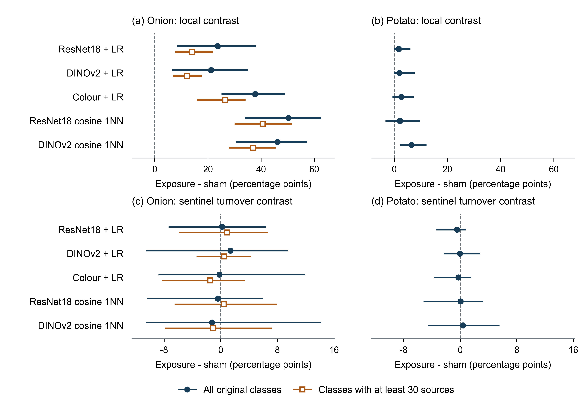
Fig. 2 Joint replacement contrasts for all five models in onion and potato. Selected-probe correctness is exposure minus sham; sentinel correctness turnover compares each policy with the same zero-exposure reference before taking exposure minus sham. Markers summarize 30 split means; bars show their 2.5th–97.5th percentiles, not population confidence intervals. Blue uses all original classes; orange changes evaluation weights to classes with at least 30 sources without refitting. Potato weights coincide
On the same selected probe anchors, primary-model BA under zero, sham and exposure was 55.32%, 57.08% and 80.74% in onion, versus 96.56%, 96.74% and 98.44% in potato. The sham error fraction available to improve was therefore 42.92% in onion and 3.26% in potato. This is a relevant constraint, not a demonstrated causal explanation for the difference: the tasks also differ in class count, provenance, acquisition and original versus augmented views. We do not attribute their contrast to the crop or to any one of these factors. Neither the potato classes nor its modest effects were removed after observing the results. Binary and original-class results appear in Online Resource 1.
The mean onion contrast also differed across original labels: 6.10 points for healthy, 12.39 for IYSV-labelled, 23.80 for pooled leaf blight and 52.33 for purple blotch. The last class contained only 13 retained components and one selected probe per allocation, with a split range of 0–100 points. Because four-class BA assigns one quarter of its weight to each original label, this sparsely supported class contributes substantially to the overall contrast. Its larger value should not be interpreted as a disease-specific mechanism or as the effect expected under a field prevalence distribution.
Table 2 Raw balanced accuracy and exposure-minus-sham contrast on the same selected probe anchors. Complementary arms and five allocation pairs are averaged within each split before the 30-split mean. BA is in percent; differences are percentage points (pp). Figure 2 and Online Resource 1 give the split variation.
Task | Model | Zero BA (%) | Sham BA (%) | Exposure BA (%) | E−H (pp)
Onion | ResNet18 + LR | 55.32 | 57.08 | 80.74 | 23.66
Onion | DINOv2 + LR | 70.16 | 70.23 | 91.41 | 21.18
Onion | Colour + LR | 40.59 | 38.15 | 75.86 | 37.71
Onion | ResNet18 1NN | 38.03 | 39.04 | 89.29 | 50.25
Onion | DINOv2 1NN | 48.57 | 49.37 | 95.46 | 46.09
Potato | ResNet18 + LR | 96.56 | 96.74 | 98.44 | 1.70
Potato | DINOv2 + LR | 97.19 | 97.13 | 99.06 | 1.93
Potato | Colour + LR | 92.87 | 92.42 | 95.05 | 2.64
Potato | ResNet18 1NN | 92.18 | 92.07 | 94.21 | 2.14
Potato | DINOv2 1NN | 89.92 | 90.65 | 97.12 | 6.47

3.2 Sentinel instability did not require shared-source exposure
On onion sentinels, ResNet18 class-balanced correctness turnover relative to zero was 11.80% under exposure and 11.62% under sham. Their difference was +0.18 percentage points, with a split range from −7.37 to +6.36 points. Exposure changed net sentinel BA by −0.31 points, whereas sham changed it by +1.10 points. These small mean net changes coexist with appreciable incorrect-to-correct and correct-to-incorrect transitions. Predicted-label change was 17.08% under exposure and 15.80% under sham; the extra changes include transitions between two incorrect classes.
Potato sentinel correctness turnover was 1.06% under exposure and 1.50% under sham, giving an exposure-minus-sham difference of −0.43 points. Both tasks therefore demonstrate that never-exposed predictions can change after an ordinary, same-class training replacement. The results do not establish an exposure-specific excess of sentinel correctness turnover. They also do not establish equivalence between policies or the absence of changes in predicted probabilities. Figure 2 separates the local probe result from this sentinel comparison so the former cannot be used to explain every observed prediction change.

3.3 The local advantage persisted with a fixed training background
Single-source replacement yielded an average own-target correctness advantage of 25.19 percentage points for ResNet18 logistic regression and 18.49 points for DINOv2 in onion. The potato contrasts were 2.48 and 2.83 points. Figure 3 displays all five models and the ten-split variation; Table 3 separates class weighting from the matched background comparison. The observed single-source advantages were corrections relative to sham: no own-target correct-to-incorrect event under exposure relative to sham was recorded in these five-model interventions. This is a finite-sample observation, not a monotonicity guarantee for the classifiers.
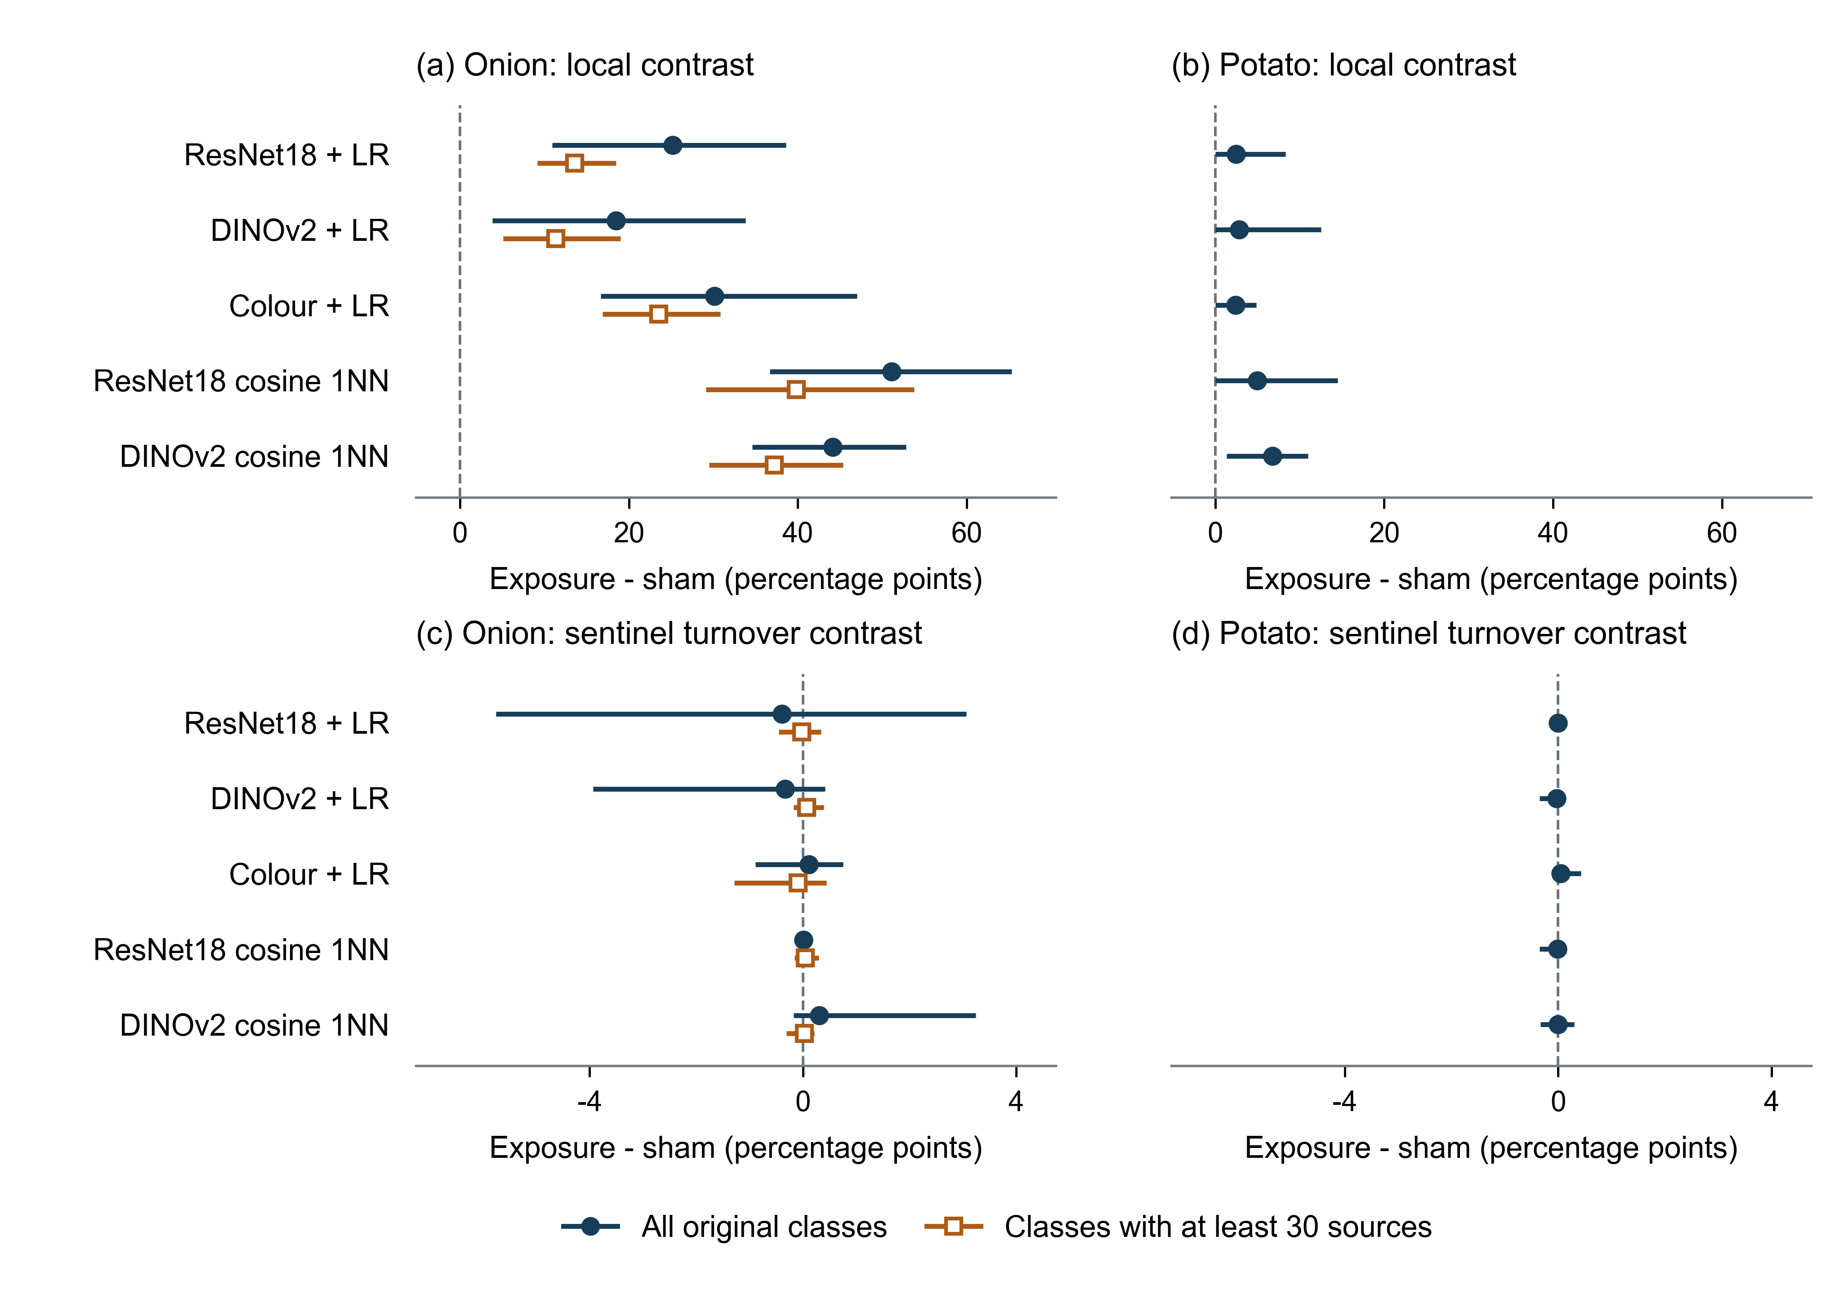
Fig. 3 Single-source replacement with the remaining training background held fixed. Each target has its own pair of fitted models. Target effects are averaged within original class, across classes and then across ten predetermined splits. Means and full ten-split minima–maxima are displayed; these are not confidence intervals and differ from the percentile bars in Fig. 2. Blue uses all classes; orange assigns weight only to classes with at least 30 sources, both for intervention targets and evaluated anchors, without refitting. Larger own-target effects indicate greater response to exposure, not superior disease recognition
When only classes with at least 30 sources received evaluation weight, the onion ResNet18 and DINOv2 contrasts fell to 13.59 and 11.32 points. Related-view gains therefore persisted outside the sparsely supported purple-blotch class, but that class materially affected their magnitude. The sensitivity retains the same multiclass fits; it cannot estimate the accuracy of a new three-class training problem.
On exactly the same ten splits and targets, the onion joint-policy contrasts were 23.34 points for ResNet18 and 17.69 for DINOv2, compared with the respective single-source values of 25.19 and 18.49. Across all five models and both tasks, the single-minus-joint split ranges crossed zero. Thus the fixed-background experiment supports a local advantage without requiring the other probes to enter training, but does not establish systematic amplification or attenuation by joint replacement. The colour model's mean onion contrast decreased from joint to single replacement, so a universal direction would also misdescribe the model comparison.
Single-source interventions changed never-exposed predictions as well. Mean onion sentinel exposure-minus-sham turnover was −0.39 points for ResNet18 and −0.33 for DINOv2, with split ranges spanning zero. These observations retain the distinction between a local advantage and more general sensitivity to training data. Full rescue, harm, probability-change, per-class and collateral outcomes are available in Online Resource 1.
Table 3 Single-source own-target contrasts and their matched joint-policy comparison. All entries are percentage points and average the same first ten splits. “≥30” changes only evaluation weights to classes with at least 30 sources; potato retains all classes. “Joint: same 10” averages the five selected joint allocations for each identical target. The last column is paired within split before averaging; all corresponding ten-split ranges span zero. Entries are rounded independently
Task | Model | Single: all (pp) | Single: ≥30 (pp) | Joint: same 10 (pp) | Single−joint (pp)
Onion | ResNet18 + LR | 25.19 | 13.59 | 23.34 | 1.85
Onion | DINOv2 + LR | 18.49 | 11.32 | 17.69 | 0.80
Onion | Colour + LR | 30.13 | 23.51 | 34.68 | -4.55
Onion | ResNet18 1NN | 51.11 | 39.82 | 49.24 | 1.87
Onion | DINOv2 1NN | 44.15 | 37.20 | 43.95 | 0.20
Potato | ResNet18 + LR | 2.48 | 2.48 | 1.71 | 0.77
Potato | DINOv2 + LR | 2.83 | 2.83 | 2.59 | 0.25
Potato | Colour + LR | 2.42 | 2.42 | 1.68 | 0.74
Potato | ResNet18 1NN | 4.95 | 4.95 | 4.57 | 0.38
Potato | DINOv2 1NN | 6.78 | 6.78 | 7.74 | -0.95

3.4 The separate onion transfer result remained a limitation
The TOM-developed ResNet18 pipeline achieved internal BA 0.927 but locked external COLD BA 0.655. Under the all-positive-edge dependence graph, the external interval was 0.621–0.691; under stricter spatial grouping it was 0.621–0.689. The external-minus-internal BA gap was −0.272, with an all-positive-graph interval of −0.311 to −0.231. AUROC was 0.735 and Brier score 0.240 externally, compared with 0.979 and 0.049 internally. Figure S2 in Online Resource 1 reports both dependence sensitivities without changing the fitted point estimates.
ResNet18 exceeded the strongest original handcrafted baseline by 0.085 external BA, but its difference from EfficientNet-B0 was only approximately 0.005 and the dependence-sensitive interval crossed zero. Swin-T had a higher external AUROC while its locked BA was lower. The comparison supports separating ranking from the transported decision rule, not a claim that ResNet18 is the best architecture. Recovered-region analyses and the calibration sensitivity retained from earlier work are reported in Online Resource 1; they do not supply new plant identities or an independent field cohort.

4 Discussion
The useful empirical distinction is between a local advantage associated with which sources enter training and broader prediction changes caused by altering the training sample. Both occur in the onion experiment, but only the local advantage is clearly larger under the exposure policy than under matched ordinary replacement. Sentinel flipping alone would have failed as an attribution criterion: sham replacements produced nearly the same average correctness turnover. In the potato archive, both the local advantage and sentinel turnover were smaller. These observations limit the interpretation of a visually compelling before-and-after prediction comparison.
This finding builds on, rather than replaces, the established leakage literature. Original-image grouping in Menco-Tovar et al. protects an evaluation boundary [4]; cluster theory and contamination analyses explain why that boundary matters [5, 6]. Our matched deletions and same-class insertions address a narrower empirical ambiguity in experiments that deliberately move related content into training. They do not detect all possible dependence and do not repair a dataset without identifiers. The explicit control is especially useful when a study attributes a change outside the exposed test sources to leakage: a comparable change under unrelated replacement is a competing explanation that should be measured.
Stability and predictive-multiplicity research already warn that aggregate performance can obscure changes in individual decisions [7, 8, 9]. Equation (2) simply makes those changes auditable. Our contribution is not the fact that gains and losses can cancel, nor a universal instability score. It is the task-specific evidence obtained when this accounting is coupled to matched source replacement. Influence-based work concerns individual training contributions under different estimators and interventions [10]; the single-source comparison fixes the other observations and identifies the response to the specified donor-to-related-view versus donor-to-alternative replacement within that training pipeline. It does not recover a background-independent property of the source. Moreover, influence measured through a frozen representation and fitted head is not whole-network memorization; Feldman and Zhang explicitly distinguish last-layer approximations from full-model effects. The paired joint comparison tests one change of background, not all possible training contexts.
Recent controlled evaluations in this journal clarify the evidential role of such a study. Božič et al. compared seven unsupervised anomaly-detection methods across four tasks and multiple training-pollution levels [21]; Requena et al. examined label noise across eight multilabel tasks and several neighbour and prototype strategies [22]. Those studies varied a threat to evaluation under explicit controls rather than relying on a new application dataset alone. Our narrower question concerns shared-source insertion with matched donor deletion and an unchanged test panel. Single-source and joint replacement answer different attribution questions, and the weighting sensitivity exposes an otherwise hidden dependence on class support. The present two-task breadth is smaller than those comparisons; repeated fits cannot compensate for that population limitation. Its useful result is the controlled distinction among local advantage, background sensitivity and changes on never-exposed sources.
Larger exposure contrasts should not be read as better classification models. In onion, nearest neighbours and colour features were often more responsive to related-view insertion than either logistic deep-feature head. Because these models use identical replacements, that result demonstrates that the vulnerability does not require a complex learned head. DINOv2 changes the representation and pretraining regime while preserving the comparison; it supplies a modern sensitivity test, not a comprehensive state-of-the-art contest. All features and penalties remain fixed, so the empirical magnitudes are conditional on those choices.
The provenance contrast is also informative. A filename scheme that appears complete did not provide a safe source boundary for onion. Conservative geometry repaired known relationships, but finite candidate retrieval cannot prove that no unrecognized connection remains. Potato supplies a stronger unit definition through original acquisition records and four actual photographs per recorded leaf. The author-recorded leaf assignments provide an evidence source distinct from the visual reconstruction used for onion. This provenance evidence does not make the two tasks controlled versions of the same population, and it does not turn each leaf into an independently sampled plant. The large onion effect and small potato effect should therefore be presented together as limits on generalization.
The agricultural implications remain correspondingly specific. Repeated views can create apparent recognition gains without adding independent acquisitions. Keeping source records and separating the relevant units are therefore more valuable than increasing nominal image counts. However, the present folder-label tasks cannot establish pathogen-specific sensitivity. The locked onion transfer analysis shows why even source-separated internal results cannot substitute for a new diagnostic evaluation with appropriate acquisition and annotation. Dataset-assigned affected foliage is a broader and less specific target than a laboratory-confirmed causal disorder.

5 Limitations
The study covers two public repeated-view tasks and one separate onion transfer contrast. Its controlled replacement rules do not emulate every accidental leakage process. The models are frozen representations and regularized heads, together with a nearest-neighbour reference; no claim is made about all end-to-end networks. The class-balanced contrast can give substantial weight to the 13-component onion purple-blotch class, with one sentinel per split. The common-class weighting sensitivity reduces this influence but does not create more rare-class sources. Ten overlapping splits and 2,040 target-within-split interventions are not independent acquisitions. Unknown overlap with DINOv2 pretraining also prevents treating its feature space as an independently trained replication.
The onion study remains conditional on heuristic dependence reconstruction, while potato's author leaf identifiers do not establish whole-plant or collection-session independence. Neither dataset was newly acquired for this study, and no common pathological review was performed. The transfer gap combines source, label practice, acquisition and case-mix changes. Its component bootstrap is an uncertainty sensitivity under available metadata, not an estimate for new farms. Finally, the study design was extended after earlier results were available; frozen subsequent execution prevents changes within the recorded analysis but does not erase that chronology.

6 Conclusion
Related-view insertion produced a local advantage over matched unrelated replacement even when every other training observation was held fixed. The effect was larger in the onion archive than in potato and smaller after reducing the weight of the sparsely supported onion class. Ordinary replacement also changed never-exposed predictions, while the matched single-versus-joint contrasts did not show a uniform direction across splits. A defensible attribution analysis should therefore report the fixed-background target response, the surrounding replacement policy and class support alongside aggregate scores. These controlled findings support more specific interpretation of related-image experiments; they do not establish a universal leakage magnitude or field diagnostic validity.

Statements and declarations
Funding. The authors received no funding for this work.
Competing interests. The authors have no relevant financial or non-financial interests to disclose.
Author contributions. Xin Li: Conceptualization, Methodology, Project administration, Supervision, Writing—original draft, Writing—review and editing. Bojian Guo: Data curation, Formal analysis, Software, Validation, Visualization. Asel Kartanova: Investigation, Resources, Methodology, Writing—review and editing.
Data availability. TOM2024 is available at https://doi.org/10.17632/3d4yg89rtr.1; the COLD dataset descriptor is https://doi.org/10.1016/j.dib.2024.110524 and the verified data record is https://doi.org/10.17632/7nxxn4gj5s.2. PlantVillage original images and historical leaf records are maintained at https://github.com/spMohanty/PlantVillage-Dataset and https://github.com/digitalepidemiologylab/plantvillage_deeplearning_paper_analysis. Version v1.8.0 of the derived research materials is archived at https://github.com/hezejuyede/Pattern_Analysis_and_Applications_Onion_Reliability_v1.0/tree/v1.8.0/v1.8. It provides fixed source assignments, image checksums, cached numerical features, complete replacement predictions and the corrected transfer-sensitivity inputs. Original images remain subject to their upstream terms. Earlier augmented-prefix estimates are explicitly superseded; the correction history is retained.
Code availability. The same versioned repository provides original experimental code and a portable entry point for reconstructing all retained replacement statistics, checking same-target comparisons and repeating specified model refits from cached features. The corrected fixed-prediction transfer sensitivity has a separate portable replay. Source-image acquisition and earlier regional/calibration model training are documented separately; those steps are not implied by the cached-input verification. Reproduction commands, versions, licenses and verification scope are specified in the repository and Online Resource 1.
Ethics approval and consent. The study reanalysed publicly available plant images and involved no human participants, animals or new field intervention. Ethics approval and participant consent were not applicable.
Online Resource 1 Complete provenance, frozen allocations, all retained models and endpoints, single-source and matched joint comparisons, transfer sensitivities and reproduction instructions

References
1. Mohanty SP, Hughes DP, Salathé M (2016) Using Deep Learning for Image-Based Plant Disease Detection. Frontiers in Plant Science 7:1419. https://doi.org/10.3389/fpls.2016.01419
2. Barbedo JGA (2018) Factors influencing the use of deep learning for plant disease recognition. Biosystems Engineering 172:84–91. https://doi.org/10.1016/j.biosystemseng.2018.05.013
3. Xu M, Park JE, Lee J, Yang J, Yoon S (2024) Plant disease recognition datasets in the age of deep learning: challenges and opportunities. Frontiers in Plant Science 15:1452551. https://doi.org/10.3389/fpls.2024.1452551
4. Menco-Tovar A, Acevedo-Barrios R, Puertas E, Martinez-Santos JC (2026) Original-image-controlled evaluation of deep and hHybrid models for bacterial morphology classification in gram-stained microscopy. Pattern Analysis and Applications 29:183. https://doi.org/10.1007/s10044-026-01751-7
5. Guignard F, Ginsbourger D, Levy Häner L, Herrera JM (2024) Some combinatorics of data leakage induced by clusters. Stochastic Environmental Research and Risk Assessment 38:2815–2828. https://doi.org/10.1007/s00477-024-02715-1
6. Apicella A, Isgrò F, Prevete R (2025) Don't push the button! Exploring data leakage risks in machine learning and transfer learning. Artificial Intelligence Review 58:339. https://doi.org/10.1007/s10462-025-11326-3
7. Bousquet O, Elisseeff A (2002) Stability and Generalization. Journal of Machine Learning Research 2:499–526. https://jmlr.org/papers/v2/bousquet02a.html
8. Marx C, Calmon F, Ustun B (2020) Predictive Multiplicity in Classification. Proceedings of the 37th International Conference on Machine Learning 119:6765–6774. https://proceedings.mlr.press/v119/marx20a.html
9. Watson-Daniels J, Parkes DC, Ustun B (2023) Predictive Multiplicity in Probabilistic Classification. Proceedings of the AAAI Conference on Artificial Intelligence 37:10306–10314. https://doi.org/10.1609/aaai.v37i9.26227
10. Feldman V, Zhang C (2020) What Neural Networks Memorize and Why: Discovering the Long Tail via Influence Estimation. Advances in Neural Information Processing Systems 33:2881–2891. https://papers.nips.cc/paper/2020/hash/1e14bfe2714193e7af5abc64ecbd6b46-Abstract.html
11. Aishwarya MP, Reddy AP (2024) Dataset of chilli and onion plant leaf images for classification and detection. Data in Brief 54:110524. https://doi.org/10.1016/j.dib.2024.110524
12. He K, Zhang X, Ren S, Sun J (2016) Deep residual learning for image recognition. 2016 IEEE Conference on Computer Vision and Pattern Recognition (CVPR):770–778. https://doi.org/10.1109/cvpr.2016.90
13. Deng J, Dong W, Socher R, Li LJ, Li K, Li FF (2009) ImageNet: A large-scale hierarchical image database. 2009 IEEE Conference on Computer Vision and Pattern Recognition:248–255. https://doi.org/10.1109/cvpr.2009.5206848
14. Oquab M et al (2024) DINOv2: Learning Robust Visual Features without Supervision. Transactions on Machine Learning Research. https://openreview.net/forum?id=a68SUt6zFt
15. Pedregosa F, Varoquaux G, Gramfort A, Michel V, Thirion B, Grisel O, Blondel M, Prettenhofer P, Weiss R, Dubourg V, Vanderplas J, Passos A, Cournapeau D, Brucher M, Perrot M, Duchesnay É (2011) Scikit-learn: Machine learning in Python. Journal of Machine Learning Research 12:2825–2830. https://jmlr.org/papers/v12/pedregosa11a.html
16. Appiah O, Hackman KO, Diakalia S, Codjia AKD, Bêbê M, Ouedraogo V, Diallo BAA, Gandji K, Abdoul-Karim D, Ogunjobi KO, Dabire G, Sanou CL, Anaafo D, Ramde E (2025) TOM2024: Datasets of tomato, onion, and maize images for developing pests and diseases AI-based classification models. Data in Brief 59:111357. https://doi.org/10.1016/j.dib.2025.111357
17. Varma S, Simon R (2006) Bias in error estimation when using cross-validation for model selection. BMC Bioinformatics 7:91. https://doi.org/10.1186/1471-2105-7-91
18. Roberts DR, Bahn V, Ciuti S, Boyce MS, Elith J, Guillera-Arroita G, Hauenstein S, Lahoz-Monfort JJ, Schröder B, Thuiller W, Warton DI, Wintle BA, Hartig F, Dormann CF (2017) Cross-validation strategies for data with temporal, spatial, hierarchical, or phylogenetic structure. Ecography 40:913–929. https://doi.org/10.1111/ecog.02881
19. Van Calster B, McLernon DJ, van Smeden M, Wynants L, Steyerberg EW (2019) Calibration: the Achilles heel of predictive analytics. BMC Medicine 17:230. https://doi.org/10.1186/s12916-019-1466-7
20. Ovadia Y, Fertig E, Ren J, Nado Z, Sculley D, Nowozin S, Dillon J, Lakshminarayanan B, Snoek J (2019) Can you trust your model's uncertainty? Evaluating predictive uncertainty under dataset shift. Advances in Neural Information Processing Systems 32. https://proceedings.neurips.cc/paper_files/paper/2019/file/8558cb408c1d76621371888657d2eb1d-Paper.pdf
21. Božič J, Fučka M, Zavrtanik V, Skočaj D (2025) Robustness of unsupervised methods for image surface-anomaly detection. Pattern Analysis and Applications 28:99. https://doi.org/10.1007/s10044-025-01477-y
22. Requena A, Galan-Cuenca A, Gallego AJ, Valero-Mas JJ (2026) Exploring the impact of label-level noise on multi-label k-Nearest Neighbor classification. Pattern Analysis and Applications 29:130. https://doi.org/10.1007/s10044-026-01707-x

