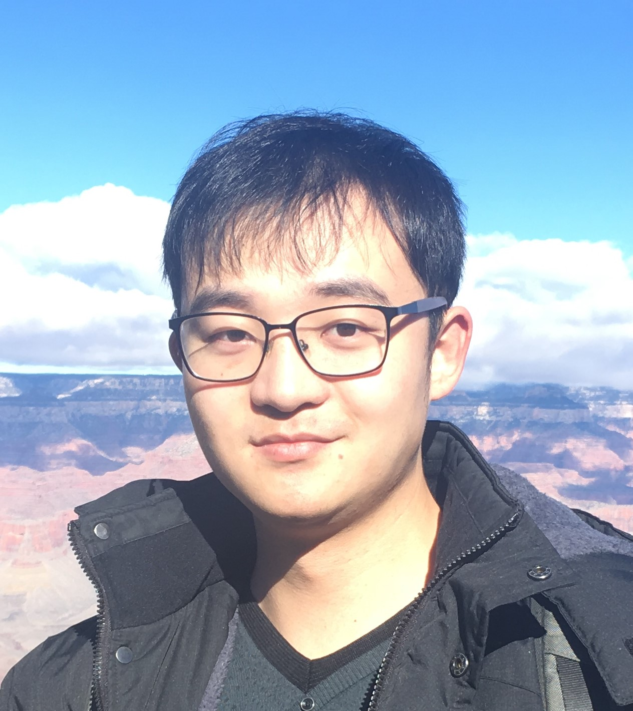
个人简历
基本信息
姓名 赫哲
性别 男
国籍 中国
出生年月 1993年2月
现工作单位\职称 山东高等技术研究院,济南，副研究员
联系地址 山东省济南市蟠龙路1501号
电话 (+86)13907278615
邮箱 zhe.he@iat.cn

科研/工作背景
2023/07－至今 副研究员、山东高等技术研究院，精密测量团队负责人
2020/05－2023/05 博士后、加州理工学院
导师：Lihong V. Wang

教育背景（自本科起）
2015/09－2020/05： 博士，物理学，德州A&M大学
导师：Marlan O. Scully
2011/09－2015/06： 学士，物理学，西安交通大学
导师：高宏

主要研究方向
低温精密测量、低温传感器、量子成像、图像重建、近场光学。

荣誉和项目
2026 山东省自然科学基金面上项目
2025 国家海外博士后引才专项
2024 国家自然基金青年项目
2024 山东省自然科学基金优秀青年项目（海外）
2023 山东省泰山学者青年专家
2020 Dr. Joseph Newton Graduate Student Service Award
2019 Haglar Heep Fellowship
2018 Haglar Heep Fellowship
2017 Herman F. Heep and Minnie Belle Heep fellowship
2014 IEEE & Microsoft Young Scholar

代表性论文
发表SCI论文27篇，其中以第一作者（通讯作者）身份发表论文21篇，包括6篇Nature Communications, Science Advances, JACS，Photonics Research。
2026
- Tong, X., He, Z., Zhang, Y., Liu, W., Huang, C., and Wang, L. V. (2026). Above-twofold quantum super-resolution microscopy enabled by multiple idler passes with entangled biphotons. Sciences Advances, 12(30), 10.1126/sciadv.aea9457.
- Wang, J., Marshall, N., Han, Z., Wang, K., Sprague, R., Yi, Z., He, Z.... & Sokolov, A. V. (2026). Single-shot wide-field biochemical imaging at 1 kHz frame rate. Proceedings of the National Academy of Sciences, 123(27), e2603591123.
- Li, G., Wu, H., Zheng, W., Cao, Q., He, Z*., & Cui, Z. (2012). Cryogenic Thermometry via Nanofilm ThermalStrain Optomechanics. Photonics Research, 14(8): 3318-3325.（通讯作者）（编辑推荐）
- Li, Z., Shao, W., He, Z., Cao, Q., Cui, Z., & Cheng, L. (2026). Dynamic response and relaxation of vortex line density in superfluid helium under nonlinear oscillating thermal counterflow. International Communications in Heat and Mass Transfer, 175, 111107.
- Li, H., Liu, Y., Wang, T., Chen, Y., Lou, J., He, Z., ... & Zheng, W. (2026). Suppression of orientation dependent heat transport across Al/α-A l 2 O 3 interfaces by interfacial atomic disorder. Physical Review B, 113(16), 165304.
2025
- He, Z.*, Wu, H., Li, G., Shao, C., Zheng, W., Cao, Q., Cui, Z. (2025). Quantum-resolution Imaging with Multicenter Integration, ACS Photonics, 12(11): 6530-6534.（通讯作者）
- Wang, J., Jiang, Z., He, Z*., Zhang, P., Yi, Z., Sokolov, A. V., & Scully, M. O. (2025). Tip-enhanced Raman spectroscopy of cell wall heterogeneity for Aspergillus Fumigatus. Applied Physics Letters, 127(11).（通讯作者）
- Yue, X., Wu, H., Wang, J., & He, Z.* (2025). Quantum super-resolution imaging: a review and perspective. Nanophotonics, 14(11), 1961-1974. (封面论文)
- Wu, H., Li, G., & He, Z.* (2025). Optomechanical thermal effect of nanofilm by time-correlated single-photon counting. Applied Physics Letters, 126(20).（通讯作者）
2024
- Kahraman, S. S., Titimbo, K., He, Z., Shen, J. T., & Wang, L. V. (2024). Quantum mechanical modeling of the multi-stage Stern–Gerlach experiment conducted by Frisch and Segrè. New Journal of Physics, 26(7), 073005. (共一作)
- He, Z., Wang, J., Wang, R., & Kurouski, D. (2024). Imaging spatial plasmon mode of nanocavity formed by Au tip and Au nanorod lattice in tip-enhanced Raman spectroscopy. Journal of Applied Physics, 135(19).
- Zhang, Y., He, Z., Tong, X., Garrett, D. C., Cao, R., & Wang, L. V. (2024). Quantum imaging of biological organisms through spatial and polarization entanglement. Science Advances, 10(10), eadk1495. (共一作)
2023
- Titimbo, K., Garrett, D. C., Kahraman, S. S., He, Z., & Wang, L. V. (2023). Numerical modeling of the multi-stage Stern–Gerlach experiment by Frisch and Segrè using co-quantum dynamics via the Bloch equation. Journal of Physics B: Atomic, Molecular and Optical Physics, 56(20), 205004. (共一作)
- He, Z., Titimbo, K., Garrett, D. C., Kahraman, S. S., & Wang, L. V. (2023). Numerical modeling of the multi-stage Stern–Gerlach experiment by Frisch and Segrè using co-quantum dynamics via the Schrödinger equation. Journal of Physics B: Atomic, Molecular and Optical Physics, 56(20), 205005.
- Wang, J., Han, Z., He, Z.*, Wang, K., Liu, X., & Sokolov, A. V. (2023). Tip-enhanced photoluminescence of monolayer MoS2 increased and spectrally shifted by injection of electrons. Nanophotonics, 12(14), 2937-2943.（通讯作者）
- He, Z., Zhang, Y., Tong, X., Li, L., & Wang, L. V. (2023). Quantum microscopy of cells at the Heisenberg limit. Nature communications, 14(1), 2441.
- Tong, X., He, Z., Zhang, Y., Solomon, S., Lin, L., Song, Q., & Wang, L. V. (2023). Experimental full-domain mapping of quantum correlation in Clauser-Horne-Shimony-Holt scenarios. Physical review applied, 19(3), 034049. (共一作)
- Wang, R., He, Z., & Kurouski, D. (2023). Near-field and photocatalytic properties of mono-and bimetallic nanostructures monitored by nanocavity surface-enhanced Raman scattering. Nano Research, 16(1), 1545-1551. (共一作)
2021
- Wang, J., Wang, K., Shen, Y., Han, Z., Li, F., He, Z., ... & Scully, M. O. (2021). Femtosecond time-resolved infrared-resonant third-order sum-frequency spectroscopy. ACS Photonics, 8(4), 1137-1142. (封面论文)
2020
- He, Z., Qiu, W., Kizer, M. E., Wang, J., Chen, W., Sokolov, A. V., ... & Scully, M. O. (2020). Resolving the sequence of RNA strands by tip-enhanced Raman spectroscopy. ACS Photonics, 8(2), 424-430. (封面论文)
- Wang, R., He, Z., Sokolov, A. V., & Kurouski, D. (2020). Gap-mode tip-enhanced Raman scattering on Au nanoplates of varied thickness. The Journal of Physical Chemistry Letters, 11(10), 3815-3820. (共一作)
- He, Z. (2020). Advances in Tip-Enhanced Raman and Photoluminescence Spectroscopy (Doctoral dissertation, Texas A&M University).
2019
- He, Z., Han, Z., Yuan, J., Sinyukov, A. M., Eleuch, H., Niu, C., ... & Scully, M. O. (2019). Quantum plasmonic control of trions in a picocavity with monolayer WS2. Science advances, 5(10), eaau8763.
2018
- He, Z., Han, Z., Kizer, M., Linhardt, R. J., Wang, X., Sinyukov, A. M., ... & Scully, M. O. (2018). Tip-enhanced Raman imaging of single-stranded DNA with single base resolution. Journal of the American Chemical Society, 141(2), 753-757.
- Shutov, A. D., Yi, Z., Wang, J., Sinyukov, A. M., He, Z., Tang, C., ... & Scully, M. O. (2018). Giant chemical surface enhancement of coherent Raman scattering on MoS2. Acs Photonics, 5(12), 4960-4968.
- Tang, C., He, Z., Chen, W., Jia, S., Lou, J., & Voronine, D. V. (2018). Quantum plasmonic hot-electron injection in lateral WS e 2/MoS e 2 heterostructures. Physical Review B, 98(4), 041402. (共一作)
2016
- He, Z., Voronine, D. V., Sinyukov, A. M., Liege, Z. N., Birmingham, B., Sokolov, A. V., ... & Scully, M. O. (2016). Tip-Enhanced Raman scattering on bulk MoS 2 substrate. IEEE Journal of Selected Topics in Quantum Electronics, 23(2), 113-118.
2015
- Cai, H., Wang, W., Liu, P., Wang, G., Liu, A., He, Z., ... & Xia, M. (2015). Enhanced synthesis of Sn nanowires with aid of Se atom via physical vapor transport. Journal of Crystal Growth, 420, 42-46.

会议论文
- Tong, X., He, Z., Zhang, Y., Li, L., & Wang, L. V. (2024, March). Super-resolution quantum microscopy at the Heisenberg limit. In Quantum Sensing, Imaging, and Precision Metrology II (p. PC1291226). SPIE.
- Titimbo, K., Garrett, D. C., Kahraman, S. S., He, Z., & Wang, L. V. (2024, March). Numerical modeling of the multi-stage Stern–Gerlach experiment by Frisch and Segrè using co-quantum dynamics via the Bloch equation. In Quantum Sensing, Imaging, and Precision Metrology II (p. PC129122F). SPIE.
- Hu, J., He, Z., Sokolov, A., Wang, X., & Scully, M. (2022, March). Resolving the sequence of DNA and RNA strands by tip-enhanced Raman spectroscopy. In Smart Photonic and Optoelectronic Integrated Circuits 2022 (p. PC1200503). SPIE.
- He, Z., Qiu, W., Kizer, M. E., Wang, J., Sokolov, A. V., Wang, X., ... & Scully, M. O. (2021, May). Gap Mode Tip-Enhanced Raman and AFM Imaging of RNA Strands. In CLEO: Applications and Technology (pp. AM1R-3). Optica Publishing Group.
- Wang, J., Wang, K., Shen, Y., Han, Z., Li, F., He, Z., ... & Scully, M. O. (2021, May). Femtosecond Time-Resolved Infrared-Resonant Third-Order Sum-Frequency Spectroscopy Towards Label-Free Imaging. In CLEO: QELS_Fundamental Science (pp. JTh3A-71). Optica Publishing Group.
- Shutov, A., Yi, Z., Wang, J., Sinyukov, A., He, Z., Tang, C., ... & Scully, M. (2018). Chemical Surface-Enhanced Coherent Raman Scattering by Semiconductor Nanoparticles. Bulletin of the American Physical Society, 63.
- Shutov, A. D., Yi, Z., Wang, J., Sinyukov, A. M., He, Z., Tang, C., ... & Scully, M. O. (2018, September). Coherent Anti-Stokes Raman Scattering Enhanced by MoS2 Nanoparticles. In Laser Science (pp. JW3A-40). Optica Publishing Group.
- Tang, C., He, Z., & Voronine, D. (2017). Nano-optical Imaging of 2D Materials. Bulletin of the American Physical Society, 62.
- He, Z., Voronine, D., Sinyukov, A., Liege, Z., Birmingham, B., Moore, K., ... & Scully, M. (2015). Chemical Mapping of CuPc on MoS2 using Tip-Enhanced Raman Scattering. Bulletin of the American Physical Society, 60.

会议经历

ORAL PRESENTATIONS
- He, Z. (2025/07). Spatial resolution enhancement by quantum entanglement, META 2025, Torremolinos, Spain
- He, Z. (2021/05). Gap Mode Tip-Enhanced Raman and AFM Imaging of RNA Strands., CLEO, Online, CA, USA
- He, Z. (2019/09). Tip-enhanced Raman imaging of DNA/RNA with single-base resolution, Integrated SPM & Optical Spectroscopy for Advanced Characterization at Nanoscale, Columbia University, NY, USA
- He, Z. (2019/07). Quantum plasmonic hot-electron injection in two-dimensional transition-metal dichalcogenide, TAMU-Casper Summer School on Quantum Science, Casper, WY, USA
- He, Z. (2019/06). Tip enhanced Raman imaging of DNA/RNA with single-base resolution, TAMU-Princeton Symposium, Princeton, NJ, USA
- He, Z. (2019/01). Tip-enhanced Raman imaging of ssDNA & RNA with subnanometer resolution, The 49th Winter Colloquium on the Physics of Quantum Electronics, Snowbird, UT, USA
- He, Z. (2015/10). Chemical Mapping of CuPc on MoS₂ using Tip-enhanced Raman Scattering, Joint Meeting of Texas Section of the AAPT/APS, Waco, TX, USA

POSTER PRESENTATIONS
- He, Z., Shutov, A (2018/09). Coherent Anti-Stokes Raman Scattering Enhanced by MoS₂ Nanoparticles, OSA Frontiers in Optics & Laser Science APS, Washington, DC, USA
- He, Z. (2018/01). ssDNA nucleotides analysis by tip-enhanced Raman scattering, The 48th Winter Colloquium on the Physics of Quantum Electronics, Snowbird, UT, USA
- He, Z. (2017/07). Enhanced plasmonic photoresponse of 2D heterostructures, TAMU-Casper Summer School on Quantum Science, Casper, WY, USA
- He, Z. (2017/01). Quantum Plasmonic Generation, Nano-Imaging, and Control Trions in Monolayer Tungsten Disulfide, The 47th Winter Colloquium on the Physics of Quantum Electronics, Snowbird, UT
- He, Z. (2016/01). Molecular Imaging on MoS₂ using Tip-enhanced Raman Spectroscopy, The 46th Winter Colloquium on the Physics of Quantum Electronics, Snowbird, UT

