# 机器环境安装

本项目所有服务，均使用docker方式部署。机器环境以centos7为准。

提供以下步骤安装，供参考

机器列表

|  |  |  |
| --- | --- | --- |
| 机器IP | 配置 | 用户 |
| 94.191.83.120 | 4核8G | Root |
| 106.55.250.100 | 2核4G | Root |
| 106.55.248.74 | 2核4G | Root |
| 106.55.249.133 | 2核4G | Root |
| 106.55.152.41 | 4核8G | Root |
| 106.52.62.38 | 4核8G | Root |
| 106.53.195.121 | 2核4G | Root |
| 106.55.246.66 | 2核4G | Root |
| 106.55.248.7 | 2核4G | Root |

机器部署情况

|  |  |  |  |
| --- | --- | --- | --- |
| 机器ip | 部署方式 | 部署内容 | 描述 |
| 94.191.83.120 | Docker | mysql-master-pro-master | 产品模块主db |
| 94.191.83.120 | Docker | mysql-master-pro-slave | 产品模块从db |
| 94.191.83.120 | Docker | mysql-master3309 | 订单模块主db |
| 94.191.83.120 | Docker | mysql-slave3310 | 订单模块从db |
| 94.191.83.120 | Docker | mongo | Mongodb |
| 94.191.83.120 | Docker | Zookeeper | Zookeeper |
| 94.191.83.120 | Docker | Rabbitmq | Rabbitmq |
| 94.191.83.120 | Docker | fastdfs | fastdfs |
| 94.191.83.120 | Docker | mysql-master | 未分库之前的主db |
| 94.191.83.120 | Docker | mysql-slave | 未分库之前的从db |
| 94.191.83.120 | Jar | Jenkins | Jenkins |
| 94.191.83.120 | 源码安装 | Mycat | Mycat |

|  |  |  |  |
| --- | --- | --- | --- |
| 机器ip | 部署方式 | 部署内容 | 描述 |
| 106.55.250.100 | Docker | mall-account | mall-account |
| 106.55.250.100 | Docker | mall-config | mall-config |
| 106.55.250.100 | Docker | mall-admin | mall-admin |
| 106.55.250.100 | Docker | mall-dashboard | mall-dashboard |

|  |  |  |  |
| --- | --- | --- | --- |
| 机器ip | 部署方式 | 部署内容 | 描述 |
| 106.55.248.74 | Docker | mall-product-service | mall-product-service |
| 106.55.248.74 | Docker | mall-pay | mall-pay |
| 106.55.248.74 | Docker | mall-order-service | mall-order-service |
| 106.55.248.74 | Docker | mall-kill | mall-kill |

|  |  |  |  |
| --- | --- | --- | --- |
| 机器ip | 部署方式 | 部署内容 | 描述 |
| 106.55.249.133 | Docker | mall-account | mall-account |
| 106.55.249.133 | Docker | mall-config | mall-config |
| 106.55.249.133 | Docker | mall-eureka | mall-eureka |

|  |  |  |  |
| --- | --- | --- | --- |
| 机器ip | 部署方式 | 部署内容 | 描述 |
| 106.55.152.41 | Docker | mall-web-order | mall-web-order |
| 106.55.152.41 | Docker | kill-mysql-master | 秒杀模块主db |
| 106.55.152.41 | Docker | kill-mysql-slave | 秒杀模块从db |
| 106.55.152.41 | Docker | mysql-master | 用户模块主db |
| 106.55.152.41 | Docker | mysql-slave | 用户模块从db |
| 106.55.152.41 | Docker | nginx | nginx |

|  |  |  |  |
| --- | --- | --- | --- |
| 机器ip | 部署方式 | 部署内容 | 描述 |
| 106.52.62.38 | Docker | mall-web-order | mall-web-order |
| 106.52.62.38 | Docker | kafka-manager | Kafka管理 |
| 106.52.62.38 | Docker | es | es |
| 106.52.62.38 | Docker | elasticsearch-head | es数据展示 |
| 106.52.62.38 | Docker | kafka | kafka |
| 106.52.62.38 | Docker | Zookeeper | Zookeeper |
| 106.52.62.38 | Docker | config | seata数据库配置 |
| 106.52.62.38 | Docker | fastdfs | fastdfs |
| 106.52.62.38 | Docker | redis | redis |
| 106.52.62.38 | jar | zipkin | 微服务链路追踪 |
| 106.52.62.38 | 源码安装 | Seata | 分布式事务 |

|  |  |  |  |
| --- | --- | --- | --- |
| 机器ip | 部署方式 | 部署内容 | 描述 |
| 106.53.195.121 | Docker | mall-product-service | mall-product-service |
| 106.53.195.121 | Docker | mall-pay | mall-pay |
| 106.53.195.121 | Docker | mall-order-service | mall-order-service |
| 106.53.195.121 | Docker | mall-kill | mall-kill |

|  |  |  |  |
| --- | --- | --- | --- |
| 机器ip | 部署方式 | 部署内容 | 描述 |
| 106.55.246.66 | Docker | mall-zuul | mall-zuul |
| 106.55.246.66 | Docker | mall-web-mng | mall-web-mng |
| 106.55.246.66 | Docker | mall-user-service | mall-user-service |

|  |  |  |  |
| --- | --- | --- | --- |
| 机器ip | 部署方式 | 部署内容 | 描述 |
| 106.55.248.7 | Docker | mall-zuul | mall-zuul |
| 106.55.248.7 | Docker | mall-web-mng | mall-web-mng |
| 106.55.248.7 | Docker | mall-user-service | mall-user-service |

## 约定项目域名

域名用的是阿里云的域名，域名解析指向了nginx所在的服务器地址

域名：http://mi.xiangxueketang.cn

## jdk与maven安装

项目需要自动打包部署，因此需要配置jdk与maven

安装jdk

yum install java-1.8.0-openjdk.x86_64

安装maven

安装maven

sudo yum install -y yum-utils

yum-config-manager --add-repo http://repos.fedorapeople.org/repos/dchen/apache-maven/epel-apache-maven.repo

yum install -y apache-maven

配置maven仓库为阿里云

<mirror>

<id>nexus-aliyun</id>

<mirrorOf>central</mirrorOf>

<name>Nexus aliyun</name>

<url>http://maven.aliyun.com/nexus/content/groups/public</url>

</mirror>

## docker安装

* 1. sudo yum install -y yum-utils device-mapper-persistent-data lvm2
  2. sudo yum-config-manager --add-repo https://[mirrors.aliyun.com/docker-ce/linux/centos/docker-ce.repo](http://mirrors.aliyun.com/docker-ce/linux/centos/docker-ce.repo)
  3. sudo yum install docker-ce

配置docker加速器（注册阿里云加速更快）、容器网段、镜像仓库

vi /etc/docker/daemon.json

{

"bip":"172.18.6.1/24",

"registry-mirrors":[" https://kzorq22x.mirror.aliyuncs.com"],

"insecure-registries":["192.168.244.10:5000"]

}

配置后重启docker服务：

systemctl daemon-reload

systemctl restart docker

## docker-compose安装

sudo curl -L https://github.com/docker/compose/releases/download/1.28.5/docker-compose-`uname -s`-`uname -m` > /usr/local/bin/docker-compose

sudo chmod +x /usr/local/bin/docker-compose

curl -L "https://get.daocloud.io/docker/compose/releases/download/1.28.5/docker-compose-$(uname -s)-$(uname -m)" -o /usr/local/bin/docker-compose

## docker仓库服务

Docker镜像仓库用的是腾讯云的仓库

登录仓库

docker login -u 2181935941@qq.com xiangxueman-docker.pkg.coding.net

推送镜像

1. 给本地镜像打标签

docker tag tag1 xiangxueman-docker.pkg.coding.net/enjoy-mi/mi-images/mall-zuul:1.0

1. 推送您的 docker 镜像

docker push xiangxueman-docker.pkg.coding.net/enjoy-mi/mi-images/mall-zuul:1.0

拉取镜像

docker pull xiangxueman-docker.pkg.coding.net/enjoy-mi/mi-images/mall-zuul:1.0

## docker挂载目录约定。

数据目录：/docker-data

日志目录：/docker-log

# 项目环境搭建

## zk搭建

docker run -d \

> -p 2181:2181 \

> -v /home/zookeeper/data/:/data/ \

> --name=zookeeper \

> --privileged zookeeper:3.4.9

## redis搭建

docker run -d --name redis -p 6379:6379 redis --requirepass "123456"

## mysql主从搭建

### 创建mysql主从库配置目录

mkdir -p /docker-data/mysql/master/conf

mkdir -p /docker-data/mysql/slave/conf

### 在/docker-data/mysql/master/conf下，创建my.cnf配置文件

[client]

port=3306

default-character-set=utf8

[mysql]

default-character-set=utf8

[mysqld]

character_set_server=utf8

sql_mode=NO_ENGINE_SUBSTITUTION,STRICT_TRANS_TABLES

# 配置大小写不敏感

lower_case_table_names=1

## 同一局域网内注意要唯一

server-id=100

## 开启二进制日志功能（关键）

log-bin=mysql-bin

### 在/docker-data/mysql/slave/conf下，创建my.cnf配置文件

[client]

port=3306

default-character-set=utf8

[mysql]

default-character-set=utf8

[mysqld]

character_set_server=utf8

sql_mode=NO_ENGINE_SUBSTITUTION,STRICT_TRANS_TABLES

# 配置大小写不敏感

lower_case_table_names=1

## 同一局域网内注意要唯一

server-id=101

### 使用docker-compose来管理mysql主从库，

### 在/docker-data/mysql下创建docker-compose.yaml：

vi docker-compose.yaml

version: '3'

services:

mysql-slave:

image: mysql:5.7

depends_on:

- mysql-master

links:

- mysql-master

volumes:

- /docker-data/mysql/slave/data:/var/lib/mysql

- /docker-data/mysql/slave/conf:/etc/mysql

- /docker-data/mysql/slave/log:/var/log/mysql

ports:

- "3308:3306"

restart: always

environment:

MYSQL_ROOT_PASSWORD: root

container_name: mysql-slave

mysql-master:

image: mysql:5.7

volumes:

- /docker-data/mysql/master/data:/var/lib/mysql

- /docker-data/mysql/master/conf:/etc/mysql

- /docker-data/mysql/master/log:/var/log/mysql

ports:

- "3307:3306"

restart: always

environment:

MYSQL_ROOT_PASSWORD: root

container_name: mysql-master

### 启动compose来启动mysql

docker-compose up -d

### 主数据库配置，连接主库并创建数据同步用户

CREATE USER 'slave'@'%' IDENTIFIED BY '123456';

GRANT REPLICATION SLAVE, REPLICATION CLIENT ON *.* TO 'slave'@'%';

SHOW MASTER STATUS ;



### 从数据库配置，连接从库配置从库同步连接（指定连接的ip/port/user/passwd以及上图中show master status命令得到的file和position值）

CHANGE MASTER TO MASTER_HOST='119.3.30.5',MASTER_PORT=3307,MASTER_USER='slave',MASTER_PASSWORD='123456',MASTER_LOG_FILE='mysql-bin.000003',MASTER_LOG_POS=774;

#启动同步进程

START SLAVE;

### 测试结果状态

主库查询进程：SHOW PROCESSLIST



从库查询进程：SHOW PROCESSLIST



## mongodb搭建

docker run -d --name mongo -p 27017:27017 -v /docker-data/mongo:/data/db mongo

## fastdfs图片服务

创建fastdfs容器服务

docker run --add-host [fastdfs.net](http://fastdfs.net/):192.168.244.10 --name fastdfs --net=host -e TRACKER_ENABLE=1 -e NGINX_PORT=8181 -v /docker-data/fastdfs:/storage/fastdfs -it mypjb/fastdfs

并进入容器内修改mod_fastdfs配置，vi /usr/local/nginx/modules/fastdfs/src/mod_fastdfs.conf

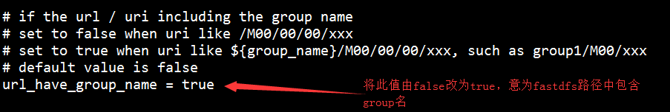

修改tracker_server地址

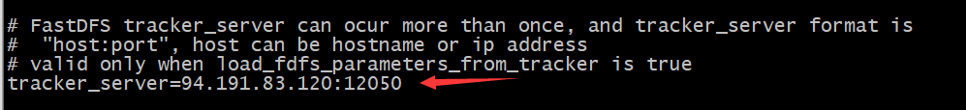

修改nginx配置，vi /usr/local/nginx/conf/nginx.conf

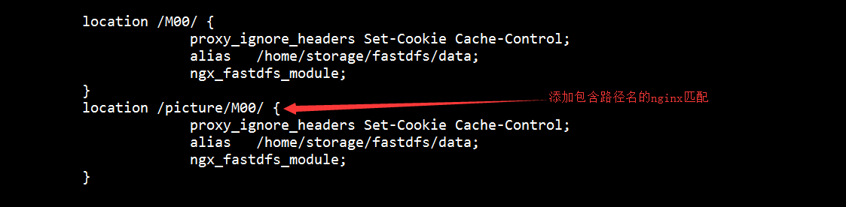

重启nginx服务，nginx -s reload

退出容器（ctrl + Q）

## rabbitMQ服务

docker run -d --name mq -p 5672:5672 -p 15672:15672 -v /docker-data/rabbitmq:/var/lib/rabbitmq -e RABBITMQ_DEFAULT_USER=admin -e RABBITMQ_DEFAULT_PASS=admin rabbitmq:3.7.14-management

## nginx服务

创建nginx命令：

docker run -ti -p 80:80 --name nginx --privileged -d -v /home/docker-data/nginx/nginx.conf:/etc/nginx/nginx.conf -v /home/docker-data/nginx/error.log:/etc/nginx/log/error.log -v /home/docker-data/nginx/server/:/etc/nginx/conf.d/ -v /home/docker-data/nginx/web/:/root/web/ --privileged=true nginx

各微服务的nginx配置

vi mi.conf

upstream zuul {

#weigth参数表示权值，权值越高被分配到的几率越大

#本机上的Squid开启3128端口

server 106.55.246.66:8193;

server 106.55.248.7:8193;

}

upstream mall {

#weigth参数表示权值，权值越高被分配到的几率越大

#本机上的Squid开启3128端口

#server 106.55.152.41:8186;

server 106.52.62.38:8186;

}

upstream mallmng {

#weigth参数表示权值，权值越高被分配到的几率越大

#本机上的Squid开启3128端口

server 106.55.248.7:8185;

server 106.55.246.66:8185;

}

upstream mallcallback {

#weigth参数表示权值，权值越高被分配到的几率越大

#本机上的Squid开启3128端口

server 106.55.248.74:8188;

server 106.53.195.121:8188;

}

upstream mallaccount {

#weigth参数表示权值，权值越高被分配到的几率越大

#本机上的Squid开启3128端口

#server 106.55.250.100:8180;

#server 106.55.249.133:8180;

server 106.52.62.38:8180;

}

server {

listen 80;

server_name mi.xiangxueketang.cn;

location /mall/api {

proxy_pass http://zuul;

proxy_set_header Host $host:$server_port;

}

location /mall {

alias /root/web/mall/static/;

index index.php index.html index.htm;

}

location /mall/static {

alias /root/web/mall/static/static/;

expires 30d;

}

#location /mall/static/css {

# alias /root/web/mall/static/static/css;

# expires 30d;

#}

#location /mall/static/img {

# alias /root/web/mall/static/static/img;

# expires 30d;

#}

location /mall-mng/api {

proxy_pass http://zuul;

}

location /mall-mng {

alias /root/web/mall-mng/static/;

index index.php index.html index.htm;

}

location /mall-mng/static {

alias /root/web/mall-mng/static/static/;

expires 30d;

}

location ~ /picture/M00{

proxy_pass http://94.191.83.120:8181;

}

location /wx {

proxy_pass http://mallcallback;

}

location /mall-account/api {

proxy_pass http://zuul;

}

location /mall-account {

alias /root/web/mall-account/static/;

index index.php index.html index.htm;

}

location /mall-account/scripts {

alias /root/web/mall-account/static/scripts/;

expires 30d;

}

}

vi nginx.conf

#运行用户

user root;

#启动进程,通常设置成和cpu的数量相等

worker_processes 4;

#全局错误日志及PID文件

error_log /var/log/nginx/error.log;

pid /var/run/nginx.pid;

#工作模式及连接数上限

events {

use epoll; #epoll是多路复用IO(I/O Multiplexing)中的一种方式,但是仅用于linux2.6以上内核,可以大大提高nginx的性能

worker_connections 1024;#单个后台worker process进程的最大并发链接数

# multi_accept on;

}

#设定http服务器，利用它的反向代理功能提供负载均衡支持

http {

#设定mime类型,类型由mime.type文件定义

include /etc/nginx/mime.types;

default_type application/octet-stream;

#设定日志格式

access_log /var/log/nginx/access.log;

#sendfile 指令指定 nginx 是否调用 sendfile 函数（zero copy 方式）来输出文件，对于普通应用，

#必须设为 on,如果用来进行下载等应用磁盘IO重负载应用，可设置为 off，以平衡磁盘与网络I/O处理速度，降低系统的uptime.

sendfile on;

#tcp_nopush on;

#连接超时时间

#keepalive_timeout 0;

keepalive_timeout 65;

tcp_nodelay on;

#开启gzip压缩

gzip on;

gzip_disable "MSIE [1-6]\.(?!.*SV1)";

#设定请求缓冲

client_header_buffer_size 1k;

large_client_header_buffers 4 4k;

include /etc/nginx/conf.d/*.conf;

include /etc/nginx/sites-enabled/*;

#设定负载均衡的服务器列表

# upstream mysvr {

#weigth参数表示权值，权值越高被分配到的几率越大

#本机上的Squid开启3128端口

# server 192.168.8.1:3128 weight=5;

# server 192.168.8.2:80 weight=1;

# server 192.168.8.3:80 weight=6;

# }

# server {

#侦听80端口

# listen 80;

#定义使用www.xx.com访问

# server_name 106.55.152.41;

#设定本虚拟主机的访问日志

#access_log logs/www.xx.com.access.log main;

#默认请求

# location / {

# root /root; #定义服务器的默认网站根目录位置

# index index.php index.html index.htm; #定义首页索引文件的名称

#

# fastcgi_pass www.xx.com;

#fastcgi_param SCRIPT_FILENAME $document_root/$fastcgi_script_name;

#include /etc/nginx/fastcgi_params;

# }

# 定义错误提示页面

# error_page 500 502 503 504 /50x.html;

# location = /50x.html {

# root /root;

# }

#静态文件，nginx自己处理

# location ~ ^/(images|javascript|js|css|flash|media|static)/ {

# root /var/www/virtual/htdocs;

#过期30天，静态文件不怎么更新，过期可以设大一点，如果频繁更新，则可以设置得小一点。

# expires 30d;

# }

#PHP 脚本请求全部转发到 FastCGI处理. 使用FastCGI默认配置.

#location ~ \.php$ {

# root /root;

# fastcgi_pass 127.0.0.1:9000;

# fastcgi_index index.php;

# fastcgi_param SCRIPT_FILENAME /home/www/www$fastcgi_script_name;

# include fastcgi_params;

#}

#设定查看Nginx状态的地址

# location /NginxStatus {

# stub_status on;

# access_log on;

# auth_basic "NginxStatus";

# auth_basic_user_file conf/htpasswd;

# }

#禁止访问 .htxxx 文件

# location ~ /\.ht {

# deny all;

# }

# }

}

## seata数据库

docker run --name config -p 3309:3306 --privileged=true -ti -e MYSQL_ROOT_PASSWORD=root -e MYSQL_DATABASE=config -e MYSQL_USER=root -e MYSQL_PASSWORD=root -v /home/docker-data/mysql/seata/conf/:/etc/mysql/conf.d -v /home/docker-data/mysql/seata/data/:/var/lib/mysql -v /home/docker-data/mysql/seata/logs/:/var/log/mysql -d mysql:5.7

## apm部署

### A、zookeeper安装

docker run -d -p 2181:2181 -v /home/zookeeper/data/:/data/ --name=zookeeper --privileged zookeeper:3.4.9

### B、kafka安装

docker run -d --name kafka --publish 9092:9092 --link zookeeper --env KAFKA_ZOOKEEPER_CONNECT=zookeeper:2181 --env KAFKA_ADVERTISED_HOST_NAME=119.3.30.5 --env KAFKA_ADVERTISED_PORT=9092 --volume /etc/localtime:/etc/localtime wurstmeister/kafka:latest

### C、es安装

docker run -e ES_JAVA_OPTS="-Xms2g -Xmx2g" -d --name es -p 9200:9200 -p 9300:9300 -e "discovery.type=single-node" docker.elastic.co/elasticsearch/elasticsearch:5.6.4

修改es的启动内存，默认启动内存是2G，如果不修改启动不久就会停掉容器

vi config/jvm.options

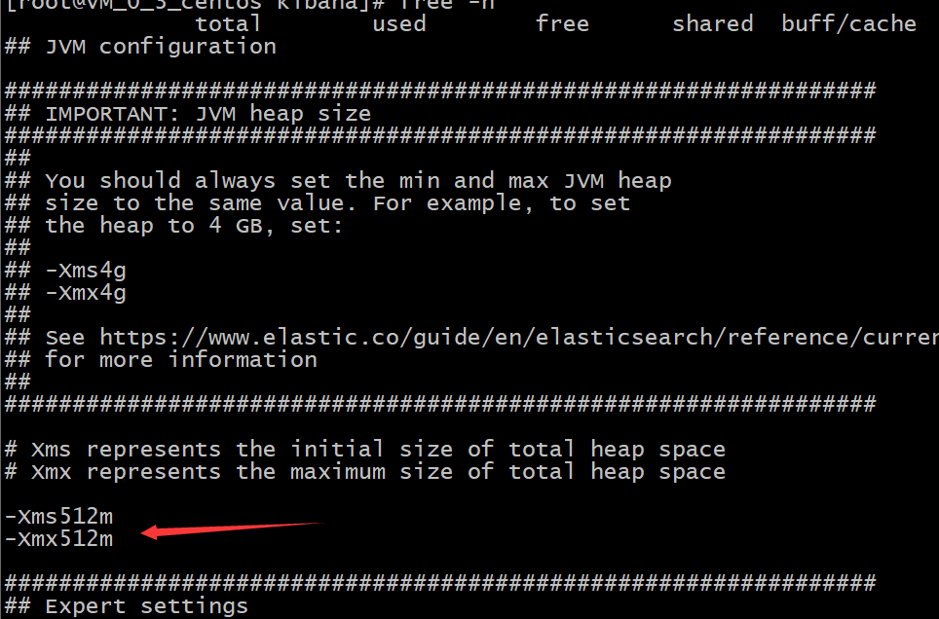

修改elasticsearch的配置文件，加入跨域配置

进入es容器

docker exec -it es /bin/bash

修改配置文件

vi config/elasticsearch.yml

加入如下配置

http.cors.enabled: true

http.cors.allow-origin: "*"

xpack.security.enabled: false

重启es

docker restart es

### D、es head安装

docker run -d -p 9100:9100 docker.io/mobz/elasticsearch-head:5

### E、Kafka manager安装

docker run -itd --name=kafka-manager -p 9000:9000 -e ZK_HOSTS="106.52.62.38:2181" sheepkiller/kafka-manager

配置详情

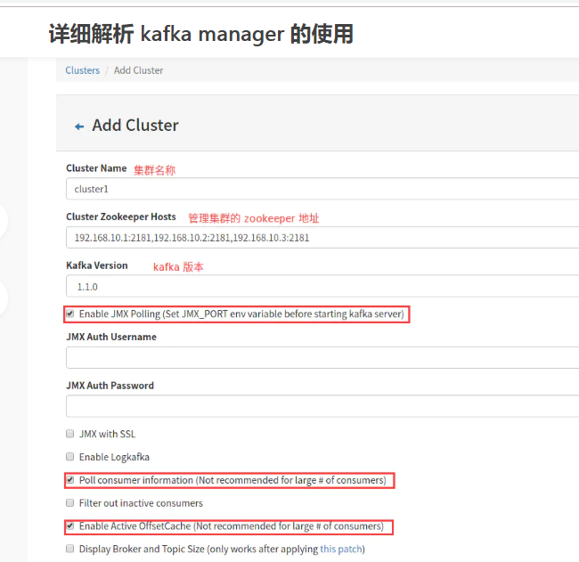

### F、zipkin安装

下载zipkin

wget -O zipkin.jar 'https://search.maven.org/remote_content?g=io.zipkin.java&a=zipkin-server&v=LATEST&c=exec'

启动zipkin

nohup java -DKAFKA_ZOOKEEPER=47.101.195.110:2181 -DKAFKA_BOOTSTRAP_SERVERS=47.101.195.110:9092 -DSTORAGE_TYPE=elasticsearch -DES_HOSTS=http://47.101.195.110:9200 -jar zipkin.jar &

## Mycat部署

Mycat下载

wget <https://github.com/MyCATApache/Mycat-Server/releases/download/Mycat-server-1675-release/Mycat-server-1.6.7.5-release-20200422133810-linux.tar.gz>

解压

tar -zxvf Mycat-server-1.6.7.5-release-20200422133810-linux.tar.gz

启动

./mycat start

# 项目代码部署

项目代码，统一使用docker方式部署。

项目打包部署统一在linux环境下进行（请确保机器环境中装好了jdk/maven/docker）

项目代码托管在腾讯云，地址为：

https://e.coding.net/xiangxueman/enjoy-mi.git

后续代码的CI和CD，持续集成和持续部署都是通过Jenkins来完成的，Jenkins项目一览图

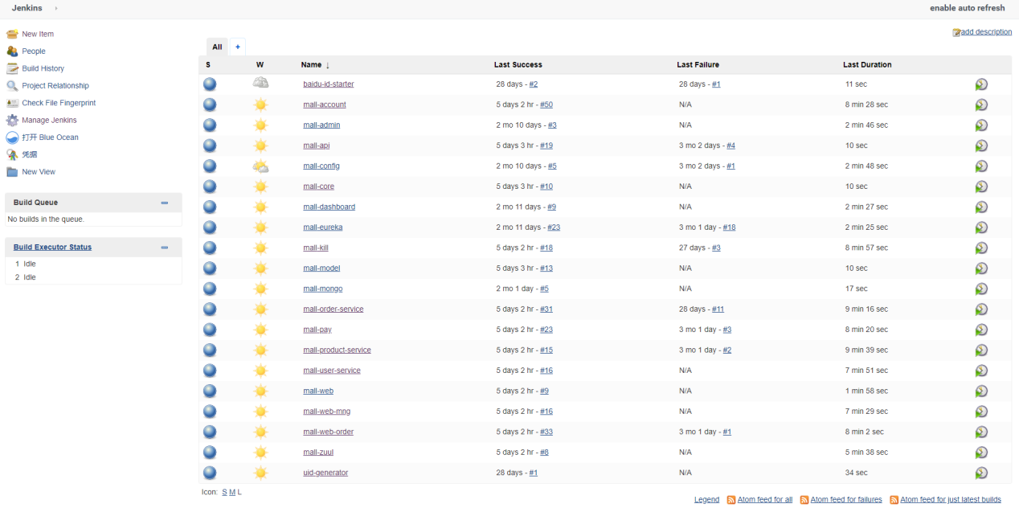

## mall-account

Jenkins中的配置内容如下：

Git地址

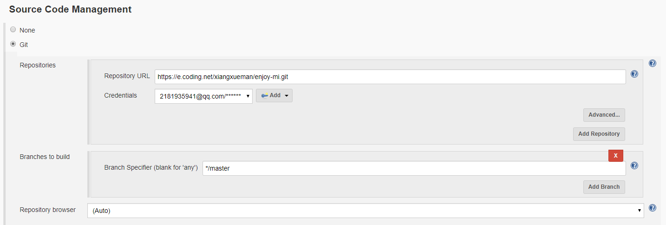

打包指令

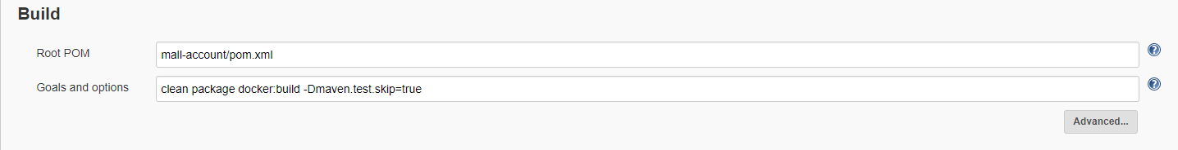

执行 shell，把镜像push到镜像仓库

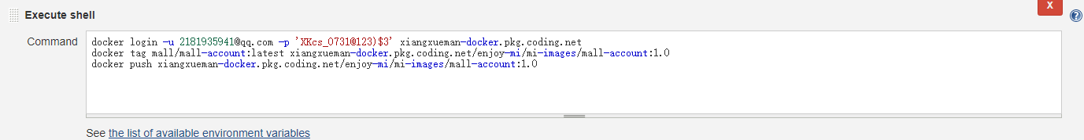

docker login -u 2181935941@qq.com -p 'XKcs_0731@123)$3' xiangxueman-docker.pkg.coding.net

docker tag mall/mall-account:latest xiangxueman-docker.pkg.coding.net/enjoy-mi/mi-images/mall-account:1.0

docker push xiangxueman-docker.pkg.coding.net/enjoy-mi/mi-images/mall-account:1.0

远程部署

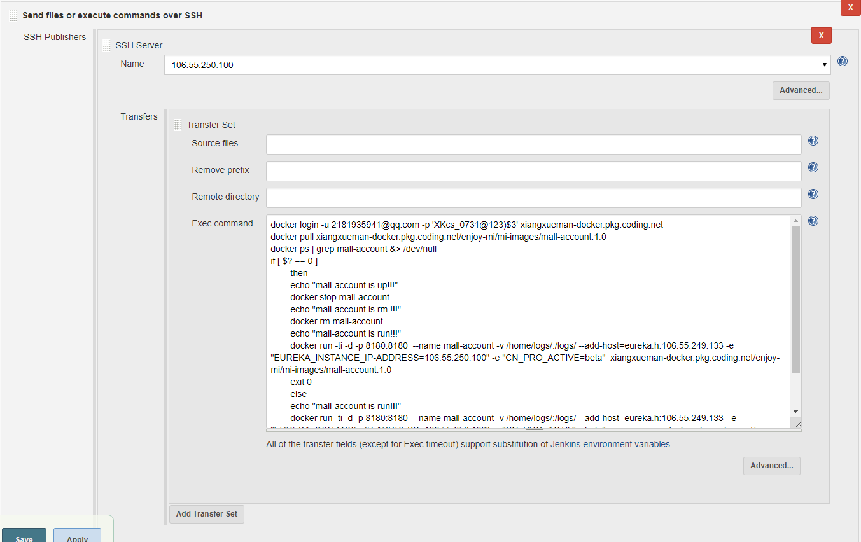

脚本

1. 先登录到镜像仓库
2. 从镜像仓库pull镜像
3. 判断主机中该镜像对应的容器是否启动
4. 如果启动了则关闭容器，删除容器，然后再根据下载的镜像启动容器
5. 如果没有启动则直接根据下载的镜像启动容器

docker login -u 2181935941@qq.com -p 'XKcs_0731@123)$3' xiangxueman-docker.pkg.coding.net

docker pull xiangxueman-docker.pkg.coding.net/enjoy-mi/mi-images/mall-account:1.0

docker ps | grep mall-account &> /dev/null

if [ $? == 0 ]

then

echo "mall-account is up!!!"

docker stop mall-account

echo "mall-account is rm !!!"

docker rm mall-account

echo "mall-account is run!!!"

docker run -ti -d -p 8180:8180 --name mall-account -v /home/logs/:/logs/ --add-host=eureka.h:106.55.249.133 -e "EUREKA_INSTANCE_IP-ADDRESS=106.55.250.100" -e "CN_PRO_ACTIVE=beta" xiangxueman-docker.pkg.coding.net/enjoy-mi/mi-images/mall-account:1.0

exit 0

else

echo "mall-account is run!!!"

docker run -ti -d -p 8180:8180 --name mall-account -v /home/logs/:/logs/ --add-host=eureka.h:106.55.249.133 -e "EUREKA_INSTANCE_IP-ADDRESS=106.55.250.100" -e "CN_PRO_ACTIVE=beta" xiangxueman-docker.pkg.coding.net/enjoy-mi/mi-images/mall-account:1.0

exit 0

fi

## mall-admin

项目构建

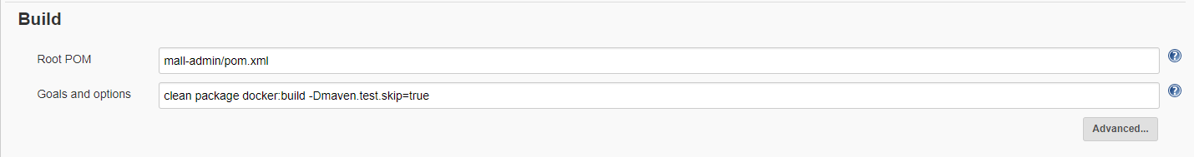

Push镜像到镜像仓库

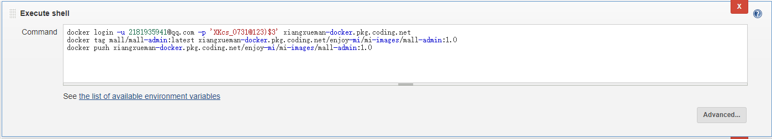

docker login -u 2181935941@qq.com -p 'XKcs_0731@123)$3' xiangxueman-docker.pkg.coding.net

docker tag mall/mall-admin:latest xiangxueman-docker.pkg.coding.net/enjoy-mi/mi-images/mall-admin:1.0

docker push xiangxueman-docker.pkg.coding.net/enjoy-mi/mi-images/mall-admin:1.0

远程发布

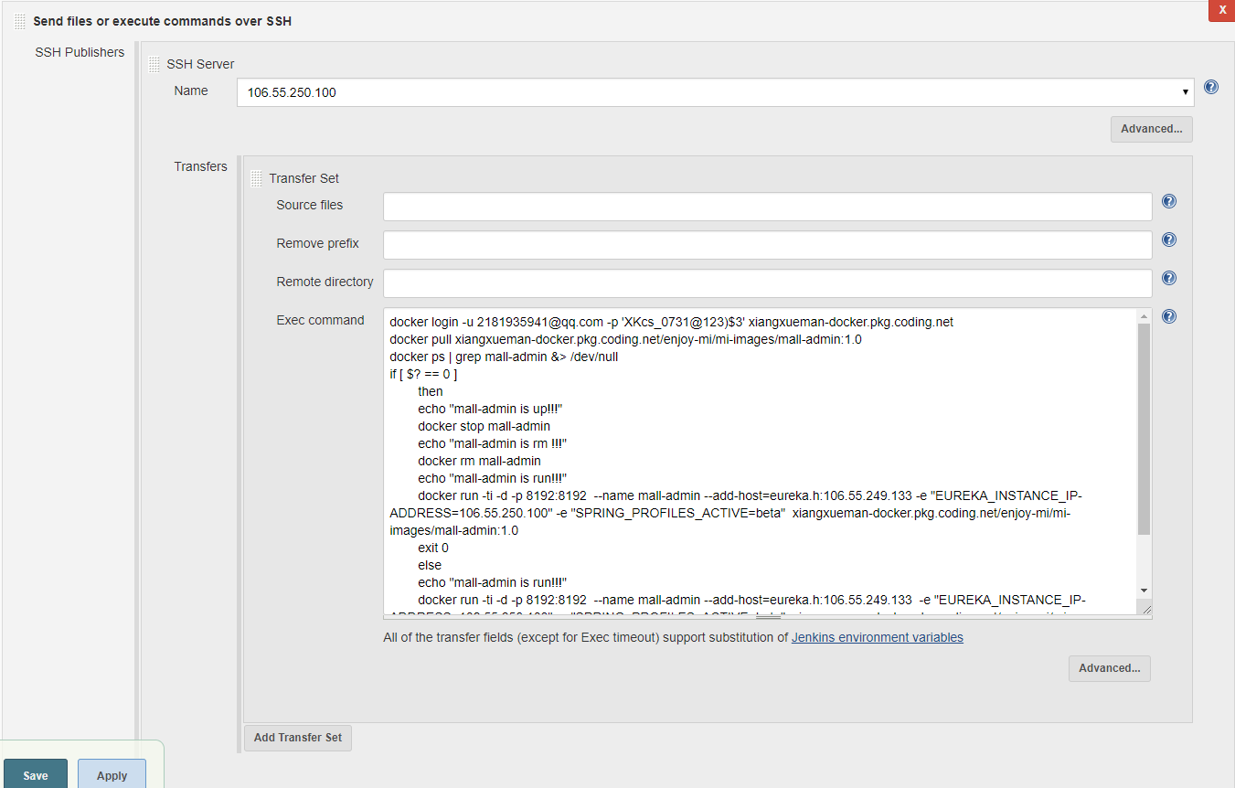

执行脚本

docker login -u 2181935941@qq.com -p 'XKcs_0731@123)$3' xiangxueman-docker.pkg.coding.net

docker pull xiangxueman-docker.pkg.coding.net/enjoy-mi/mi-images/mall-admin:1.0

docker ps | grep mall-admin &> /dev/null

if [ $? == 0 ]

then

echo "mall-admin is up!!!"

docker stop mall-admin

echo "mall-admin is rm !!!"

docker rm mall-admin

echo "mall-admin is run!!!"

docker run -ti -d -p 8192:8192 --name mall-admin --add-host=eureka.h:106.55.249.133 -e "EUREKA_INSTANCE_IP-ADDRESS=106.55.250.100" -e "SPRING_PROFILES_ACTIVE=beta" xiangxueman-docker.pkg.coding.net/enjoy-mi/mi-images/mall-admin:1.0

exit 0

else

echo "mall-admin is run!!!"

docker run -ti -d -p 8192:8192 --name mall-admin --add-host=eureka.h:106.55.249.133 -e "EUREKA_INSTANCE_IP-ADDRESS=106.55.250.100" -e "SPRING_PROFILES_ACTIVE=beta" xiangxueman-docker.pkg.coding.net/enjoy-mi/mi-images/mall-admin:1.0

exit 0

fi

## mall-config

项目构建

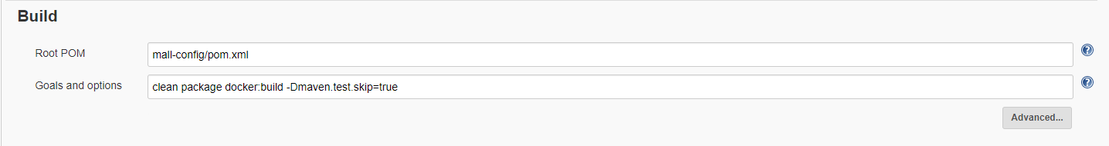

Push镜像到镜像仓库

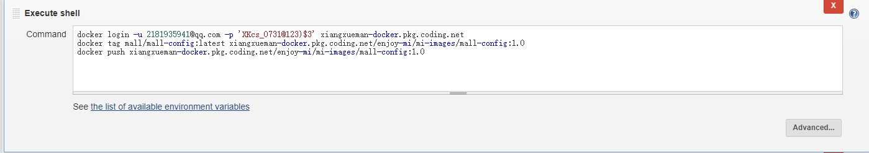

docker login -u 2181935941@qq.com -p 'XKcs_0731@123)$3' xiangxueman-docker.pkg.coding.net

docker tag mall/mall-config:latest xiangxueman-docker.pkg.coding.net/enjoy-mi/mi-images/mall-config:1.0

docker push xiangxueman-docker.pkg.coding.net/enjoy-mi/mi-images/mall-config:1.0

远程发布

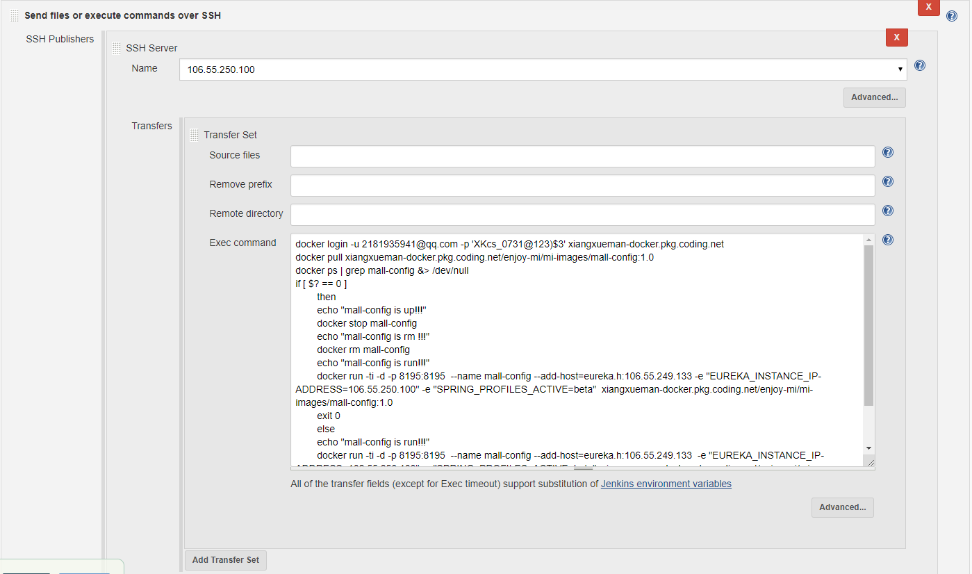

执行脚本

docker login -u 2181935941@qq.com -p 'XKcs_0731@123)$3' xiangxueman-docker.pkg.coding.net

docker pull xiangxueman-docker.pkg.coding.net/enjoy-mi/mi-images/mall-config:1.0

docker ps | grep mall-config &> /dev/null

if [ $? == 0 ]

then

echo "mall-config is up!!!"

docker stop mall-config

echo "mall-config is rm !!!"

docker rm mall-config

echo "mall-config is run!!!"

docker run -ti -d -p 8195:8195 --name mall-config --add-host=eureka.h:106.55.249.133 -e "EUREKA_INSTANCE_IP-ADDRESS=106.55.250.100" -e "SPRING_PROFILES_ACTIVE=beta" xiangxueman-docker.pkg.coding.net/enjoy-mi/mi-images/mall-config:1.0

exit 0

else

echo "mall-config is run!!!"

docker run -ti -d -p 8195:8195 --name mall-config --add-host=eureka.h:106.55.249.133 -e "EUREKA_INSTANCE_IP-ADDRESS=106.55.250.100" -e "SPRING_PROFILES_ACTIVE=beta" xiangxueman-docker.pkg.coding.net/enjoy-mi/mi-images/mall-config:1.0

exit 0

fi

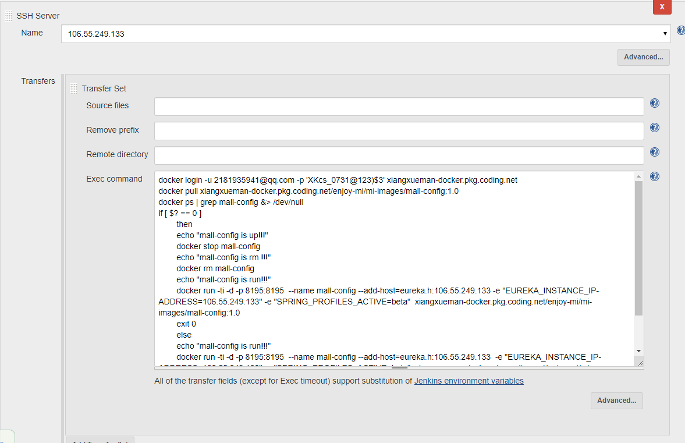

执行脚本

docker login -u 2181935941@qq.com -p 'XKcs_0731@123)$3' xiangxueman-docker.pkg.coding.net

docker pull xiangxueman-docker.pkg.coding.net/enjoy-mi/mi-images/mall-config:1.0

docker ps | grep mall-config &> /dev/null

if [ $? == 0 ]

then

echo "mall-config is up!!!"

docker stop mall-config

echo "mall-config is rm !!!"

docker rm mall-config

echo "mall-config is run!!!"

docker run -ti -d -p 8195:8195 --name mall-config --add-host=eureka.h:106.55.249.133 -e "EUREKA_INSTANCE_IP-ADDRESS=106.55.249.133" -e "SPRING_PROFILES_ACTIVE=beta" xiangxueman-docker.pkg.coding.net/enjoy-mi/mi-images/mall-config:1.0

exit 0

else

echo "mall-config is run!!!"

docker run -ti -d -p 8195:8195 --name mall-config --add-host=eureka.h:106.55.249.133 -e "EUREKA_INSTANCE_IP-ADDRESS=106.55.249.133" -e "SPRING_PROFILES_ACTIVE=beta" xiangxueman-docker.pkg.coding.net/enjoy-mi/mi-images/mall-config:1.0

exit 0

fi

## mall-dashboard

项目构建

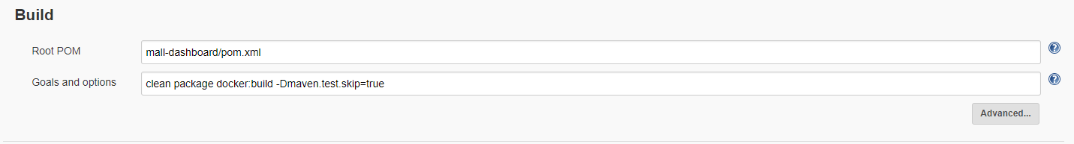

Push镜像到镜像仓库

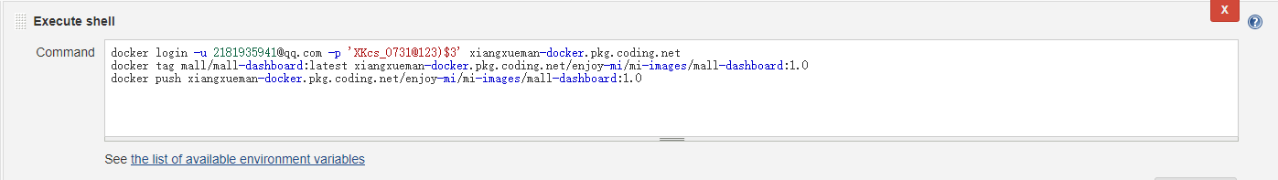

docker login -u 2181935941@qq.com -p 'XKcs_0731@123)$3' xiangxueman-docker.pkg.coding.net

docker tag mall/mall-dashboard:latest xiangxueman-docker.pkg.coding.net/enjoy-mi/mi-images/mall-dashboard:1.0

docker push xiangxueman-docker.pkg.coding.net/enjoy-mi/mi-images/mall-dashboard:1.0

远程发布

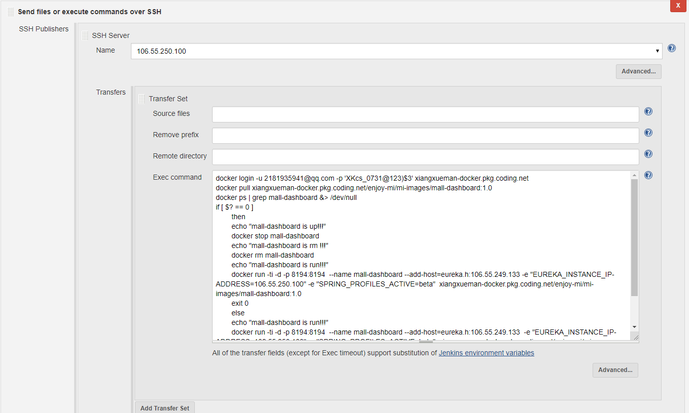

执行脚本

docker login -u 2181935941@qq.com -p 'XKcs_0731@123)$3' xiangxueman-docker.pkg.coding.net

docker pull xiangxueman-docker.pkg.coding.net/enjoy-mi/mi-images/mall-dashboard:1.0

docker ps | grep mall-dashboard &> /dev/null

if [ $? == 0 ]

then

echo "mall-dashboard is up!!!"

docker stop mall-dashboard

echo "mall-dashboard is rm !!!"

docker rm mall-dashboard

echo "mall-dashboard is run!!!"

docker run -ti -d -p 8194:8194 --name mall-dashboard --add-host=eureka.h:106.55.249.133 -e "EUREKA_INSTANCE_IP-ADDRESS=106.55.250.100" -e "SPRING_PROFILES_ACTIVE=beta" xiangxueman-docker.pkg.coding.net/enjoy-mi/mi-images/mall-dashboard:1.0

exit 0

else

echo "mall-dashboard is run!!!"

docker run -ti -d -p 8194:8194 --name mall-dashboard --add-host=eureka.h:106.55.249.133 -e "EUREKA_INSTANCE_IP-ADDRESS=106.55.250.100" -e "SPRING_PROFILES_ACTIVE=beta" xiangxueman-docker.pkg.coding.net/enjoy-mi/mi-images/mall-dashboard:1.0

exit 0

fi

## mall-eureka

项目构建

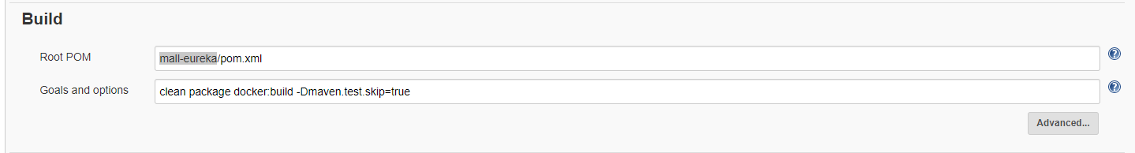

Push镜像到镜像仓库

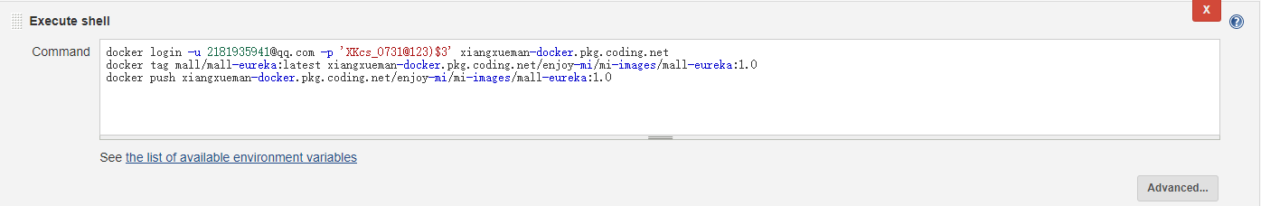

docker login -u 2181935941@qq.com -p 'XKcs_0731@123)$3' xiangxueman-docker.pkg.coding.net

docker tag mall/mall-eureka:latest xiangxueman-docker.pkg.coding.net/enjoy-mi/mi-images/mall-eureka:1.0

docker push xiangxueman-docker.pkg.coding.net/enjoy-mi/mi-images/mall-eureka:1.0

远程发布

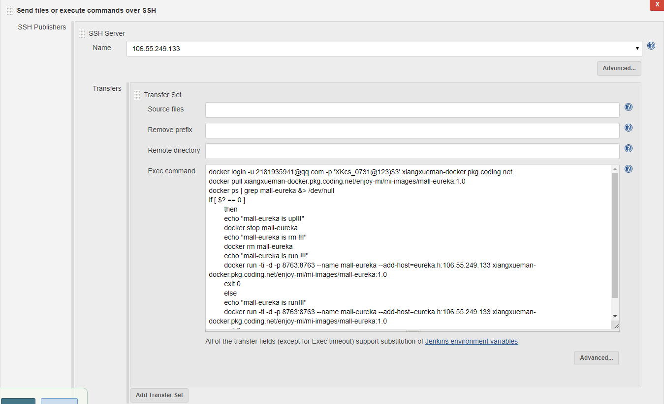

执行脚本

docker login -u 2181935941@qq.com -p 'XKcs_0731@123)$3' xiangxueman-docker.pkg.coding.net

docker pull xiangxueman-docker.pkg.coding.net/enjoy-mi/mi-images/mall-eureka:1.0

docker ps | grep mall-eureka &> /dev/null

if [ $? == 0 ]

then

echo "mall-eureka is up!!!"

docker stop mall-eureka

echo "mall-eureka is rm !!!"

docker rm mall-eureka

echo "mall-eureka is run !!!"

docker run -ti -d -p 8763:8763 --name mall-eureka --add-host=eureka.h:106.55.249.133 xiangxueman-docker.pkg.coding.net/enjoy-mi/mi-images/mall-eureka:1.0

exit 0

else

echo "mall-eureka is run!!!"

docker run -ti -d -p 8763:8763 --name mall-eureka --add-host=eureka.h:106.55.249.133 xiangxueman-docker.pkg.coding.net/enjoy-mi/mi-images/mall-eureka:1.0

exit 0

fi

## mall-kill

项目构建

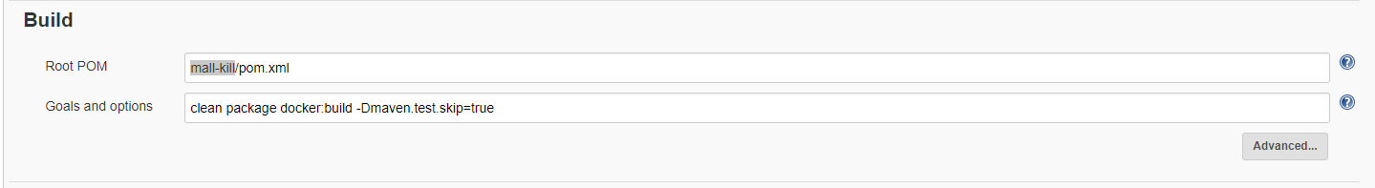

Push镜像到镜像仓库

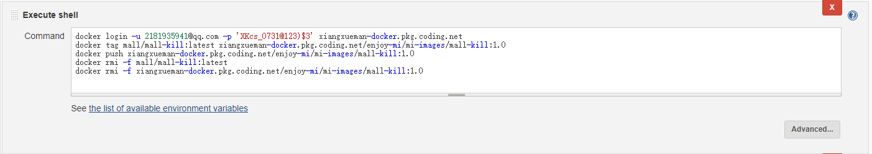

docker login -u 2181935941@qq.com -p 'XKcs_0731@123)$3' xiangxueman-docker.pkg.coding.net

docker tag mall/mall-kill:latest xiangxueman-docker.pkg.coding.net/enjoy-mi/mi-images/mall-kill:1.0

docker push xiangxueman-docker.pkg.coding.net/enjoy-mi/mi-images/mall-kill:1.0

docker rmi -f mall/mall-kill:latest

docker rmi -f xiangxueman-docker.pkg.coding.net/enjoy-mi/mi-images/mall-kill:1.0

远程发布

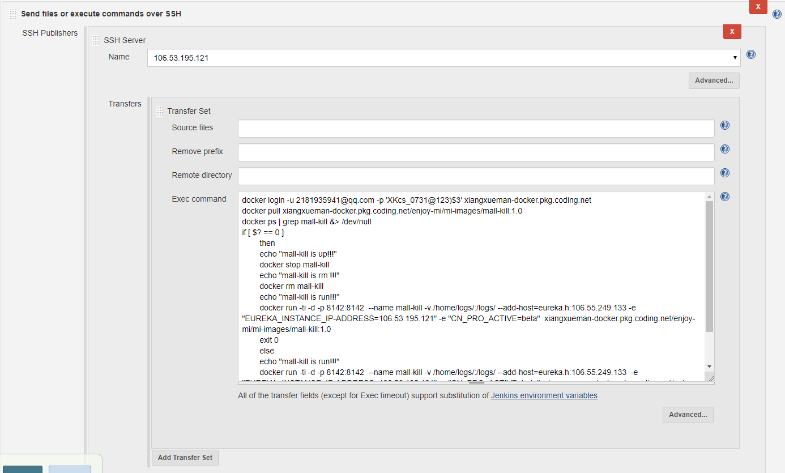

执行脚本

docker login -u 2181935941@qq.com -p 'XKcs_0731@123)$3' xiangxueman-docker.pkg.coding.net

docker pull xiangxueman-docker.pkg.coding.net/enjoy-mi/mi-images/mall-kill:1.0

docker ps | grep mall-kill &> /dev/null

if [ $? == 0 ]

then

echo "mall-kill is up!!!"

docker stop mall-kill

echo "mall-kill is rm !!!"

docker rm mall-kill

echo "mall-kill is run!!!"

docker run -ti -d -p 8142:8142 --name mall-kill -v /home/logs/:/logs/ --add-host=eureka.h:106.55.249.133 -e "EUREKA_INSTANCE_IP-ADDRESS=106.53.195.121" -e "CN_PRO_ACTIVE=beta" xiangxueman-docker.pkg.coding.net/enjoy-mi/mi-images/mall-kill:1.0

exit 0

else

echo "mall-kill is run!!!"

docker run -ti -d -p 8142:8142 --name mall-kill -v /home/logs/:/logs/ --add-host=eureka.h:106.55.249.133 -e "EUREKA_INSTANCE_IP-ADDRESS=106.53.195.121" -e "CN_PRO_ACTIVE=beta" xiangxueman-docker.pkg.coding.net/enjoy-mi/mi-images/mall-kill:1.0

exit 0

fi

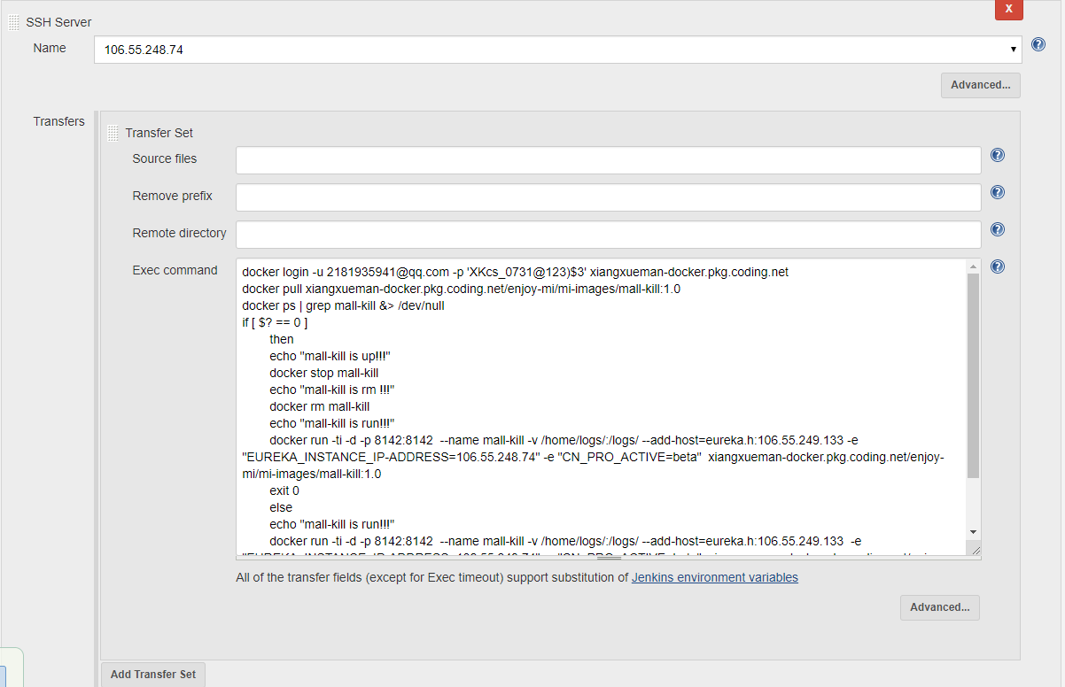

执行脚本

docker login -u 2181935941@qq.com -p 'XKcs_0731@123)$3' xiangxueman-docker.pkg.coding.net

docker pull xiangxueman-docker.pkg.coding.net/enjoy-mi/mi-images/mall-kill:1.0

docker ps | grep mall-kill &> /dev/null

if [ $? == 0 ]

then

echo "mall-kill is up!!!"

docker stop mall-kill

echo "mall-kill is rm !!!"

docker rm mall-kill

echo "mall-kill is run!!!"

docker run -ti -d -p 8142:8142 --name mall-kill -v /home/logs/:/logs/ --add-host=eureka.h:106.55.249.133 -e "EUREKA_INSTANCE_IP-ADDRESS=106.55.248.74" -e "CN_PRO_ACTIVE=beta" xiangxueman-docker.pkg.coding.net/enjoy-mi/mi-images/mall-kill:1.0

exit 0

else

echo "mall-kill is run!!!"

docker run -ti -d -p 8142:8142 --name mall-kill -v /home/logs/:/logs/ --add-host=eureka.h:106.55.249.133 -e "EUREKA_INSTANCE_IP-ADDRESS=106.55.248.74" -e "CN_PRO_ACTIVE=beta" xiangxueman-docker.pkg.coding.net/enjoy-mi/mi-images/mall-kill:1.0

exit 0

fi

## mall-order-service

项目构建

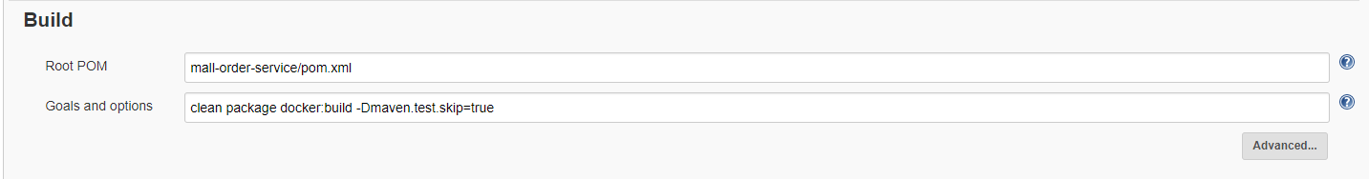

Push镜像到镜像仓库

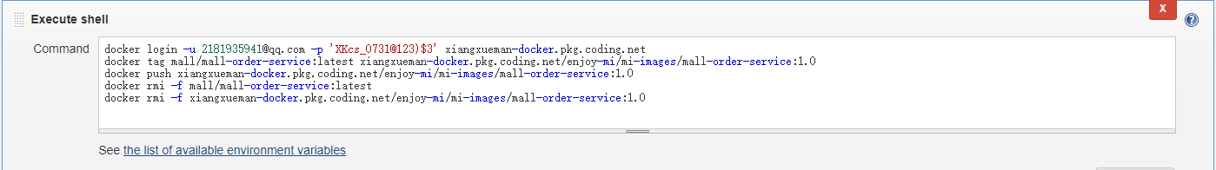

docker login -u 2181935941@qq.com -p 'XKcs_0731@123)$3' xiangxueman-docker.pkg.coding.net

docker tag mall/mall-order-service:latest xiangxueman-docker.pkg.coding.net/enjoy-mi/mi-images/mall-order-service:1.0

docker push xiangxueman-docker.pkg.coding.net/enjoy-mi/mi-images/mall-order-service:1.0

docker rmi -f mall/mall-order-service:latest

docker rmi -f xiangxueman-docker.pkg.coding.net/enjoy-mi/mi-images/mall-order-service:1.0

远程发布

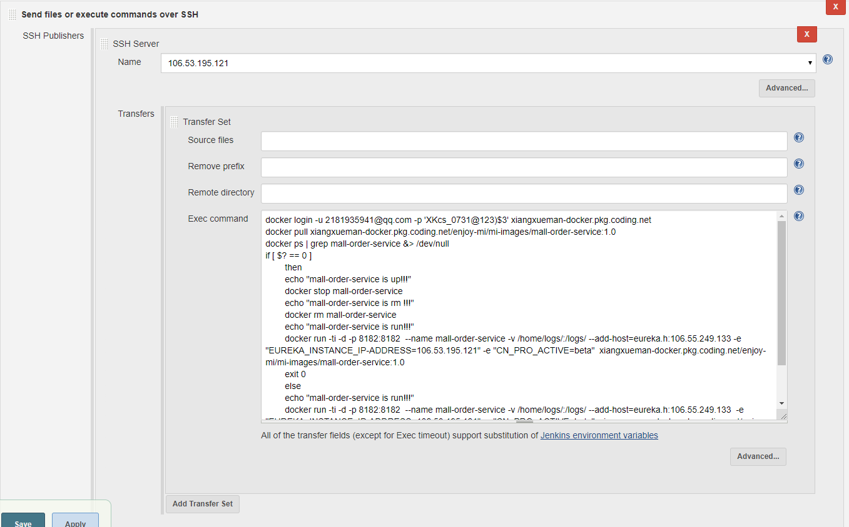

执行脚本

docker login -u 2181935941@qq.com -p 'XKcs_0731@123)$3' xiangxueman-docker.pkg.coding.net

docker pull xiangxueman-docker.pkg.coding.net/enjoy-mi/mi-images/mall-order-service:1.0

docker ps | grep mall-order-service &> /dev/null

if [ $? == 0 ]

then

echo "mall-order-service is up!!!"

docker stop mall-order-service

echo "mall-order-service is rm !!!"

docker rm mall-order-service

echo "mall-order-service is run!!!"

docker run -ti -d -p 8182:8182 --name mall-order-service -v /home/logs/:/logs/ --add-host=eureka.h:106.55.249.133 -e "EUREKA_INSTANCE_IP-ADDRESS=106.53.195.121" -e "CN_PRO_ACTIVE=beta" xiangxueman-docker.pkg.coding.net/enjoy-mi/mi-images/mall-order-service:1.0

exit 0

else

echo "mall-order-service is run!!!"

docker run -ti -d -p 8182:8182 --name mall-order-service -v /home/logs/:/logs/ --add-host=eureka.h:106.55.249.133 -e "EUREKA_INSTANCE_IP-ADDRESS=106.53.195.121" -e "CN_PRO_ACTIVE=beta" xiangxueman-docker.pkg.coding.net/enjoy-mi/mi-images/mall-order-service:1.0

exit 0

fi

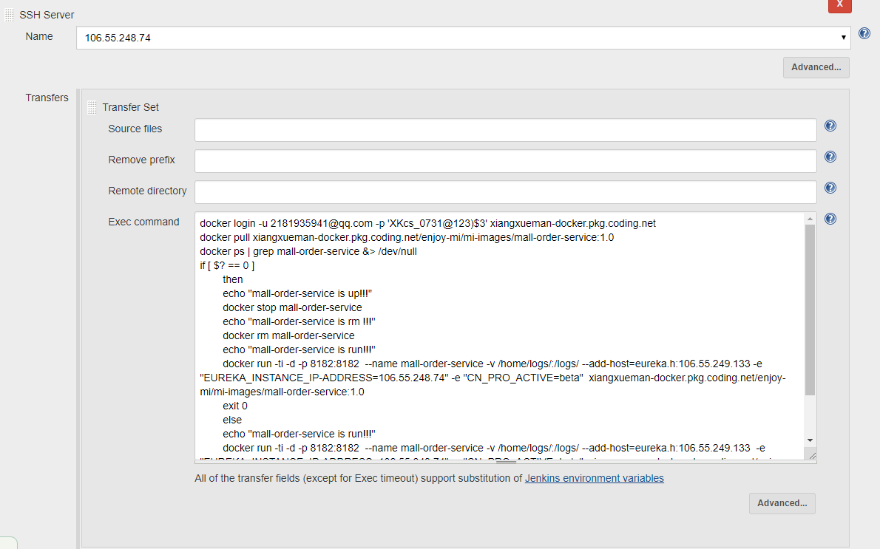

执行脚本

docker login -u 2181935941@qq.com -p 'XKcs_0731@123)$3' xiangxueman-docker.pkg.coding.net

docker pull xiangxueman-docker.pkg.coding.net/enjoy-mi/mi-images/mall-order-service:1.0

docker ps | grep mall-order-service &> /dev/null

if [ $? == 0 ]

then

echo "mall-order-service is up!!!"

docker stop mall-order-service

echo "mall-order-service is rm !!!"

docker rm mall-order-service

echo "mall-order-service is run!!!"

docker run -ti -d -p 8182:8182 --name mall-order-service -v /home/logs/:/logs/ --add-host=eureka.h:106.55.249.133 -e "EUREKA_INSTANCE_IP-ADDRESS=106.55.248.74" -e "CN_PRO_ACTIVE=beta" xiangxueman-docker.pkg.coding.net/enjoy-mi/mi-images/mall-order-service:1.0

exit 0

else

echo "mall-order-service is run!!!"

docker run -ti -d -p 8182:8182 --name mall-order-service -v /home/logs/:/logs/ --add-host=eureka.h:106.55.249.133 -e "EUREKA_INSTANCE_IP-ADDRESS=106.55.248.74" -e "CN_PRO_ACTIVE=beta" xiangxueman-docker.pkg.coding.net/enjoy-mi/mi-images/mall-order-service:1.0

exit 0

fi

## mall-pay

项目构建

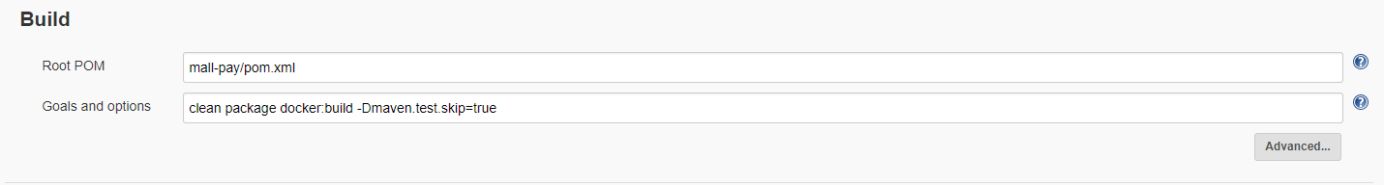

Push镜像到镜像仓库

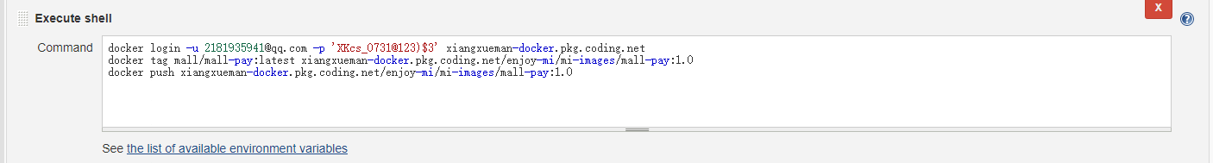

docker login -u 2181935941@qq.com -p 'XKcs_0731@123)$3' xiangxueman-docker.pkg.coding.net

docker tag mall/mall-pay:latest xiangxueman-docker.pkg.coding.net/enjoy-mi/mi-images/mall-pay:1.0

docker push xiangxueman-docker.pkg.coding.net/enjoy-mi/mi-images/mall-pay:1.0

远程发布

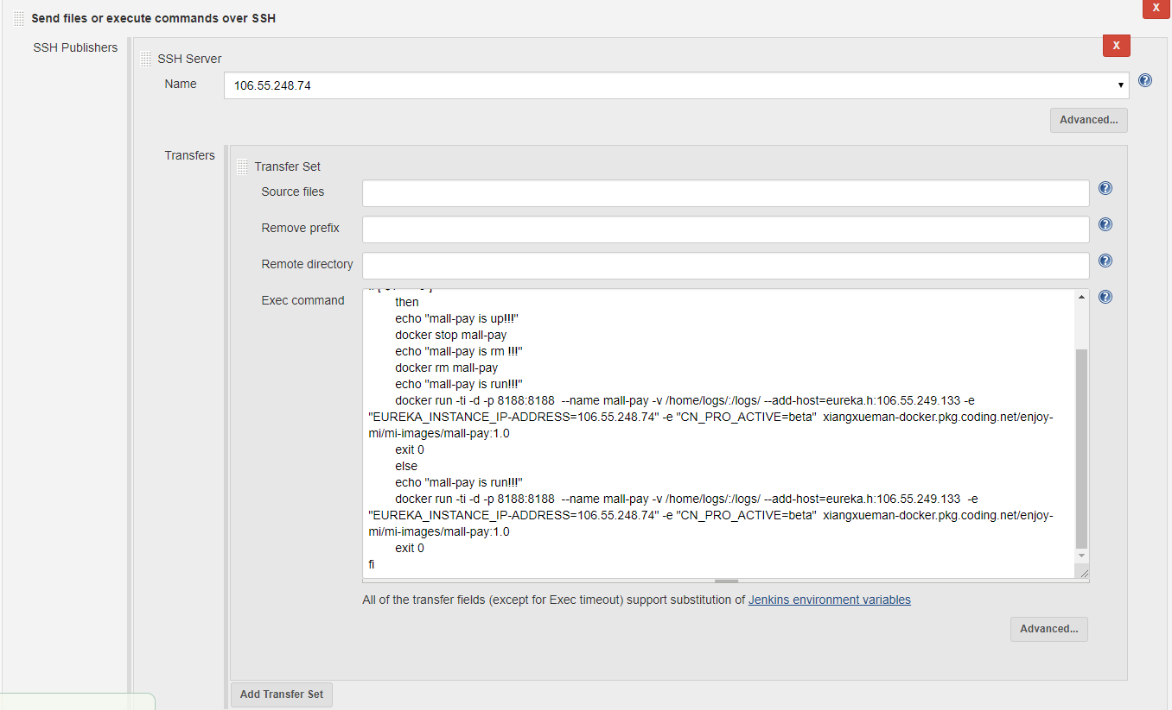

执行脚本

docker login -u 2181935941@qq.com -p 'XKcs_0731@123)$3' xiangxueman-docker.pkg.coding.net

docker pull xiangxueman-docker.pkg.coding.net/enjoy-mi/mi-images/mall-pay:1.0

docker ps | grep mall-pay &> /dev/null

if [ $? == 0 ]

then

echo "mall-pay is up!!!"

docker stop mall-pay

echo "mall-pay is rm !!!"

docker rm mall-pay

echo "mall-pay is run!!!"

docker run -ti -d -p 8188:8188 --name mall-pay -v /home/logs/:/logs/ --add-host=eureka.h:106.55.249.133 -e "EUREKA_INSTANCE_IP-ADDRESS=106.55.248.74" -e "CN_PRO_ACTIVE=beta" xiangxueman-docker.pkg.coding.net/enjoy-mi/mi-images/mall-pay:1.0

exit 0

else

echo "mall-pay is run!!!"

docker run -ti -d -p 8188:8188 --name mall-pay -v /home/logs/:/logs/ --add-host=eureka.h:106.55.249.133 -e "EUREKA_INSTANCE_IP-ADDRESS=106.55.248.74" -e "CN_PRO_ACTIVE=beta" xiangxueman-docker.pkg.coding.net/enjoy-mi/mi-images/mall-pay:1.0

exit 0

fi

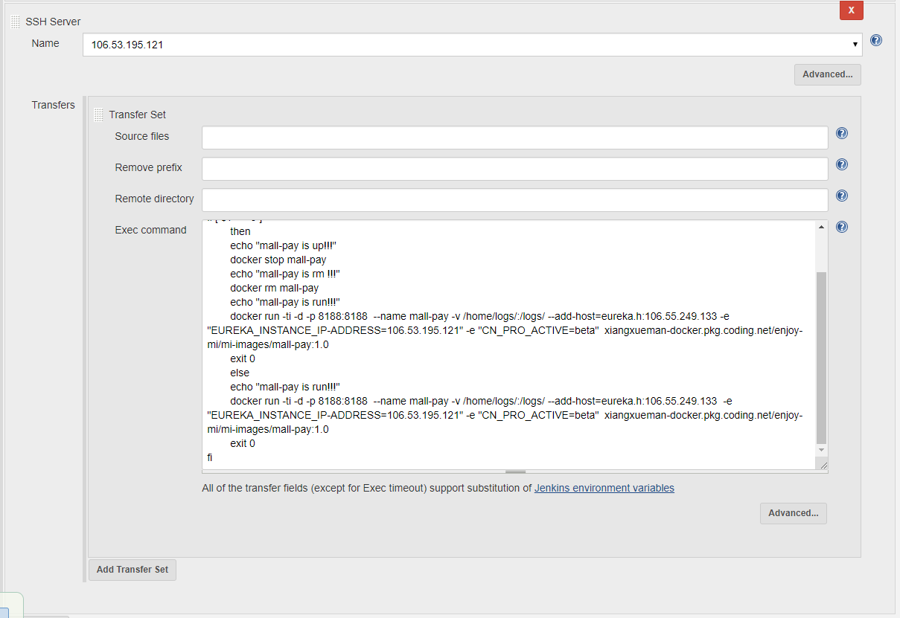

执行脚本

docker login -u 2181935941@qq.com -p 'XKcs_0731@123)$3' xiangxueman-docker.pkg.coding.net

docker pull xiangxueman-docker.pkg.coding.net/enjoy-mi/mi-images/mall-pay:1.0

docker ps | grep mall-pay &> /dev/null

if [ $? == 0 ]

then

echo "mall-pay is up!!!"

docker stop mall-pay

echo "mall-pay is rm !!!"

docker rm mall-pay

echo "mall-pay is run!!!"

docker run -ti -d -p 8188:8188 --name mall-pay -v /home/logs/:/logs/ --add-host=eureka.h:106.55.249.133 -e "EUREKA_INSTANCE_IP-ADDRESS=106.53.195.121" -e "CN_PRO_ACTIVE=beta" xiangxueman-docker.pkg.coding.net/enjoy-mi/mi-images/mall-pay:1.0

exit 0

else

echo "mall-pay is run!!!"

docker run -ti -d -p 8188:8188 --name mall-pay -v /home/logs/:/logs/ --add-host=eureka.h:106.55.249.133 -e "EUREKA_INSTANCE_IP-ADDRESS=106.53.195.121" -e "CN_PRO_ACTIVE=beta" xiangxueman-docker.pkg.coding.net/enjoy-mi/mi-images/mall-pay:1.0

exit 0

fi

## mall-product-service

项目构建

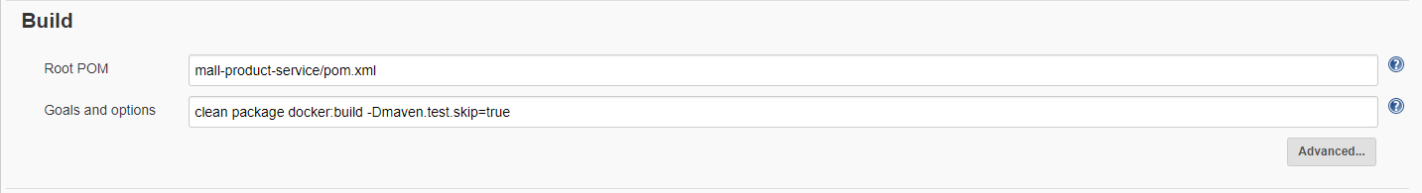

Push镜像到镜像仓库

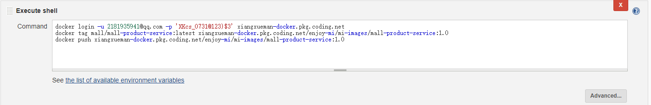

docker login -u 2181935941@qq.com -p 'XKcs_0731@123)$3' xiangxueman-docker.pkg.coding.net

docker tag mall/mall-product-service:latest xiangxueman-docker.pkg.coding.net/enjoy-mi/mi-images/mall-product-service:1.0

docker push xiangxueman-docker.pkg.coding.net/enjoy-mi/mi-images/mall-product-service:1.0

远程发布

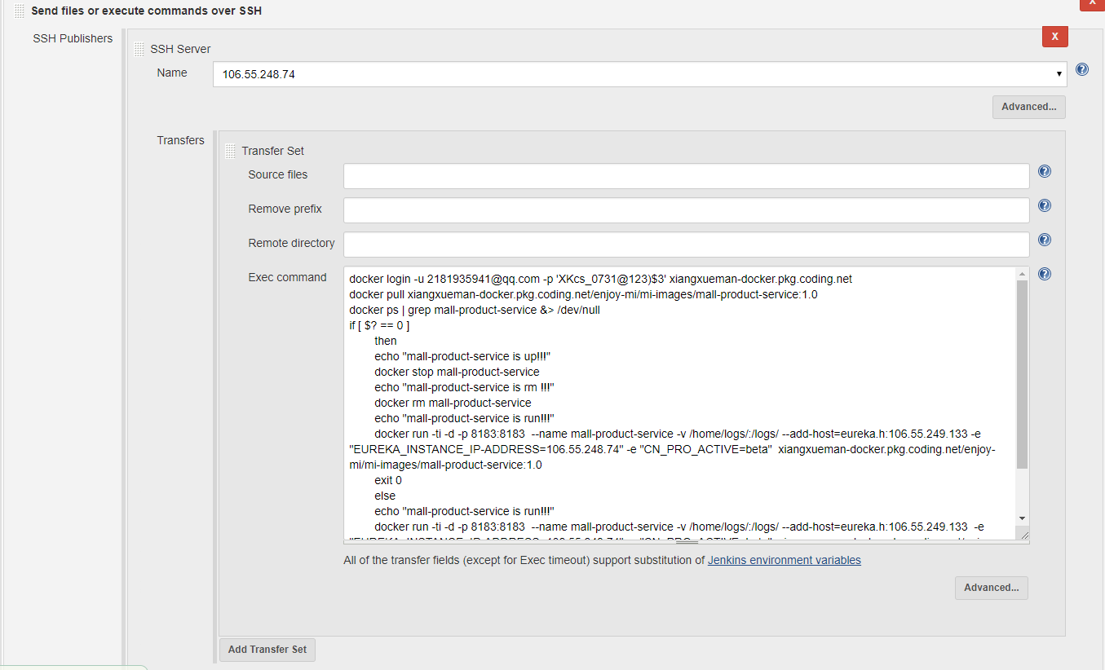

执行脚本

docker login -u 2181935941@qq.com -p 'XKcs_0731@123)$3' xiangxueman-docker.pkg.coding.net

docker pull xiangxueman-docker.pkg.coding.net/enjoy-mi/mi-images/mall-product-service:1.0

docker ps | grep mall-product-service &> /dev/null

if [ $? == 0 ]

then

echo "mall-product-service is up!!!"

docker stop mall-product-service

echo "mall-product-service is rm !!!"

docker rm mall-product-service

echo "mall-product-service is run!!!"

docker run -ti -d -p 8183:8183 --name mall-product-service -v /home/logs/:/logs/ --add-host=eureka.h:106.55.249.133 -e "EUREKA_INSTANCE_IP-ADDRESS=106.55.248.74" -e "CN_PRO_ACTIVE=beta" xiangxueman-docker.pkg.coding.net/enjoy-mi/mi-images/mall-product-service:1.0

exit 0

else

echo "mall-product-service is run!!!"

docker run -ti -d -p 8183:8183 --name mall-product-service -v /home/logs/:/logs/ --add-host=eureka.h:106.55.249.133 -e "EUREKA_INSTANCE_IP-ADDRESS=106.55.248.74" -e "CN_PRO_ACTIVE=beta" xiangxueman-docker.pkg.coding.net/enjoy-mi/mi-images/mall-product-service:1.0

exit 0

fi

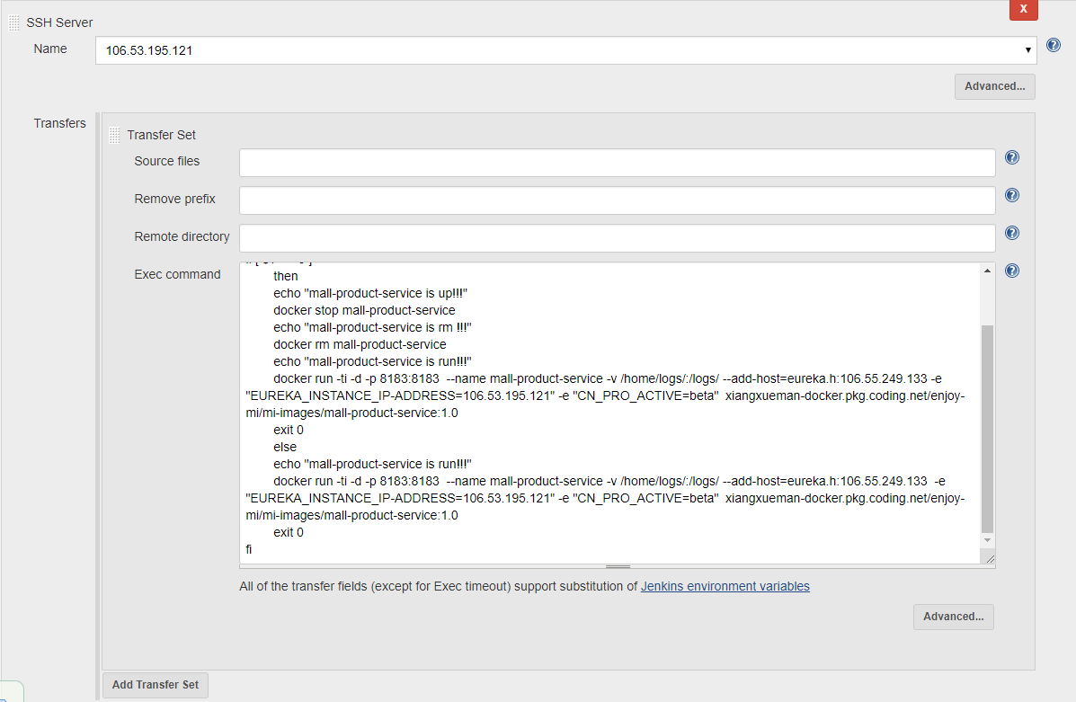

执行脚本

docker login -u 2181935941@qq.com -p 'XKcs_0731@123)$3' xiangxueman-docker.pkg.coding.net

docker pull xiangxueman-docker.pkg.coding.net/enjoy-mi/mi-images/mall-product-service:1.0

docker ps | grep mall-product-service &> /dev/null

if [ $? == 0 ]

then

echo "mall-product-service is up!!!"

docker stop mall-product-service

echo "mall-product-service is rm !!!"

docker rm mall-product-service

echo "mall-product-service is run!!!"

docker run -ti -d -p 8183:8183 --name mall-product-service -v /home/logs/:/logs/ --add-host=eureka.h:106.55.249.133 -e "EUREKA_INSTANCE_IP-ADDRESS=106.53.195.121" -e "CN_PRO_ACTIVE=beta" xiangxueman-docker.pkg.coding.net/enjoy-mi/mi-images/mall-product-service:1.0

exit 0

else

echo "mall-product-service is run!!!"

docker run -ti -d -p 8183:8183 --name mall-product-service -v /home/logs/:/logs/ --add-host=eureka.h:106.55.249.133 -e "EUREKA_INSTANCE_IP-ADDRESS=106.53.195.121" -e "CN_PRO_ACTIVE=beta" xiangxueman-docker.pkg.coding.net/enjoy-mi/mi-images/mall-product-service:1.0

exit 0

fi

## mall-user-service

项目构建

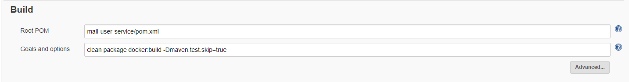

Push镜像到镜像仓库

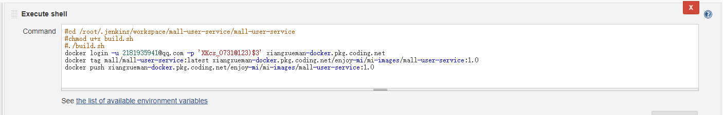

#cd /root/.jenkins/workspace/mall-user-service/mall-user-service

#chmod u+x build.sh

#./build.sh

docker login -u 2181935941@qq.com -p 'XKcs_0731@123)$3' xiangxueman-docker.pkg.coding.net

docker tag mall/mall-user-service:latest xiangxueman-docker.pkg.coding.net/enjoy-mi/mi-images/mall-user-service:1.0

docker push xiangxueman-docker.pkg.coding.net/enjoy-mi/mi-images/mall-user-service:1.0

远程发布

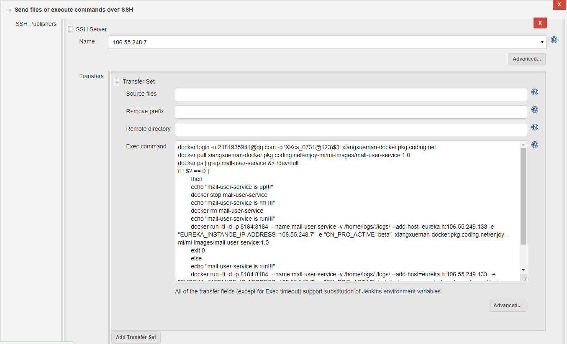

执行脚本

docker login -u 2181935941@qq.com -p 'XKcs_0731@123)$3' xiangxueman-docker.pkg.coding.net

docker pull xiangxueman-docker.pkg.coding.net/enjoy-mi/mi-images/mall-user-service:1.0

docker ps | grep mall-user-service &> /dev/null

if [ $? == 0 ]

then

echo "mall-user-service is up!!!"

docker stop mall-user-service

echo "mall-user-service is rm !!!"

docker rm mall-user-service

echo "mall-user-service is run!!!"

docker run -ti -d -p 8184:8184 --name mall-user-service -v /home/logs/:/logs/ --add-host=eureka.h:106.55.249.133 -e "EUREKA_INSTANCE_IP-ADDRESS=106.55.248.7" -e "CN_PRO_ACTIVE=beta" xiangxueman-docker.pkg.coding.net/enjoy-mi/mi-images/mall-user-service:1.0

exit 0

else

echo "mall-user-service is run!!!"

docker run -ti -d -p 8184:8184 --name mall-user-service -v /home/logs/:/logs/ --add-host=eureka.h:106.55.249.133 -e "EUREKA_INSTANCE_IP-ADDRESS=106.55.248.7" -e "CN_PRO_ACTIVE=beta" xiangxueman-docker.pkg.coding.net/enjoy-mi/mi-images/mall-user-service:1.0

exit 0

fi

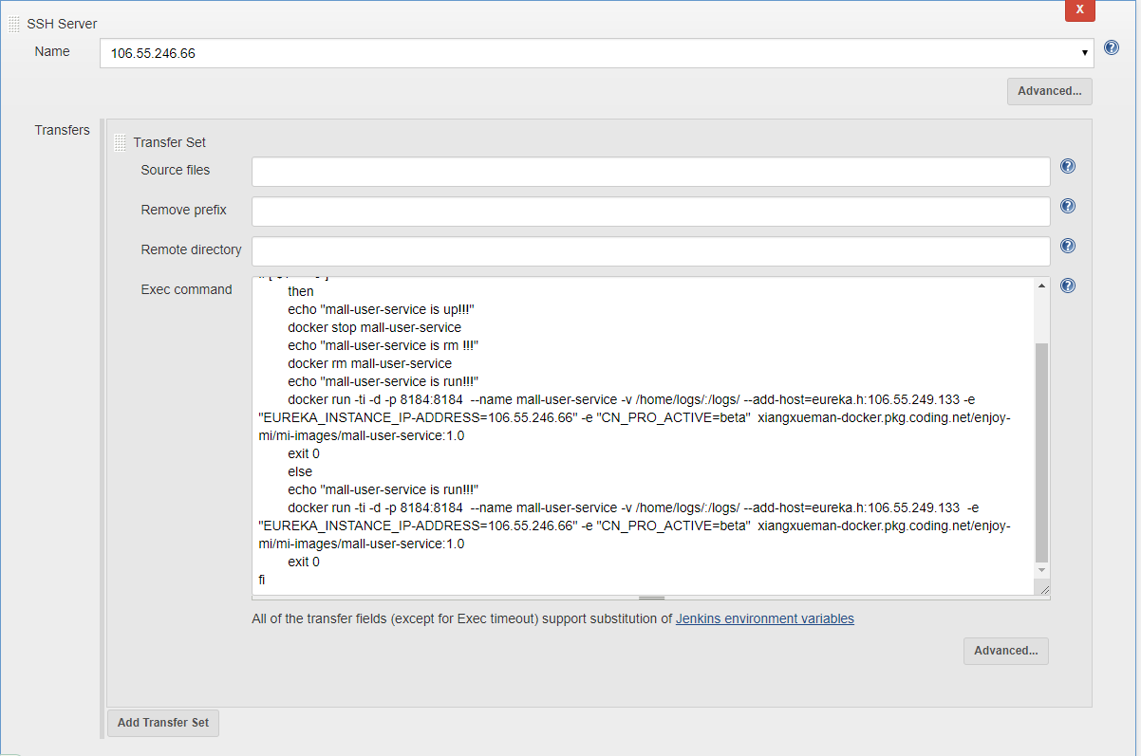

执行脚本

docker login -u 2181935941@qq.com -p 'XKcs_0731@123)$3' xiangxueman-docker.pkg.coding.net

docker pull xiangxueman-docker.pkg.coding.net/enjoy-mi/mi-images/mall-user-service:1.0

docker ps | grep mall-user-service &> /dev/null

if [ $? == 0 ]

then

echo "mall-user-service is up!!!"

docker stop mall-user-service

echo "mall-user-service is rm !!!"

docker rm mall-user-service

echo "mall-user-service is run!!!"

docker run -ti -d -p 8184:8184 --name mall-user-service -v /home/logs/:/logs/ --add-host=eureka.h:106.55.249.133 -e "EUREKA_INSTANCE_IP-ADDRESS=106.55.246.66" -e "CN_PRO_ACTIVE=beta" xiangxueman-docker.pkg.coding.net/enjoy-mi/mi-images/mall-user-service:1.0

exit 0

else

echo "mall-user-service is run!!!"

docker run -ti -d -p 8184:8184 --name mall-user-service -v /home/logs/:/logs/ --add-host=eureka.h:106.55.249.133 -e "EUREKA_INSTANCE_IP-ADDRESS=106.55.246.66" -e "CN_PRO_ACTIVE=beta" xiangxueman-docker.pkg.coding.net/enjoy-mi/mi-images/mall-user-service:1.0

exit 0

fi

## mall-web-mng

项目构建

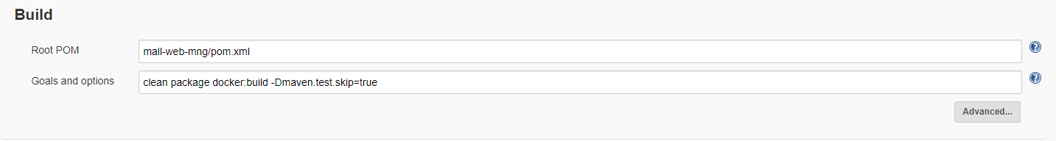

Push镜像到镜像仓库

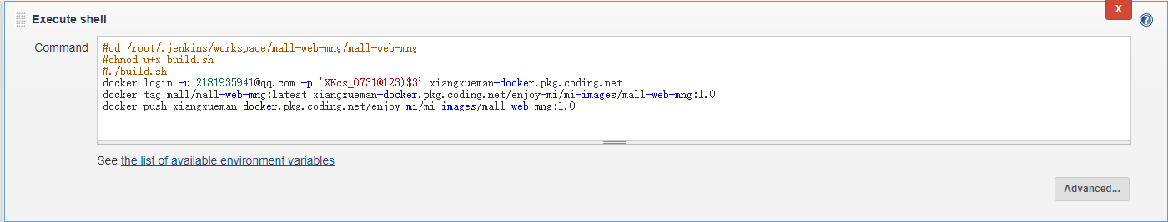

#cd /root/.jenkins/workspace/mall-web-mng/mall-web-mng

#chmod u+x build.sh

#./build.sh

docker login -u 2181935941@qq.com -p 'XKcs_0731@123)$3' xiangxueman-docker.pkg.coding.net

docker tag mall/mall-web-mng:latest xiangxueman-docker.pkg.coding.net/enjoy-mi/mi-images/mall-web-mng:1.0

docker push xiangxueman-docker.pkg.coding.net/enjoy-mi/mi-images/mall-web-mng:1.0

远程发布

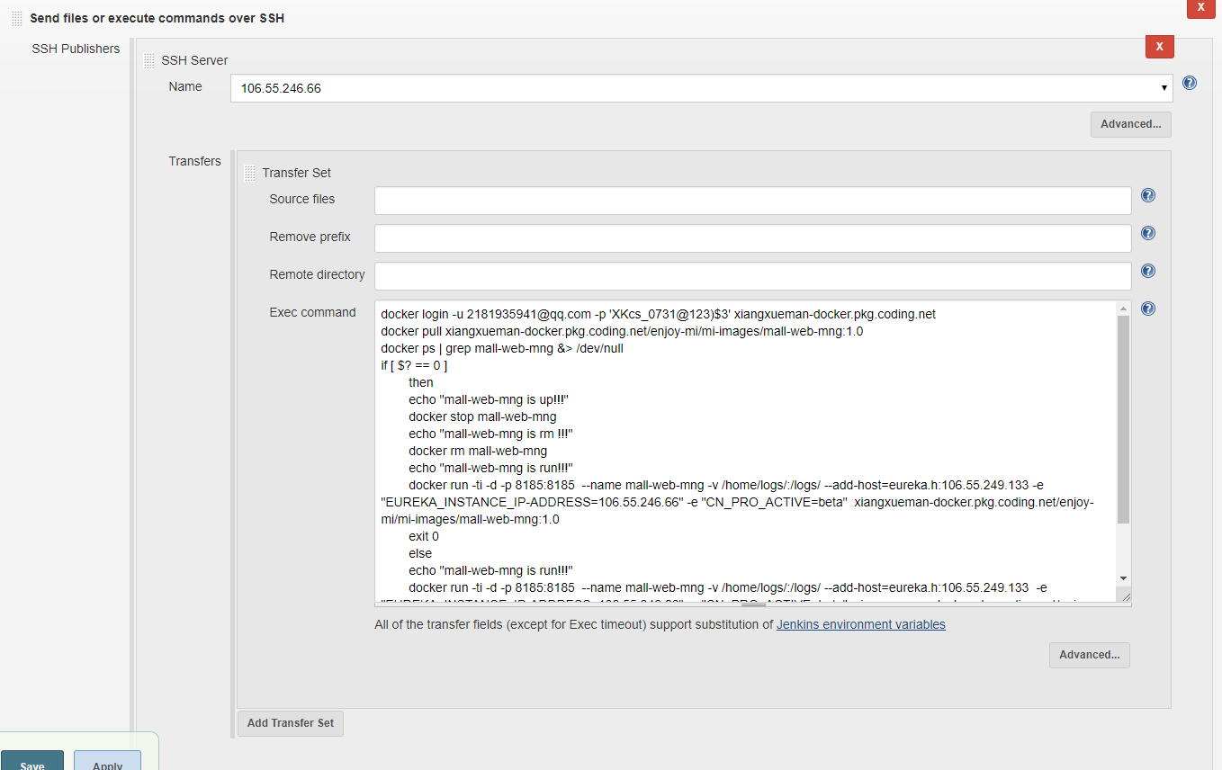

执行脚本

docker login -u 2181935941@qq.com -p 'XKcs_0731@123)$3' xiangxueman-docker.pkg.coding.net

docker pull xiangxueman-docker.pkg.coding.net/enjoy-mi/mi-images/mall-web-mng:1.0

docker ps | grep mall-web-mng &> /dev/null

if [ $? == 0 ]

then

echo "mall-web-mng is up!!!"

docker stop mall-web-mng

echo "mall-web-mng is rm !!!"

docker rm mall-web-mng

echo "mall-web-mng is run!!!"

docker run -ti -d -p 8185:8185 --name mall-web-mng -v /home/logs/:/logs/ --add-host=eureka.h:106.55.249.133 -e "EUREKA_INSTANCE_IP-ADDRESS=106.55.246.66" -e "CN_PRO_ACTIVE=beta" xiangxueman-docker.pkg.coding.net/enjoy-mi/mi-images/mall-web-mng:1.0

exit 0

else

echo "mall-web-mng is run!!!"

docker run -ti -d -p 8185:8185 --name mall-web-mng -v /home/logs/:/logs/ --add-host=eureka.h:106.55.249.133 -e "EUREKA_INSTANCE_IP-ADDRESS=106.55.246.66" -e "CN_PRO_ACTIVE=beta" xiangxueman-docker.pkg.coding.net/enjoy-mi/mi-images/mall-web-mng:1.0

exit 0

fi

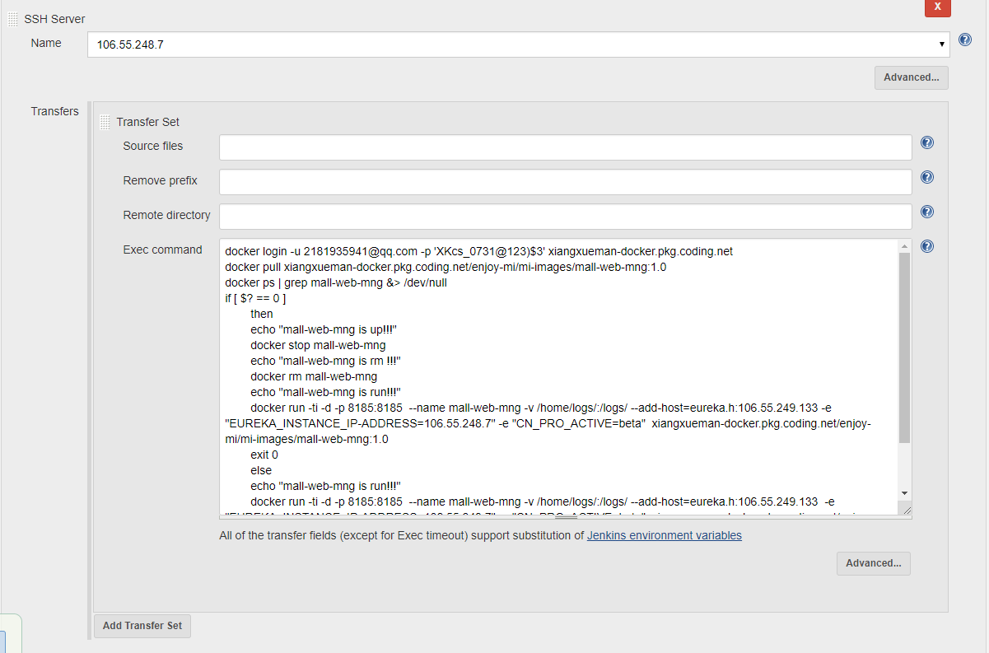

执行脚本

docker login -u 2181935941@qq.com -p 'XKcs_0731@123)$3' xiangxueman-docker.pkg.coding.net

docker pull xiangxueman-docker.pkg.coding.net/enjoy-mi/mi-images/mall-web-mng:1.0

docker ps | grep mall-web-mng &> /dev/null

if [ $? == 0 ]

then

echo "mall-web-mng is up!!!"

docker stop mall-web-mng

echo "mall-web-mng is rm !!!"

docker rm mall-web-mng

echo "mall-web-mng is run!!!"

docker run -ti -d -p 8185:8185 --name mall-web-mng -v /home/logs/:/logs/ --add-host=eureka.h:106.55.249.133 -e "EUREKA_INSTANCE_IP-ADDRESS=106.55.248.7" -e "CN_PRO_ACTIVE=beta" xiangxueman-docker.pkg.coding.net/enjoy-mi/mi-images/mall-web-mng:1.0

exit 0

else

echo "mall-web-mng is run!!!"

docker run -ti -d -p 8185:8185 --name mall-web-mng -v /home/logs/:/logs/ --add-host=eureka.h:106.55.249.133 -e "EUREKA_INSTANCE_IP-ADDRESS=106.55.248.7" -e "CN_PRO_ACTIVE=beta" xiangxueman-docker.pkg.coding.net/enjoy-mi/mi-images/mall-web-mng:1.0

exit 0

fi

## mall-web-order

项目构建

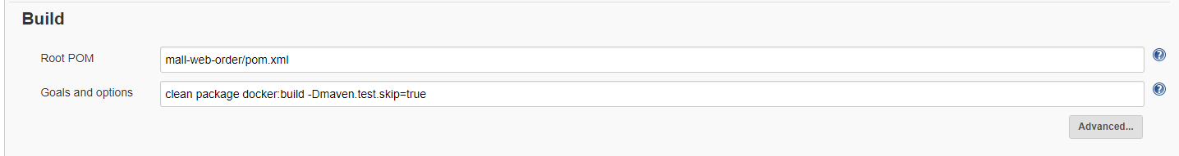

Push镜像到镜像仓库

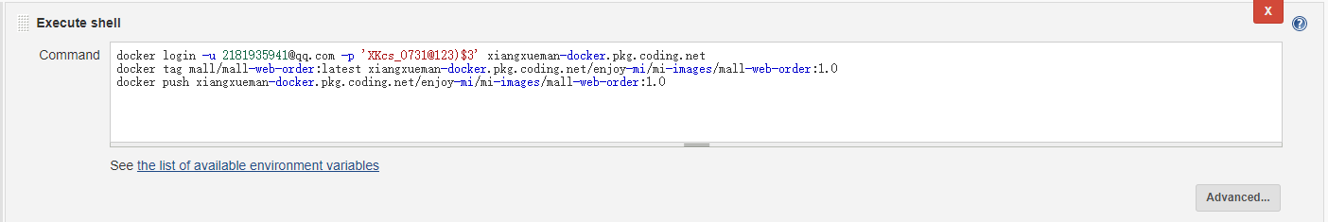

docker login -u 2181935941@qq.com -p 'XKcs_0731@123)$3' xiangxueman-docker.pkg.coding.net

docker tag mall/mall-web-order:latest xiangxueman-docker.pkg.coding.net/enjoy-mi/mi-images/mall-web-order:1.0

docker push xiangxueman-docker.pkg.coding.net/enjoy-mi/mi-images/mall-web-order:1.0

远程发布

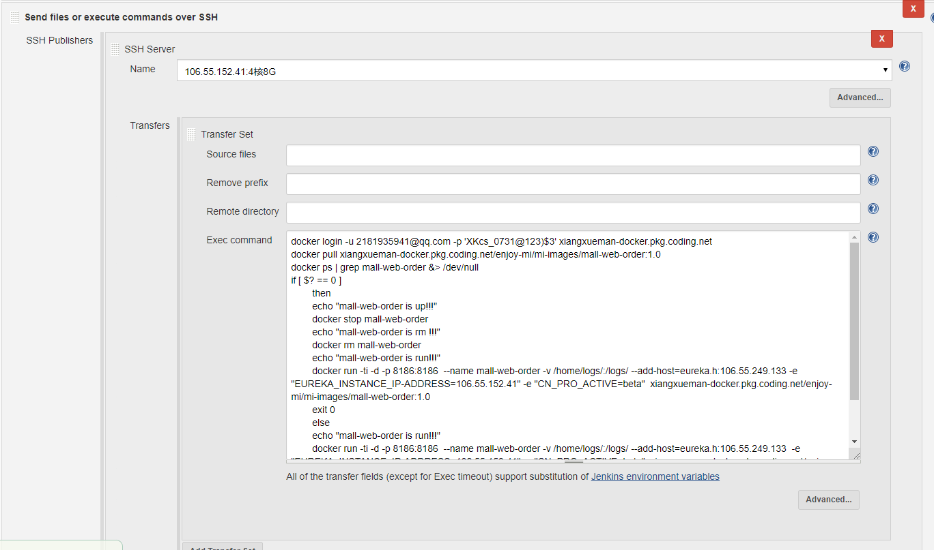

执行脚本

docker login -u 2181935941@qq.com -p 'XKcs_0731@123)$3' xiangxueman-docker.pkg.coding.net

docker pull xiangxueman-docker.pkg.coding.net/enjoy-mi/mi-images/mall-web-order:1.0

docker ps | grep mall-web-order &> /dev/null

if [ $? == 0 ]

then

echo "mall-web-order is up!!!"

docker stop mall-web-order

echo "mall-web-order is rm !!!"

docker rm mall-web-order

echo "mall-web-order is run!!!"

docker run -ti -d -p 8186:8186 --name mall-web-order -v /home/logs/:/logs/ --add-host=eureka.h:106.55.249.133 -e "EUREKA_INSTANCE_IP-ADDRESS=106.55.152.41" -e "CN_PRO_ACTIVE=beta" xiangxueman-docker.pkg.coding.net/enjoy-mi/mi-images/mall-web-order:1.0

exit 0

else

echo "mall-web-order is run!!!"

docker run -ti -d -p 8186:8186 --name mall-web-order -v /home/logs/:/logs/ --add-host=eureka.h:106.55.249.133 -e "EUREKA_INSTANCE_IP-ADDRESS=106.55.152.41" -e "CN_PRO_ACTIVE=beta" xiangxueman-docker.pkg.coding.net/enjoy-mi/mi-images/mall-web-order:1.0

exit 0

fi

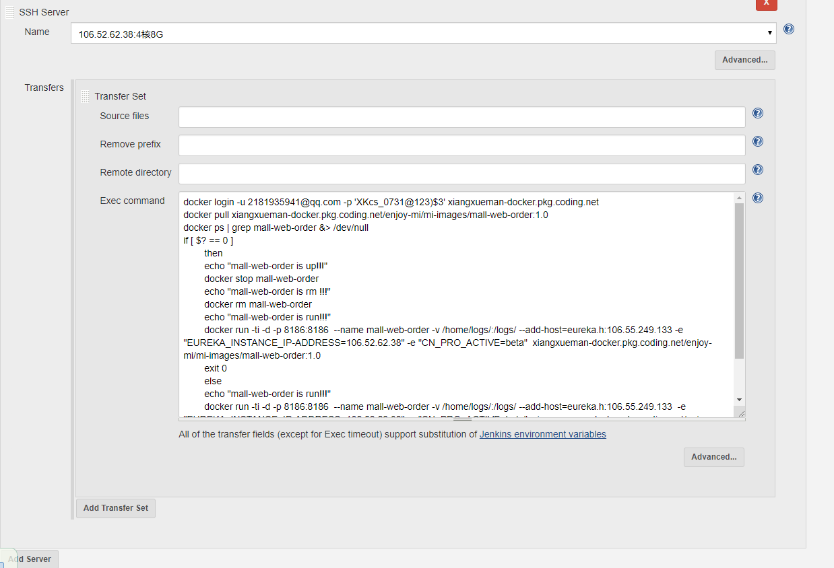

执行脚本

docker login -u 2181935941@qq.com -p 'XKcs_0731@123)$3' xiangxueman-docker.pkg.coding.net

docker pull xiangxueman-docker.pkg.coding.net/enjoy-mi/mi-images/mall-web-order:1.0

docker ps | grep mall-web-order &> /dev/null

if [ $? == 0 ]

then

echo "mall-web-order is up!!!"

docker stop mall-web-order

echo "mall-web-order is rm !!!"

docker rm mall-web-order

echo "mall-web-order is run!!!"

docker run -ti -d -p 8186:8186 --name mall-web-order -v /home/logs/:/logs/ --add-host=eureka.h:106.55.249.133 -e "EUREKA_INSTANCE_IP-ADDRESS=106.52.62.38" -e "CN_PRO_ACTIVE=beta" xiangxueman-docker.pkg.coding.net/enjoy-mi/mi-images/mall-web-order:1.0

exit 0

else

echo "mall-web-order is run!!!"

docker run -ti -d -p 8186:8186 --name mall-web-order -v /home/logs/:/logs/ --add-host=eureka.h:106.55.249.133 -e "EUREKA_INSTANCE_IP-ADDRESS=106.52.62.38" -e "CN_PRO_ACTIVE=beta" xiangxueman-docker.pkg.coding.net/enjoy-mi/mi-images/mall-web-order:1.0

exit 0

fi

## mall-zuul

项目构建

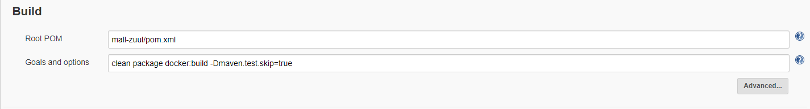

Push镜像到镜像仓库

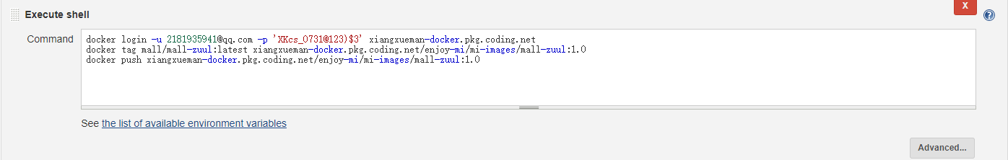

docker login -u 2181935941@qq.com -p 'XKcs_0731@123)$3' xiangxueman-docker.pkg.coding.net

docker tag mall/mall-zuul:latest xiangxueman-docker.pkg.coding.net/enjoy-mi/mi-images/mall-zuul:1.0

docker push xiangxueman-docker.pkg.coding.net/enjoy-mi/mi-images/mall-zuul:1.0

远程发布

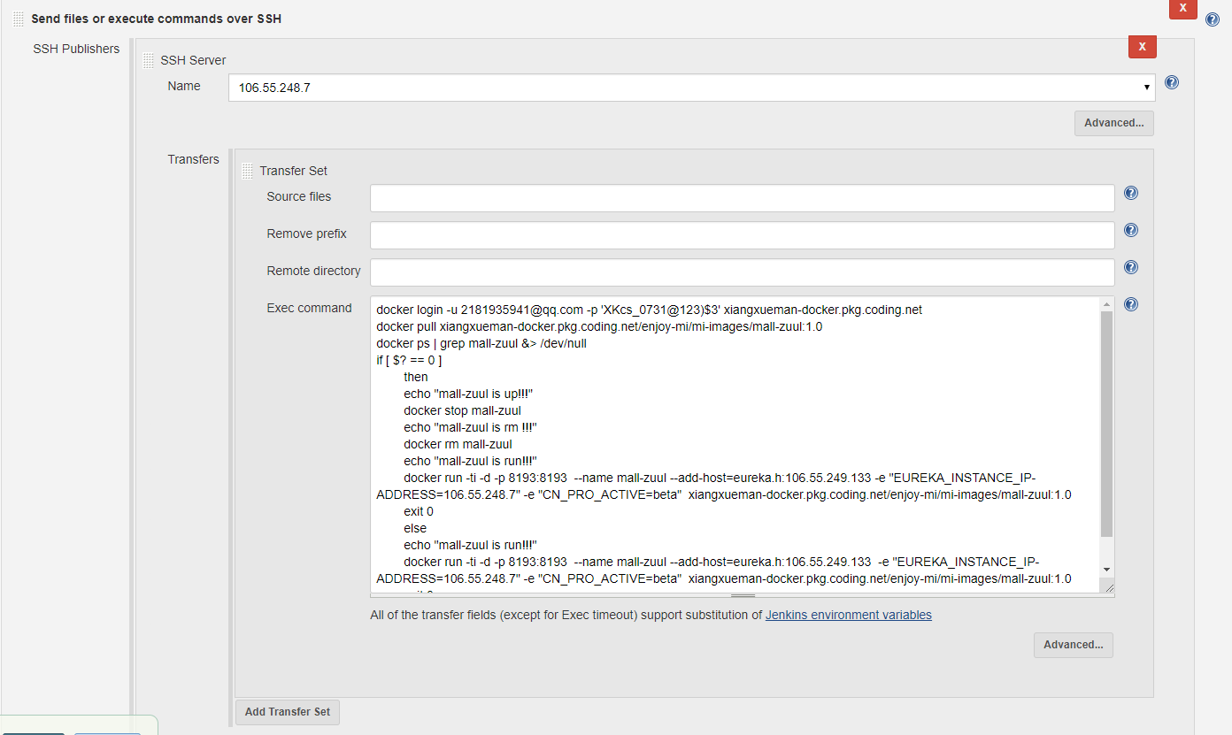

执行脚本

docker login -u 2181935941@qq.com -p 'XKcs_0731@123)$3' xiangxueman-docker.pkg.coding.net

docker pull xiangxueman-docker.pkg.coding.net/enjoy-mi/mi-images/mall-zuul:1.0

docker ps | grep mall-zuul &> /dev/null

if [ $? == 0 ]

then

echo "mall-zuul is up!!!"

docker stop mall-zuul

echo "mall-zuul is rm !!!"

docker rm mall-zuul

echo "mall-zuul is run!!!"

docker run -ti -d -p 8193:8193 --name mall-zuul --add-host=eureka.h:106.55.249.133 -e "EUREKA_INSTANCE_IP-ADDRESS=106.55.248.7" -e "CN_PRO_ACTIVE=beta" xiangxueman-docker.pkg.coding.net/enjoy-mi/mi-images/mall-zuul:1.0

exit 0

else

echo "mall-zuul is run!!!"

docker run -ti -d -p 8193:8193 --name mall-zuul --add-host=eureka.h:106.55.249.133 -e "EUREKA_INSTANCE_IP-ADDRESS=106.55.248.7" -e "CN_PRO_ACTIVE=beta" xiangxueman-docker.pkg.coding.net/enjoy-mi/mi-images/mall-zuul:1.0

exit 0

fi

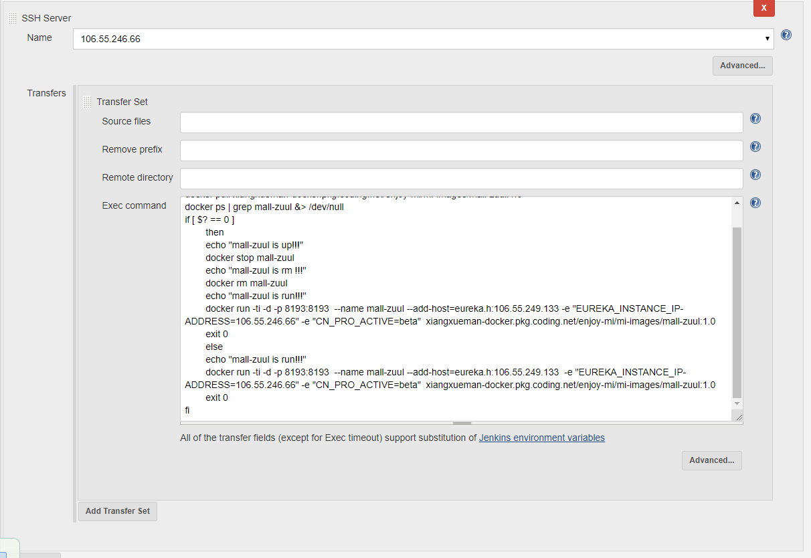

执行脚本

docker login -u 2181935941@qq.com -p 'XKcs_0731@123)$3' xiangxueman-docker.pkg.coding.net

docker pull xiangxueman-docker.pkg.coding.net/enjoy-mi/mi-images/mall-zuul:1.0

docker ps | grep mall-zuul &> /dev/null

if [ $? == 0 ]

then

echo "mall-zuul is up!!!"

docker stop mall-zuul

echo "mall-zuul is rm !!!"

docker rm mall-zuul

echo "mall-zuul is run!!!"

docker run -ti -d -p 8193:8193 --name mall-zuul --add-host=eureka.h:106.55.249.133 -e "EUREKA_INSTANCE_IP-ADDRESS=106.55.246.66" -e "CN_PRO_ACTIVE=beta" xiangxueman-docker.pkg.coding.net/enjoy-mi/mi-images/mall-zuul:1.0

exit 0

else

echo "mall-zuul is run!!!"

docker run -ti -d -p 8193:8193 --name mall-zuul --add-host=eureka.h:106.55.249.133 -e "EUREKA_INSTANCE_IP-ADDRESS=106.55.246.66" -e "CN_PRO_ACTIVE=beta" xiangxueman-docker.pkg.coding.net/enjoy-mi/mi-images/mall-zuul:1.0

exit 0

fi

# 项目架构图

