1

View the exhibit and examine the structure of the STORES table.
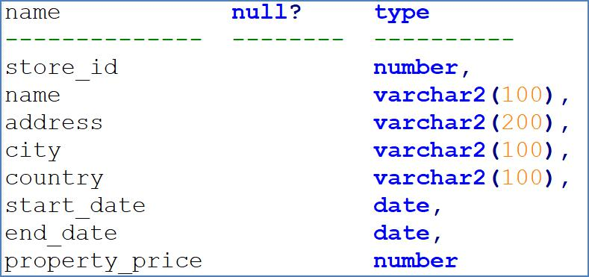

You want to display the NAME of the store along with the ADDRESS, START_DATE, PROPERTY_PRICE, and the projected property price, which is 115% of property price.

The stores displayed must have START_DATE in the range of 36 months starting from 01-Jan-2000 and above. Which SQL statement would get the desired output?

A. select name, concat(address || ', ' || city || ', ', country) as full_address, start_date, property_price, property_price * 115/100

from stores

where months_between(start_date, '01-JAN-2000') <= 36;

1 / 24

B. select name, concat(address || ', ' || city || ', ', country) as full_address, start_date, property_price, property_price * 115/100

from stores

where to_number(start_date - to_date('01-JAN-2000', 'DD-MON-RRRR')) <=36;

C. SELECT name, address || ',' || city || ',' || country AS full_address, start_date, property_price, property_price * 115/100

FROM stores

WHERE MONTHS_BETWEEN (start_date, TO_DATE('01-JAN-2000','DD-MON-RRRR')) <=36;

D. SELECT name, concat (address || ',' || city || ', ', country) AS full_address, start_date, property_price, property_price * 115/100

FROM stores

WHERE MONTHS_BETWEEN (start_date, TO_DATE('01-JAN-2000','DD-MON-RRRR')) <=36;

解析：

A（X）：使用字符串来表示日期，没用使用 TO_DATE 做转换

B（X）：两个 date 类型的数据相减，结果就是数值类型，不需要再调用 to_number 了

C（X）：没有使用 concat 函数，使用该函数可以解决||连接操作在不同平台上的执行结果不同的问题

2 / 24
2

View the Exhibit and examine the structure of CUSTOMERS table.

Using the CUSTOMERS table, you need to generate a report that shows an increase in the credit limit by 15% for all customers. Customers whose credit limit has not been entered should have the message "Not Available" displayed.

Which SQL statement would produce the required result?
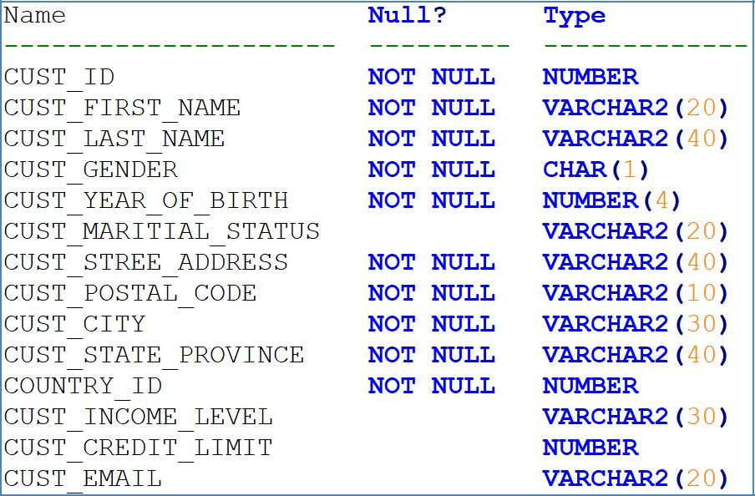

A. SELECT NVL (TO CHAR(cust_credit_limit * .15), 'Not Available') "NEW CREDIT" FROM customers; B. SELECT TO_CHAR (NVL(cust_credit_limit * .15), 'Not Available') "NEW CREDIT" FROM customers;
C. SELECT NVL(cust_credit_limit * .15), 'Not Available') "NEW CREDIT" FROM customers;

D. SELECT NVL(cust_credit_limit), 'Not Available') "NEW CREDIT" FROM customers;

解析：

NVL 函数要求第一个参数的类型要和第一个参数兼容，即可以自动转换为第一个参数的类型

3

View the Exhibit and examine the structure of ORDERS and ORDER_ITEMS tables. Evaluate the following SQL Statement:

select oi.order_id, product_id, order_date from order_items oi join orders o
using(order_id);

Which statement is true reguarding the execution of this SQL Statement?

- The statement would not execute because the table aliases are not allowed in the JOIN clause.

- The statement would not execute because the table aliases prefix is not used in the USING clause.

- The statement would not execute because all the columns in the SELECT cluase are not prefixed with table aliases.

- The statement would not execute because the column part of the USING cluase cannot have a qualifier in the SELECT list.

4

4 / 24

Which two statements are true?

- The USER_SYNONYMS view can provide information about private synonyms.

- The user SYSTEM owns all the base tables and user-accessible views of the data dictionary.

- All the dynamic performance views prefixed with v$ are accessible to all the database users.

- The USER_OBJECTS view can provide information about the tables and views created by the user who queries the view.

- DICTIONARY is a view that contains the names of all the data dictionary view that the user can access.

5

View the exhibit the structure of the ORDER_ITMES table.

Examine the following SQL Statements

select order_id, product_id, unit_price from order_items

where unit_price = (select max(unit_price) from order_items group by order_id);

You want to display the PRODUCT_ID of the product that has the highest UNIT_PRICE per ORDER_ID

What correction should be made in the above SQL statement to achieve this?

A. Replace = with the IN operator

B. Replace = with the >ANY operator

5 / 24
C. Replace = with the | >ALL operator

D. Remove the GROUP BY clause from the subquery and place it in the main query.

6

View the Exhibit and examine the details of the ORDER_ITEMS table.

6 / 24

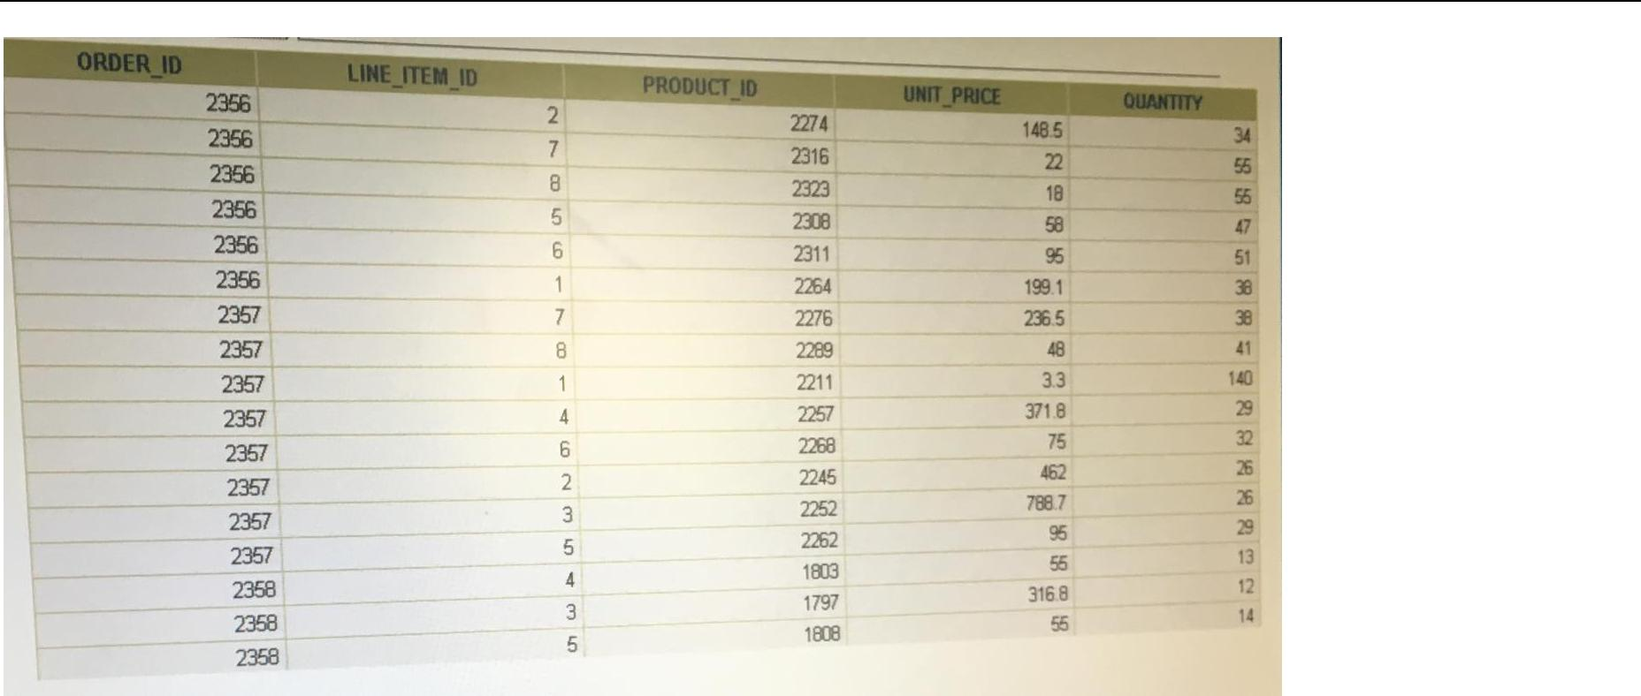

Evaluate the following SQL statements:

Statement1:

select max(unit_price * quantity) "Maximum Order" from order_items;

7 / 24

Statement2:

select max(unit_price * quantity) "Maximum Order" from order_items

group by order_id;

Which statements are true reguarding the output of these SQL statements?（choose all that apply.）

- Statement 1 would return only one row output.

- Both the statements would give the same output.

- Statement 2 would return multiple rows of output.

- Statement 1 would not return any row because the GROUP BY clause is missing.

- Both statements would ignore NULL values for the UNIT_PRICE and QUANTITY columns.

7

View the exhibit and examine the structure of the ORDERS table. The columns ORDER_MODE and ORDER_TOTAL have default values ‘direct’ and 0 respectively.

8 / 24

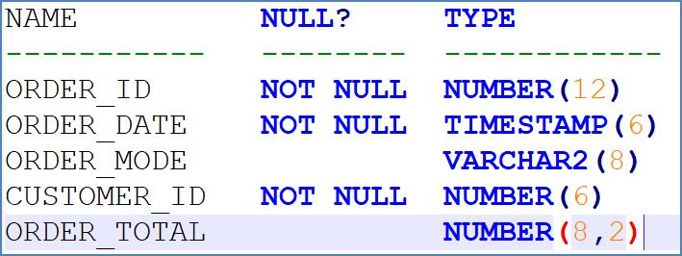

Which two INSERT statements are valid？

- insert into orders values(1, '09-mar-2007', 'online', '', 1000);

- insert into orders(order_id, order_date, order_mode, customer_id, order_total) values(1, to_date(null), 'online', 101, null);

- insert into (select order_id, order_date, customer_id from orders) values(1, '09-mar-2007', 101);

- insert into orders values(1, '09-mar-2007', default, 101, default);

- insert into orders(order_id, order_date, order_mode, order_total) values(1, '10-mar-2007', 'online', 1000);

解析：

A（X）：customer_id 有 not null 约束

B（X）：ORDRE_DATE 有 NOT NULL 约束

D（X）: CUSTOMER_ID 有 NOT NULL 约束

8

View the exhibit and examine the structure of the PRODUCT_INFORMATION and INVENTORIES tables.

9 / 24

You have a requirement from the supplies department to give a list containing PRODUCT_ID, SUPPLIER_ID, and QUANTITY_ON_HAND for all the products wherein QUANTITY_ON_HAND is less than five.

Which two SQL statements can accomplish the task?

A. select product_id, quantity_on_hand, supplier_id from product_information

natural join inventories and quantity_on_hand < 5;

B. select i.product_id, i.quantity_on_hand, pi.supplier_id from product_information pi join inventories i using(product_id) and quantity_on_hand < 5;

C. select i.product_id, i.quantity_on_hand, pi.supplier_id from product_information pi join inventories i

on (pi.product_id = i.product_id) where quantity_on_hand < 5;

D. select i.product_id, i.quantity_on_hand, pi.supplier_id from product_information pi join inventories i

on (pi.product_id = i.product_id) and quantity_on_hand < 5;

10 / 24

9

You need to list the employees in DEPARTMENT_ID 30 in a single row, ordered by HIRE_DATE.

Examine the sample output:

Emp_list Earliest

-------------------------------------------- -----------

Raphaely;Khoo;Tobias;Baida;Himuro;Colmenares 07-DEC-02

Which query will provide the required output?

A. select listagg(last_name)

within group order by (hire_date) "Emp_List", min(hire_date) "Earliest" from employees

where department_id = 30;

B. select listagg(last_name, '; ')

within group (order by hire_date) "Emp_List", min(hire_date) "Earliest" from employees

where department_id = 30;

C. select listagg(last_name, '; ') "Emp_List", min(hire_date) "Earliest" from employees

where department_id = 30

11 / 24

within group order by hire_date;

D. select listagg(last_name, '; ') "Emp_List", min(hire_date) "Earliest" from employees

where department_id = 30 order by hire_date;

10

View the Exhibit and exmaine the description of the EMPLOYEES table

Evaluate the following SQL statement

select first_name, employee_id, next_day(add_months(hire_date, 6), 1) "Review" from employees;

The query was written to retrieve the the FIRST_NAME, EMPLOYEE_ID, and review date for employees. The review date is the first Monday after the completion of six months of the hiring. The NLS_TERRITORY parameter is set to AMERICA in the session.

Which statement is true regarding this query?

- The query would execute to give the desired output.

- The query would not execute because the functions cannot be nested.

12 / 24

- The query would execute but the output would give review dates that are Sundays.

- The query would not execute because the NEXT_DAY function accepts a string as argument.

解析：

Next_day 的第一天为 Sunday

11

What is the primary difference between the rational database (RDB) and object-oriented database (OODB) models?

- OODB supports multiple objects in the same database, whereas RDB support only tables.

- RDB supports E.F. Codd’s rules, whereas OODB does not support them.

- OODB incorporates methods with data structure definition, whereas RDB does not allow this.

- RDB allows the definition of relationships between different tables, whereas OODB does not allow this.

12

Which statement is true regarding the SESSION_PRIVS dictionary view?

13 / 24

- It contains the current object privileges available in the user session

- It contains the current system privileges available in the user session.

- It contains the object privileges granted to other users by the current user session

- It contains the system privileges granted to other users by the current user session.

13

Examine the commands used to create DEPARTMENT_DETAILS and COURSE_DETAILS

SQL> create table department_details

(

department_id number primary key,

department_name varchar2(50),

hod varchar2(50));

SQL> create table course_details

(

course_id number primary key, course_name varchar2(50),

department_id number references department_details(department_id));

You want to generate a list of all department IDs that does not exist in the COURSE_DETAILS table.
14 / 24

You execute the SQL statement

select d.department_id from course_details c inner join department_details d on c.department_id <> d.department_id;

What is the outcome?

- It executes successfully and display the required list.

- It executes successfully but displays an incorrect list.

- It fails because the on clause condition is not valid.

- It fails because the join type used is incorrect.

14

Which three tasks can be performed by DDL statements?

- Providing an alternative name for a table

- modifying a table to prevent data that violate certain conditions from being entered in a column

- preventing any data modification to a table

- preventing data retrieval from a table outside of office hours

- creating multiple savepoints to enable partial rollback of a transaction

15 / 24

15

View the Exhibit and examine the structure of the customers table.
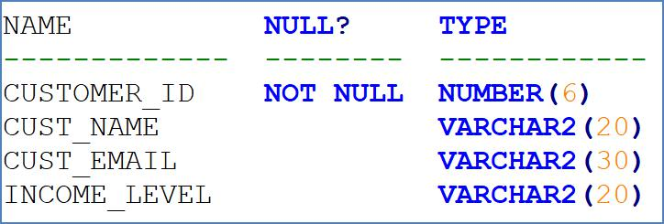

CUSTOMER_VU is a view based on CUSTOMERS_BR1 table which has the same structure as CUSTOMERS table. CUSTOMERS needs to be updated to reflect the latest information about the customers.

What is the error in the following MERGE statement?

merge into customers c using customer_vu cv on (c.customer_id = cv.customer_id)

when matched then update set

c.customer_id = cv.customer_id, c.cust_name = cv.cust_name, c.cust_email = cv.cust_email, c.cincome_level = cv.income_level
when not matched then

insert values(cv.customer_id, cv.cust_name, cv.cust_email, cv.income_level)

16 / 24

where cv.income_level > 100000;

- The CUSTOMER_ID column cannot be updated.

- The INTO clause is misplaced in the command.

- The WHERE clause cannot be used with INSERT

- CUSTOMER_VU cannot be used as a data source.

解析：

ERROR at line 2:

ORA-38104: Columns referenced in the ON Clause cannot be updated: "D1"."DEPARTMENT_ID"

16

Examine the command to create the BOOKS table.

SQL> create table books

(

book_id CHAR(6) PRIMARY KEY, title VARCHAR2(100) NOT NULL, publisher_id VARCHAR2(4), author_id VARCHAR2(50)

17 / 24

);

The BOOK_ID value 101 does not exis in the table.

Examine the SQL statement.

insert into books (book_id, title, author_id values('101', 'LEARNING SQL', 'Tim Jones');

- It executes successfully and the row is inserted with a null PUBLISHER_ID

- It executes successfully only if NULL is explicitly specified in the INSERT statement.

- It executes successfully only if NULL PUBLISHER_ID column name is added to the columns list in the INSERT statement.

- It executes successfully only if NULL PUBLISHER_ID column name is added to the columns list and NULL is explicitly specified in the INSERT statement.

17

Examine the structure of the DEPARTMENTS table

18 / 24

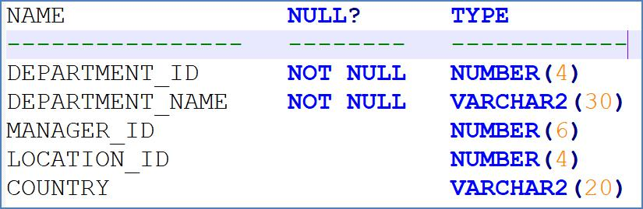

You execute the following command

alter table departments set unused(country);

Which two statements are true?

- Synonyms existing on the DEPARTMENTS table would have to be re-created

- Unique key constraints defined on the COUNTRY column are removed.

- Views created on the DEPARTMENTS table that include the COUNTRY column are automatically modified and remain valid.

- Indexes created on the COUNTRY column exist until the DROP UNUSED COLUMNS command is executed

- A new column, COUNTRY, can be added to the DEPARTMENTS table after executing the command.

18

19 / 24

Examine the structure of the EMPLOYEES table.
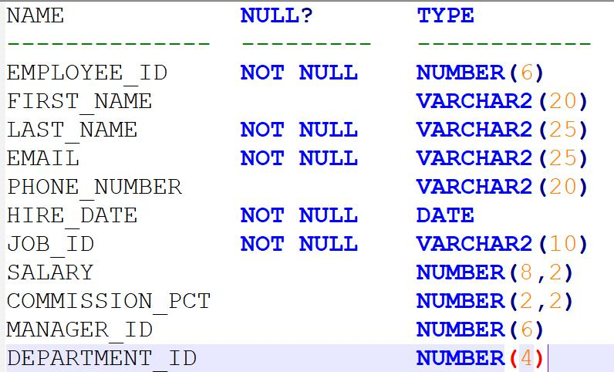

You must update the salary of all employees in DEPARTMENT_ID 30 to equal the salary of their managers and their commission to the maximum commission in DEPARTMENT_ID 30

Which statement would give the correct result?

update employees e

set e.salary = NVL((select m.salary from employees m where m.employee_id = e.manager_id), e.salary), e.commission_pct = (select max(commission_pct) from employees c)

where e.department_id = 30;

update employees e

set e.salary = NVL((select m.salary from employees m where m.employee_id = e.manager_id), e.salary), e.commission_pct = (select max(commission_pct) from employees c where c.department_id = e.department_id

20 / 24
 | and department_id = 30 group by department_id);
 | update employees e
 | set e.salary = (select m.salary from employees m where m.employee_id = e.manager_id),
 | e.commission_pct = (select max(commission_pct) from employees |  | c where c.department_id = e.department_id
 | group by department_id);
 | where department_id = 30;
 | update employees e
 | set e.salary = (select m.salary from employees m where m.employee_id = e.manager_id),
 | e.commission_pct = (select max(commission_pct) from employees c where c.department_id = e.department_id
 | and e.department_id = 30);
 | 解析：主句必须有 department_id | = 30，排除 B, D

A（X）：其中的子查询 select max(commission_pct) from employees c 查询的所有员工中 commission_pct 最大的

19

Examine the data in the ORD_ITEMS table:

21 / 24

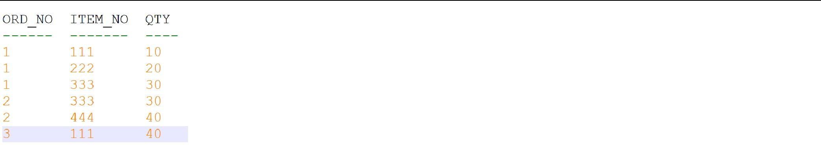

Execute this query:

select item_no, avg(qty)

from ord_items

having avg(qty) > min(qty) * 2 group by item_no;

Which statement is true reguarding the result?

- It returns an error because the HAVING clause should be specified after the GROUP BY clause.

- It returns an error because all the aggregate functions used in the HAVING clause must be specified in the SELECT list.

- It displays the item nos with their average quantity where the average quantity is more than double the minimum quantity of that item in the table.

- It displays the item nos with their average quantity where the average quantity is more than double the overall minimum quantity of all the items in the table.

22 / 24

20

Examine this Entity Relationship Model diagram:
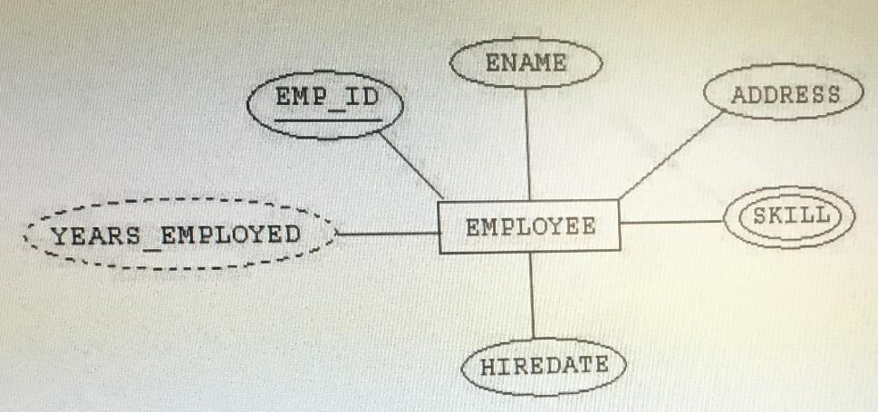

Which three statements are true?

- SKILL is a multi-valued attribute

- YEARS_EMPLOYED is a derived attribute

- YEARS_EMPLOYED is a key attribute

- SKILL is a composite attribute

- EMP_ID is a key attribute

23 / 24

F. EMPLOYEE is a weak entity.

-----------------------------------------------------175tiku -----------------

24 / 24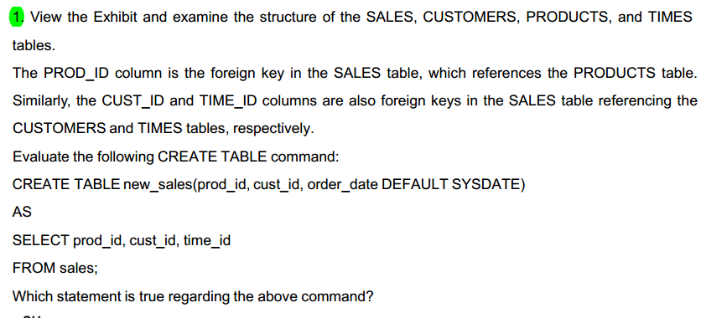

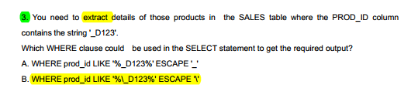
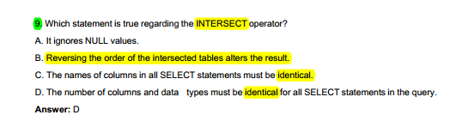
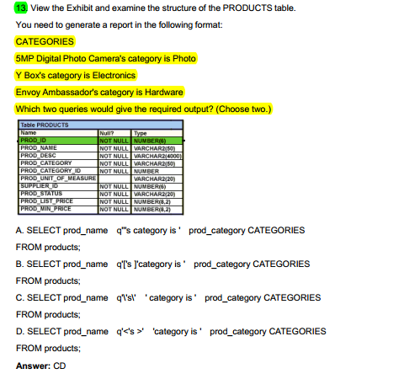
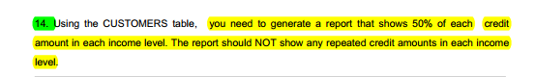
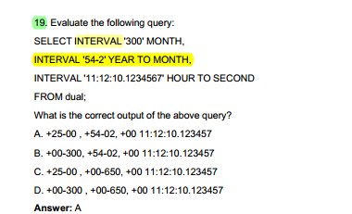
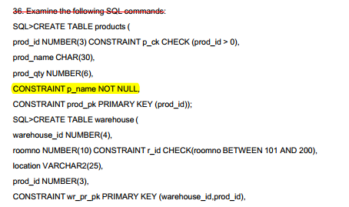
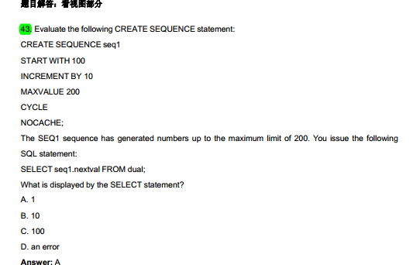

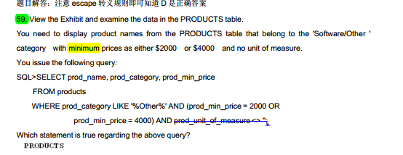

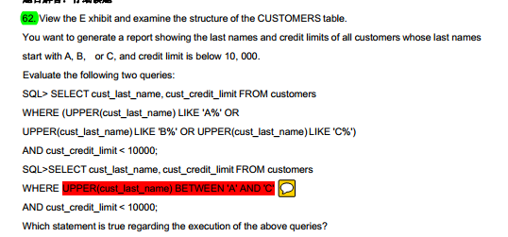

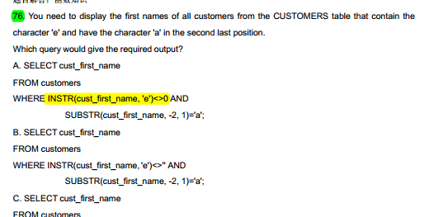
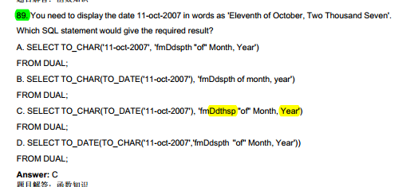

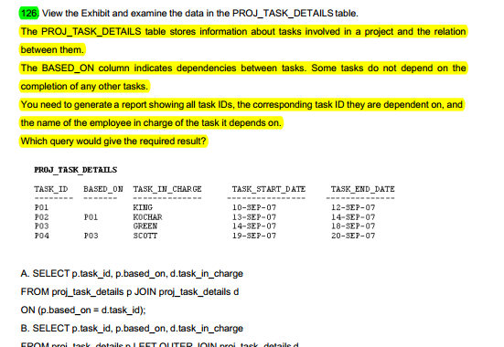
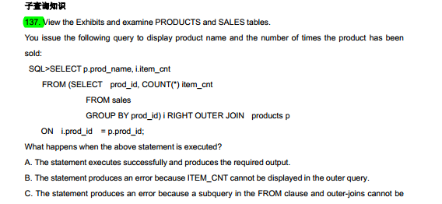

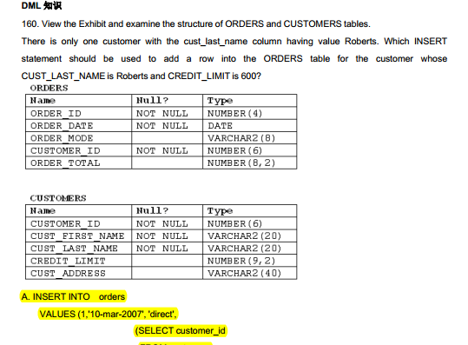

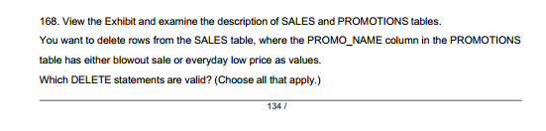

-----------------------------------------------------161tiku -----------------
