RESUME

Chris Baker

Address: 35 Albert Street, Williamstown, 3016
Phone: 0409 670 578, 9397 7959
Email: chris@dynacomm.info

PROFILE

An experienced Project Leader/Senior Analyst Programmer with 30+ years in the IT industry. Provided specialist support to the development, delivery and enhancement of Electronic Funds Transfer and Retail Banking products and services.

Competencies include:

- Strong customer focus | - Problem resolution
- Excellent industry knowledge | - Value Adding
- Adaptable | - Eye for detail

EFT CAREER HIGHLIGHTS

2005-06 Developed, Unit, System, DR and ETE tested batch settlement reports and batch processing stream for ANZ P2C project, within critical project timeframes
2002-04 Upgraded ACIP BASE24 to Release 6.0 and developed SAA Triple DES and TSS ESM enhancements
Developed and installed XPNET API to connect FDR acquirer with Pathway Authorisation system, replacing redundant ASYNCH protocol with X25 at HUECU
Migrated BASE24 to S Series and co-ordinated communications testing for BP
1998-02 Provided 1st and 2nd Level Help Desk support for the ACI BASE24 ATM and POS products throughout Australia and New Zealand.
1997 Co-ordinated Interchange testing for ANZ BASE24 5.1.2 upgrade project, included Re-certification of MasterCard APC and VISA AVS Interchanges and successful testing of all POS Interchanges, within critical project timeframes
1989-90 Installed and customised Tandem TESS Switch, POS and ATM Manager systems at SBNSW, developing Eracom security module support and AS2805 dynamic key management.
1987-88 Project Leader converting TESS Switch, POS and ATM Manager systems from Tandem to the IBM System 88/STRATUS, personally developing AS2805 Interface and Burroughs 1810 Device Handler.
1985- 86 Set up Victorian Switch as part of new Building Society Cash card ATM & EFTPOS
network

TECHNICAL SUMMARY

Software/Languages/Tools
TAL | CICS/VSAM
PATHWAY/SCOBOL | COBOL ,76, II, 85
TACL, BATCHCOM | ENDEVOR
CONNECT:DIRECT | DB2, FILEAID
TEST DIRECTOR | ASP/ACCESS , IIS
TSO/ISPF, MVS JCL | SQL SERVER 7
EASYTRIEVE | Consumer Transaction (PC)
CONTROL-M, CONTROL-D

PROFESSIONAL EXPERIENCE

ANZ May 2005 to March 2006
Contract Senior Analyst Programmer - Tandem Batch / BASE24 POS to CTM Project

Project to collect and deliver EFTPOS merchant, acquirer and issuer settlement totals to IBM host system.

Responsibilities/Achievements:
- Develop batch settlement summary and transaction detail reports in COBOL and TAL
- Develop TEST DIRECTOR scripts and perform Unit and DR testing
- Develop complex batch processing job stream, including CONNECT:DIRECT file transfer under BATCHCOM, using TACL routines and extended memory segments
- System, ETE and DR test environment batch processing installation and support

BENDIGO BANK LIMITED February to April 2005
Contract Senior Analyst Programmer

Responsibilities/Achievements:
- Install latest Carreker Fraudlink ON US Cheque and Deposit application upgrades into ENDEVOR, applied BBL customisation, compiled and unit tested to schedule
- Specification, coding and unit testing tasks as member of RFS 5.3 enhancements projects team. Projects included:
- Cashcard AS2805 interface fallback voucher modifications differential analysis and specification
- introduced Elders accounts new pro-rata quarterly fees modifications, code and extensive batch cycle unit testing

ACI WORLDWIDE (PACIFIC) October 2002 to September 2004
ACI WORLDWIDE (PACIFIC) is the Australian subsidiary of Applied Communications Inc (ACI). ACI supply HP Nonstop based BASE24 EFT products to 60% of the world EFT market. BASE24 consists of online transaction processes written in TAL and screen requester/servers written in ScreenCOBOL and COBOL.

Technical Consultant / Senior Analyst Programmer - BASE24 6.0

Responsibilities:
- Upgrade ACI Asia / Pacific specific code to run under
the newest release of BASE24 (Release 6.0) and make use of latest enhancements
- Support ACIP client base in migration to BASE24 Release 6.0

Achievements:
- Migrated BASE24 Prepaid to release 6.0, including AS2805 f120 token enhancement
- Enhanced SAA TDES, supported variable length Public keys, restored data key support and developed ESM MKII Transaction Security Services (TSS) support (refer diagram at end)
- Migrated BASE24 POS AS2805 device handler to release 6.0
- Included TDES support in VPRO SAA and ATM components
- Merged AMBCOM and SECUCOM (MKII) ESM command interfaces and included TDES software support
- Specified and developed BASE24 Gift Voucher enhancements for eTREND
- Installed BASE24 Release 6.0, TCP/IP, SAA, CPF, CAF/PBF

Senior A/P Customer Projects

Achievements in italics
- HUECU - developed and installed XPNET API to connect FDR acquirer with Pathway Authorisation system, replacing redundant ASYNCH protocol with X25
(rescued project after initial sales blunder, by quickly developing and installing API to sit between XPNET stations, assisted customer in resolving FDR protocol and message format issues outside of ACIP project scope)
- BP - migrated BASE24 POS from offsite D Series to onsite S Series, included XPNET/BASE24 installation, assessment of capability to perform production level of performance against existing BP applications (VPRO stress test) and integration testing of BASE24 with in house and external systems through a new communications network
(troubleshooted a number of communications problems and facilitated their resolution between external parties, which threatened to delay implementation)

ACI WORLDWIDE (PACIFIC) November 1997 to September 2002
Help Desk Support, Software Distribution
Responsibilities:
- Provide 1st and 2nd Level Help Desk support for the ACI BASE24 ATM, POS and Switching products throughout Australia and New Zealand. Gather information, analyse and resolve problems, liase with support staff in Melbourne and Omaha, Nebraska
- Distribute software fixes and updates to clients.
- Train up on new ACI products Extricator/Replicator and eCourier to provide ANZ and HPA with first level support

Achievements:
- Provided reliable and responsive direct contact with client technical resources
- Solicited detailed, precise and specific case information to expedite speedy problem resolution from Omaha based resources in non overlapping time zone
- Gained in depth knowledge of XPNET and BASE24 applications while productively involved resolving pressing customer issues
- Installed eCourier customer email billing system on LINUX in Edmonton, Canada

Senior A/P Special Projects

Responsibilities:
- BASE24 Inventory/PrePaid SAA development for OPTUS
- Customer Information System (CIS) design, development and support - MS IIS, ASP, JScript, SQLServer7, JavaScript
- ACIP Intranet Development & Support - scoped, designed and developed on web server platform (MS IIS, ASP, ACCESS)
- ACIP External Website Support - FrontPage
- HELP24 Clarify Database rollout for Asia Pacific
- Installed and customised the ACI BASE24 Telebanking/Billpay system
- Upgraded and tested the Help Service problem resolution database to be Y2K compliant.

Achievements:
- Completed Post Graduate CSE Web Development subject at RMIT (High Distinction) during own time
- Produced proof of concept document and developed prototype of browser based Intranet site, then developed application and built ACIP Intranet
- Produced feasibility report into replacing Tandem based Asia Pacific BASE24 problem tracking system with Omaha based Clarify system, with local client and co-ordinated rollout of new system to Asia Pacific
- Replicated parent company third party CIS VB client application functionality (used by ACIP sales and marketing staff, but support for product retired) to run on web server, with browser client

ACI PACIFIC/ANZ November 1996 to October 1997
Interchange Testing Co-Ordinator/System Tester

Project to upgrade ANZ's EFTPOS software to the 5.1.2 release of ACI's Base24 product

Responsibilities:
- Co-ordinate system testing and re-certification of all ANZ's EFTPOS Interchanges.
- Develop testing schedule, distribute test plans & cards, tailor test plans, interface with interchange parties and internal ANZ system test leaders
- Lead a team of up to five interchange system testers and personally perform considerable testing during the actual testing phase.

Achievements:
Re-certification of MasterCard APC and VISA AVS Interchanges and successful testing of all POS Interchanges, within critical project timeframes

TANDEM AUSTRALIA DEVELOPMENT July 1996 to October 1996
Senior Developer (A/P)

Commenced development of the Auto install and Japanese localisation components of Release 1.5 of Tandem's PTP Services for the CICS API product (MICROFOCUS UNIKIX COBOL code adapted to the Tandem).

Japanese Localisation involved connecting PTP through SNAX to IBM’s 3270 Personal Communications Manager on Windows 95. This required installation and configuration of Japanese versions of the comms manager and windows.

EMPLOYMENT HISTORY

The following projects/roles were performed for a single employer under the changing business names CONTINUUM, PAXUS, IDAPS, ADAPS & DATA CENTRE.

Position | Project/Role | Date
Project Leader/  Senior A/P | Converted Victorian Workcover Authority ADABAS/NATURAL and IMSD/COBOL Customer, Payables and Receivables sub-systems to DB2/CICS/COBOL General Insurance/Workcover | 1995-96
Project Leader/  Technical Analyst | Full SDLC project on Sandhurst Trustees and Capital Building Society accounts conversion & customisation to RFS for Bendigo Building Society  (Easytrieve+ conversion code interfacing to Online CICS/COBOL add functions) | 1992-94
Technical Analyst | Developed a new intelligent workstation delivery system (IBM CICS) for RFS to support the Consumer Transaction (CT) message formats.(CICS/COBOL/ASSEMBLER)  involved in ANZ TBS90 back office banking terminal software development using CT  (IBM PC DOS, OS/2) | 1991
Senior A/P | Developed and installed a new EFT Delivery System supporting STRATUS ON/2 Host/2 message formats for Co-Op Building Society (IBM CICS) | 1990
Project Leader  /Senior A/P | Managed and lead a small Project team to assist with the installation of TESS switch and POS Terminal and ATM Managers for SBNSW. Team developed ESM support for the switch & a Burroughs 1810 POS terminal and produced an AS2805 Dynamic Key Management system. (Tandem/COBOL/TAL) | 1988-90
Project Leader/  Applications  Consultant | EFT/88 project, converting Switch, POS and ATM Manager systems from Tandem to the IBM System 88/STRATUS. (COBOL/TAL to COBOL) | 1987-88
Senior A/P | Set up the Idaps Building Society Switch, establishing interchange links with CCATM's Base24 network, AUSTNET, VISA Base1, ANZ, NAB & (COBOL/TAL) | 1985-66
Project Leader/  A/P | Developed Library Circulation, Acquisitions and Online Cataloguing systems (CICS, COBOL and ADABAS/Natural. | 1976-84
Programmer | Projects to develop, Sales Forecasting and Analysis system for a major retailer, General Accounting System for a direct outlet wholesaler,  A parts Implosion/Explosion System | 1973-76
Operator/  Shift leader | Responsible for operation of three Honeywell 200s and managed transition to Honeywell 2050s, establishing operating procedures and training other Operations staff. | 1970-73

WEB SITES

The following Web Sites developed using HTML, server side includes, ASP and ACCESS as appropriate:

Australian Neuroscience Nursing Association
- http://anna.asn.au/
Victoria Manor - http://victoriamanor.com.au
Nicolet - http://nicolet.com.au
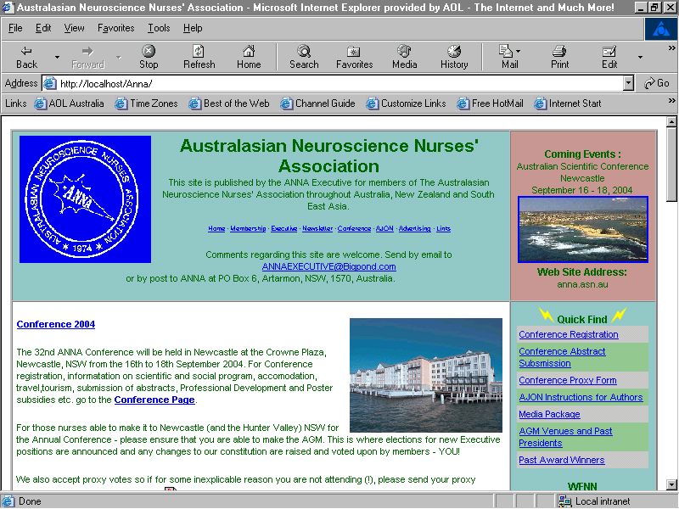

Friends of Bellarine Rail Trail – http://fbrt.com.au
Dynamic Communities - http://dynacomm.info

DIAGRAMS

The following diagram illustrates the BASE24 online processing configuration used to test SAA ESM TDES under TSS:

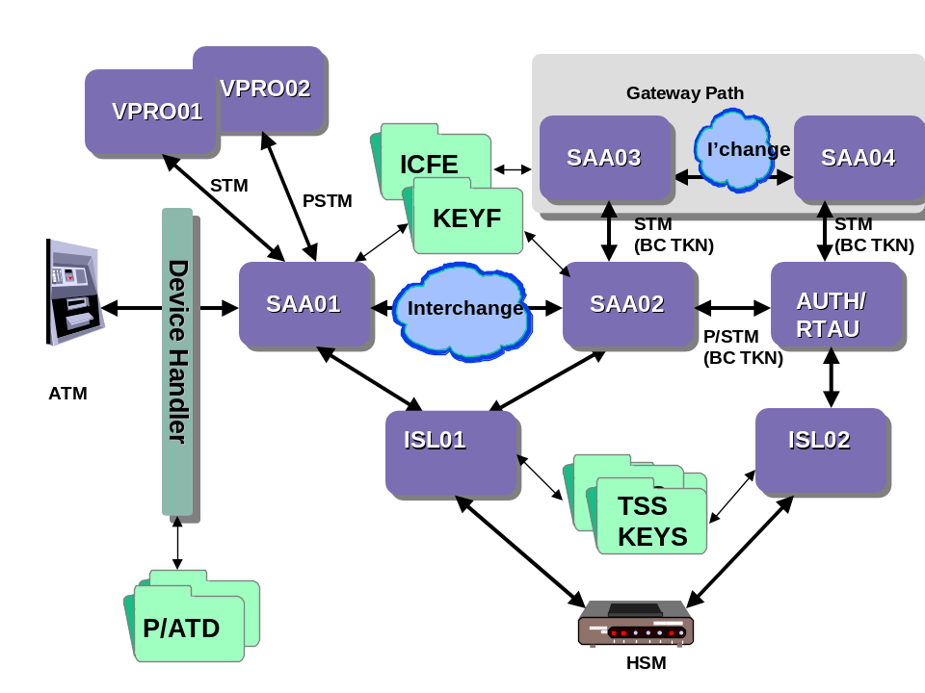

REFERENCES

Details provided on request

