1. Print the confusion matrix and overall accuracy for classifiers with three features.

PCA Confusion Matrix:

[[12 0 0 0 0 0 0 0 0 0]

[ 0 11 0 0 0 0 0 0 0 1]

[ 0 0 12 0 0 0 0 0 0 0]

[ 0 0 0 12 0 0 0 0 0 0]

[ 0 0 0 3 7 0 0 0 0 2]

[ 0 0 0 0 0 12 0 0 0 0]

[ 0 0 0 0 0 0 10 0 0 2]

[ 0 0 0 0 0 0 0 12 0 0]

[ 0 0 0 2 0 0 0 0 10 0]

[ 0 0 0 0 0 0 0 0 0 12]]

PCA Accuracy: 0.916666666667

LDA Confusion Matrix:

[[12 0 0 0 0 0 0 0 0 0]

[ 0 12 0 0 0 0 0 0 0 0]

[ 0 0 12 0 0 0 0 0 0 0]

[ 0 0 0 12 0 0 0 0 0 0]

[ 0 0 0 0 12 0 0 0 0 0]

[ 0 0 0 0 0 12 0 0 0 0]

[ 0 0 0 0 0 0 12 0 0 0]

[ 0 0 0 0 0 0 0 12 0 0]

[ 0 0 0 0 0 0 0 0 12 0]

[ 0 0 0 0 0 0 0 0 0 12]]

LDA Accuracy: 1.0

Fusion Confusion Matrix:

[[12 0 0 0 0 0 0 0 0 0]

[ 0 12 0 0 0 0 0 0 0 0]

[ 0 0 12 0 0 0 0 0 0 0]

[ 0 0 0 12 0 0 0 0 0 0]

[ 0 0 0 0 12 0 0 0 0 0]

[ 0 0 0 0 0 12 0 0 0 0]

[ 0 0 0 0 0 0 12 0 0 0]

[ 0 0 0 0 0 0 0 12 0 0]

[ 0 0 0 0 0 0 0 0 12 0]

[ 0 0 0 0 0 0 0 0 0 12]]

Fusion Accuracy: 1.0 alpha: 0.1

Fusion Confusion Matrix:

[[12 0 0 0 0 0 0 0 0 0]

[ 0 12 0 0 0 0 0 0 0 0]

[ 0 0 12 0 0 0 0 0 0 0]

[ 0 0 0 12 0 0 0 0 0 0]

[ 0 0 0 0 12 0 0 0 0 0]

[ 0 0 0 0 0 12 0 0 0 0]

[ 0 0 0 0 0 0 12 0 0 0]

[ 0 0 0 0 0 0 0 12 0 0]

[ 0 0 0 0 0 0 0 0 12 0]

[ 0 0 0 0 0 0 0 0 0 12]]

Fusion Accuracy: 1.0 alpha: 0.2

Fusion Confusion Matrix:

[[12 0 0 0 0 0 0 0 0 0]

[ 0 12 0 0 0 0 0 0 0 0]

[ 0 0 12 0 0 0 0 0 0 0]

[ 0 0 0 12 0 0 0 0 0 0]

[ 0 0 0 0 12 0 0 0 0 0]

[ 0 0 0 0 0 12 0 0 0 0]

[ 0 0 0 0 0 0 12 0 0 0]

[ 0 0 0 0 0 0 0 12 0 0]

[ 0 0 0 0 0 0 0 0 12 0]

[ 0 0 0 0 0 0 0 0 0 12]]

Fusion Accuracy: 1.0 alpha: 0.3

Fusion Confusion Matrix:

[[12 0 0 0 0 0 0 0 0 0]

[ 0 12 0 0 0 0 0 0 0 0]

[ 0 0 12 0 0 0 0 0 0 0]

[ 0 0 0 12 0 0 0 0 0 0]

[ 0 0 0 0 12 0 0 0 0 0]

[ 0 0 0 0 0 12 0 0 0 0]

[ 0 0 0 0 0 0 12 0 0 0]

[ 0 0 0 0 0 0 0 12 0 0]

[ 0 0 0 0 0 0 0 0 12 0]

[ 0 0 0 0 0 0 0 0 0 12]]

Fusion Accuracy: 1.0 alpha: 0.4

Fusion Confusion Matrix:

[[12 0 0 0 0 0 0 0 0 0]

[ 0 12 0 0 0 0 0 0 0 0]

[ 0 0 12 0 0 0 0 0 0 0]

[ 0 0 0 12 0 0 0 0 0 0]

[ 0 0 0 0 12 0 0 0 0 0]

[ 0 0 0 0 0 12 0 0 0 0]

[ 0 0 0 0 0 0 12 0 0 0]

[ 0 0 0 0 0 0 0 12 0 0]

[ 0 0 0 0 0 0 0 0 12 0]

[ 0 0 0 0 0 0 0 0 0 12]]

Fusion Accuracy: 1.0 alpha: 0.5

Fusion Confusion Matrix:

[[12 0 0 0 0 0 0 0 0 0]

[ 0 12 0 0 0 0 0 0 0 0]

[ 0 0 12 0 0 0 0 0 0 0]

[ 0 0 0 12 0 0 0 0 0 0]

[ 0 0 0 2 10 0 0 0 0 0]

[ 0 0 0 0 0 12 0 0 0 0]

[ 0 0 0 0 0 0 10 0 0 2]

[ 0 0 0 0 0 0 0 12 0 0]

[ 0 0 0 1 0 0 0 0 11 0]

[ 0 0 0 0 0 0 0 0 0 12]]

Fusion Accuracy: 0.958333333333 alpha: 0.6

Fusion Confusion Matrix:

[[12 0 0 0 0 0 0 0 0 0]

[ 0 12 0 0 0 0 0 0 0 0]

[ 0 0 12 0 0 0 0 0 0 0]

[ 0 0 0 12 0 0 0 0 0 0]

[ 0 0 0 2 9 0 0 0 0 1]

[ 0 0 0 0 0 12 0 0 0 0]

[ 0 0 0 0 0 0 10 0 0 2]

[ 0 0 0 0 0 0 0 12 0 0]

[ 0 0 0 2 0 0 0 0 10 0]

[ 0 0 0 0 0 0 0 0 0 12]]

Fusion Accuracy: 0.941666666667 alpha: 0.7

Fusion Confusion Matrix:

[[12 0 0 0 0 0 0 0 0 0]

[ 0 11 0 0 0 0 0 0 0 1]

[ 0 0 12 0 0 0 0 0 0 0]

[ 0 0 0 12 0 0 0 0 0 0]

[ 0 0 0 2 8 0 0 0 0 2]

[ 0 0 0 0 0 12 0 0 0 0]

[ 0 0 0 0 0 0 10 0 0 2]

[ 0 0 0 0 0 0 0 12 0 0]

[ 0 0 0 2 0 0 0 0 10 0]

[ 0 0 0 0 0 0 0 0 0 12]]

Fusion Accuracy: 0.925 alpha: 0.8

Fusion Confusion Matrix:

[[12 0 0 0 0 0 0 0 0 0]

[ 0 11 0 0 0 0 0 0 0 1]

[ 0 0 12 0 0 0 0 0 0 0]

[ 0 0 0 12 0 0 0 0 0 0]

[ 0 0 0 2 8 0 0 0 0 2]

[ 0 0 0 0 0 12 0 0 0 0]

[ 0 0 0 0 0 0 10 0 0 2]

[ 0 0 0 0 0 0 0 12 0 0]

[ 0 0 0 2 0 0 0 0 10 0]

[ 0 0 0 0 0 0 0 0 0 12]]

Fusion Accuracy: 0.925 alpha: 0.9

1. Compare the results for PCA feature and LDA feature, which feature is better? Why?

LDA feature is better. PCA is good for pattern representation rather than for pattern discrimination. LDA is good for discrimination. PCA try to find principle component so that it will project the original images to subspace. Because of that, PCA is difficult to classify the faces. But LDA is try to separate different class, for example, make between classes far away from each other and make within classes close to themselves. So, LDA is a better choice to compare the faces from those train and test faces’ images.

1. Let α = 0.1, 0.2, . . . , 0.9. Retrain your classifier for fused feature and re-calculate its accuracy for each α. Plot accuracy versus α for different α. Submit this plot. What do you observe?

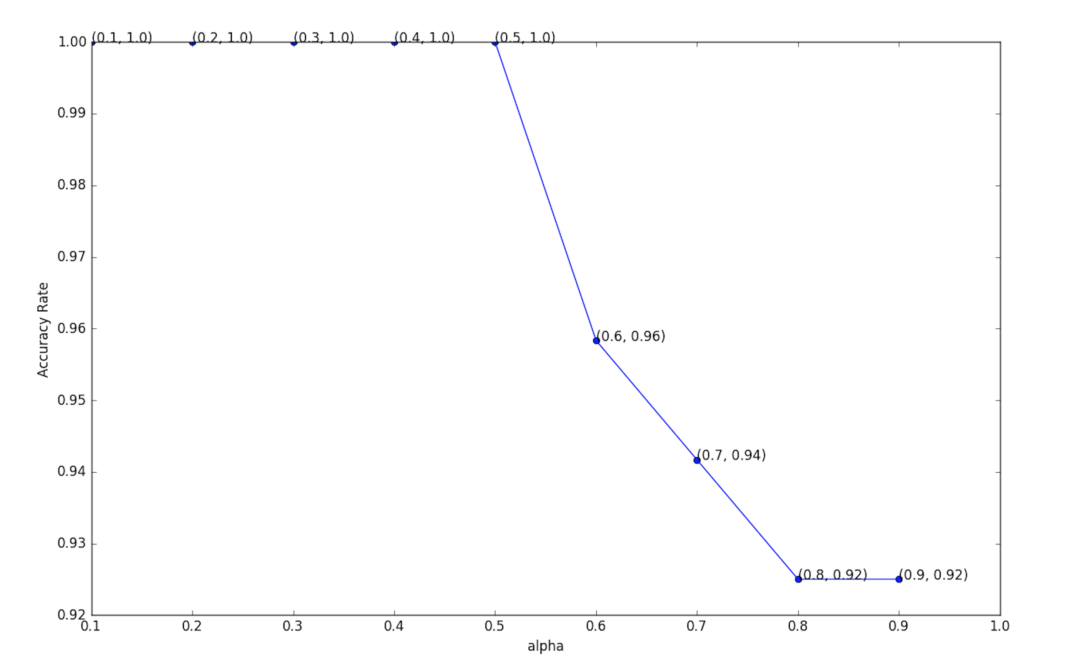

From this figure, when the alpha increase, the accuracy rate is decrease.

1. Does the fused feature outperform both PCA feature and LDA feature? Why?

No. The fused feature only outperform PCA feature. From the python print result, LDA’s accuracy is 100%, and the fused’s accuracy is decreasing with the increasing of alpha. Because LDA is better than PCA in this condition and the PCA feature is good for repesentation instead of discrimination. Some part of PCA features will always affect the result and make its accuracy decrease.