Tight, through and one-sided wrapping
Every page of a document is the result of many small decisions. Where does a line end, how much space goes between two paragraphs, and which words move to the next page when the current one is full? A layout engine answers these questions thousands of times for a single report. Tables, lists and footnotes add constraints of their own. A table row may refuse to split across pages, a list number needs room before its text, and a footnote belongs on the page of its reference, which in turn changes how much body text fits above it.
Measuring is better than guessing. A probe document varies one property at a time: the font size, the line spacing, the width of the margins. Word lays it out and exports it, and the positions of the lines tell which rule it followed.
Word breaks lines at spaces and after hyphens, keeps the last line of a paragraph from standing alone at the top of a page, and pulls a heading onto the next page when the text that follows it would not fit. None of these rules is complicated on its own; together they decide where every glyph ends up. Every page of a document is the result of many small decisions. Where does a line end, how much space goes between two paragraphs, and which words move to the next page when the current one is full? A layout engine answers these questions thousands of times for a single report.
Tables, lists and footnotes add constraints of their own. A table row may refuse to split across pages, a list number needs room before its text, and a footnote belongs on the page of its reference, which in turn changes how much body text fits above it. Measuring is better than guessing. A probe document varies one property at a time: the font size, the line spacing, the width of the margins. Word lays it out and exports it, and the positions of the lines tell which rule it followed.
Every page of a document is the result of many small decisions. Where does a line end, how much space goes between two paragraphs, and which words move to the next page when the current one is full? A layout engine answers these questions thousands of times for a single report. Word breaks lines at spaces and after hyphens, keeps the last line of a paragraph from standing alone at the top of a page, and pulls a heading onto the next page when the text that follows it would not fit. None of these rules is complicated on its own; together they decide where every glyph ends up.
Every page of a document is the result of many small decisions. Where does a line end, how much space goes between two paragraphs, and which words move to the next page when the current one is full? A layout engine answers these questions thousands of times for a single report. Tables, lists and footnotes add constraints of their own. A table row may refuse to split across pages, a list number needs room before its text, and a footnote belongs on the page of its reference, which in turn changes how much body text fits above it.
Measuring is better than guessing. A probe document varies one property at a time: the font size, the line spacing, the width of the margins. Word lays it out and exports it, and the positions of the lines tell which rule it followed. Word breaks lines at spaces and after hyphens, keeps the last line of a paragraph from standing alone at the top of a page, and pulls a heading onto the next page when the text that follows it would not fit. None of these rules is complicated on its own; together they decide where every glyph ends up.
Tables, lists and footnotes add constraints of their own. A table row may refuse to split across pages, a list number needs room before its text, and a footnote belongs on the page of its reference, which in turn changes how much body text fits above it. Every page of a document is the result of many small decisions. Where does a line end, how much space goes between two paragraphs, and which words move to the next page when the current one is full? A layout engine answers these questions thousands of times for a single report.
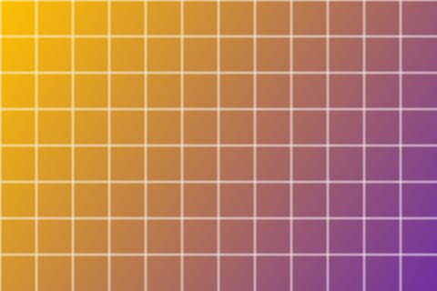
Word breaks lines at spaces and after hyphens, keeps the last line of a paragraph from standing alone at the top of a page, and pulls a heading onto the next page when the text that follows it would not fit. None of these rules is complicated on its own; together they decide where every glyph ends up. Measuring is better than guessing. A probe document varies one property at a time: the font size, the line spacing, the width of the margins. Word lays it out and exports it, and the positions of the lines tell which rule it followed.
Every page of a document is the result of many small decisions. Where does a line end, how much space goes between two paragraphs, and which words move to the next page when the current one is full? A layout engine answers these questions thousands of times for a single report.

