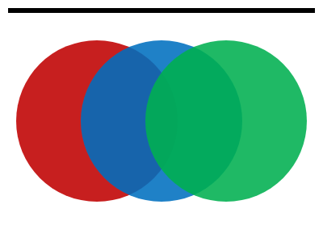
Inline pictures
Text before the picture and text after it on the same line.
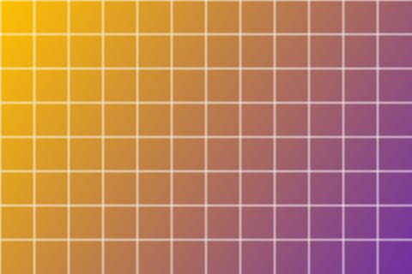
A small vector picture  in a line of text.

Shapes on the page
Every page of a document is the result of many small decisions. Where does a line end, how much space goes between two paragraphs, and which words move to the next page when the current one is full? A layout engine answers these questions thousands of times for a single report.

