PORJECT

Step 2 : Choose the cryptocurrencies to include
The asset universe was selected using the following criteria:

1. Large Market Capitalization
Large-cap cryptocurrencies were chosen because they:
- dominate the cryptocurrency market
- attract the highest trading volume
- are widely held by investors and institutions
Assets with larger market capitalizations also tend to have more stable liquidity and longer historical datasets, which are essential for reliable portfolio analysis.

2. Data Availability
3.
You selected assets that might have lower or imperfect correlations, allowing diversification benefits to potentially emerge.

• Bitcoin (BTC)
• Ethereum (ETH)
• Binance Coin (BNB)
• Solana (SOL)
• Cardano (ADA)
• XRP (XRP)

Step 3: picking time horizon
January 2021 – December 2023
This period was selected because it captures several important market phases in the cryptocurrency ecosystem, including:
- a strong bull market in 2021
- a major market downturn in 2022
- a partial recovery in 2023
Including different market conditions allows the analysis to evaluate portfolio performance during both expansion and contraction phases, which is important when assessing diversification and risk management strategies.
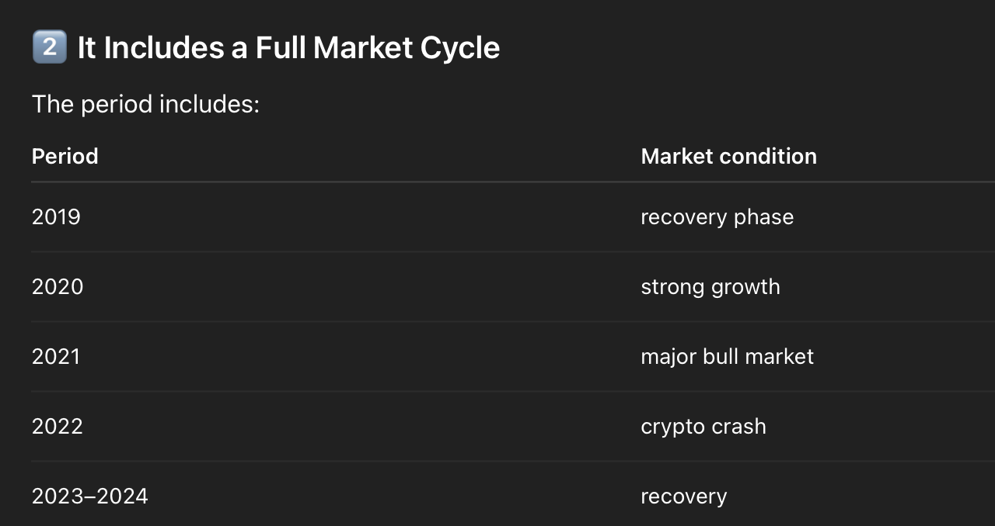

Step 6: return calc

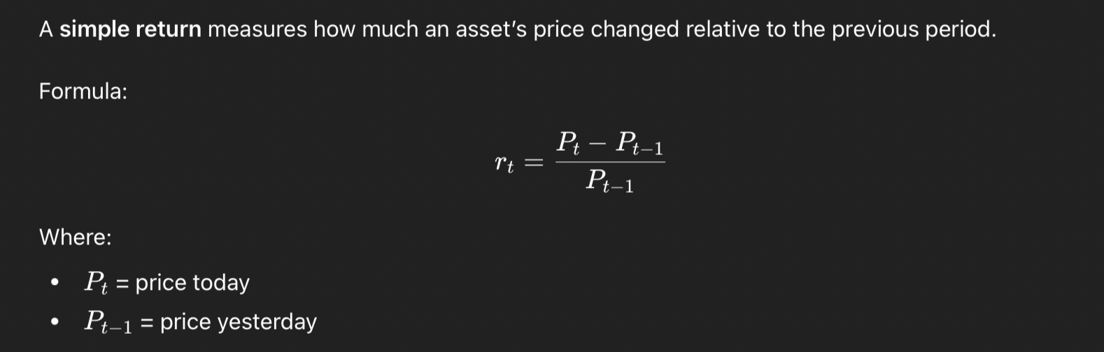
Tableau de croix, old = 100%

Step 7: control portfolio

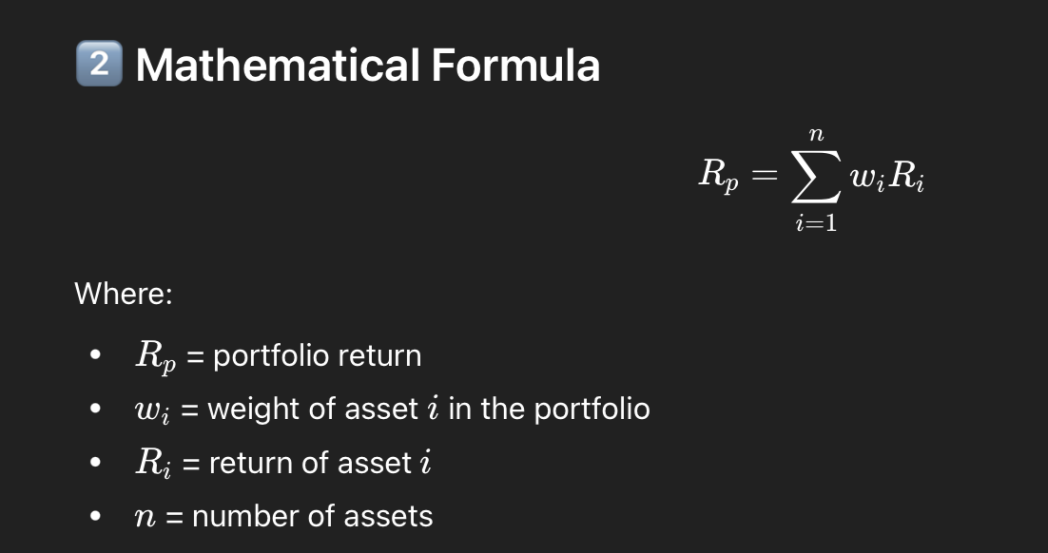

We multiply each column with the weigth of the column.
Then we sum each row to get how much we’re globally up/ down that day.
End up with a pandas series “porftolio returns” with dates and daily porf returns.

Step 8: test portfolio
Now you define a test portfolio where the weights will be determined by an optimization algorithm.
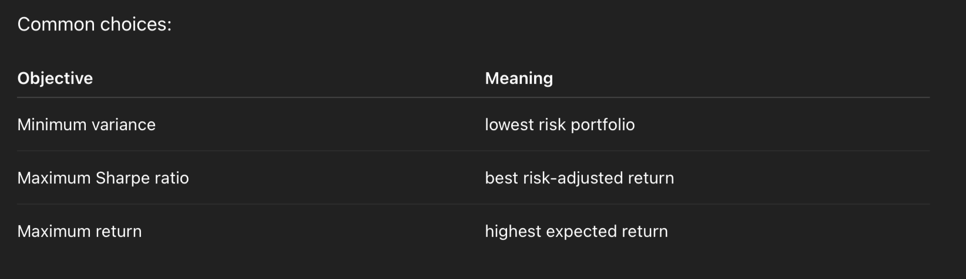
Markowitz Mean–Variance optimization = the framework
Maximum Sharpe ratio = one possible solution inside that framework

Harry Markowitz introduced the Mean–Variance framework in Modern Portfolio Theory.
A portfolio is fully described by two things:
expected return (mean)
risk (variance or volatility)
The goal is to find efficient portfolios that:
maximize return for a given level of risk
or
minimize risk for a given level of retur

on efficient frontier

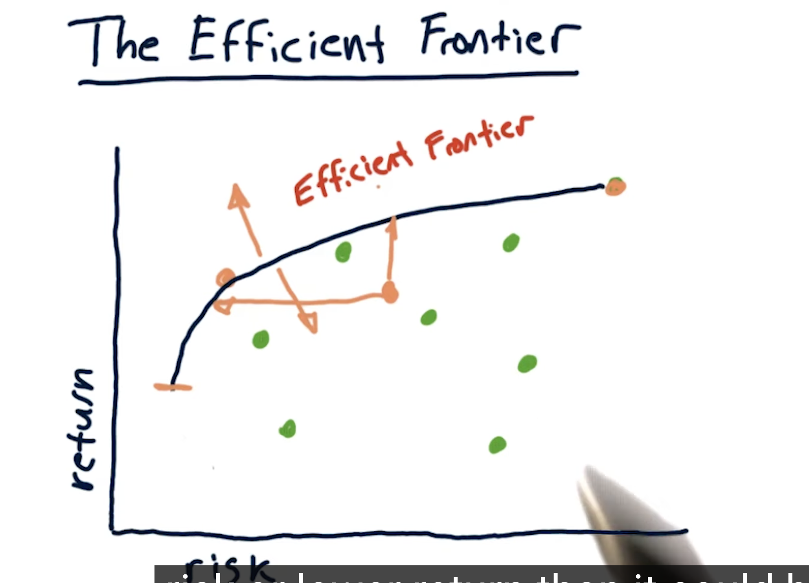
Any portfolio under the efficient frontier is not optimal, its either higehr risk or lower return than could be if on efficient frontier.
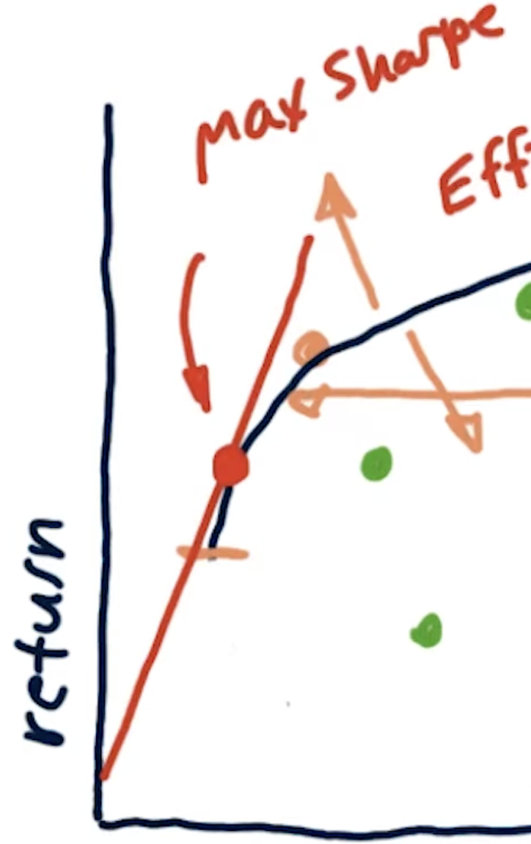 If we draw tangeante, we get max Sharpe ratio portfolio.

The framework produces many portfolios:
low risk / low return
medium risk / medium return
high risk / high return

All efficient ones lie on the efficient frontier. The framewrok gives mutiple portfolios not just one.

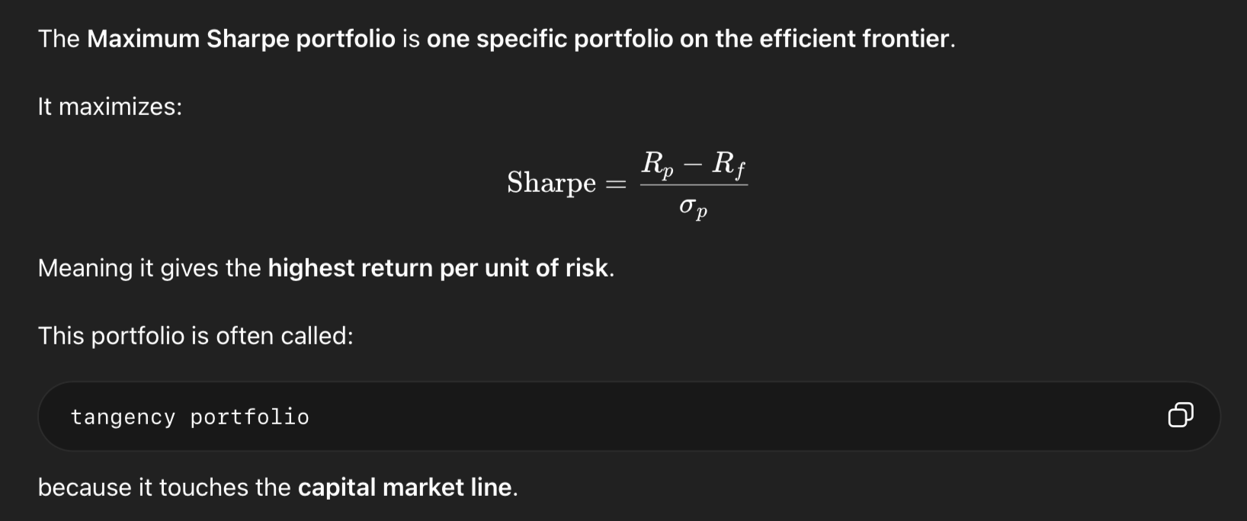

That’s the one we’ll take to answer Which portfolio gives the best risk-adjusted performance?
We will maximize risk-adjusted return. the optimizer will search for the portfolio that produces the highest return relative to its risk

Constraints:
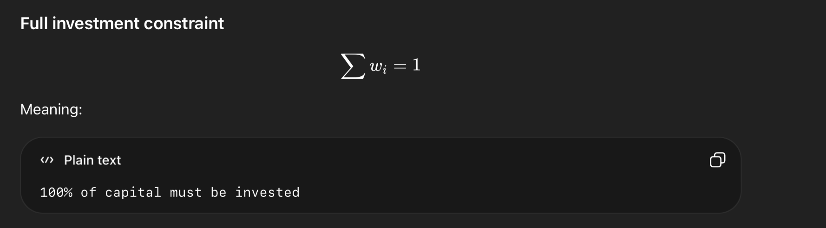
• To not invest more than 100% (leveraging)
• To not invest less than 100% (holding implicit cash)

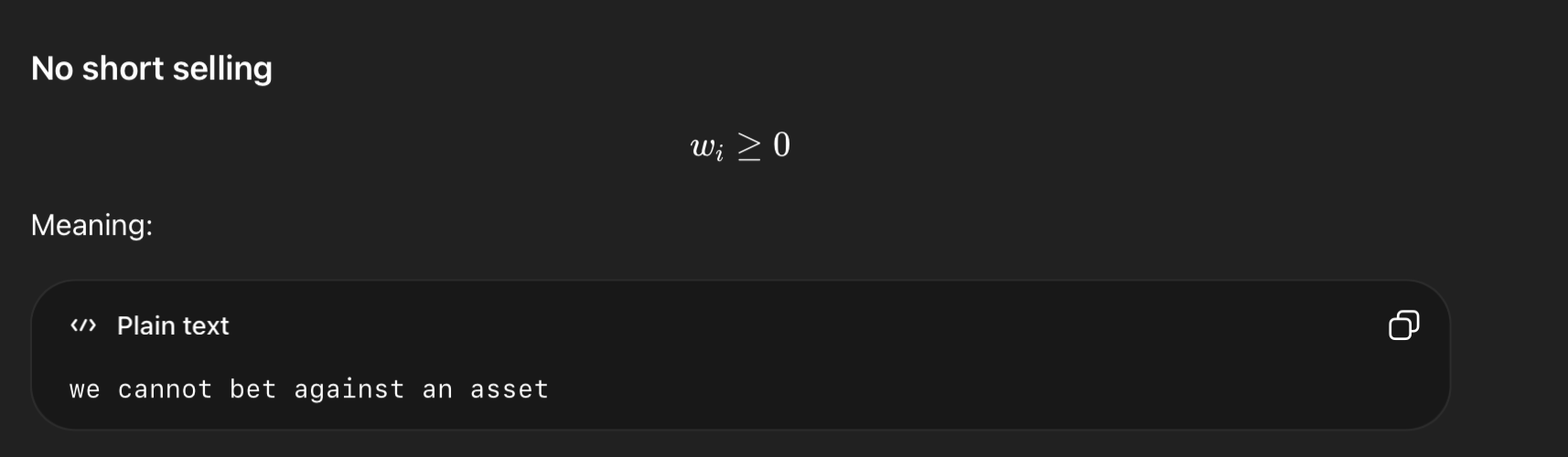
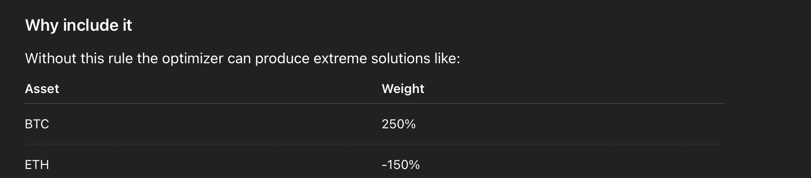

Normallemet on aurait inclu un constraint de diversifcation but we’ll lighten it this time to test how mathematically accurate the optimizer is, then strict diversification constraints can actually interfere with the experiment, because they restrict the optimizer’s ability to find the true mathematical optimum.
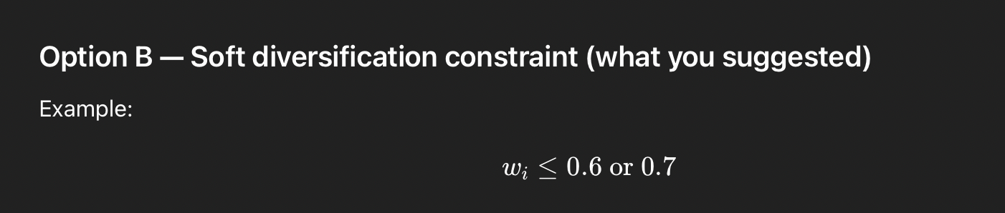
• still prevents full concentration
• allows the optimizer to express strong preferences
• avoids artificially forcing diversification
To avoid unrealistic corner solutions while preserving the optimizer’s flexibility, a relatively loose maximum allocation constraint of 70% per asset was imposed. This prevents the optimizer from allocating the entire portfolio to a single cryptocurrency while still allowing substantial concentration if justified by the return–risk characteristics of the assets.

Step 9: STATS
Take the return series of each crypto and describe its behavior statistically. So instead of looking at portfolio performance, you now look at each asset on its own:
• mean return
• median return
• standard deviation
• variance
• minimum return
• maximum return
• skewness
• kurtosis

WHY????
Does diversification improve the risk-adjusted performance of cryptocurrency portfolios?
To answer that, you must first know:
- Which assets are high return
- Which assets are high risk
- Which assets have extreme crashes
- Whether the return distributions are normal or heavy-tailed
Crypto is known for:
- extreme volatility
- crashes
- fat tails
The statistics will show that.
That explains why risk management matters in crypto portfolios.
Observations
- Crypto assets exhibit large differences in volatility.
- Smaller altcoins show higher risk and higher average returns.
- Return distributions are strongly non-normal.
- Many assets exhibit fat tails and extreme events.
This justifies:
- portfolio diversification
- careful risk analysis
- simulation methods later in the project.
- BTC
- Lowest mean return and lowest volatility ==> behaves like the most stable asset

- SOL
- Highest average return and the highest volatility ==> high risk / high return asset

- The min and max returns show that Crypto markets show very extreme daily moves, comapred to typical stock market (±2% – ±5%)

Step 10: Correlation and covariance matrices

Cor:
- Values close to 1 → assets move together
- Values close to 0 → weak relationship
Lower correlation = better diversification.
If all were close to 1 –> diversification wouldn’t help.
All of the project is based on checking if a certain diversification strategy (here max Sharpe) can be helpful. If diversification itself is not useful since all are corelated then Kolo Baz.

Step 11
Expected return: The average return we expect an asset to generate in the future. = E[R] = expected value of the return

We need it for the Sharpe function:
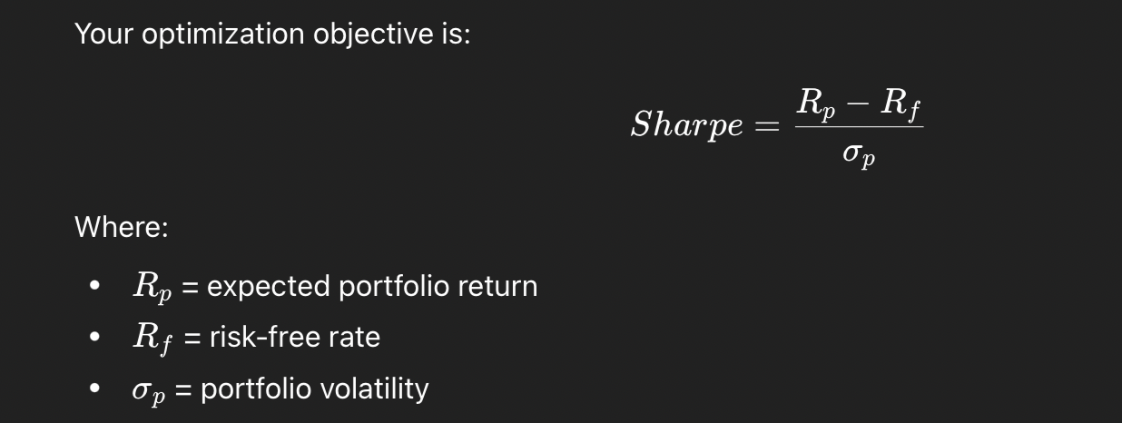
Avec
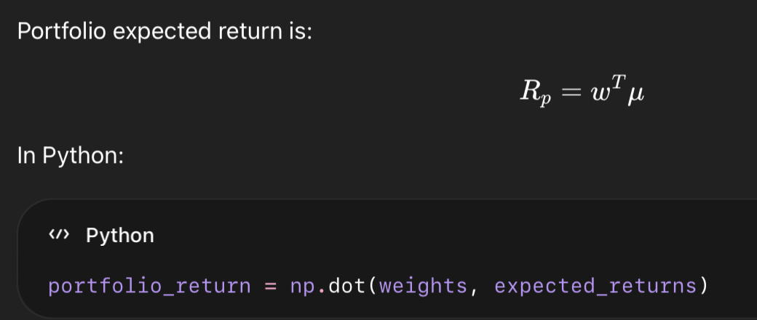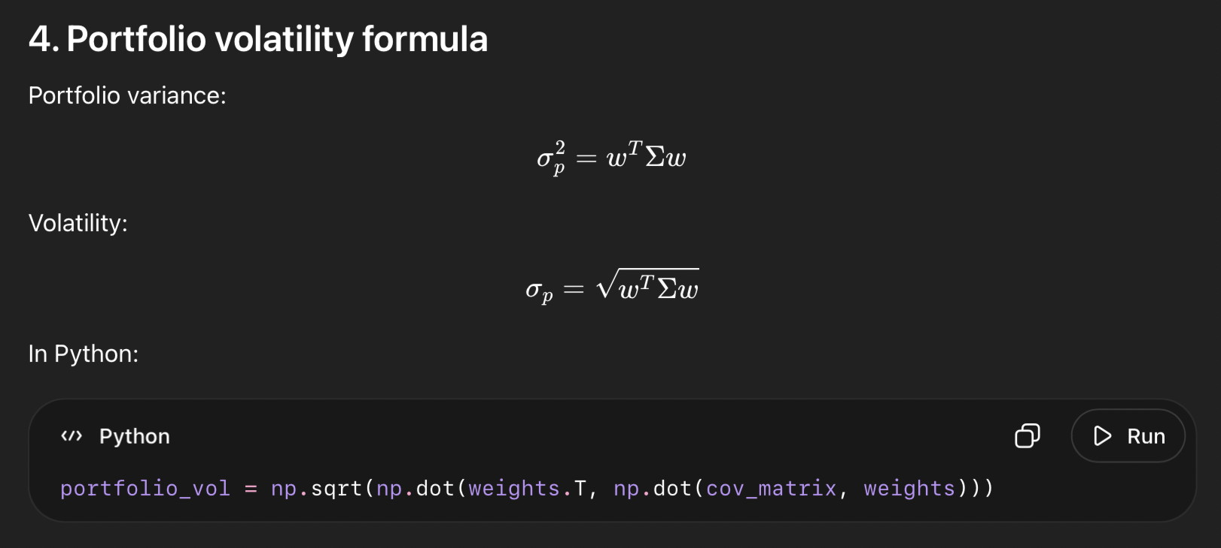

Why negelcetd risk free rate in Sharpe.

Step 13 : comparing

  - Test with max=0.7
  - Then with max= 0.4

