**education++ user guide**

Welcome to the education++ user guide. The requirements for using education++ are split up into 2 sections: Professor Use Guide and Student User Guide

education++ is a module created for Moodle that integrates gamification elements into normal coursework, making for a competitive, exciting, and fun learning environment. Professors can setup “incentives” for students to purchase (such as badges or rewards like dropping a student’s lowest quiz mark). Then students can earn points that they can spend on these rewards as defined by the professor, all while competing with their classmates on the leaderboards.

Professor User Guide

Once the education++ module has been installed (See the installation guide), a professor can use the module with ease

**Add an Education++ Instance to Your Course**

1. Navigate to your course
2. Turn Editing On, Then select “Add an activity or resource” (To the top “non-week”)

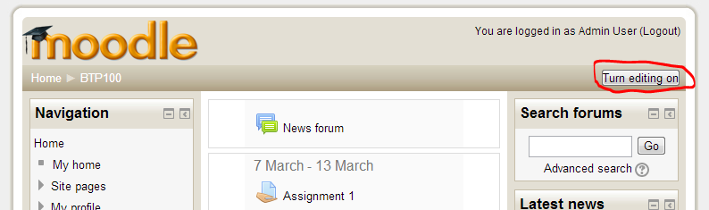 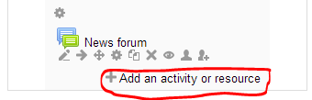

1. Select educationplusplus and click add  
    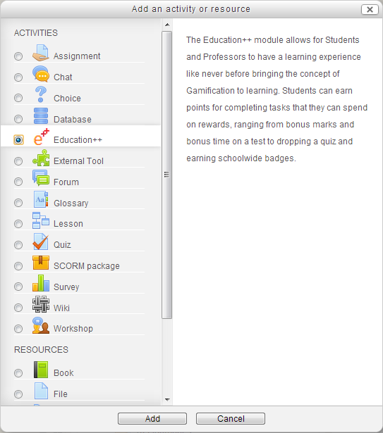  
   Name the Education++ instance (You can simply name it Education++ if you like)
2. When you click on the education++ instance, you will be greeted with the following screen: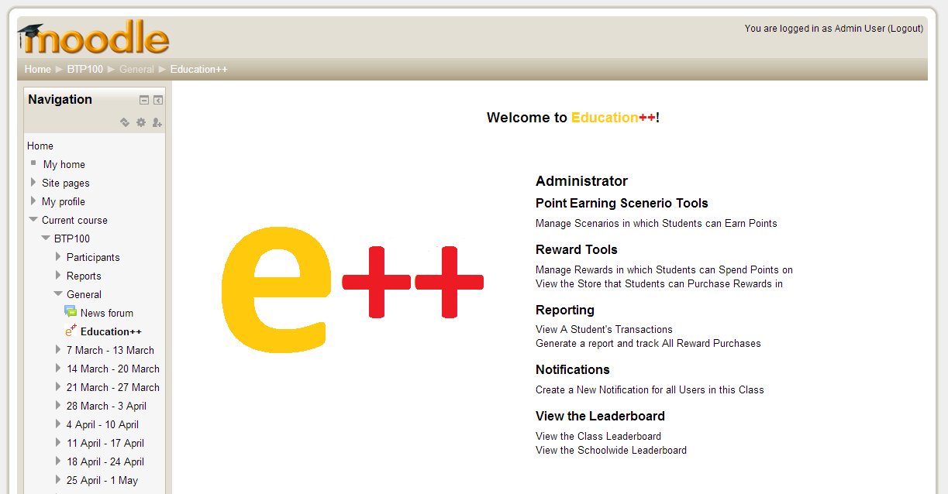

**Set-up Scenarios in Which Students can Earn Points**

1. Firstly, ensure you have assignments/tests/quizzes for your students to complete
2. Enter the education++ instance and click on “Manage Scenarios in which Students can Earn Points”.
3. Note that you can return to this page in the future to edit these scenarios. Click on “create a new scenario in which students can earn points”.
4. Fill out all the first four fields with your desired information: Name (name of the scenario), Point Value (how much a student earns for unlocking the scenario), Expiry Date (last date for a student to achieve the scenario) and Description (General Description).
5. Set the requirements to whatever you desire: select an assignment, then the requirement (Completed is if there is any mark for the student, > is if they have exceeded the set mark. >= is if they have matched or exceeded the set mark and = is if they have matched the set mark exactly) and then the set mark. You can add other requirements if you desire.
6. Select “Create New Point Earning Scenario”. Note: If a student meets the requirements of a scenario, the number of points set by Point Value is awarded

**Set up Rewards that Students can Spend Points on**

1. Enter the education++ instance and click on “Manage Rewards in which Students can Spend Points on”.
2. Note that you can return to this page in the future to edit these rewards. Click on “Create a new Incentive”.
3. From here you need to decide whether or not you want to create a Badge or a Reward. A reward should have a “physical reward” (such as dropping a quiz, 5 minutes extra on a test), while a Badge has no “physical value”, but if a student purchases a badge it will show up in their profile and on the school leaderboard.
4. Fill out all the fields. “Quantity Per Student” (Reward only) is the number of times a student can purchase said reward. Note that a badge can only be purchased once by a student. You can set the store visibility as not on if you do not wish the students to be able to purchase the incentive yet.
5. Select “Create New Incentive”

**Track the Awarding process of Rewards**

1. Enter education++ and click on “Generate a report and track All Reward Purchases”.
2. Check off and keep track of those students who have received their reward.

The remaining links are additional non-critical tools: Click on “View A Student's Transactions” to view all earned scenarios and purchases by a student, Click on “Create a New Notification for all Users in this Class” to send a notification to all students in the class, and you can view the school and class leaderboards by clicking “View the School Leaderboard” and “View the Class Leaderboard” respectively. Note: A student wont show up on the class leaderboard until they enter education++ for the first time

Student User Guide

When you first click on the education++ instance you will be greeted with this screen

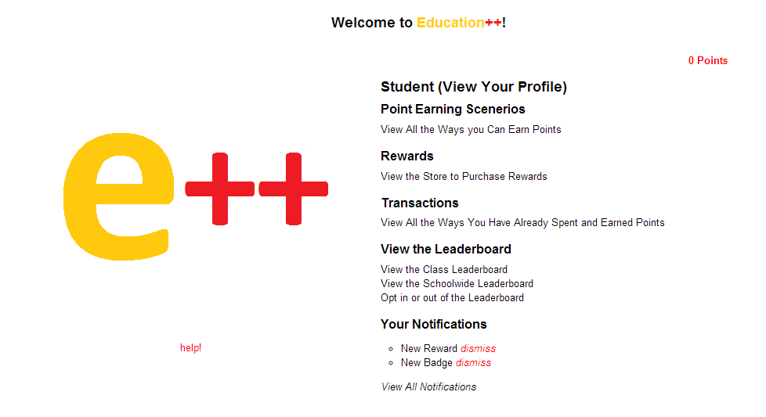

**Buy an Incentive**

1. Provided you have adequate points, you can purchase an incentive by clicking “View the Store to Purchase Rewards” and then click on buy for the incentive you wish to purchase.
2. The professor will be notified of a Reward purchase, or if you purchased a badge, your badge will now be displayed on your User Profile and the School Leaderboard

**How to Earn Points**

1. Your professor defines how to earn points, to see what your professor has made for you to earn, click on “View All the Ways you Can Earn Points”

The remaining links are additional non-critical tools: Click on “View All the Ways You Have Already Spent and earned Points” to view all of your earned scenarios and purchases, Click on “View All Notifications” to view all notifications sent to you (purchases, unlocks and messages from your professor, and you can view the school and class leaderboards by clicking “View the School Leaderboard” and “View the Class Leaderboard” respectively. You can also opt out of the leaderboard system by clicking “Opt in or out of the leaderboard system”.