- UV Setup (Learn it - what is UV setup?)
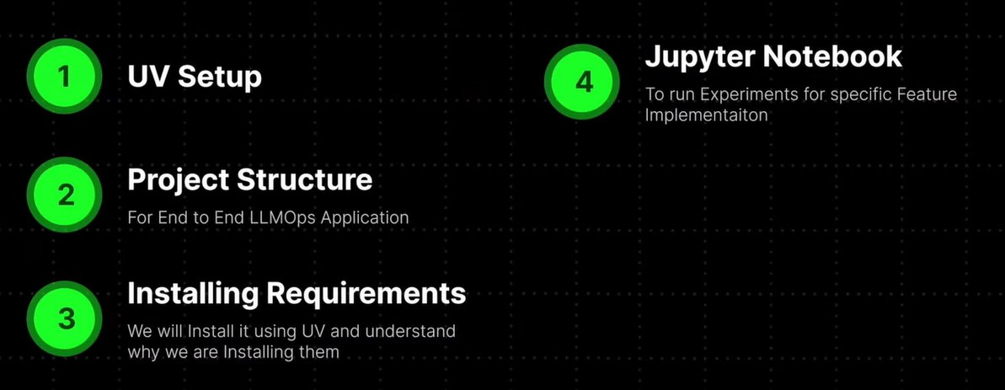
- https://docs.astral.sh/uv/getting-started/installation/
- uv 0.10.0 (0ba432459 2026-02-05) this version installed in our project
- uv init . (This command is used for python setup used in vs code)
- uv venv .venv (This command for virtual environment)
- uv add ipykernel (This is for jupyter notebook environment)
- uv sync (check on internet uses of this command)

- LLMOps/
- │
- ├── data/(This folder stores all the input documents that your AI system will read and learn from. These can be text files, PDFs, Word documents, or any knowledge base files)
- │
- ├── multi_doc_chat/( This is the main application folder where all AI logic and system modules are written. It contains all components required to build the RAG chatbot.)
- │ ├── config/ (Stores project settings like chunk size, model name, database paths, and environment configuration. It helps avoid hardcoding values inside code.)
- │ ├── exceptions/(Handles errors safely and professionally and makes debugging easier.)
- │ ├── logger/( Records system activities like loading documents, model calls, failures, and debugging logs. This helps track system performance and errors.)
- │ ├── loaders/( Loads documents from different sources like TXT, PDF, or directories and converts them into LangChain document format.)
- │ ├── splitter/( Breaks large documents into smaller chunks so that embeddings and retrieval work efficiently.)
- │ ├── embeddings/(Converts text chunks into numerical vectors that AI models can understand and compare.)
- │ ├── vectorstore/(Stores embeddings into vector databases like FAISS or Chroma and allows fast similarity search. Means Stores AI knowledge in searchable format)
- │ ├── retriever/( Searches vector database and finds relevant document chunks based on user question.)
- │ ├── llm/( Contains Large Language Model logic such as OpenAI, Ollama, or other LLM integrations used to generate final answers.)
- │ ├── pipeline/( Combines loader → splitter → embedding → retriever → LLM into one full RAG workflow. Means Controls complete AI processing flow.)
- │ ├── utils/( Stores helper functions like file handling, text cleaning, validation, or reusable small functions.)
- │
- ├── notebook/( Used for experimentation, testing, and research before implementing code into production modules.)
- ├── .env(Stores secret keys like API keys, tokens, and environment variables securely.)
- ├── main.py(Acts as the main entry point of the application. It runs the pipeline and connects all modules together.)
Real LLMOps systems follow separation of concerns:
Data → Processing → Storage → Retrieval → Generation → Deployment

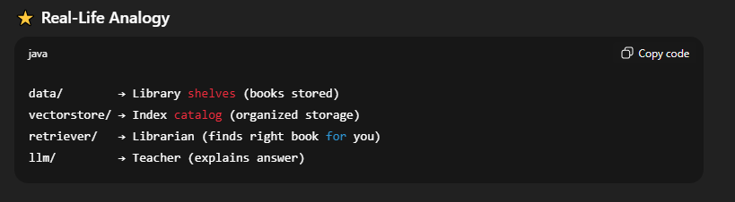
- Q. What is diff b/w pyproject.toml and uv.lock?
- Some important packages install
- ! uv pip install langchain openai tiktoken rapidocr-onnxruntime python-dotenv langchain-community
- uv pip list (This is use for check the packages list that are installed and used our project)
- What is data ingestion?
- What is RecursiveCharacterTextSplitter, chunk_size & chunk_overlap?
- Chunkviz.up.railway.app
- What is chunk?
What about your project
I developed a production-ready full-stack LLMOps RAG chat system with modular architecture using FastAPI backend and Next.js frontend with centralized logging and error handling.
fullstack-llmops-rag-chat-system

