**Setting Up the Viper Lab Systems**

1. Make sure UR10, Yaskawa, and MotionCapture (MoCap) systems are powered on. See[**Guide_Viper_LabStartup.docx**](https://docs.google.com/document/d/1BAmqS1IHBqDtPBvMvqEbPO2h1yOo1Sq8BW36DQlnniA/edit?usp=sharing)for additional help with this step.
   1. Power on the Linux and Windows machines.
   2. The cameras that surround the Viper Lab should have a **blue ring** around the lens. This means they are on standby.
2. On the Windows machine, power up the *Motive* application. The screen should show the Viper Lab workspace.
   1. Navigate to settings.
      1. This is what you should be seeing at the bottom.
      2. The most important is the “Enable” switch. This means the Windows machine is streaming to the network switch, which allows Linux machine to pick up Rigid Bodies in the workspace.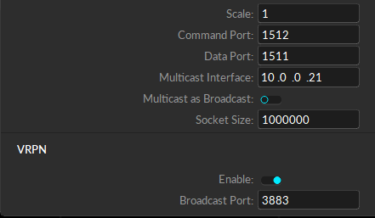
      3. 10.0.0.21 is the IP address for the Windows machine.
   2. **IMPORTANT:** The Windows machine (10.0.0.21) can ping Linux (10.0.0.31) but Linux cannot ping Windows. This is okay and not a concern.
   3. For navigating the interface,
      1. Click the **scroller** on the mouse and drag to pan
      2. Click the right hand mouse and drag to rotate around
      3. Roll the scroller to zoom in or out
3. To check that the Linux machine can see VRPN data, run the following command on the Linux machine:
   1. **roslaunch vrpn_client_ros vrpn_optitrack.launch**
   2. If any rigid bodies are being currently viewed by MoCap on the Motive interface, you should see the same rigid bodies pop up in the launch terminal after running the above command:
      1. “Connection established.”
      2. “Found new sender: <name>”
      3. “Creating new tracker: <name>”
4. If connection is not being established or there’s another error, the problem is most likely in the launch file on the Linux machine. Run the following commands:
   1. **roscd vrpn_client_ros**
   2. **cd launch**
   3. **atom vrpn_optitrack.launch**
5. The launch file should look something like this:

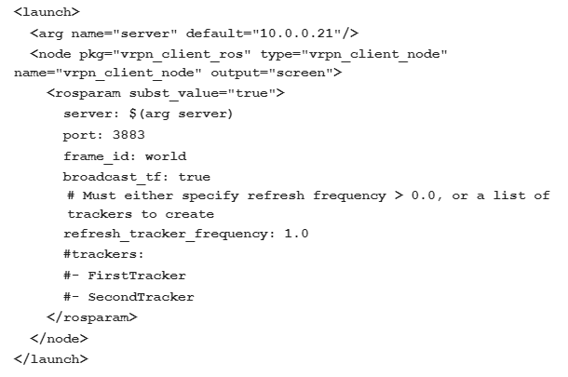

1. If everything is working correctly, here’s how to add some rigid bodies to the system.
   1. On Motive, find your 4 points on the screen for an object you want to track.
   2. Using left click on the mouse, drag and create a box around the 4 points
   3. Right click on that area and select “Create Rigid Body”
   4. In the top right corner there are two tabs. “Devices” and “Assets”. Click on “Assets” to view the new rigid body. It will be named “RigidBody”.
   5. Appropriately rename the rigid body you created so that you can track it in ROS.
   6. If this is successful, the Linux terminal window running the program will update and let you know that it sees your new rigid body with the appropriate name.
   7. Explore **rostopic echo** and see what kind of data the vrpn client can stream to you.
2. When you’re ready to start using the Viper Lab altogether, terminate the terminal window running the single launch file. Run the following command:
   1. **roslaunch viper_lab realTime_system.launch**