Vision-Based Three-Dimensional Reconstruction System
Hikmet Furkan Karabaş
Istanbul Ticaret University | Computer Engineering
November 9, 2026

Project overview
The project aims to reconstruct exportable 3D assets from real-world photographs and videos. The current prototype reconstructs a colored sparse point cloud from overlapping photographs and provides a working local desktop demonstration. Dense surfaces and finished textured assets remain future work.

Input photographs and methodology
Castle is a real six-photograph dataset with published camera intrinsics. The two inputs below show the same facade from different viewpoints; they are not synthetic renderings.
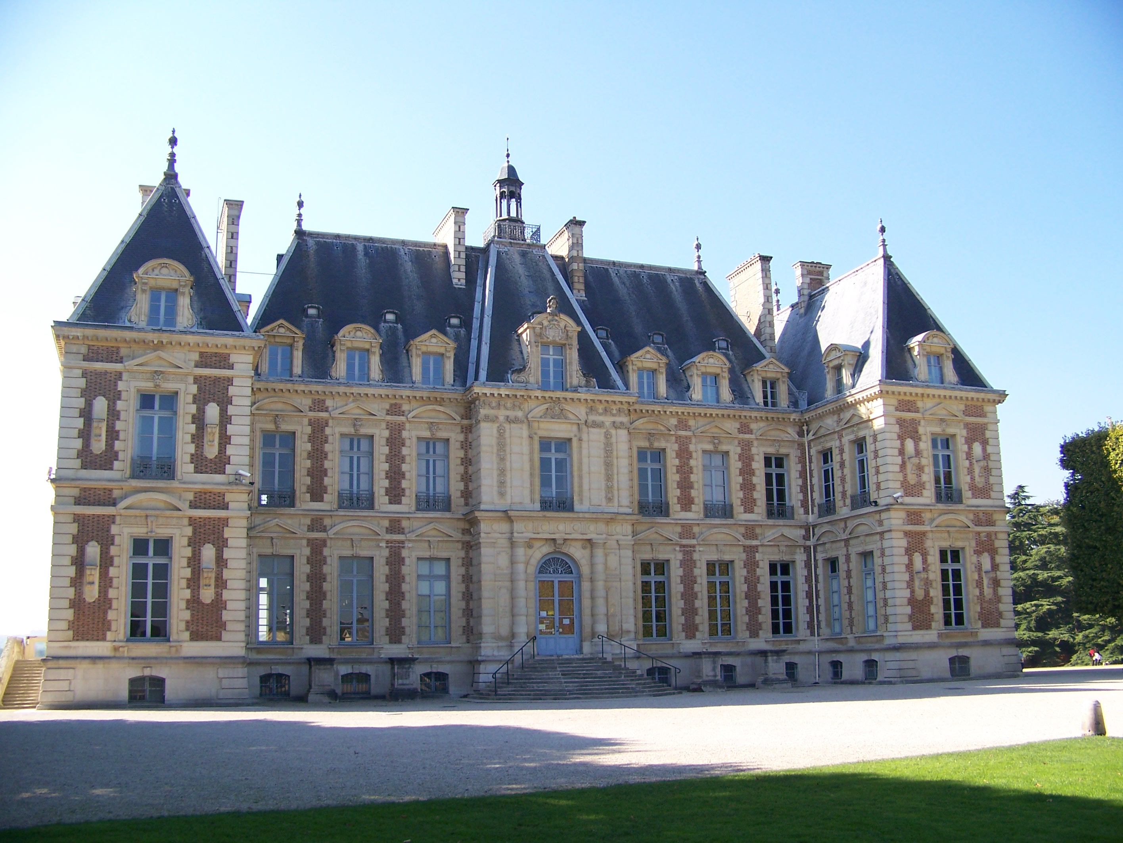 | 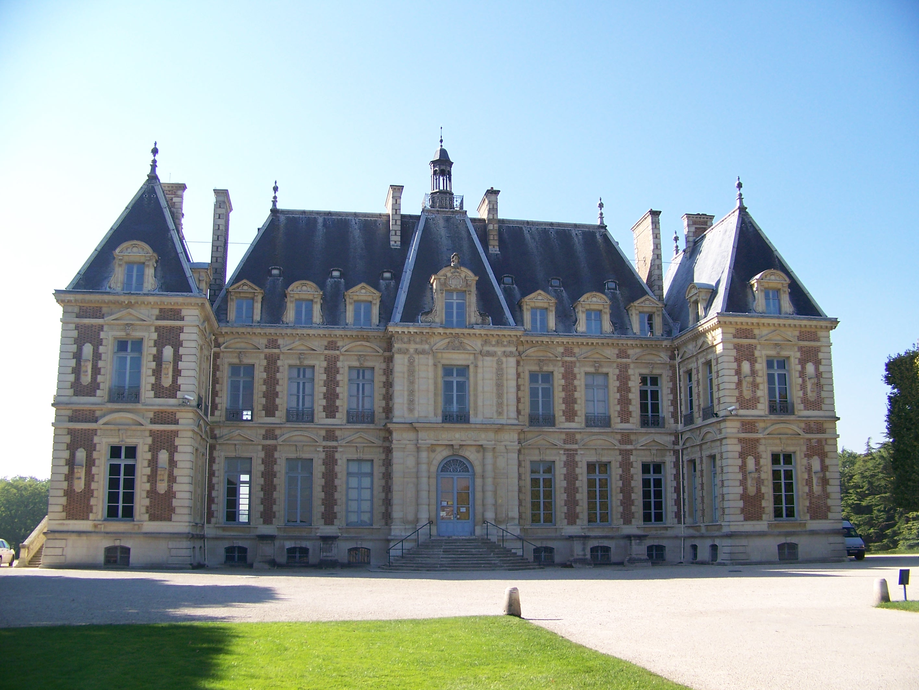
Figure 1. Original Castle input photographs: 100_7101.JPG (left) and 100_7103.JPG (right). Source: the existing local OpenMVG Sceaux Castle sample.
Image input → Preprocessing → Feature extraction → Feature matching → Geometric verification → Camera pose estimation → Triangulation → Incremental SfM → Bundle Adjustment → Sparse point cloud
The pipeline is camera-independent and CPU-based. It uses OpenCV, NumPy and SciPy for geometry, Open3D for point-cloud export and viewing, and Tkinter/ttk for the desktop layer. Known camera positions are not reconstruction inputs.
Implemented component | Current capability
Input handling | JPEG/PNG images, EXIF orientation, recorded resizing and streamed video-frame extraction
Sparse geometry | SIFT/ORB, calibrated two-view geometry, persistent tracks, PnP registration and triangulation
Optimization and delivery | Bounded local BA, fixed-camera point refinement, colored PLY export and interactive viewing

Feature matching and geometric validation
Geometrically verified feature tracks connect image observations to shared 3D landmarks. The same modular reconstruction engine serves both the command line and the desktop application.
Method | Implemented role
SIFT and ORB | SIFT uses floating-point descriptors with L2 distance; ORB retains binary descriptors and Hamming distance.
Matching and RANSAC | KNN matching, Lowe ratio filtering and reciprocal consistency precede robust geometric verification.
Essential matrix and camera pose | Calibrated, undistorted correspondences estimate relative rotation and translation direction. Monocular translation has no absolute scale.
Triangulation and incremental SfM | Validated ray intersections create landmarks. Persistent 2D–3D associations register further cameras using PnP RANSAC.
Bundle Adjustment and point refinement | Local BA jointly refines bounded camera/point subsets. The final point-only pass keeps cameras fixed and optimizes existing multi-view landmarks.
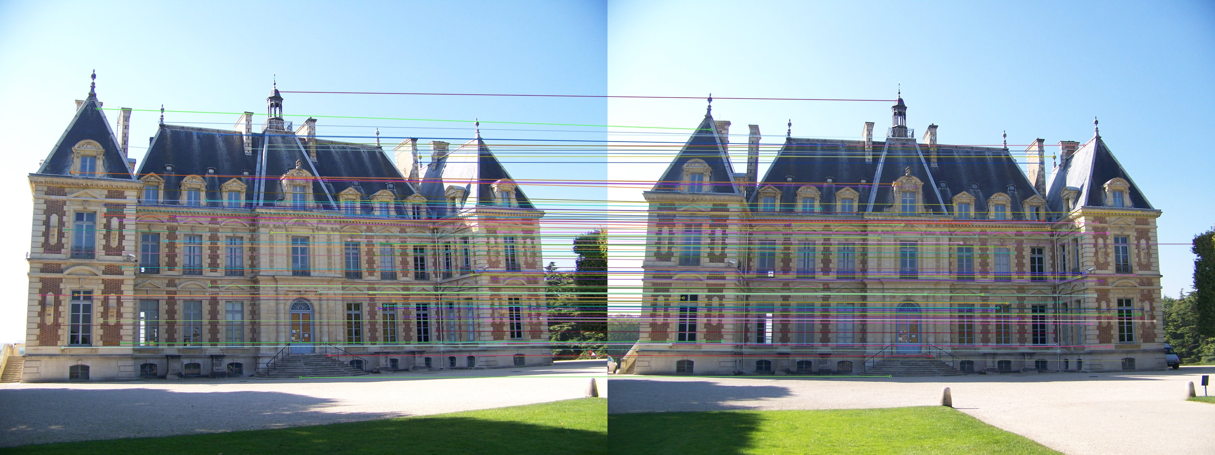
Figure 2. Actual Castle feature matching between the two inputs in Figure 1. The project verified 952 correspondences geometrically; 100 are displayed. Colored lines identify individual correspondences.
Geometry check | Applied criterion
Observation validity | Positive camera-space depth and maximum 2 px reprojection error
Triangulation | Minimum 1° ray angle; invalid or extreme points are rejected
Optimization safety | Finite, bounded updates; invalid proposals retain the original geometry
Repeated windows and weak overlap can still produce ambiguous matches. A large match count or low image residual alone does not prove correct camera geometry.

Desktop application
The functional desktop app selects an image folder and calibration JSON, launches reconstruction in an isolated process, reports verified stages and final counts, and opens the actual PLY in a separate interactive Open3D window.
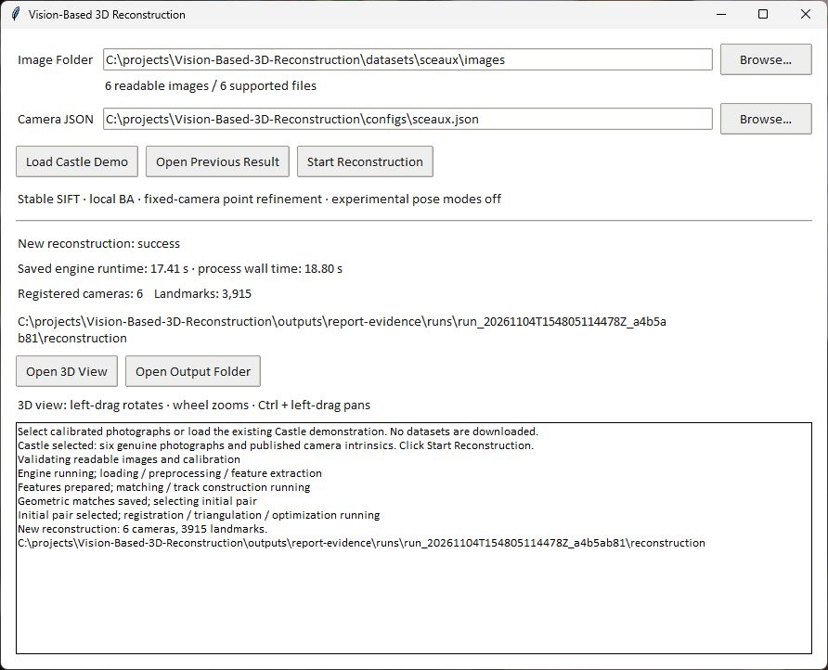
Figure 3. Genuine capture of the current Tkinter application after a newly computed Castle run: success, 6 registered cameras and 3,915 landmarks. This capture records 17.41 s engine time; controlled benchmark timings below come from separate runs.
Presentation action | Observed behavior
Load Castle Demo | Locates existing photographs and calibration; no dataset download or precomputed point substitution
Start Reconstruction | Runs the actual engine; GUI updates remain on the main thread and conflicting actions are disabled
Open 3D View / Output Folder | Loads the generated colored PLY or opens its saved artifacts; previous results are explicitly labeled
Castle is a convenient dataset preset, not a hardcoded reconstruction. Custom calibrated-image folder support exists, but successful reconstruction from arbitrary user photographs has not been independently validated. Launch: .venv\Scripts\python.exe -m vision3d.demo

Real reconstruction results
The quality-improved Castle output registers all 6 photographs and contains 3,915 colored 3D landmarks. The camera-aligned rendering below displays every exported point, preserving its estimated coordinates and sampled color.
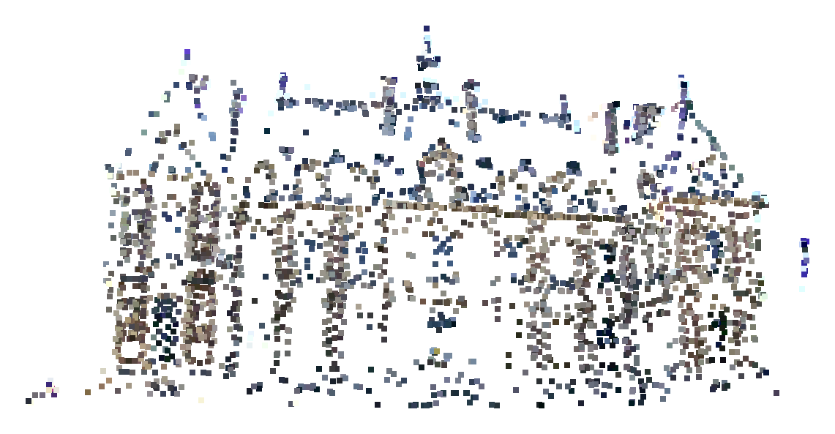
Figure 4. Actual refined Castle sparse point cloud, rendered through the project’s Open3D viewer from the latest completed run. Only uniform white viewport margins were removed; no points were added, filtered or moved for this image.
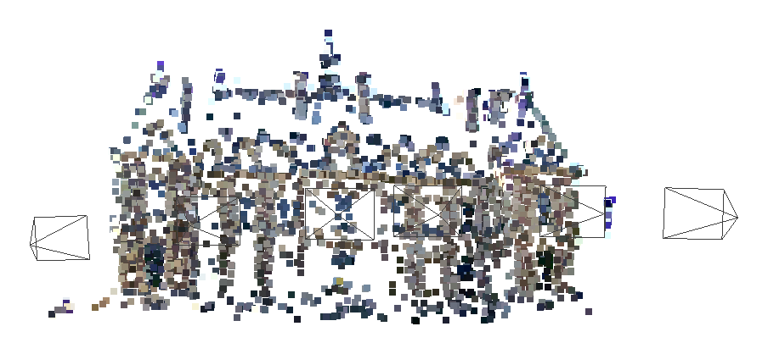
Figure 5. The same real cloud with estimated camera frustum outlines enabled. The outlines are optional viewing context, not reconstructed surfaces or additional landmarks.
Result | Verified value
Registered cameras / landmarks | 6/6 / 3,915
Accepted observations | 10,488; zero invalid final observations
Median maximum triangulation angle | 10.062°; arbitrary monocular scale
This is a sparse point cloud, not a mesh or a textured asset. Many walls, roof surfaces and unseen areas remain incomplete. Camera-aligned framing and point size improve readability separately from geometric refinement.

Experimental improvements
Fixed-camera multi-view refinement adjusts existing landmarks with at least three accepted observations. Camera poses, intrinsics, landmark identities, colors and observation associations remain unchanged. Two-view points are preserved.
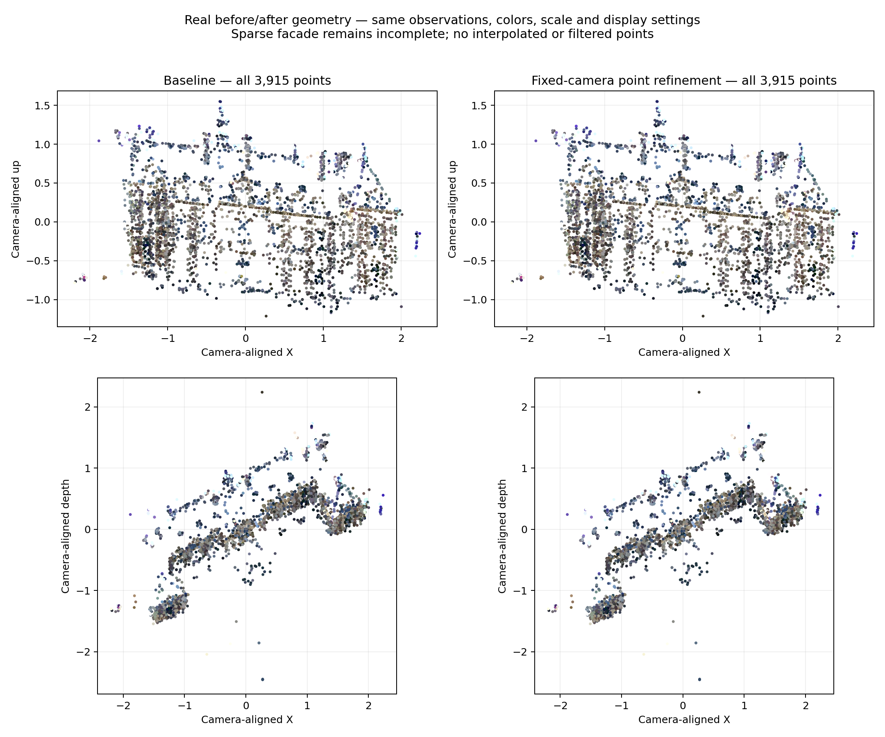
Figure 6. Genuine project-generated Castle before/after comparison with identical view, scale and display settings. All 3,915 points appear in both columns; the geometric changes are modest.
Castle metric | Baseline | Refined
Registered cameras | 6/6 | 6/6
Colored landmarks | 3,915 | 3,915
RMS reprojection error | 0.587 px | 0.477 px
Median reprojection error | 0.285 px | 0.306 px
Engine runtime | 16.74 s | 20.75 s
The pass improves aggregate reprojection fit, while the median residual increases slightly. It accepts 1,499 multi-view point updates and changes no camera pose. Lower reprojection error does not establish improved absolute depth, surface accuracy or camera accuracy.

Limitations and future work
Scene and mode | Cameras | Points | RMS px | Time s
Castle baseline | 6/6 | 3,915 | 0.587 | 16.74
Castle refined | 6/6 | 3,915 | 0.477 | 20.75
Temple 30 baseline | 18/30 | 2,664 | 0.654 | 10.82
Temple 30 refined | 18/30 | 2,664 | 0.448 | 14.13
Temple provides an additional real-world check: camera poses and landmark counts are unchanged, while RMS reprojection error falls from 0.654 to 0.448 px. Reference rotation error remains 6.61°. These are individual run timings, not hardware-wide performance guarantees.
Current repository verification: 115 automated tests passed, 0 failed. Tests cover the existing pipeline, orchestration, fixed-camera refinement, rollback and visualization utilities. Experimental graph recovery and joint BA remain disabled by default.
• Surfaces remain sparse and incomplete; 61% of Castle landmarks have only two accepted observations.
• Absolute depth accuracy and metric scale remain uncertain; frontal views and calibration assumptions limit geometric evidence.
• Challenging camera geometry and accumulated pose drift remain unresolved. Custom scenes and other hardware still need independent validation.
Planned stage | Purpose
More reliable geometry | Improve calibration, coverage, initialization and independent accuracy evaluation
Dense point cloud generation | Estimate additional surface detail from validated camera geometry
Mesh generation | Convert validated geometry into connected surfaces
Optional texture mapping | Add image-based appearance to a suitable surface
OBJ / GLB export | Deliver interoperable 3D assets
Desktop improvements | Improve usability around the verified processing workflow
The demonstrated achievement is real, interactive sparse reconstruction. More complete geometry and stronger accuracy validation are required before claiming a finished 3D model.
Evidence: README and technical reports TASK01–TASK07; reconstruction-quality experiment metrics, PLYs and renderer outputs; the original Sceaux Castle photographs and a live desktop capture. Castle source: OpenMVG / Pierre Moulon. Temple source: Middlebury multi-view stereo benchmark. Published intrinsics are used; reference poses are evaluation-only.

