Incremental Structure from Motion for Sparse 3D Reconstruction from Multiple Images
Hikmet Furkan Karabaş
Computer Engineering, Istanbul Ticaret University
Supervisor — Sevcan Kahraman

Abstract—Recovering three-dimensional structure from overlapping photographs requires reliable image correspondences and camera pose estimates. This paper presents a calibrated incremental structure-from-motion pipeline that combines local feature matching, geometric verification, two-view initialization, and successive camera registration to produce a colored sparse point cloud. A fixed-camera refinement pass reduced root-mean-square reprojection error from 0.587 to 0.477 px on Castle (6/6 cameras, 3,915 landmarks) and from 0.654 to 0.448 px on Temple 30 (18/30 cameras, 2,664 landmarks). Median error increased on both sequences. The results characterize image-space fit under fixed camera poses. Surface accuracy and performance on unconstrained photographs remain unverified.
Keywords—Structure from motion, 3D reconstruction, feature matching, camera pose estimation, bundle adjustment.

I. Introduction
Overlapping photographs provide multiple observations of a scene without requiring a depth sensor. Recovering its geometry requires determining which image features correspond to the same physical point and estimating the cameras from those correspondences. Repeated texture can introduce false matches, while limited parallax can make depth poorly constrained even when image residuals are small. In an incremental reconstruction, errors in early poses and points can also influence later registrations.
This study evaluates a calibrated pipeline for ordered photographs of a static scene. It estimates camera extrinsics, reconstructs colored 3D landmarks, and exports a sparse point cloud. The implementation separates correspondence construction, geometric estimation, and optimization so that an additional refinement pass can be evaluated on the same observations and cameras as the baseline.

II. Related Work
Lowe introduced SIFT descriptors and a nearest-neighbor distance ratio for rejecting ambiguous matches [1]. Hartley and Zisserman describe the epipolar constraints, camera models, and triangulation principles used to infer structure from multiple views [2]. Schönberger and Frahm describe an incremental SfM architecture that initializes from an image pair and repeatedly adds images and points [3]. Triggs et al. review bundle adjustment, including robust objectives, sparse computation, and gauge freedom [4]. The present study combines established methods and evaluates the effect of a bounded landmark-only pass on two sequences.

III. Proposed Method

A. Calibration and correspondences
Images are oriented and resized before grayscale feature extraction. Intrinsic parameters are mapped to the processed image grid. The experiments use supplied intrinsics, with zero lens distortion assumed for Castle and already distortion-corrected images for Temple. SIFT correspondences pass a two-nearest-neighbor ratio test and a reciprocal check. Pairwise RANSAC geometry verifies candidate matches, and verified matches are linked into tracks. Track merges that would assign two keypoints from the same image to one track are rejected.

B. Initialization and camera registration
The initial pair is selected using track-compatible support, triangulation angle, and cheirality. Matched pixels are undistorted and normalized for essential-matrix estimation with RANSAC. Pose recovery sets the first camera as the reference and uses a unit translation baseline, leaving metric scale unresolved. Triangulated candidates must satisfy depth, parallax, and reprojection checks. Later views are prioritized by available 2D–3D support and its spatial coverage. RANSAC-based perspective-n-point estimation is followed by Levenberg–Marquardt pose refinement and inlier checks. New points are triangulated from the registered view pair with the widest ray angle and validated across views.

C. Optimization and reprojection error
For an observation of landmark Xⱼ in image i, the pixel error is
$e_{ij} = ‖π_{i}(R_{i}X_{j} + t_{i}) − u_{ij}‖₂$ (1)
Here uᵢⱼ is the measured keypoint, Rᵢ and tᵢ map world coordinates to camera coordinates, and πᵢ projects to processed pixels using the camera intrinsics and distortion model.
Local bundle adjustment jointly refines selected camera poses and landmarks using a sparse robust least-squares solve. Two fixed boundary cameras constrain the gauge. A candidate is rolled back if it introduces invalid observations or violates the geometric and fit checks. The separate final pass adjusts only landmarks seen in at least three views using a soft-L1 loss. An update must lower squared reprojection error, preserve positive depth and angular support, and pass reprojection and displacement bounds. Intrinsics, poses, and observation associations stay fixed.

IV. Preliminary Evaluation

A. Protocol and results
The Castle sequence comprises six Sceaux Castle photographs [5]. The second sequence uses the first 30 views of Middlebury TempleRing [6]. Both runs use supplied calibration and the stable matching and registration configuration. Each refined result is compared with its corresponding baseline on an identical set of accepted observations. Table I reports RMS and median Euclidean pixel errors at the processed resolution, together with observed engine time.
TABLE I. BEFORE → AFTER REFINEMENT
Metric | Castle | Temple 30
Registered cameras | 6/6 | 18/30
Colored landmarks | 3,915 | 2,664
RMS (px) | 0.587 → 0.477 | 0.654 → 0.448
Median (px) | 0.285 → 0.306 | 0.261 → 0.274
Runtime (s) | 16.74 → 20.75 | 10.82 → 14.13
Figure 1 pairs one Castle input with an Open3D rendering of the refined cloud reconstructed from all six views. Distinct facade features are visible, with gaps where few landmarks were recovered.
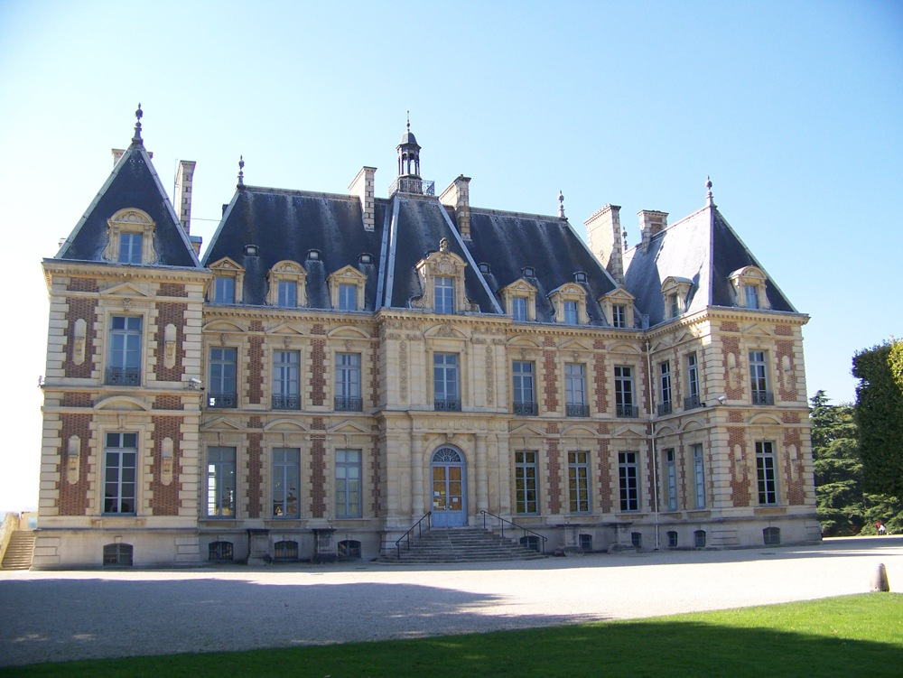
(a)
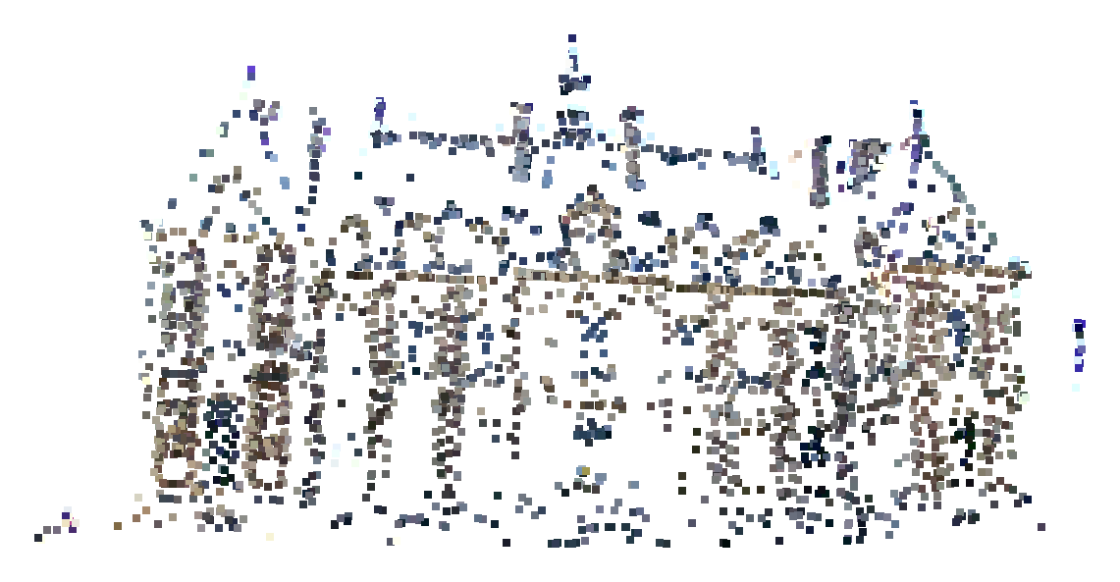
(b)
Fig. 1. (a) Castle input photograph, 100_7101.JPG (© Pierre Moulon, 2012) [5]. (b) Refined colored sparse point cloud.

B. Interpretation
RMS decreased on both sequences while median error rose. The changes are consistent with reduced influence from larger residuals and do not imply uniform improvement across observations. The refinement kept camera poses and landmark counts unchanged. On the registered Temple views, the median aligned rotation error was 6.61° and the median relative translation-direction error was 2.84° before and after refinement. Reference poses were used only for evaluation. Castle has no reference poses in the supplied sample. The measured runtime increases are specific to these runs. On Castle, 1,499 of 1,517 eligible landmarks were updated, while 2,398 two-view landmarks were left untouched. The paired comparison used 10,488 accepted observations.

V. Limitations and Planned Evaluation
Twelve of the 30 Temple views remain unregistered. Calibration and sufficient viewpoint overlap remain important, and monocular scale is undetermined. The sparse landmarks leave gaps and cannot represent a continuous surface. Lower image-space error alone cannot establish absolute 3D accuracy. Dense reconstruction, meshing, and texture mapping remain future work. Arbitrary user photographs have yet to be validated end to end.
The remaining two pages of the final paper will expand the experimental evaluation, limitations, and conclusions. The evaluation will distinguish registration coverage, image-space fit, and agreement with reference geometry where suitable reference data are available.

References
[1] D. G. Lowe, “Distinctive image features from scale-invariant keypoints,” Int. J. Comput. Vis., vol. 60, no. 2, pp. 91–110, 2004.
[2] R. Hartley and A. Zisserman, Multiple View Geometry in Computer Vision, 2nd ed. Cambridge University Press, 2004.
[3] J. L. Schönberger and J.-M. Frahm, “Structure-from-motion revisited,” in Proc. IEEE CVPR, 2016, pp. 4104–4113.
[4] B. Triggs, P. F. McLauchlan, R. I. Hartley, and A. W. Fitzgibbon, “Bundle adjustment—A modern synthesis,” in Vision Algorithms: Theory and Practice, LNCS 1883. Springer, 2000, pp. 298–372.
[5] P. Moulon, “Sceaux Castle image dataset,” OpenMVG, 2012. [Online]. Available: github.com/openMVG/ImageDataset_SceauxCastle
[6] S. M. Seitz, B. Curless, J. Diebel, D. Scharstein, and R. Szeliski, “A comparison and evaluation of multi-view stereo reconstruction algorithms,” in Proc. IEEE CVPR, 2006, vol. 1, pp. 519–528.

