Module2_RMD_doc1

Houston

April 27, 2018

# This is a level 1 header

## R Markdown

### This is a level three header.

* The following text is provided
* for easier cutting and pasting as you
* work through the exercises in
* Module 2 - lesson 2: R Markdown Syntax ******************************************

# This is a level 1 header

### This is a level 3 header

Here is a link to [GOOGLE](https://www.google.com/)

Here is a word in **bold** and another word in **bold**.

Here is a word in *italics* and another word in *italics*.

When we compile our document, we are using the rmarkdown package.

Here are some example R commands:

2+2  
mean(c(1,2,3,4,5))

Here is an example of a non-numbered list:

* Breakfast
  + food
    - eggs
    - toast
    - bacon
  + drink
    - apple juice
* Lunch
  + taco
* Dinner
  + baked chicken
  + broccoli
  + rice

Here is an example of a numbered list:

1. Breakfast
   1. food
      1. eggs
      2. toast
      3. bacon
   2. drink
      1. apple juice
2. Lunch
   1. taco
3. Dinner
   1. baked chicken
   2. broccoli
   3. rice

Here is an example of a blockquote:

This is a block quote. This paragraph has two lines.

1. This is a list inside a block quote.
2. Second item.

Here is an example of a nested blockquote:

This is a block quote. This paragraph has two lines.

This text is nested

Here is an example of code in a blockquote:

2+2  
mean(c(1,2,3,4,5))

Here is the figure that is in the default R file, but I deleted the code. 

plot(pressure)

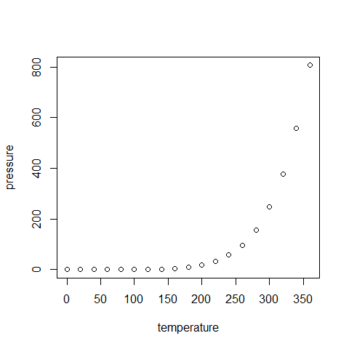

## Insert Tables

knitr::kable(head(cars))

|  |  |
| --- | --- |
| speed | dist |
| 4 | 2 |
| 4 | 10 |
| 7 | 4 |
| 7 | 22 |
| 8 | 16 |
| 9 | 10 |