**Eventstreams**

The eventstream feature in the Microsoft Fabric Real-Time Intelligence provide real-time events and transform them, and then route them to various destinations like KQL, Activator, Lakehouse, Stream etc. We can associate azure blob storage events as data source for eventstream

**1.We can create eventstreams from New Item under workspace as following**

**2. Connect data source events here as follows**

**3. Connect Azure Blob Storage data source coms under azure events**

**4. Configure Connection String for Azure Blob Storage events**

**5. Connect Azure Blob Storage Event**

**Eventhouse as Destination of Eventstream**

Eventhouses provide a solution for handling and analyzing large volumes of data, particularly in scenarios requiring real-time analytics and exploration

We can create eventhosue from following New Item under fabric workspace

1. We can add eventhouse as destination of eventsource as following

2.**We can select Data Ingestion Mode as following**

**Direct Ingestion Mode:**

Direct ingestion mode ingests your event data directly into the Eventhouse without any processing. You can use direct ingestion mode to add an Eventhouse destination to your default stream or a derived stream.

**Event processing before Ingestion:**

The event processing before ingestion mode processes your event data before ingesting it into the Eventhouse. Use this mode if you apply operators such as filtering or aggregation to process the data before ingestion, or after a derived stream.

[**Add an Eventhouse destination to an eventstream**](https://learn.microsoft.com/en-us/fabric/real-time-intelligence/event-streams/add-destination-kql-database?pivots=enhanced-capabilities)

**3. Capturing Events Logs (Blob storage events) in KQL Destination Table like Event Processed Time UTC, Blob name and its Type like Blob Creation**

**Creation of Activator and associate as a destination of Event stream**

Basically, Activator is a no-code experience in Microsoft Fabric, and this automatically sets alerts (as part of creation Rule) as Email, Teams Notification and calling fabric Item Like Notebook on meeting specific data condition

1. **Under workspace need to go with New Item to add activator**

1. **Click on Activator to Configure and Add Rule**

1. **Go with Get Data here**

1. **Select Event Streams from Data Stream tab as a data source for the Activator**

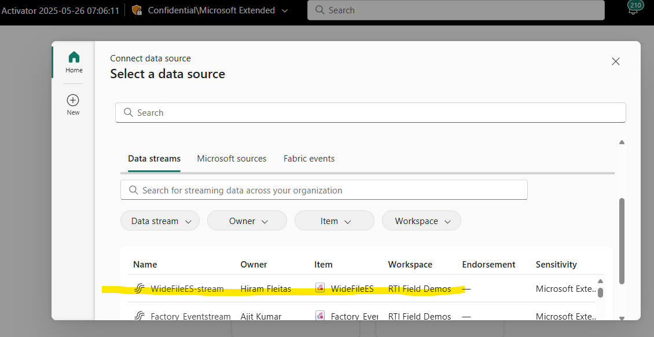

1. **Go to Next to connect with Data source**

1. **Make a connection with Event Stream here**

1. **Add a Rule to Call Notebook**

1. **Select Notebook under Action Type as a Fabric Item with Job Type Run Notebook for stream event alert in activator**

**Notebook Creation Logic**

**Cell 1:**

Query data from KQL DB for latest File from Events Log table

**Cell 2:**

Exit Notebook in case of Blob Operation is not Microsoft.Storage.BlobCreated

**Cell 3:** Extract File Name (from latest Stream Event Log table) under Cell1 data frame

**Cell 4:** Access blob Storage with SAS Token

**Cell 5:** Read currently streamed Parquet file from blob storage andProcess Data frame into JSON as single data column in data frame.

**Cell 6:** Write to Eventhouse with JSON mapping

**Cell 7:** Terminate execution of Notebook explicitly because of after data load in mapping table finished still Notebook execution goes for a long time when we monitor in “View Recent Runs” under Run Tab

**Some Stats**

1. **Before File upload file in blob storage the following row count as follows:**

1. **File uploaded in Blob Storage**

1. **After File upload in blob storage the events stream capture event log as follows:**

1. **Data insight from Event Stream**

1. **Activator Live Feed**

After Data Upload in Blob storage, Activator (as destination of Event stream) triggers the execution of Notebook, Json mapping table is populated and KQL Function triggering as a part of Policy Updates in Ternium_0 table so count increases as following

