A Word template for Tektonika

A. Firstauthor1, B. Secondauthor2, C. Thirdauthor1,2, and D. Relegated2

1Department of Earth Sciences, A University, Acity, UK. afirstauthor@auniversity.ac.uk

2School of Earth Sciences, Another University, Bcity, Norway.

# Abstract

This is the abstract of a scientific paper. The methods are described in sufficient detail for the work to be reproduced. The software used in analyses is open source and the data are archived with well-curated metadata.

# Second-language abstract

Este es el resumen de un artículo científico. Los métodos se describen con suficiente detalle para que el trabajo sea reproducido. El software utilizado en los análisis es de código abierto y los datos se archivan con metadatos bien seleccionados.

# 1 Introduction

You may be wondering, does the world really need another journal article? In this section, we will tell you why this work is in fact necessary and interesting. We will cite lots of previous literature (e.g., Einstein and Rosen, 1935) and provide an overview of where the rest of this paper is going.

## 1.1 A subsection

Figures in this paper will not exceed 85 × 200 mm (for single column figures) or 175 × 200 mm (for two column figures). This required the authors to think a little bit in advance about the sizes and shapes of their figures, and hopefully scale things appropriately (Einstein and Rosen, 1935).

Sometimes, papers contain figures. Figure 1 is an example of such a figure.

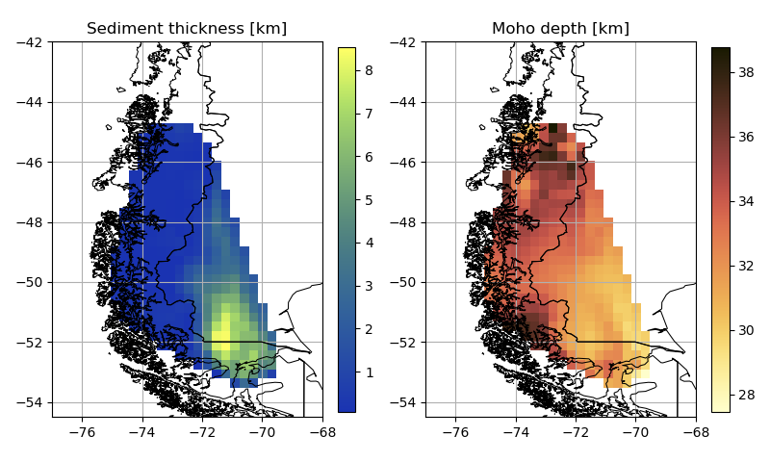

Figure 1. Maps of sediment thickness and Moho depth across the study region in Patagonia.

### 1.1.1 Math!

Occasionally tectonics requires math. On such occasions, we include equations in our paper, like:

$\left|∇u\left(x\right)\right|= \frac{1}{f(x)}, x∈Ω$ (1)

and sometimes equations fall in the middles of sentences, like Einstein and Rosen (1935) might do in their paper. On other occasions, tables might be included in the text of a paper. Here we include Table 1 as an example.

|  |  |
| --- | --- |
| **Animal name** | **Number of legs** |
| Dog | 4 |
| Spider | 8, plus 2 pedipalps |

Table 1. A table containing some minimally useful information about dogs and spiders.

# Author contributions

Author 1 did some stuff. Author 2 did other stuff. All authors contributed to the project in a meaningful way.

# Acknowledgements

Thank you to the reviewers who gave us feedback on this article, to the agencies who funded this work, and to our friends for tolerating our excessive enthusiasm about this result.

# Data availability

The data cited in this work are available through a repository.

# References

Einstein, A. and Rosen, N. (1935). The particle problem in the general theory of relativity. *Physica Review*, 48(1):73. doi: 10.1103/PhysRev.48.73