3. Data and Methodology

This chapter describes the datasets, feature engineering pipeline, detrending methodology, rule-learning algorithms, walk-forward validation protocol, baseline models, and evaluation metrics used throughout the thesis. Section 3.4 provides a detailed technical description of all three rule-learning algorithms, including their internal mechanics, how they differ from one another, and why those differences matter for interpreting the results in Chapters 4 and 5.

3.1 Study Regions and Data

This study examines two geographically and climatically distinct Portuguese wine regions: the Douro Demarcated Region (RDD) and the Vinho Verde Region (RVV). The RDD dataset covers 89 annual observations from 1934 to 2022. The RVV dataset covers 80 annual observations from 1942 to 2021. Both datasets consist of one observation per year, where each observation contains a set of meteorological and phenological covariates together with annual wine production in thousands of hectolitres (mhl) as the response variable. Table 3.1 summarises the key characteristics of both datasets.

Characteristic | RDD (Douro) | RVV (Vinho Verde)
Period | 1934–2022 | 1942–2021
Observations (n) | 89 years | 80 years
Climate type | Continental / semi-arid | Temperate Atlantic
Production trend | +80% increase (1930s–2010s) | −65% decline (1960s–2020s)
Walk-forward scenarios | 18 | 16
Response variable | Annual wine production (mhl) | Annual wine production (mhl)
Table 3.1. Dataset characteristics for the two study regions.

3.2 Feature Engineering

Covariates were constructed from daily temperature, rainfall, and soil water balance records, supplemented by Leaf Area Index (LAI) estimates from a vine phenological model. All variables were aggregated over windows defined by phenological stage and calendar date, producing features that correspond to agronomically meaningful periods of vine development. The feature naming convention encodes the variable type, phenological stage, year offset (current or previous year), and window width; for example, swa_hv_y1_b20 denotes soil water availability (swa) in the 20 days before (b20) harvest (hv) in the current year (y1).

Feature families included: mean and minimum temperature at each phenological window; total rainfall and number of wet days (days with rainfall > 1 mm); soil water availability (mm) at budburst, flowering, veraison, and harvest; accumulated heat degree-days above 35°C and cold days below 15°C; and LAI at budburst and flowering. Lagged versions of selected features (previous growing season, denoted y0) were included to capture carryover effects from the prior year. The final feature matrix contained 59 candidate predictors per region.

3.3 Detrending and the Two-Decision Decomposition

All models operate on linearly detrended residuals r_t = y_t − (α + βt), where y_t is observed production and (α + βt) is the OLS linear trend estimated on the training set. Predictions are converted back to the original scale by adding the projected trend value: ŷ_t = r̂_t + (α + βt). All preprocessing steps are performed exclusively on the training fold within each scenario to prevent data leakage.
The two-decision decomposition is illustrated in Figure 3.3 using the RDD production series. Panel A shows the original series with the OLS trend; Panel B shows the detrended residuals that form the target for all rule-learning algorithms.
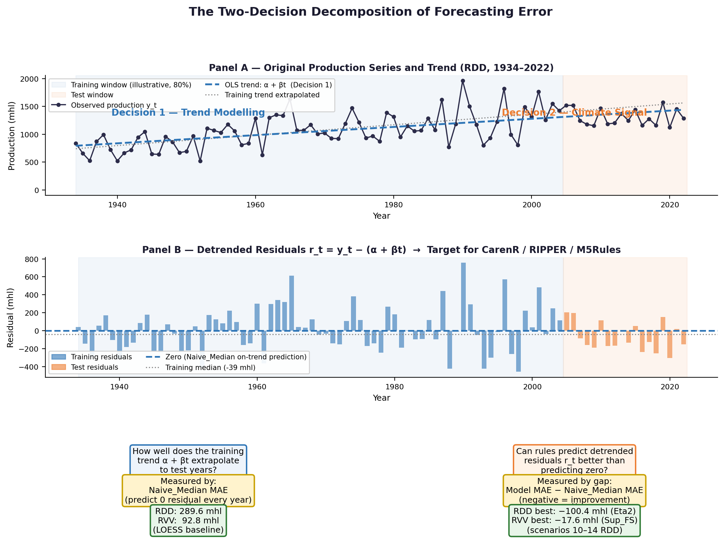
Figure 3.3. The two-decision decomposition (RDD, 1934-2022). Panel A: observed production y_t with OLS trend (alpha + beta*t). Panel B: detrended residuals r_t = y_t - (alpha + beta*t). Blue = training; orange = test (illustrative 80/20 split). Panel C: Decision 1 - trend quality, measured by Naive_Median MAE. Panel D: Decision 2 - climate signal, measured by model-vs-baseline MAE gap.

Decision 1 — Trend modelling: how accurately does the training-period trend extrapolate to test years? Measured by Naive_Median MAE.

Decision 2 — Climate signal extraction: can a rule-based model predict detrended residuals better than zero? Measured by the gap between a model's weighted MAE and the Naive_Median weighted MAE.

3.4 Rule-Learning Algorithms

Three rule-learning algorithms were evaluated, representing three fundamentally different approaches to extracting interpretable patterns from the same data. Understanding how each algorithm works internally, and specifically what question it is designed to answer, is essential for correctly interpreting the results in Chapter 4 and the comparison in Section 4.6. Table 3.2 summarises the key characteristics of all three algorithms before each is described in detail.

Property | CarenR | RIPPER | M5Rules
Task type | Distributional subgroup discovery | Classification rule learning | Piecewise linear regression
Target variable | Continuous (detrended residuals) | Discretised classes (Low/Med/High) | Continuous (detrended residuals)
Core question answered | When does the shape of the production distribution shift significantly? | Which climate class does a year belong to? | What exact production level does a year have?
Statistical criterion | Kolmogorov–Smirnov two-sample test (p ≤ 0.10) | Information gain / Gini (FOIL gain for rule growing) | Standard deviation reduction (MSE minimisation)
Rule output | IF conditions THEN distribution shifts up/down | IF conditions THEN class = Low / Med / High | IF conditions THEN production = linear model(features)
Feature input | Discretised equal-frequency bins | Continuous (RIPPER finds own thresholds) | Continuous (M5Rules finds own thresholds)
Prediction output | Mean/median of matching subgroup | Class midpoint or median | Linear model evaluated at feature values
Fallback (no rules fire) | Training median residual | Default rule (most common class) | Global linear model (no conditions)
Interpretability | Very high, simple IF/THEN with distributional evidence | High, ordered IF/THEN classification | Medium: IF/THEN rules but with linear models at leaves
Table 3.2. Summary comparison of the three rule-learning algorithms.

3.4.1 CarenR: Distribution Rules via the CAREN Framework

CarenR is built on the CAREN association rule engine, originally developed by Jorge et al. (2006) for discovering distribution rules in numeric data. It is the primary algorithm of this thesis and the only one of the three that is specifically designed for continuous response variables without requiring pre-discretisation of the target. This section describes its mechanics in detail.

Conceptual foundation. Most rule-learning algorithms ask: "what value does this observation have?" CarenR asks a different question: "is there a subgroup of observations, defined by a conjunction of input feature conditions, where the statistical distribution of the target variable is significantly different from the distribution across the full dataset?" A CarenR rule does not say "this year will produce X mhl." It says "in years satisfying these climate conditions, the production distribution is shifted upward (or downward) in a statistically significant way, the entire distributional shape is different — not just the mean." This distinction between point prediction and distributional shift is fundamental to understanding both the strengths and the limitations of CarenR.

Step 1: Feature discretisation. CarenR requires discrete (ordinal) input features. Each continuous climate feature is independently discretised into four equal-frequency bins (quartiles). Equal-frequency binning ensures that each bin contains approximately the same number of observations, avoiding sparse bins at extreme values that would make the KS test unreliable. For example, the feature swa_hv_y1_b20 (soil water at harvest) might be discretised into bins [20–74 mm], [74–101 mm], [101–152 mm], [152–350 mm], each containing approximately 22 of the 89 RDD observations. For Goal 1 (Rule Discovery), bin boundaries are computed on the full historical dataset. For Goal 2 (Predictive Validation), bin boundaries are computed exclusively on the training fold within each scenario, preventing any leakage of test-set information into the discretisation step.

Step 2: Feature selection (Goal 2 only). This step applies only to Goal 2 (Predictive Validation). For Goal 1 (Rule Discovery), CarenR operates on all 59 domain-engineered features without further algorithmic filtering — the feature set is defined entirely by viticulture domain knowledge. For Goal 2, with 59 candidate features each discretised into 4 bins, the full itemset search space is combinatorially large, and a feature selection step reduces the feature set before rule induction. This thesis evaluates several selection strategies (described in Table 3.3 below) as distinct CarenR variants. Three selection strategies are evaluated, each reflecting a different way of measuring association between a discrete feature and a continuous target. η²-based selection (eta-squared) is the most statistically appropriate: it applies a one-way ANOVA across the four bins of each feature and measures how much of the variance in the continuous production residual is explained by the discrete groupings — directly answering whether the bins produce meaningfully different production distributions. Pearson correlation (|r| above the median across all features) is a simpler approximation that treats bin numbers as equally spaced ordinal values; it is less rigorous but computationally efficient and tends to identify the same features in practice. Support-filtered Pearson selection adds a coverage requirement: each bin of a retained feature must contain at least a minimum fraction of training observations, preventing selection of features with extreme or sparse bin distributions. The convergence of all three strategies on the same variable families (confirmed in Section 4.6) is evidence that the feature rankings are robust to the choice of selection criterion. All feature selection is performed exclusively on training data within each fold.

Step 3: Rule induction via subgroup search. CarenR searches for conjunctions of feature-bin conditions (itemsets) that define subgroups with distributional shift in the target variable. The search proceeds breadth-first: single-condition rules are evaluated first, then two-condition conjunctions are formed from the most promising single conditions, and so on up to a maximum rule length (typically 3–4 conditions). For each candidate subgroup, the observations satisfying all conditions are identified — for Goal 1 this is the full historical dataset; for Goal 2 it is the training fold — and a two-sample Kolmogorov–Smirnov (KS) test is performed comparing the target distribution in the subgroup against the global distribution.

Step 4: The Kolmogorov–Smirnov test. The KS test is a non-parametric statistical test that compares two empirical cumulative distribution functions (ECDFs). Given a subgroup S of n_S observations and the global reference set of n_T observations (the full dataset for Goal 1, the training fold for Goal 2), the KS statistic D is the maximum absolute difference between the two ECDFs:

D = max|F_S(x) − F_T(x)|

where F_S(x) is the empirical CDF of the target in the subgroup and F_T(x) is the empirical CDF in the global set. A large D indicates that the two distributions are far apart — the subgroup has a systematically different pattern of production values. The p-value associated with D measures the probability of observing this large a difference by chance if the two samples were drawn from the same distribution. A rule is retained only if p ≤ 0.10 (the significance threshold used in this study). The KS test makes no assumption about the shape of either distribution, which is important given the small sample sizes (n = 80–89) and the non-normal distribution of production residuals.

Step 5: Support filter. A statistically significant rule that covers only two or three observations (very low support) is not useful: it describes a pattern too rare to be actionable and is likely to be a chance finding. CarenR applies a minimum support filter: a rule is retained only if it covers at least 15% of the reference observations — approximately 12–13 years for an 89-year dataset in Goal 1, or the equivalent share of the training fold in Goal 2. This filter ensures that reported rules represent patterns that recur meaningfully across the historical record, not isolated outlier years.

Step 6: Rule output and prediction. Each retained rule describes a climate subgroup as a conjunction of feature-bin conditions, along with the median residual of the target variable within the subgroup and the KS p-value. An example RDD rule output reads: "IF wet days post-flowering ∈ [0, 3.33] AND wet days post-maturity ∈ [0, 3.46] THEN production is +121 mhl above trend on average (support 28%, p = 0.0043)." For Goal 1, the retained rules are the direct output — each rule represents an interpretable agroclimatic pattern. For Goal 2 (Predictive Validation), the feature values of a test year are checked against all retained rules. If one or more rules fire, their subgroup medians are combined as a support-weighted sum — each rule's median residual weighted by the proportion of training observations it covers. If no rule fires, the model falls back to the training median residual, producing the same prediction as the Naive_Median baseline. This fallback means CarenR never predicts worse than the naive baseline unless it fires a rule, which makes the walk-forward evaluation in Chapter 5 a direct test of whether the fired rules add value beyond the median.
The CarenR prediction rule can be stated formally. For a test observation x_new, let R_fired be the set of retained rules whose conditions are all satisfied. Let p(I) = median{r_i : i in S(I)} be the subgroup median residual for rule I. If R_fired is empty, all variants return the training median (fallback = Naive_Median). Otherwise:
SUP-weighted: r_hat = SUM_j supp(I_j)*p(I_j) / SUM_j supp(I_j)
CONF-weighted: r_hat = SUM_j w(I_j)*p(I_j) / SUM_j w(I_j), w(I) = -log(p-value_KS(I))
Fallback: r_hat = median{r_i : i in D_train} when R_fired is empty
The final forecast re-adds the trend: y_hat_t = r_hat_t + (alpha_hat + beta_hat*t).

What makes CarenR unique. Three properties distinguish CarenR from standard rule learners. First, the KS-test criterion detects distributional shift rather than class membership or squared error reduction. This allows CarenR to identify features whose relationship with production is probabilistic and distributional, for example, LAI at harvest in Vinho Verde (Section 4.6.3), which reliably shifts the distribution of production residuals without reliably predicting any single year's exact value. Second, rules are verified against a global null distribution rather than constructed greedily to separate pre-defined classes, making them statistically grounded in a way that classification rules are not. Third, the prediction framework developed in this thesis incorporates an explicit fallback mechanism: when no rule matches a test year's conditions, the prediction defaults to the training median rather than forcing an uninformed estimate. This design choice makes the overall approach conservative — it only departs from the naive baseline when at least one rule fires, ensuring that CarenR's predictions can only add noise if they are wrong, never if they abstain.

Variant | Feature selector | Selection criterion | Notes
CarenR_Dist | None | All 59 features | Widest search; most risk of spurious rules
CarenR_Dist_FS | Pearson |r|, top-N | Retain above-median |r| features | Most common baseline variant
CarenR_Dist_Eta2 | η² (ANOVA effect size) | Bin-wise ANOVA η² with response | Best for RDD, captures non-linear association
CarenR_Dist_Sup_FS | Pearson + support ≥ 20% | Conservative: |r| + minimum bin coverage | Most stable across both regions
CarenR_Dist_Thresh | Pearson hard threshold | |r| ≥ 0.30 | Reduces feature set aggressively
CarenR_Dist_Sup | Pearson + support filter | |r| + support filter (less strict than Sup_FS) | Intermediate conservatism
CarenR_Dist_Lag | ACF-based lag features | Augment set with autocorrelated lags | Tests carryover temporal effects
CarenR_Dist_Conf | Confidence-weighted prediction | Weight rules by 1 − p-value | Stronger rules get more prediction weight
CarenR_Dist_Stack | Two-stage stacking | CarenR residuals as second-stage input | Tests whether stacking adds value
CarenR_Dist_Sup_Thresh | Pearson threshold + support filter | |r| ≥ 0.30 + minimum bin coverage | Threshold and support combined; base for Lag, Conf, Stack variants
CarenR_Supervised | Per-fold supervised bins | Maximise between-group residual SS (greedy 1D splits) | Evaluates target leakage from discretisation
Table 3.3. CarenR variants evaluated in this thesis, differing in feature selection strategy or prediction mechanism.
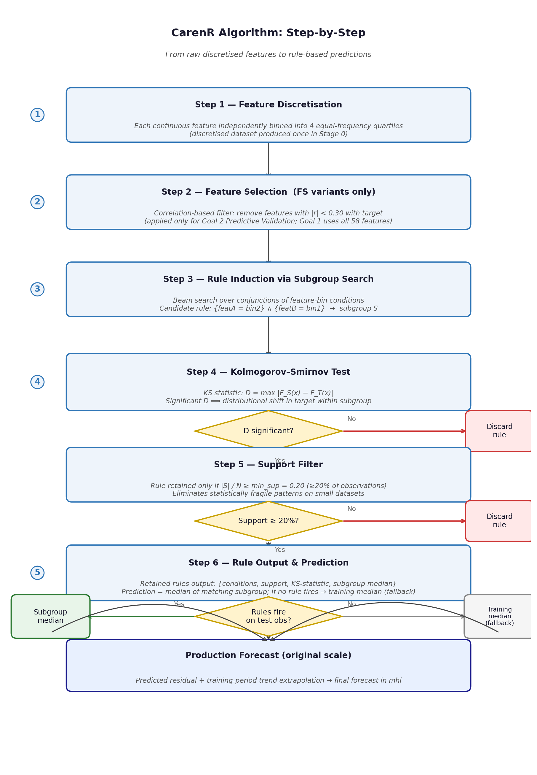
Figure 3.4. CarenR algorithm flowchart. Diamonds are filter decisions; red paths discard candidates failing KS significance or min_sup = 0.20; green path retains rules; grey fallback returns training median when no rule fires.
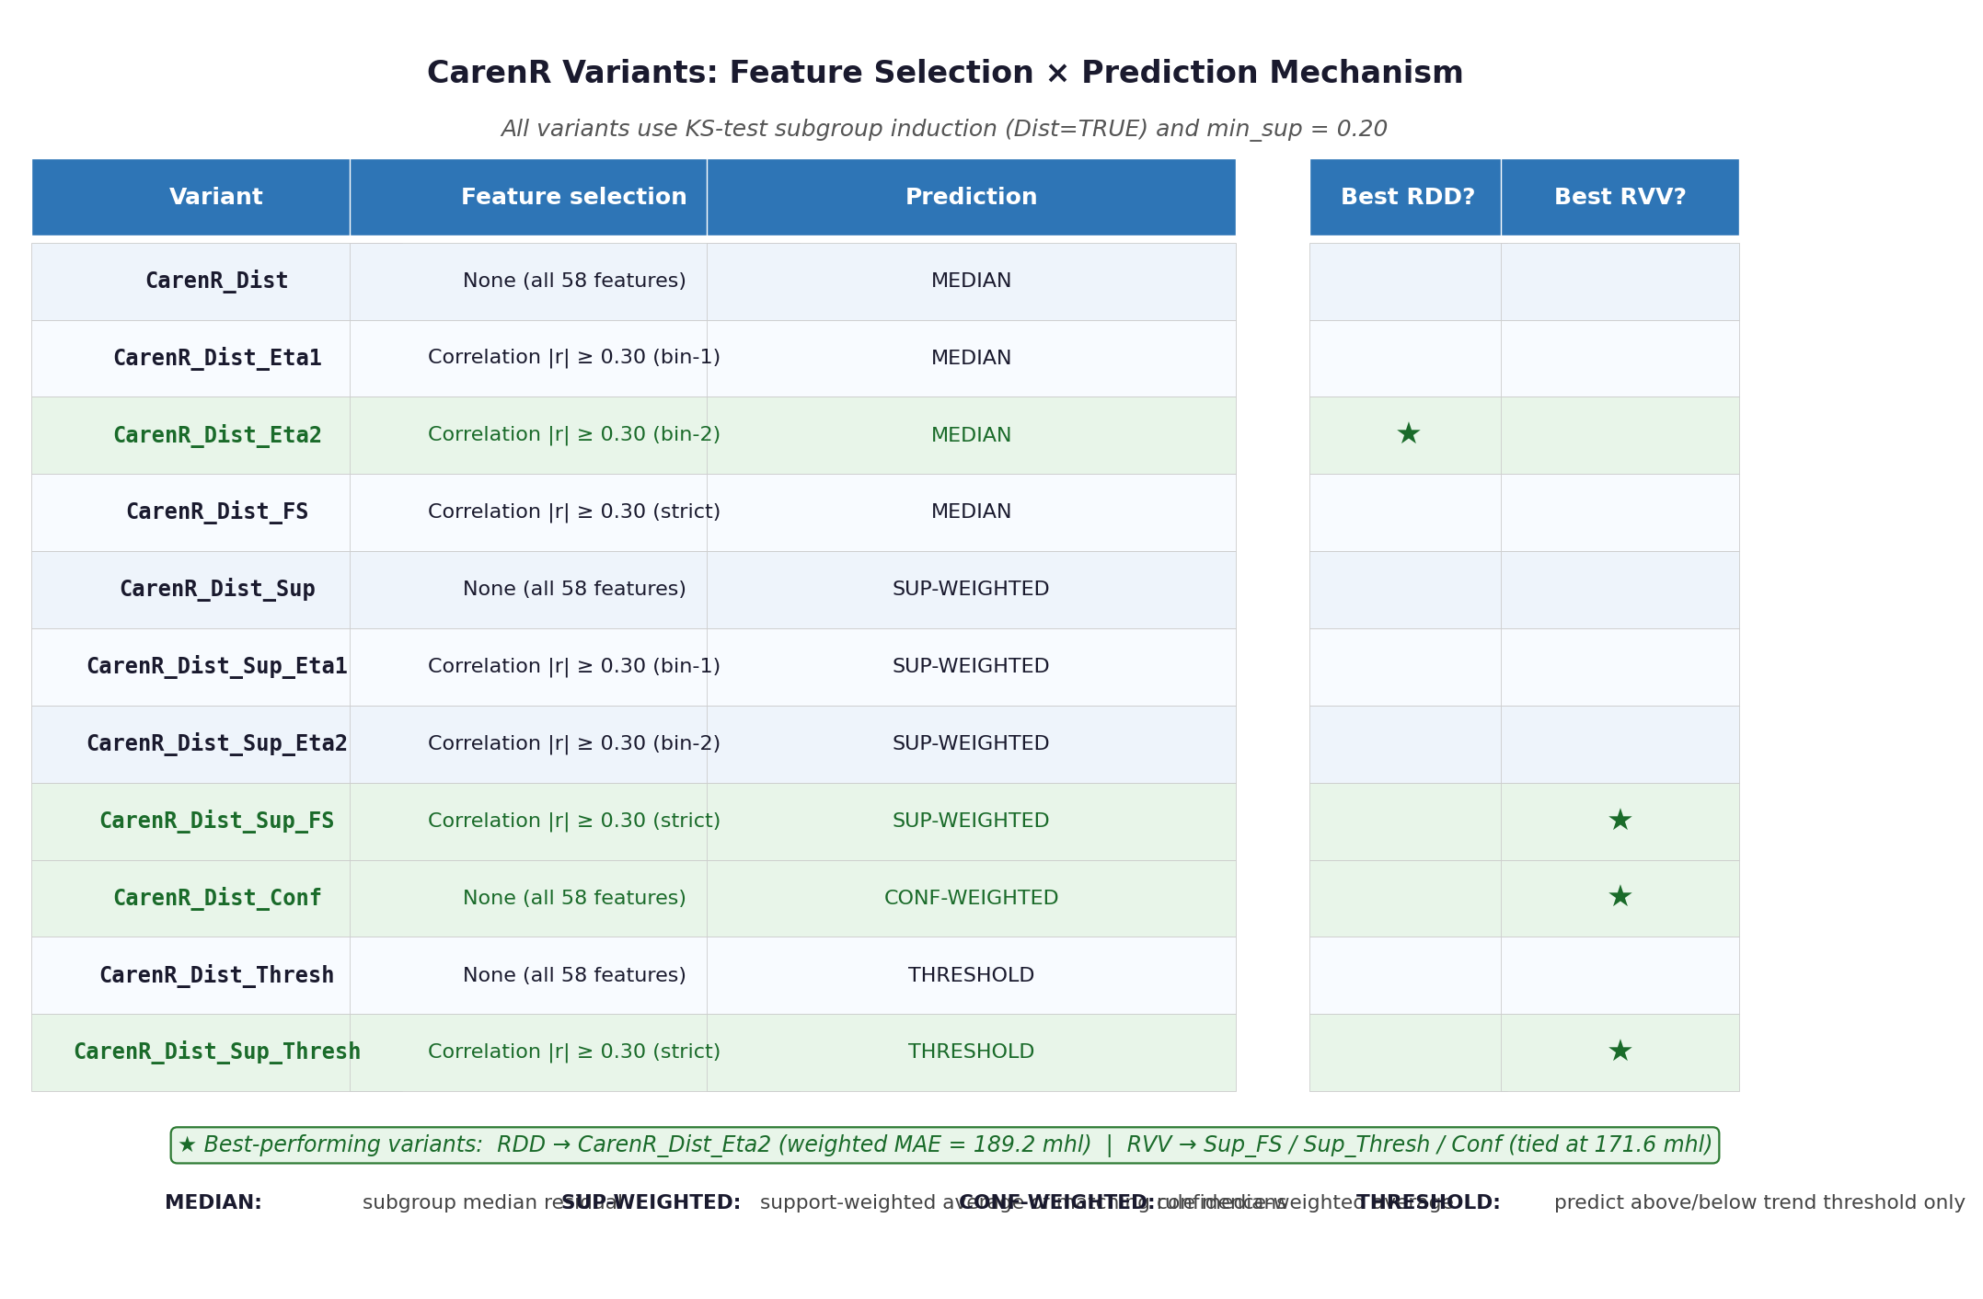
Figure 3.5. The 11 CarenR variants by feature selection and prediction mechanism. Starred: best per region - Eta2 for RDD (189.2 mhl), Sup_FS / Sup_Thresh / Conf for RVV (171.6 mhl, three-way tie).

3.4.2 RIPPER: Repeated Incremental Pruning to Produce Error Reduction

RIPPER, implemented as JRip in the Weka machine learning toolkit (Witten et al., 2011), is a propositional rule learning algorithm for classification. It was introduced by Cohen (1995) as an efficient, scalable alternative to earlier rule learners such as CN2, and remains one of the most widely used interpretable classification algorithms. In this thesis RIPPER serves as an interpretable classification benchmark, allowing the rules found by CarenR to be compared against a well-established rule-based classification baseline.

Target discretisation. RIPPER is a classifier and requires a discrete target variable. The continuous production residuals are therefore discretised into three ordinal classes — Low, Medium, and High — using tertile boundaries. For Goal 1 (Rule Discovery), boundaries are estimated on the full historical dataset. For Goal 2 (Predictive Validation), boundaries are estimated within each training fold to prevent leakage. Each class contains approximately one third of the observations. This discretisation step introduces a loss of information relative to CarenR and M5Rules, which both operate on the continuous response.

Rule growing with FOIL gain. RIPPER constructs rules one class at a time, starting with the minority class and working towards the majority class. For each class, it grows a rule by greedily adding conditions that maximise the FOIL information gain, a measure that rewards conditions that increase the ratio of positive (target class) to negative (other class) examples covered by the rule. Starting from an empty condition set, RIPPER adds one condition at a time until no further gain is possible or a stopping criterion is met. The grown rule is typically a conjunction of 2–5 conditions that together define a subregion of feature space highly concentrated in the target class.

Rule pruning with MDL. Overfitting is controlled by a pruning step that removes conditions from the grown rule using the Minimum Description Length (MDL) principle: conditions whose removal reduces the total description length of the rule set plus the data are deleted. This balances rule complexity against coverage, a rule that is slightly less precise but covers more observations is preferred over a highly specific rule covering very few. After pruning, RIPPER checks whether replacing or revising a rule reduces the total error, iterating until convergence.

Ordered rule list and default rule. The final output of RIPPER is an ordered rule list: rules are applied in the order they were learned, and the first rule whose conditions are satisfied assigns the class for a given observation. Any observation not covered by any explicit rule is assigned the default class, the most frequent class in the training data. This ordered, default-inclusive structure ensures complete coverage: every observation receives a class label. In this thesis, the default rule covered the majority of observations (all years not matching explicit climate conditions), limiting RIPPER's ability to characterise positive (above-trend) production years in the Douro.

Why RIPPER struggles with small datasets. RIPPER was designed for large databases where each class is represented by thousands of examples. With n = 80–89 observations split into three classes of approximately 27–30 each, the per-class sample size is very small relative to the dimensionality of the feature space. FOIL gain estimates are unreliable on such small samples, and the MDL pruning criterion may be too aggressive or too permissive. The result is either overly specific rules (high precision, very low support) or a near-trivial rule list (one or two rules plus a default) that captures only the most obvious patterns. Cross-validated accuracy of 35–42%, only slightly above the 33% random baseline, reflects this limitation directly.

3.4.3 M5Rules: Rule Induction with Linear Regression Consequents

M5Rules, also implemented in Weka, is a piecewise linear regression rule learner derived from the M5 model tree algorithm (Quinlan, 1992; Wang and Witten, 1997). Instead of predicting a class label or a distributional shift, M5Rules predicts an exact numerical value for each observation by applying a linear regression model whose coefficients depend on which region of feature space the observation falls in. This makes M5Rules the only algorithm in this study that produces a direct point estimate of the production residual, making it directly comparable to the naive baseline and to CarenR's subgroup-median prediction.

Model tree construction. M5Rules begins by constructing a regression model tree using a top-down recursive partitioning procedure. At each node of the tree, M5Rules selects the feature and split threshold that maximise the reduction in standard deviation of the target variable across the two resulting child nodes, analogous to the variance reduction criterion used by CART, but applied to a regression setting. This process continues recursively until each leaf contains a minimum number of observations (default: 4 in Weka). The result is a binary tree that partitions the feature space into disjoint regions, with a multivariate linear regression model estimated at each leaf using the observations that reach it.

Leaf model estimation and smoothing. Within each leaf, a linear regression model is fitted to the training observations in that leaf using ordinary least squares. M5Rules applies a smoothing procedure that interpolates between the leaf model and progressively coarser ancestor models as the observation moves up the tree, reducing the discontinuities at split boundaries that would otherwise produce implausible predictions near the edges of each leaf region. The smoothed prediction at leaf depth d is a weighted combination of the leaf model and each ancestor model's prediction.

Pruning and conversion to rules. After tree construction, M5Rules prunes branches whose removal does not increase cross-validation error beyond a tolerance threshold. The pruned tree is then converted into an ordered rule list: each path from the root to a leaf becomes one rule, with the conditions along the path as the antecedent and the leaf's linear model as the consequent. Rules are applied in order; the first matching rule is used, with the final rule having no conditions (applies to all observations) as a universal default. This conversion gives M5Rules the same human-readable rule format as RIPPER but with a linear model at each leaf rather than a class label.

Why M5Rules collapses to a global model on small datasets. M5Rules' standard deviation reduction criterion requires that each split create two child nodes, each with sufficient observations for reliable linear regression. With a minimum leaf size of 4 and n = 80–89 training observations, the algorithm cannot split the data more than a few times before individual leaves become too small for stable regression. In practice, M5Rules found no beneficial split in either region on the full dataset, collapsing to a single global linear model: one rule with no conditions that applies to all observations. This global model fits the training data with R² ≈ 0.40–0.53 but generalises poorly, with cross-validated R² falling to 0.004 (RDD) and −0.07 (RVV). The negative CV R² for RVV confirms that the model is worse than simply predicting the global mean; it has overfit the training set despite using a single linear equation.

Comparison with CarenR and RIPPER. The three algorithms differ fundamentally in what they optimise and what they produce. CarenR searches for distributional anomalies using a non-parametric test; it will find a feature informative if it shifts the distribution of production residuals in a statistically reliable way, even if that shift is not captured by a linear coefficient or a class boundary. RIPPER searches for class-separating conditions using information gain; it will find a feature informative if it concentrates one production class, regardless of the distribution of other classes. M5Rules searches for variance-reducing splits using squared error; it will find a feature informative if it enables a more accurate linear model, penalising large deviations quadratically. A feature that shifts the mean of the distribution of production residuals (detected by CarenR) but does not cleanly separate the three classes (not detected by RIPPER) and adds noise rather than linearity to the regression (not detected by M5Rules) will appear in CarenR's output but not in the others. This is precisely the situation for LAI at harvest in Vinho Verde, as discussed in Section 4.6.3.

3.5 Walk-Forward Validation Protocol

Model performance for Goal 2 was assessed using a walk-forward expanding-window validation. The earliest 80% of each regional time series defines the minimum training window. At each subsequent step (scenario), the training window is extended by one year and the model is re-fitted from scratch on all available training data; the next year is then predicted and its prediction error recorded. This generates 18 evaluation scenarios for RDD and 16 for RVV. All preprocessing steps — linear trend estimation, feature discretisation, and feature selection — are performed exclusively on the training fold within each scenario to prevent data leakage.
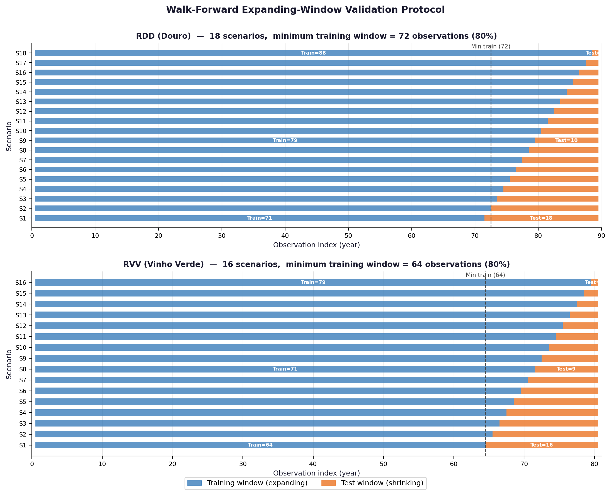
Figure 3.6. Walk-forward expanding-window validation: RDD (18 scenarios, top) and RVV (16 scenarios, bottom). Blue = expanding training window; orange = shrinking test window. Dashed line = minimum training boundary (80% of observations).

3.6 Baseline Models

Naive_Median: predicts the median of the training-set residuals for every test year, equivalent to predicting that every test year will be exactly on trend. Minimises MAE among all constant predictors.

Naive (last value): predicts the most recently observed production value, corresponding to a random-walk assumption.

Naive_MA (moving average): predicts the mean of the three most recent training observations in original units.

Decision Tree (CART): a CART regressor included as a non-rule-based ML comparator. Unlike the rule-learning algorithms, CART partitions the feature space using recursive binary splits that minimise squared error at each node, producing a tree structure rather than an explicit IF-THEN rule list. It was included to test whether the interpretability constraint comes at a cost in predictive performance relative to a standard ML baseline. The tree was fitted with default Weka hyperparameters within each training fold, subject to the same walk-forward protocol as all other models.

The 17 models evaluated in the walk-forward experiment span three categories: four baselines and comparators (Naive_Median, Naive, Naive_MA, and Decision Tree), two standard rule learners (RIPPER and M5Rules), and 11 CarenR variants. The baselines serve as benchmarks against which rule-learning algorithms are assessed: Naive_Median is the primary reference (it minimises MAE under a constant prediction), while Naive and Naive_MA test whether any model adds value over simpler alternatives that ignore climate information entirely. Decision Tree is included as a non-rule-based ML comparator to isolate the contribution of rule structure. The 11 CarenR variants all use the same distributional subgroup discovery algorithm but differ in how features are pre-selected within each training fold, enabling a systematic sensitivity analysis of this design choice. Table 3.8 lists all 17 models.

Model | Type | Feature selection / distinguishing design choice
Naive_Median | Baseline | Predicts training-set median residual (primary baseline)
Naive | Baseline | Predicts most recent observed value (random-walk)
Naive_MA | Baseline | Predicts mean of 3 most recent training observations
Decision Tree | ML comparator | CART regressor on all 59 features; recursive binary splits
RIPPER | Rule learner | Classification rules on tertile-discretised residuals
M5Rules | Rule learner | Piecewise linear regression rules
CarenR_Dist | CarenR variant | All 59 features; default minimum support
CarenR_Dist_FS | CarenR variant | Top-N features by |Pearson correlation| with target
CarenR_Dist_Thresh | CarenR variant | Features with |correlation| >= 0.30
CarenR_Dist_Sup | CarenR variant | All 59 features; higher minimum support (broader rules)
CarenR_Dist_Sup_Thresh | CarenR variant | Correlation threshold + higher minimum support
CarenR_Dist_Eta2 | CarenR variant | Top-N features by eta-squared (ANOVA on discretised bins)
CarenR_Dist_Lag | CarenR variant | Sup_Thresh config + lagged production residuals
CarenR_Dist_Conf | CarenR variant | Sup_Thresh config; confidence-weighted by -log(p-value)
CarenR_Dist_Stack | CarenR variant | Sup_Thresh rules stacked with a lag regression step
CarenR_Dist_Sup_FS | CarenR variant | Support-filtered + top-N Pearson feature selection
CarenR_Supervised | CarenR variant | Per-fold supervised feature discretisation (cut-points maximise residual separation)
Table 3.8. Complete set of 17 models evaluated in the walk-forward validation.

3.7 Evaluation Metric

The primary evaluation metric is scenario-size-weighted MAE on the original production scale (mhl):

Weighted MAE = Σ (n_s × MAE_s) / Σ n_s

where n_s is the number of test observations in scenario s. This weighting gives more influence to scenarios with larger test sets, which in the expanding-window design are the early scenarios with shorter training histories. Statistical significance of model differences was assessed using the Wilcoxon signed-rank test applied to per-scenario MAE pairs; the post-hoc era-balanced analysis used a binomial sign test (Section 5.4).

3.8 Software and Reproducibility

The full pipeline was implemented in R (version 4.x). CarenR was run via the caren R package. RIPPER and M5Rules were run via RWeka, providing a JVM bridge to Weka 3.8. The pipeline is controlled by a master runner script (run_all_pipelines.R) that sequences data preparation, rule discovery, walk-forward validation, rule interpretation, and output generation. All detrending parameters and model hyperparameters are centralised in a configuration file (utils/config.R) to ensure reproducibility.

