3. Data and Methodology

This chapter describes the full data pipeline, from the meteorological source files provided by Professor Cunha's group to the curated annual feature datasets used for rule discovery and walk-forward prediction, together with the detrending methodology, algorithm descriptions, and evaluation protocol. Section 3.1 tells the complete data story: the sources, transformations, and decisions that shaped the final datasets. This pipeline was developed over an extended period of exploratory data analysis and represents a significant methodological contribution in its own right, as no publicly available equivalent phenology-anchored climate feature dataset existed for these two regions across the full 80–90 year time horizons.

3.1 Data Sources

The datasets for both regions originate from two independent source streams that were joined at the annual level.

3.1.1 Meteorological Data

Daily meteorological records for the Douro region were sourced from the BCM base climate files maintained by the University of Porto's viticulture research group (Professor Mário Cunha). The source files (BCM_base_RDD.xls, BCM_base_RVV.xls) contain one row per calendar day from 1933-01-01 to 2022-12-31 for RDD (32,842 daily records) and from 1941-01-01 to 2022-11-13 for RVV (29,902 daily records). Each daily record contains the following primary meteorological variables:

Variable | Description | Unit
Tmax | Daily maximum temperature | °C
Tmin | Daily minimum temperature | °C
Tmed | Daily mean temperature | °C
Rain | Daily total rainfall | mm
Sm | Soil water availability (model-derived) | mm
Iaf | Leaf Area Index (phenological model) | m²/m²
Eto | Reference evapotranspiration | mm
Table 3.1. Primary daily meteorological variables in the raw source files.

The soil water availability (Sm) and Leaf Area Index (Iaf) values are not direct measurements but model-derived estimates produced by the STICS vine growth model calibrated to each region's soil and vine characteristics by Professor Cunha's group over decades of field work. These modelled variables are critical for the analysis: Sm represents the balance between precipitation, evapotranspiration, and soil water-holding capacity integrated daily, while Iaf represents vine canopy development as a continuous daily estimate anchored to the vine's phenological state.

In Stage 1 of the pipeline (script: 1_data_preparation_stage_1.R), five binary/threshold indicator variables were derived from the pre-processed daily records provided by Professor Cunha's group:

Derived indicator | Condition | Agronomic meaning
R>0.1 | Rain > 0.1 mm | Wet day indicator (trace rainfall)
Tmed<15 | Tmed < 15°C | Cold day, impairs flowering and fruit set
Tmax>35 | Tmax > 35°C | Heat-stress day, causes flower abortion, accelerates ripening
Tmin<0 | Tmin < 0°C | Frost day, potential bud and shoot damage
Sm<1.5Wp | Sm < 1.5 × wilting point | Severe soil water stress, below vine survival threshold
Sm>0.9Fc | Sm > 0.9 × field capacity | Near-saturation, promotes disease, excessive vigour
Table 3.2. Binary threshold indicators derived from source daily meteorological variables in Stage 1.

The wilting point (Wp) and field capacity (Fc) thresholds used in the Sm indicators were set based on soil profile parameters calibrated for each region. The resulting Stage 1 output is a clean daily dataset with 17 columns per region (dataPrep_meteo_rdd.csv, dataPrep_meteo_rvv.csv) spanning the full time horizon.

3.1.2 Phenology and Production Data

Annual wine production records and vine phenological dates were sourced from the Pheno_Prd source files maintained by the same research group (Pheno_Prd_1933_2022_recente.xlsx for RDD; equivalent for RVV). Each annual record contains:

Variable | Description
Wine_mhl | Annual regional wine production (thousands of hectolitres)
DOY_BB | Day of Year of Bud Break, start of vegetative growth
DOY_Fl | Day of Year of Flowering, critical fruit-set window
DOY_sM | Day of Year of Start of Maturity (veraison), berry ripening begins
DOY_Fs | Day of Year of Fruit Set, end of berry cell division
DOY_Hv | Day of Year of Harvest, end of growing season
Table 3.3. Annual phenology and production variables.

The phenological dates (DOY_BB through DOY_Hv) are derived from the STICS phenological sub-model and represent the average calendar date of each key event across the regional vine population for each year. These dates vary by 2–4 weeks across years for each stage, reflecting the sensitivity of vine phenology to temperature, warmer springs advance flowering and harvest, cooler springs delay them. The variability in these anchor dates is what makes phenology-based windowing more informative than fixed calendar windows: a feature computed as "the 20 days before Harvest" adapts to the actual harvest date of each year rather than always covering, say, the first three weeks of September.

The production series for RDD spans 1933–2022 (90 observations), but the feature construction starts at 1934 to allow for previous-year (y0) features, leaving 89 usable observations. For RVV, the series spans 1942–2021 with 80 usable observations. The production values show the structural trajectories described in Chapter 2: RDD production ranging from 518 to 1,961 mhl with a mean of 1,116 mhl and an upward trend; RVV production ranging from 494 to 3,443 mhl with a mean of 1,621 mhl and a sharp downward trend since the 1960s.

3.2 Feature Engineering: From Daily Records to Annual Features

The core methodological contribution of the data pipeline is the transformation from 32,842 (RDD) and 29,902 (RVV) daily records into 59 annual agroclimatic features per region. This transformation is performed by script 2_features_creation.R and is anchored entirely on the phenological dates for each year. For each year y1, each combination of (meteorological variable × phenological anchor × window position × window width × year offset) defines one feature.

3.2.1 Feature Naming Convention

All 59 features follow a systematic naming convention that encodes all relevant information about how the feature was computed:

{variable}_{stage}_{year}_{position}{width}

where:

Component | Options | Meaning
variable | tm, tn, swa, iaf, rf, days.rf, sw.less.15wp, sw.above.09fc, days.maxTemp.above.35, tm.days.less.15, days.minTemp.less.0 | The meteorological quantity being aggregated
stage | bb (Bud Break), fl (Flowering), sM (Start Maturity), hv (Harvest) | The phenological anchor point for the window
year | y1 (current harvest year), y0 (previous year) | Which growing season the feature refers to
position | c (centred), b (before), a (after) | Whether the window is centred on, before, or after the stage date
width | 5, 10, 15, 20, 30 (days) | Half-width (centred) or full width (before/after) of the aggregation window
Table 3.4. Feature naming convention components.

For example: swa_hv_y1_b20 = soil water availability (swa), in the 20 days BEFORE (b20) Harvest (hv), in the current year (y1). tm_fl_y0_b10 = mean temperature (tm), in the 10 days BEFORE (b10) Flowering (fl), in the PREVIOUS year (y0). iaf_fl_y1_a10 = Leaf Area Index (iaf), in the 10 days AFTER (a10) Flowering (fl), in the current year (y1).

3.2.2 Feature Groups and Counts

Table 3.5 summarises the 59 features by variable family and their counts. The distribution reflects the relative importance of different variable types in the viticulture literature: mean temperature (tm) and minimum temperature (tn) variables are most numerous because temperature governs nearly every phenological process; soil water and LAI variables are next because they are the primary within-season stress indicators; rainfall and heat/cold day counts complete the picture.

Variable family | Symbol | Count | What it measures
Mean daily temperature | tm | 12 | Average thermal conditions at key phenological windows
Leaf Area Index | iaf | 10 | Vine canopy development, proxy for vegetative vigour
Soil water deficit days | sw.less.15wp | 8 | Days when soil water < 1.5× wilting point, severe stress
Rainfall event count | days.rf.above.1mm | 6 | Number of days with rainfall > 1 mm, disease pressure proxy
Soil water availability | swa | 5 | Absolute soil water balance at harvest and flowering windows
Soil saturation days | sw.above.09fc | 4 | Days when soil water > 90% field capacity, excess moisture
Heat stress days (Tmax > 35°C) | days.maxTemp.above.35 / days.tempMax.above.35 | 4 | Extreme heat events, flower abortion and thermal damage
Rainfall sum | rf | 3 | Total precipitation at harvest and flowering windows
Cold days (Tmed < 15°C) | tm.days.less.15 | 2 | Cool days impairing pollination and fruit set
Frost days (Tmin < 0°C) | days.minTemp.less.0 | 2 | Frost events, bud and shoot damage risk
Minimum temperature | tn | 1 | Night temperature at harvest, berry quality proxy
Previous-year soil water | y0 variants of swa/sw | 2 | Carry-over water stress from prior season
Table 3.5. Feature groups, counts, and agronomic meanings. Total: 59 features per region.

3.2.3 Current-Year vs Previous-Year Features

A key design decision in the feature engineering was the inclusion of previous-year (y0) features alongside current-year (y1) features. As discussed in Section 2.2, vine physiology has a two-year temporal structure: inflorescence primordia that determine current-year bunch number are formed in the prior growing season, and vine carbohydrate reserves that determine shoot vigour are accumulated during the prior year's harvest-to-dormancy period. Failing to include prior-year features would miss this carry-over mechanism entirely.

In the final feature matrix, 15 of the 59 features (25%) use y0 (previous-year) anchors. The most agronomically motivated y0 features are:

tm_fl_y0_b10 (mean temperature in the 10 days before previous-year flowering): captures the thermal conditions governing inflorescence primordia formation in the prior season, the mechanism that determines current-year bunch potential.

tm_bb_y0_a30 (mean temperature in the 30 days after previous-year bud break): captures the early-season thermal conditions that initiate the prior year's vegetative growth phase, influencing vine carbohydrate allocation.

tm_sm_y0_a20 (mean temperature in the 20 days after previous-year start of maturity): captures the heat load during the prior year's ripening phase, which governs both berry quality in the prior year and the vine's thermal stress exposure at the end of the growing season.

sw.above.09fc_fl_y0_a20 (soil saturation days in the 20 days after previous-year flowering): captures prior-year excess soil moisture during flowering, the carry-over mechanism identified in RVV CarenR Rule 2 (see Section 4.1.2).

3.2.4 Feature Discretisation for CarenR

The continuous feature matrix (dataPrep_cont_dataset_*.csv, 59 columns × 89/80 rows) is used directly by M5Rules and RIPPER, which perform their own internal threshold finding. For CarenR, a separate discretised version of the dataset (dataPrep_dis_rule_dataset_*.csv) is produced by script 2_features_creation.R using equal-frequency binning into four quartile intervals. Each feature is independently divided into four bins, each containing approximately 25% of the training observations, with the boundaries represented as interval notation (e.g. [18.3|22.4] for the bin from 18.3°C to 22.4°C).

The equal-frequency choice, rather than equal-width or domain-knowledge-based breakpoints, ensures that each bin is populated by a comparable number of observations. This is important for the KS test used by CarenR: a bin with only two or three observations would produce an unreliable distributional comparison regardless of its meteorological significance. In the walk-forward scenarios, the bin boundaries are re-estimated within each training fold, ensuring that the discretisation reflects the distribution of climate conditions actually observed in the training period, not the full historical record that would be unknowable at prediction time.

3.3 Data Pipeline Summary

Figure 3.1 summarises the complete data pipeline from raw sources to the final modelling datasets. The pipeline was implemented as a sequence of seven R scripts coordinated by a master runner (run_all_pipelines.R), with all intermediate datasets written to disk at each stage to allow inspection and validation.
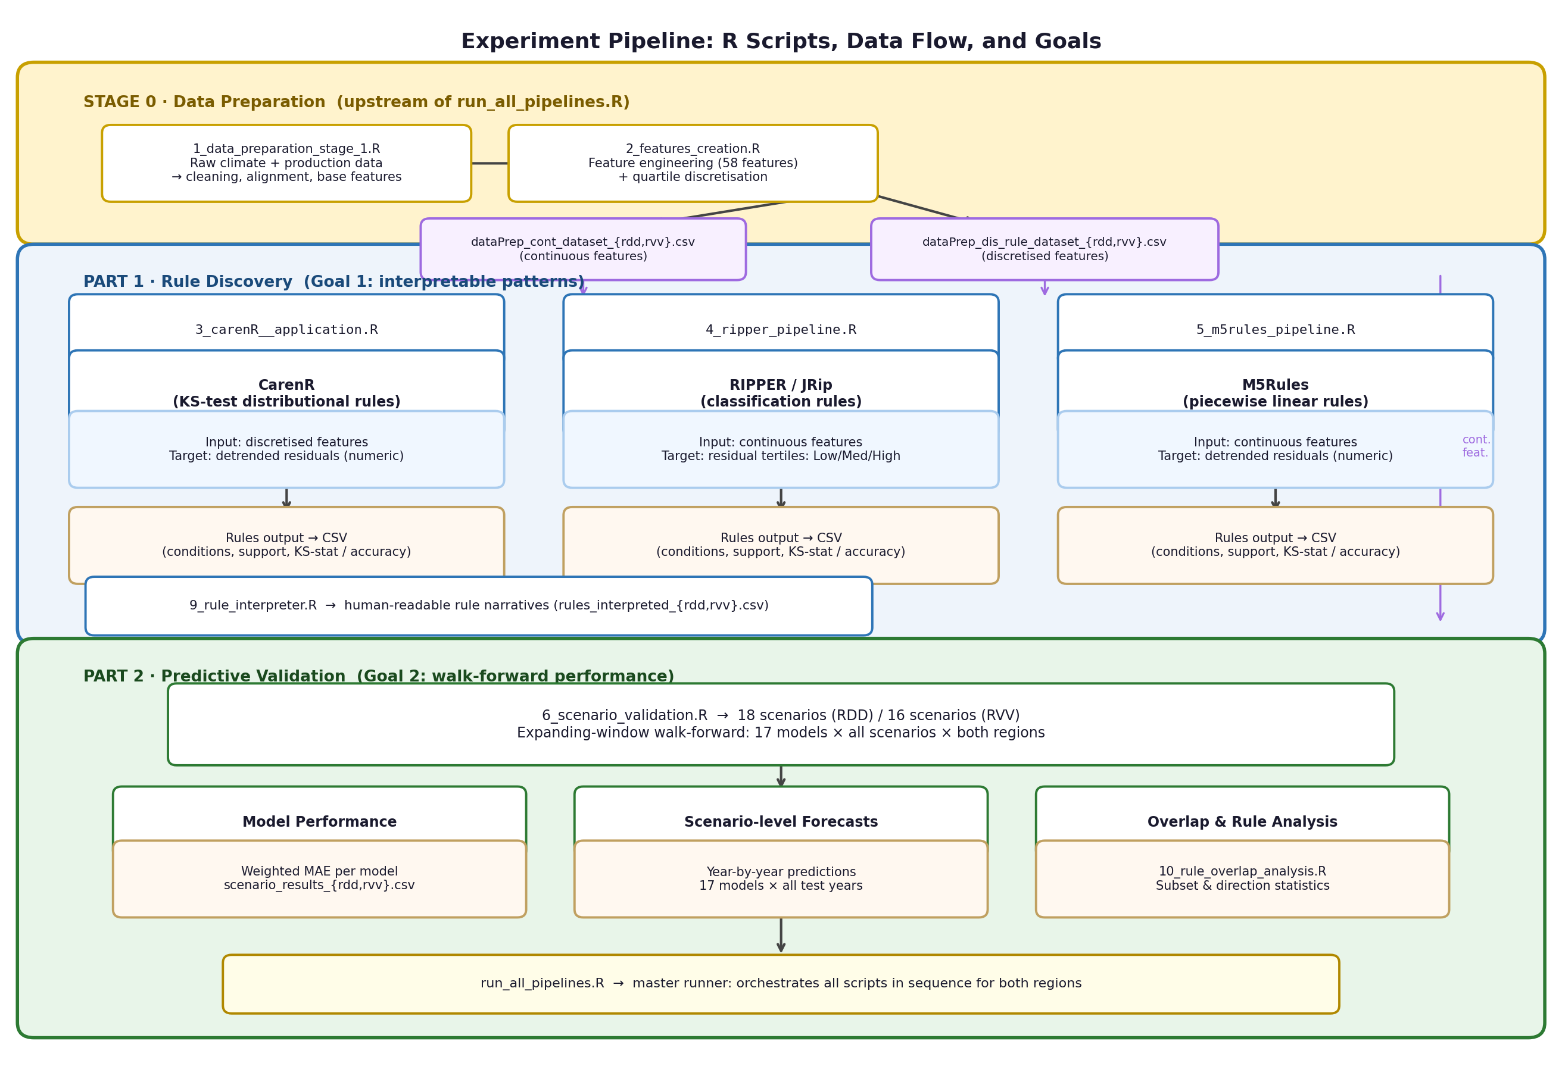
Figure 3.1. Experiment pipeline: Stage 0 data preparation (1_data_preparation_stage_1.R, 2_features_creation.R), Part 1 rule discovery (3_carenR__application.R, 4_ripper_pipeline.R, 5_m5rules_pipeline.R, 9_rule_interpreter.R), and Part 2 walk-forward predictive validation (6_scenario_validation.R, 10_rule_overlap_analysis.R). run_all_pipelines.R orchestrates all steps for both regions.

Stage | Script | Input | Output | Key transformation
0: Raw data | (external) | BCM_base*.xls  Pheno_Prd*.xlsx | Raw Excel files | Daily climate + annual phenology/production from field stations and STICS model
1: Daily prep | 1_data_preparation_stage_1.R | Raw Excel files | dataPrep_meteo_*.csv  dataPrep_production_*.csv | Column standardisation, binary threshold indicators (Tmax>35, Sm<1.5Wp etc.), date decomposition. 32,842 rows (RDD), 29,902 rows (RVV).
2: Feature engineering | 2_features_creation.R | dataPrep_meteo_*.csv  dataPrep_production_*.csv | dataPrep_cont_dataset_*.csv  dataPrep_dis_rule_dataset_*.csv | Phenological window aggregation → 59 annual features per region. Equal-frequency discretisation (4 bins) for CarenR. 89 rows (RDD), 80 rows (RVV).
3: Rule discovery | 3_carenR__application.R  4_ripper_pipeline.R  5_m5rules_pipeline.R | dataPrep_*_dataset_*.csv | RulesTemp_*_linear.csv  ripper_rules_*.txt  m5rules_rules_*.txt | Full-dataset rule induction for all three algorithms. CarenR: 48 rules (RDD), 20 rules (RVV).
4: Walk-forward validation | 6_scenario_validation.R | dataPrep_cont_dataset_*.csv | scenario_metrics_*.csv  scenario_predictions_*.csv  scenario_summary_*.csv | 17-model × 18/16 scenario expanding-window evaluation. All preprocessing within fold.
5: Rule interpretation | 9_rule_interpreter.R | RulesTemp_*.csv  ripper_rules_*.txt  m5rules_rules_*.txt | rules_interpreted_*.txt/.csv  ripper_interpreted_*.txt  m5rules_interpreted_*.txt | Translation of raw rule outputs to plain-English descriptions with agronomic pathway annotations.
Table 3.6. Complete data pipeline from raw sources to final outputs. Each stage writes intermediate datasets to disk for auditability.

The entire pipeline from Stage 1 through Stage 5 is reproducible by running run_all_pipelines.R. All key configuration parameters were fixed before the final analysis run and are centralised in utils/config.R. Table 3.7 summarises the fixed configuration choices.
Parameter | Value | Location in code
Detrending method | Linear (OLS) | config.R: detrend_method
CarenR support threshold | 15% (sᵢ ≥ 0.15) | config.R: support_threshold
Significance threshold | p ≤ 0.10 | config.R: alpha_threshold
Minimum training fraction | 80% | config.R: min_train_frac
Feature selection strategy | Per variant (η², Pearson, or support-filtered) | config.R: fs_strategy
Table 3.7. Fixed configuration parameters for the final analysis run (utils/config.R).

