5.8 Per-Scenario MAE: Douro (RDD)

Table 5.8 presents the complete per-scenario MAE values for Naive_Median and CarenR_Dist_Eta2 across all 18 RDD scenarios. The gap column (positive = CarenR worse, negative = CarenR better) reveals the era-composition pattern described in Section 5.2. Scenarios 10–14, highlighted in green, are the five consecutive era-balanced scenarios where CarenR outperforms the naive baseline. The training period for each scenario is 1934 through the year indicated; the test period begins the year immediately following and extends to 2022.

Scen. | Train period | Test period | Naive_Median  MAE (mhl) | CarenR_Eta2  MAE (mhl) | Gap  (+ = CarenR worse) | Era phase
1 | 1934–2004 | 2005–2022 | 183.5 | 199.5 | +16.0 | Early, era-confounded
2 | 1934–2005 | 2006–2022 | 199.7 | 204.8 | +5.1 | Early, era-confounded
3 | 1934–2006 | 2007–2022 | 223.3 | 216.0 | −7.3 | Early, marginal CarenR win
4 | 1934–2007 | 2008–2022 | 203.9 | 203.7 | −0.2 | Early, near-tie
5 | 1934–2008 | 2009–2022 | 184.3 | 209.5 | +25.1 | Early, era-confounded
6 | 1934–2009 | 2010–2022 | 174.4 | 201.4 | +27.0 | Early, era-confounded
7 | 1934–2010 | 2011–2022 | 186.5 | 214.4 | +27.9 | Early, era-confounded
8 | 1934–2011 | 2012–2022 | 174.9 | 190.5 | +15.6 | Early, era-confounded
9 | 1934–2012 | 2013–2022 | 164.0 | 172.7 | +8.7 | Early, era-confounded
10 | 1934–2013 | 2014–2022 | 170.5 | 140.5 | −30.0 | Balanced era ★ CarenR wins
11 | 1934–2014 | 2015–2022 | 165.4 | 148.3 | −17.1 | Balanced era ★ CarenR wins
12 | 1934–2015 | 2016–2022 | 186.7 | 158.9 | −27.9 | Balanced era ★ CarenR wins
13 | 1934–2016 | 2017–2022 | 170.1 | 138.6 | −31.5 | Balanced era ★ CarenR wins
14 | 1934–2017 | 2018–2022 | 176.3 | 145.0 | −31.3 | Balanced era ★ CarenR wins
15 | 1934–2018 | 2019–2022 | 157.6 | 177.0 | +19.5 | Late, small test sets
16 | 1934–2019 | 2020–2022 | 158.1 | 180.1 | +21.9 | Late, small test sets
17 | 1934–2020 | 2021–2022 | 86.7 | 120.2 | +33.4 | Late: 2 yr test, noisy
18 | 1934–2021 | 2022 | 143.9 | 208.7 | +64.8 | Late: 1 yr test, noisy
Table 5.8. Per-scenario MAE for Naive_Median and CarenR_Dist_Eta2 across all 18 RDD scenarios. Green rows = CarenR wins (scenarios 10–14). Gap = CarenR MAE − Naive_Median MAE.
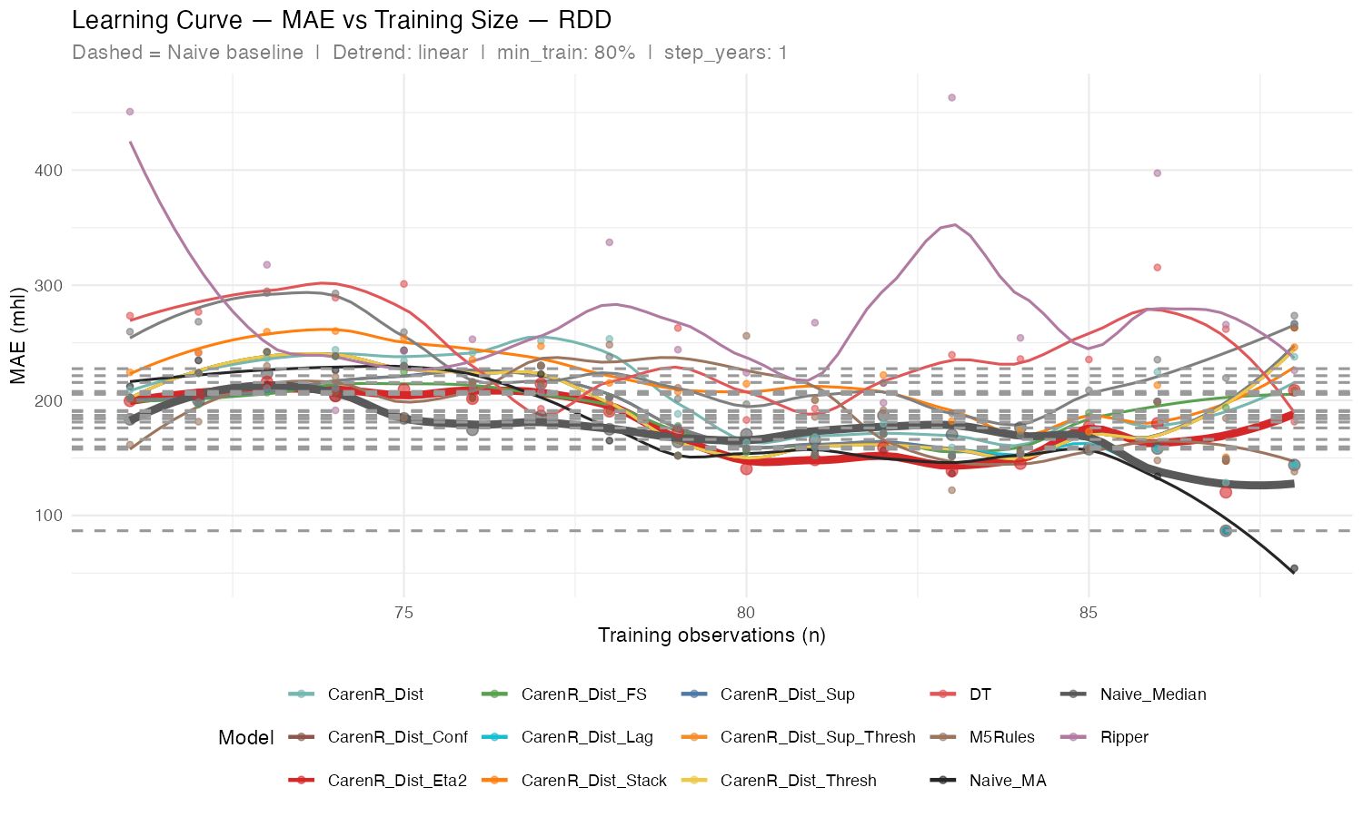
Figure 5.5. MAE learning curve for all 17 models across 18 RDD scenarios (x-axis = training observations). LOESS smoothing applied.

Several observations from Table 5.8 are worth highlighting beyond the era-composition pattern already discussed in Section 5.2.

Scenarios 3 and 4 (marginal CarenR wins, −7.3 and −0.2 mhl): These two early scenarios show CarenR marginally matching or beating the naive baseline, despite low post-1990 training share (~22%). They do not represent reliable era-balanced wins; their margins are near-zero and not consistent across the broader early window.

Scenarios 17 and 18 (large positive gaps, +33 and +65 mhl): Scenario 17 tests two years (2021–2022) and Scenario 18 tests a single year (2022). With very small test sets, the scenario MAE reflects only one or two observations, so large gaps may reflect anomalous years rather than systematic model failure. These late scenarios were therefore excluded from the era-balanced binomial analysis (Section 5.4).

Scenario Naive_Median MAE range (86.7–223.3 mhl): The variation in Naive_Median MAE across scenarios reflects the inherent year-to-year production variability of the test year in each case. When the test year happens to be close to the trend (Scenario 17: 2021 was near-trend), Naive_Median performs very well. When the test year is a strong outlier (Scenario 3: 2007 was above-trend in Douro), Naive_Median has a high error regardless of what any model does. This variability confirms the importance of using weighted aggregate metrics rather than relying on any single scenario.

5.9 Per-Scenario MAE: Vinho Verde (RVV)

Table 5.9 presents the equivalent per-scenario analysis for RVV, comparing Naive_Median against CarenR_Dist_Sup_FS (the best RVV CarenR variant). The "outcome" column indicates whether CarenR fell back to the median (identical prediction, zero gap) or fired rules that hurt prediction (positive gap).

Scen. | Train period | Test period | Naive_Median  MAE (mhl) | CarenR_Sup_FS  MAE (mhl) | Gap  (+ = CarenR worse) | Outcome
1 | 1942–2005 | 2006–2021 | 143.0 | 143.0 | +0.0 | FALLBACK, no rules fired
2 | 1942–2006 | 2007–2021 | 137.3 | 151.4 | +14.1 | HARMFUL, rules fired, hurt prediction
3 | 1942–2007 | 2008–2021 | 115.7 | 115.7 | +0.0 | FALLBACK, no rules fired
4 | 1942–2008 | 2009–2021 | 106.0 | 139.4 | +33.4 | HARMFUL, rules fired, hurt prediction
5 | 1942–2009 | 2010–2021 | 111.4 | 150.2 | +38.8 | HARMFUL, rules fired, hurt prediction
6 | 1942–2010 | 2011–2021 | 121.5 | 165.5 | +44.0 | HARMFUL, rules fired, hurt prediction
7 | 1942–2011 | 2012–2021 | 129.5 | 180.8 | +51.3 | HARMFUL, rules fired, hurt prediction
8 | 1942–2012 | 2013–2021 | 130.5 | 192.7 | +62.2 | HARMFUL, rules fired, hurt prediction
9 | 1942–2013 | 2014–2021 | 151.8 | 222.6 | +70.8 | HARMFUL, rules fired, worst gap
10 | 1942–2014 | 2015–2021 | 171.0 | 244.8 | +73.8 | HARMFUL, rules fired, worst gap
11 | 1942–2015 | 2016–2021 | 175.2 | 257.6 | +82.4 | HARMFUL, rules fired, largest gap
12 | 1942–2016 | 2017–2021 | 206.2 | 206.2 | +0.0 | FALLBACK, no rules fired
13 | 1942–2017 | 2018–2021 | 184.0 | 184.0 | +0.0 | FALLBACK, no rules fired
14 | 1942–2018 | 2019–2021 | 213.8 | 213.8 | +0.0 | FALLBACK, no rules fired
15 | 1942–2019 | 2020–2021 | 235.9 | 235.9 | +0.0 | FALLBACK, no rules fired
16 | 1942–2020 | 2021 | 260.3 | 260.3 | +0.0 | FALLBACK, no rules fired
Table 5.9. Per-scenario MAE for Naive_Median and CarenR_Dist_Sup_FS across all 16 RVV scenarios. Gap = CarenR MAE − Naive_Median MAE. All gaps are zero or positive: CarenR never beats the baseline.
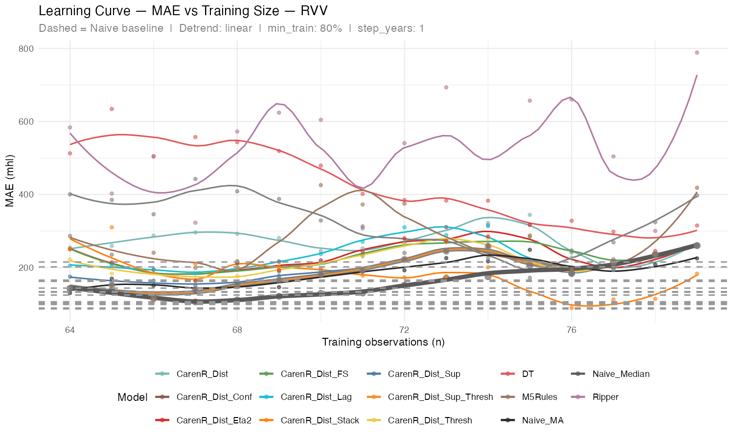
Figure 5.6. MAE learning curve for all 17 models across 16 RVV scenarios. LOESS smoothing applied.

The RVV per-scenario table reveals important structure that the aggregate weighted MAE figure of 172 mhl obscures.

The degradation trajectory (Scenarios 4–11): The gap between CarenR and the naive baseline grows monotonically from +33 mhl (Scenario 4) to +82 mhl (Scenario 11). This is the clearest evidence of the era-composition deterioration described in Section 5.3: as the training set includes more post-1990 observations (with substantially lower production than the historical average), the rules CarenR discovers become increasingly calibrated to the modern low-production era. When those rules are applied to test years that are also in the modern era, they fire conditions that, by coincidence, match the training set's era characteristics rather than genuine inter-annual climate signals, and predict in the wrong direction.

The fallback pattern (Scenarios 1, 3, 12–16): Seven of 16 scenarios show a zero gap, CarenR fired no rules and fell back to the training median. This is not a failure in the same sense as the harmful-rules scenarios: it means CarenR correctly identified that no confident rule applied to the test year and made the safe prediction. The fallback scenarios are concentrated in early scenarios (1, 3) and late scenarios (12–16). The late fallback pattern is interesting: in scenarios 12–16, the training set is very era-balanced (all modern era), but CarenR apparently finds no applicable rules. This suggests that with a homogeneous modern-era training set, the wine production signal becomes too noisy for any subgroup to achieve both KS significance and ≥20% support, confirming that the era structure is what created the spurious rules in the first place.

Weighted MAE decomposition: The weighted aggregate of 172 mhl is dominated by the 9 harmful scenarios (weighted by test-set sizes of 20–80 years in early scenarios). The 7 fallback scenarios contribute 0 mhl to the gap. This means the 22% gap between CarenR and Naive_Median in RVV is entirely attributable to the harmful-rules scenarios, not to the fallback scenarios. The Wilcoxon test on harmful-rules scenarios (p = 0.004, Section 5.4) correctly identifies these as the source of the problem.

