Figures

This section contains the key figures referenced in the results chapters. All figures were generated by the automated R pipeline (plot_model_comparison.R) from the walk-forward evaluation results.

Figure 1 — Vinho Verde Production Time Series with Prediction Error Bands

Figure 1 illustrates the full RVV production time series (1942–2021) alongside the MAE error bands for the best-performing models. The dashed horizontal line is the global mean (1,621 mhl). The shaded band centred on the mean represents the ±140 mhl error band of the Naive_Median baseline; the wider band shows the ±172 mhl error of the best CarenR variant. The figure contextualises what the MAE numbers mean in practice: even the best model has an error band that spans a substantial fraction of the series range. The structural decline from the 1960s peak (~3,000 mhl) to the modern era (~800 mhl) is clearly visible, illustrating the non-stationarity that motivates the detrending step described in Section 3.3.

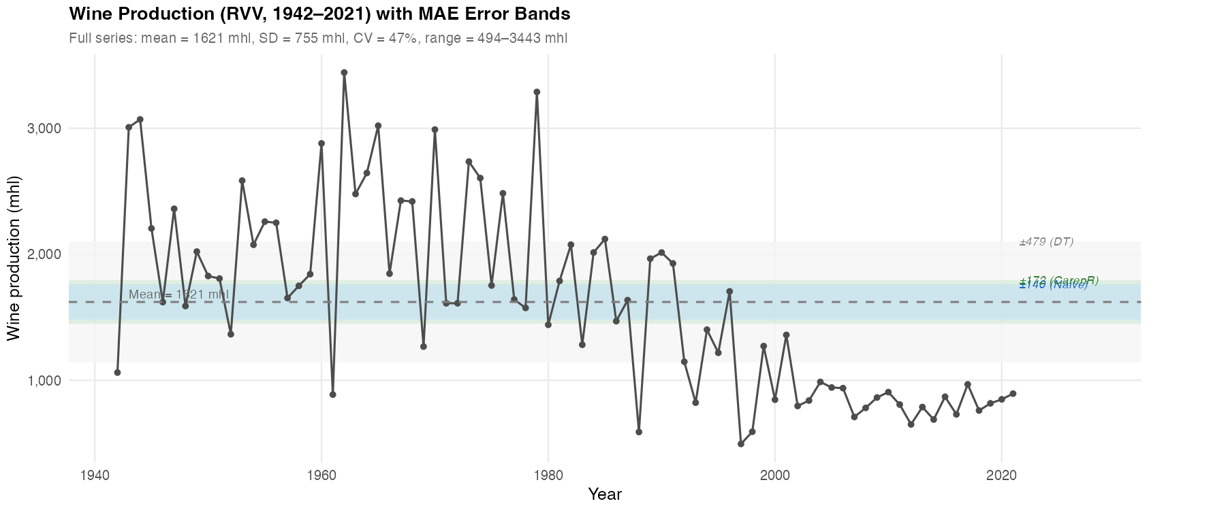
Figure 1. RVV annual wine production (1942–2021). Dashed line = global mean (1,621 mhl). Shaded bands = ±MAE for Naive_Median (dark, ±140 mhl) and best CarenR variant (light, ±172 mhl). The structural decline post-1980 reflects EU accession and industry restructuring, not climate variation.

Figure 2 — Weighted MAE: All 17 Models, Vinho Verde

Figure 2 shows the complete 17-model ranking for the Vinho Verde region, sorted by weighted MAE. The dashed vertical blue line marks the Naive_Median baseline (140 mhl). All CarenR variants (green bars) exceed this baseline, as do all other ML models. The figure visually confirms that no rule-based model consistently beats the naive baseline in RVV, and shows the substantial gap between CarenR variants (172–275 mhl) and the most poorly-performing models (RIPPER 508 mhl, Decision Tree 479 mhl). The best CarenR variant (Sup_FS, marked with ★) ties with CarenR_Dist_Sup_Thresh and CarenR_Dist_Conf at 172 mhl — the closest any ML model comes to the baseline.

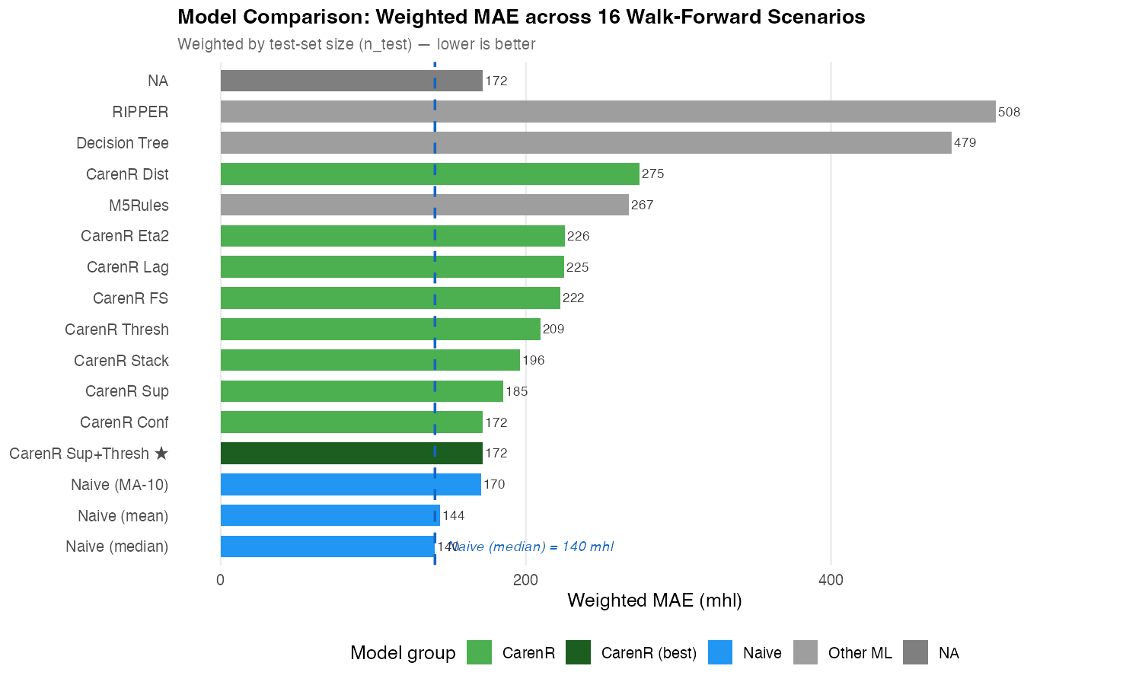
Figure 2. Weighted MAE for all 17 models in Vinho Verde (16 walk-forward scenarios). Blue = naive baselines; green = CarenR variants; grey = other ML models. Dashed line = Naive_Median reference (140 mhl). Lower is better.

Figure 3 — Per-Scenario MAE Trajectory, Vinho Verde

Figure 3 shows the per-scenario MAE for key models across all 16 RVV scenarios. The Naive_Median (solid dark blue) provides a varying baseline — its per-scenario MAE reflects the inherent year-to-year production variability of each test year. The best CarenR variant (CarenR Sup_FS, dark green solid line) tracks close to the Naive_Median in early scenarios (1–3) then diverges progressively in scenarios 4–11, reaching a gap of ~82 mhl in Scenario 11. In the final scenarios (12–16) the gap closes because CarenR falls back to the median (no rules fire). Decision Tree (dotted grey) and M5Rules (dotted dark) are consistently and substantially above all other models. This figure directly illustrates the harmful-rules degradation pattern described in Section 5.3.

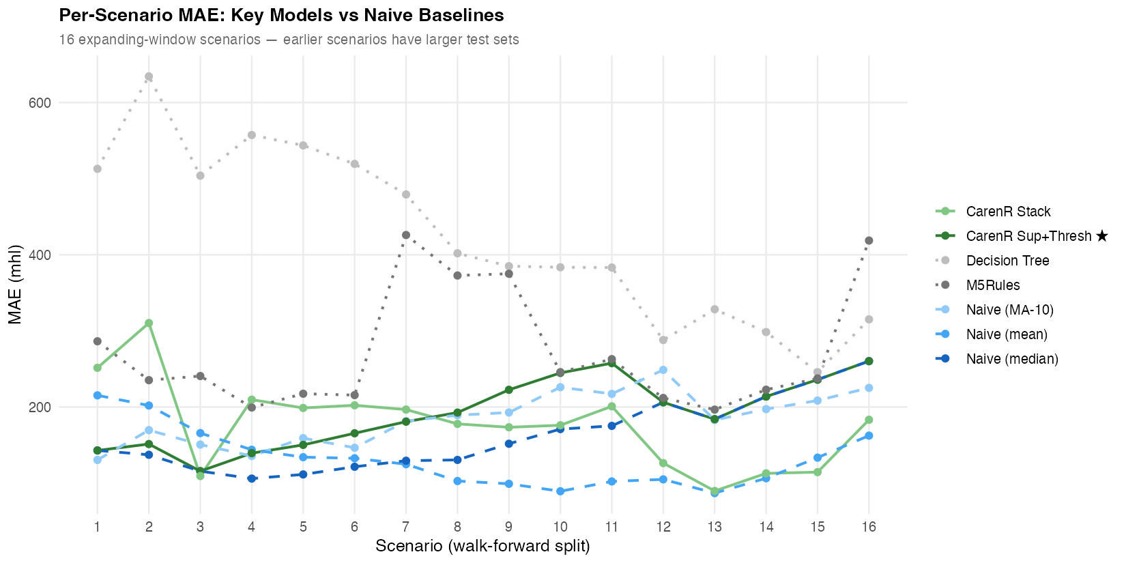
Figure 3. Per-scenario MAE for key models across 16 RVV walk-forward scenarios. Scenarios are ordered chronologically; earlier scenarios have larger test sets. CarenR Sup_FS (dark green) tracks the baseline in early/late scenarios but diverges in scenarios 4–11 when harmful rules fire.

Figure 4 — Linear vs LOESS Detrending: Weighted MAE Comparison

Figure 4 compares the weighted MAE for all 17 models under linear detrending (blue bars) versus LOESS detrending (green bars) for the Vinho Verde region. The two vertical dashed lines show the respective Naive_Median baselines: green (LOESS, ~90 mhl) and blue (linear, ~140 mhl). For every model, LOESS detrending produces a lower absolute MAE — the green bars are consistently shorter than the blue bars. This reflects the better trend fit of LOESS for RVV (Decision 1 improvement). However, CarenR_Lag under LOESS (green bar, short) is notable: even with a lower baseline, CarenR falls to or below the baseline with LOESS because rules are suppressed. The figure visually demonstrates the Decision 1 / Decision 2 trade-off: LOESS moves the goalposts (lower floor) but prevents CarenR from scoring at all.

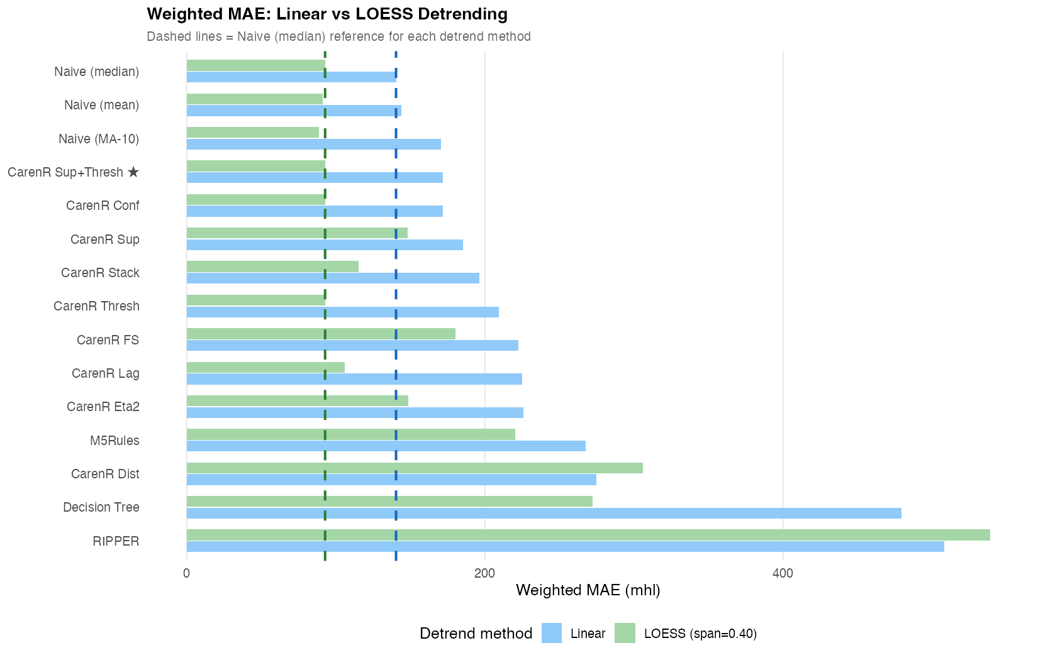
Figure 4. Weighted MAE under linear (blue) vs LOESS (green) detrending for all 17 models, Vinho Verde. Dashed lines = Naive_Median baseline for each detrend method (linear: 140 mhl, LOESS: ~90 mhl). LOESS improves Decision 1 (lower floor) but suppresses CarenR rule induction, illustrating the fundamental trade-off between trend quality and residual signal availability.

