Technical Diagrams: Pipeline, Algorithm, and Validation Framework
This document contains four technical figures for integration into Chapter 3 of the thesis. Figures 3.1–3.4 provide visual summaries of the experiment pipeline, the CarenR algorithm, the walk-forward validation protocol, and the CarenR variant taxonomy.

Figure 3.1 — Experiment Pipeline Overview
The full pipeline proceeds in three stages. Stage 0 (upstream, run manually) transforms raw daily meteorological and production source files into two parallel annual datasets per region: a continuous-feature matrix and a discretised-feature matrix. The two goals — Rule Discovery (Part 1) and Predictive Validation (Part 2) — share these datasets but apply different algorithms and target transformations. The master runner script run_all_pipelines.R coordinates Parts 1 and 2 in sequence for both regions.
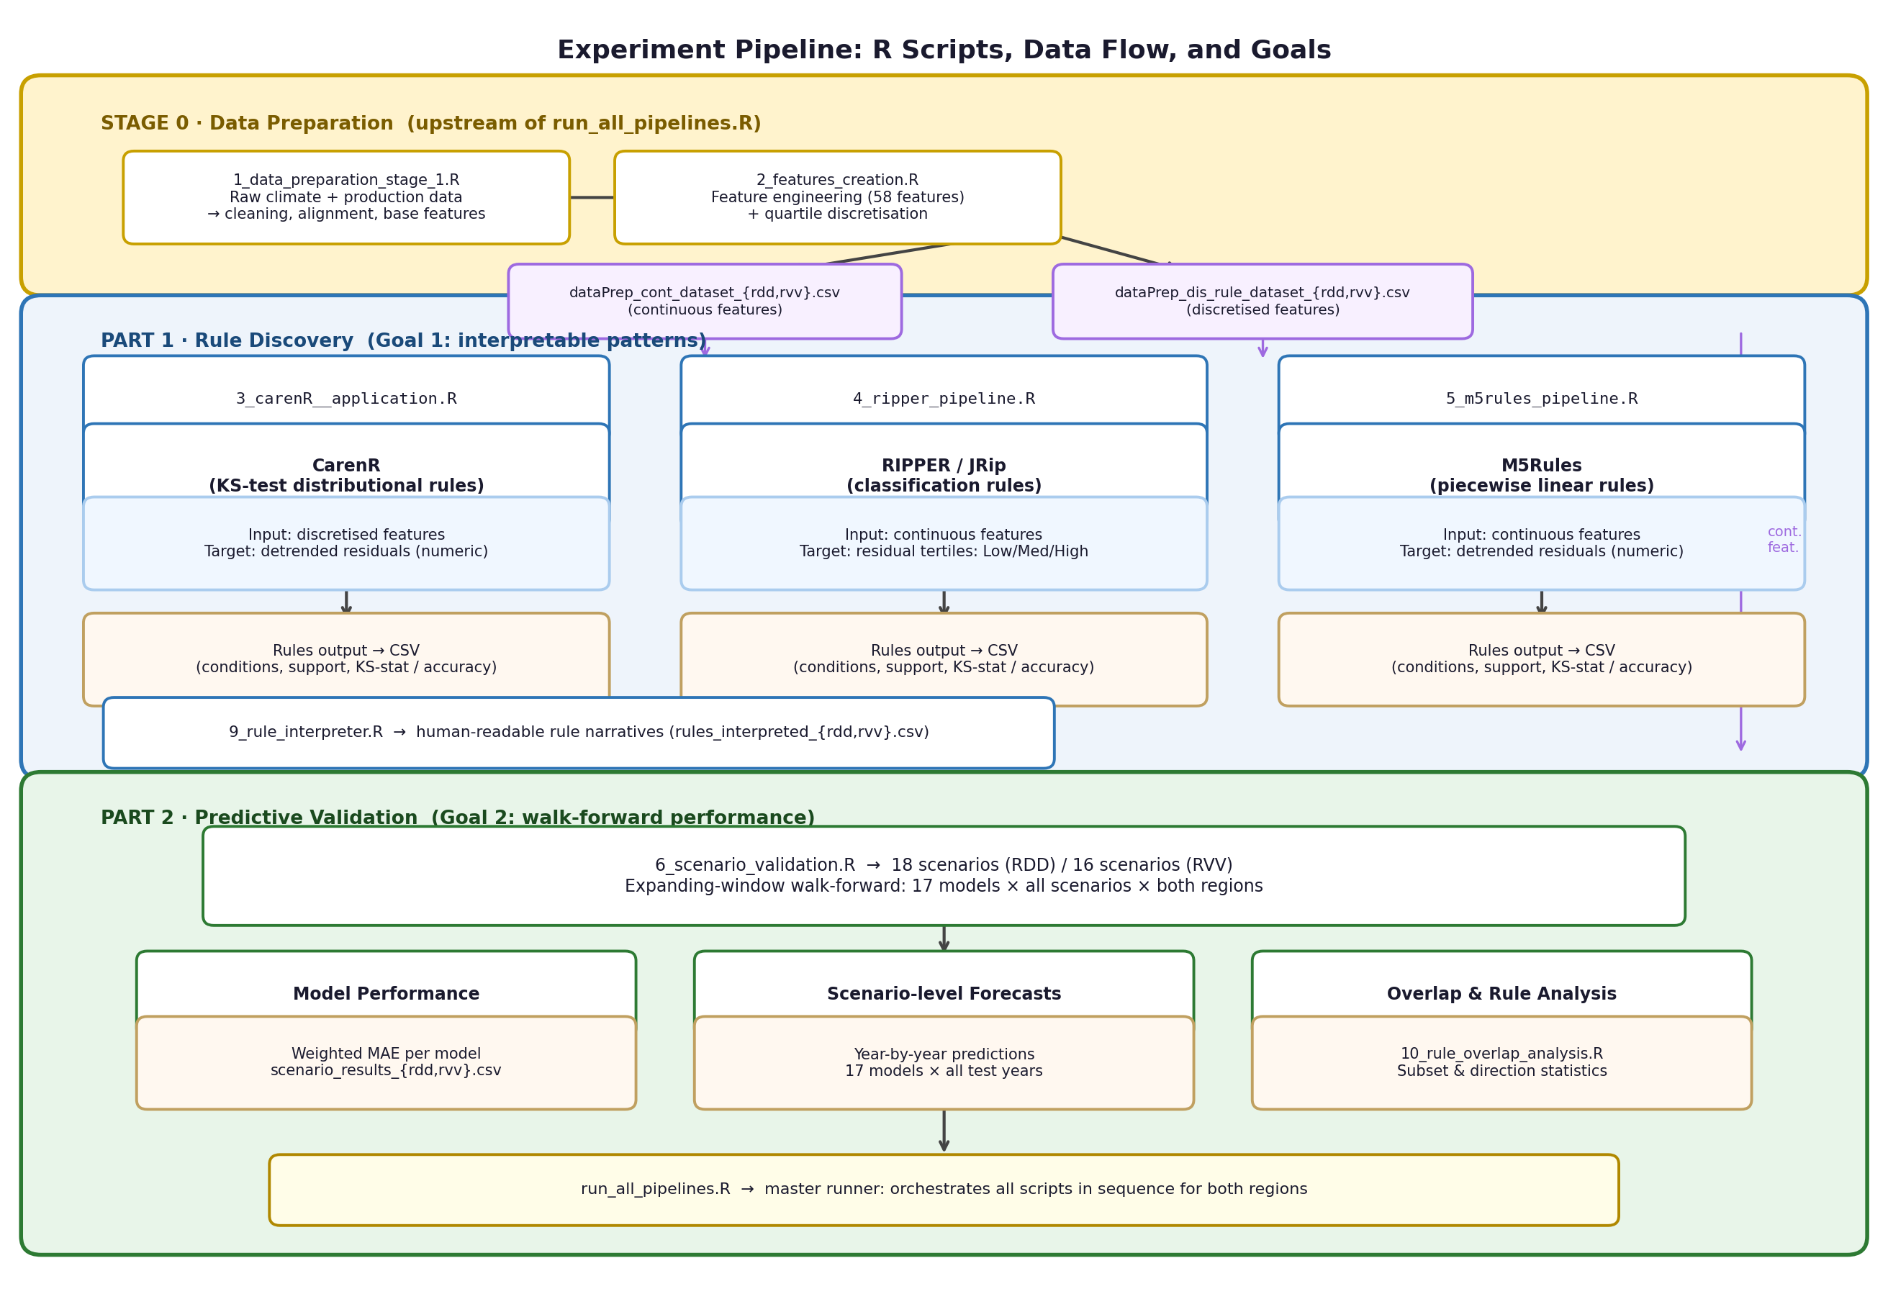
Figure 3.1. Experiment pipeline: Stage 0 data preparation, Part 1 rule discovery (CarenR, RIPPER, M5Rules), and Part 2 walk-forward predictive validation. Arrows show data flow; coloured boxes indicate R scripts. run_all_pipelines.R orchestrates all steps. Each stage writes intermediate datasets to disk for auditability.

Figure 3.2 — Walk-Forward Expanding-Window Validation
The walk-forward protocol fixes a minimum training window at 80% of each regional series (72 observations for RDD; 64 for RVV). At each subsequent scenario the training window expands by one year and the test window shrinks by one year. This produces 18 scenarios for RDD (test sizes 18 down to 1) and 16 scenarios for RVV (test sizes 16 down to 1). Because the window expands rather than slides, earlier scenarios capture longer historical context while later scenarios approach real-time forecasting conditions.
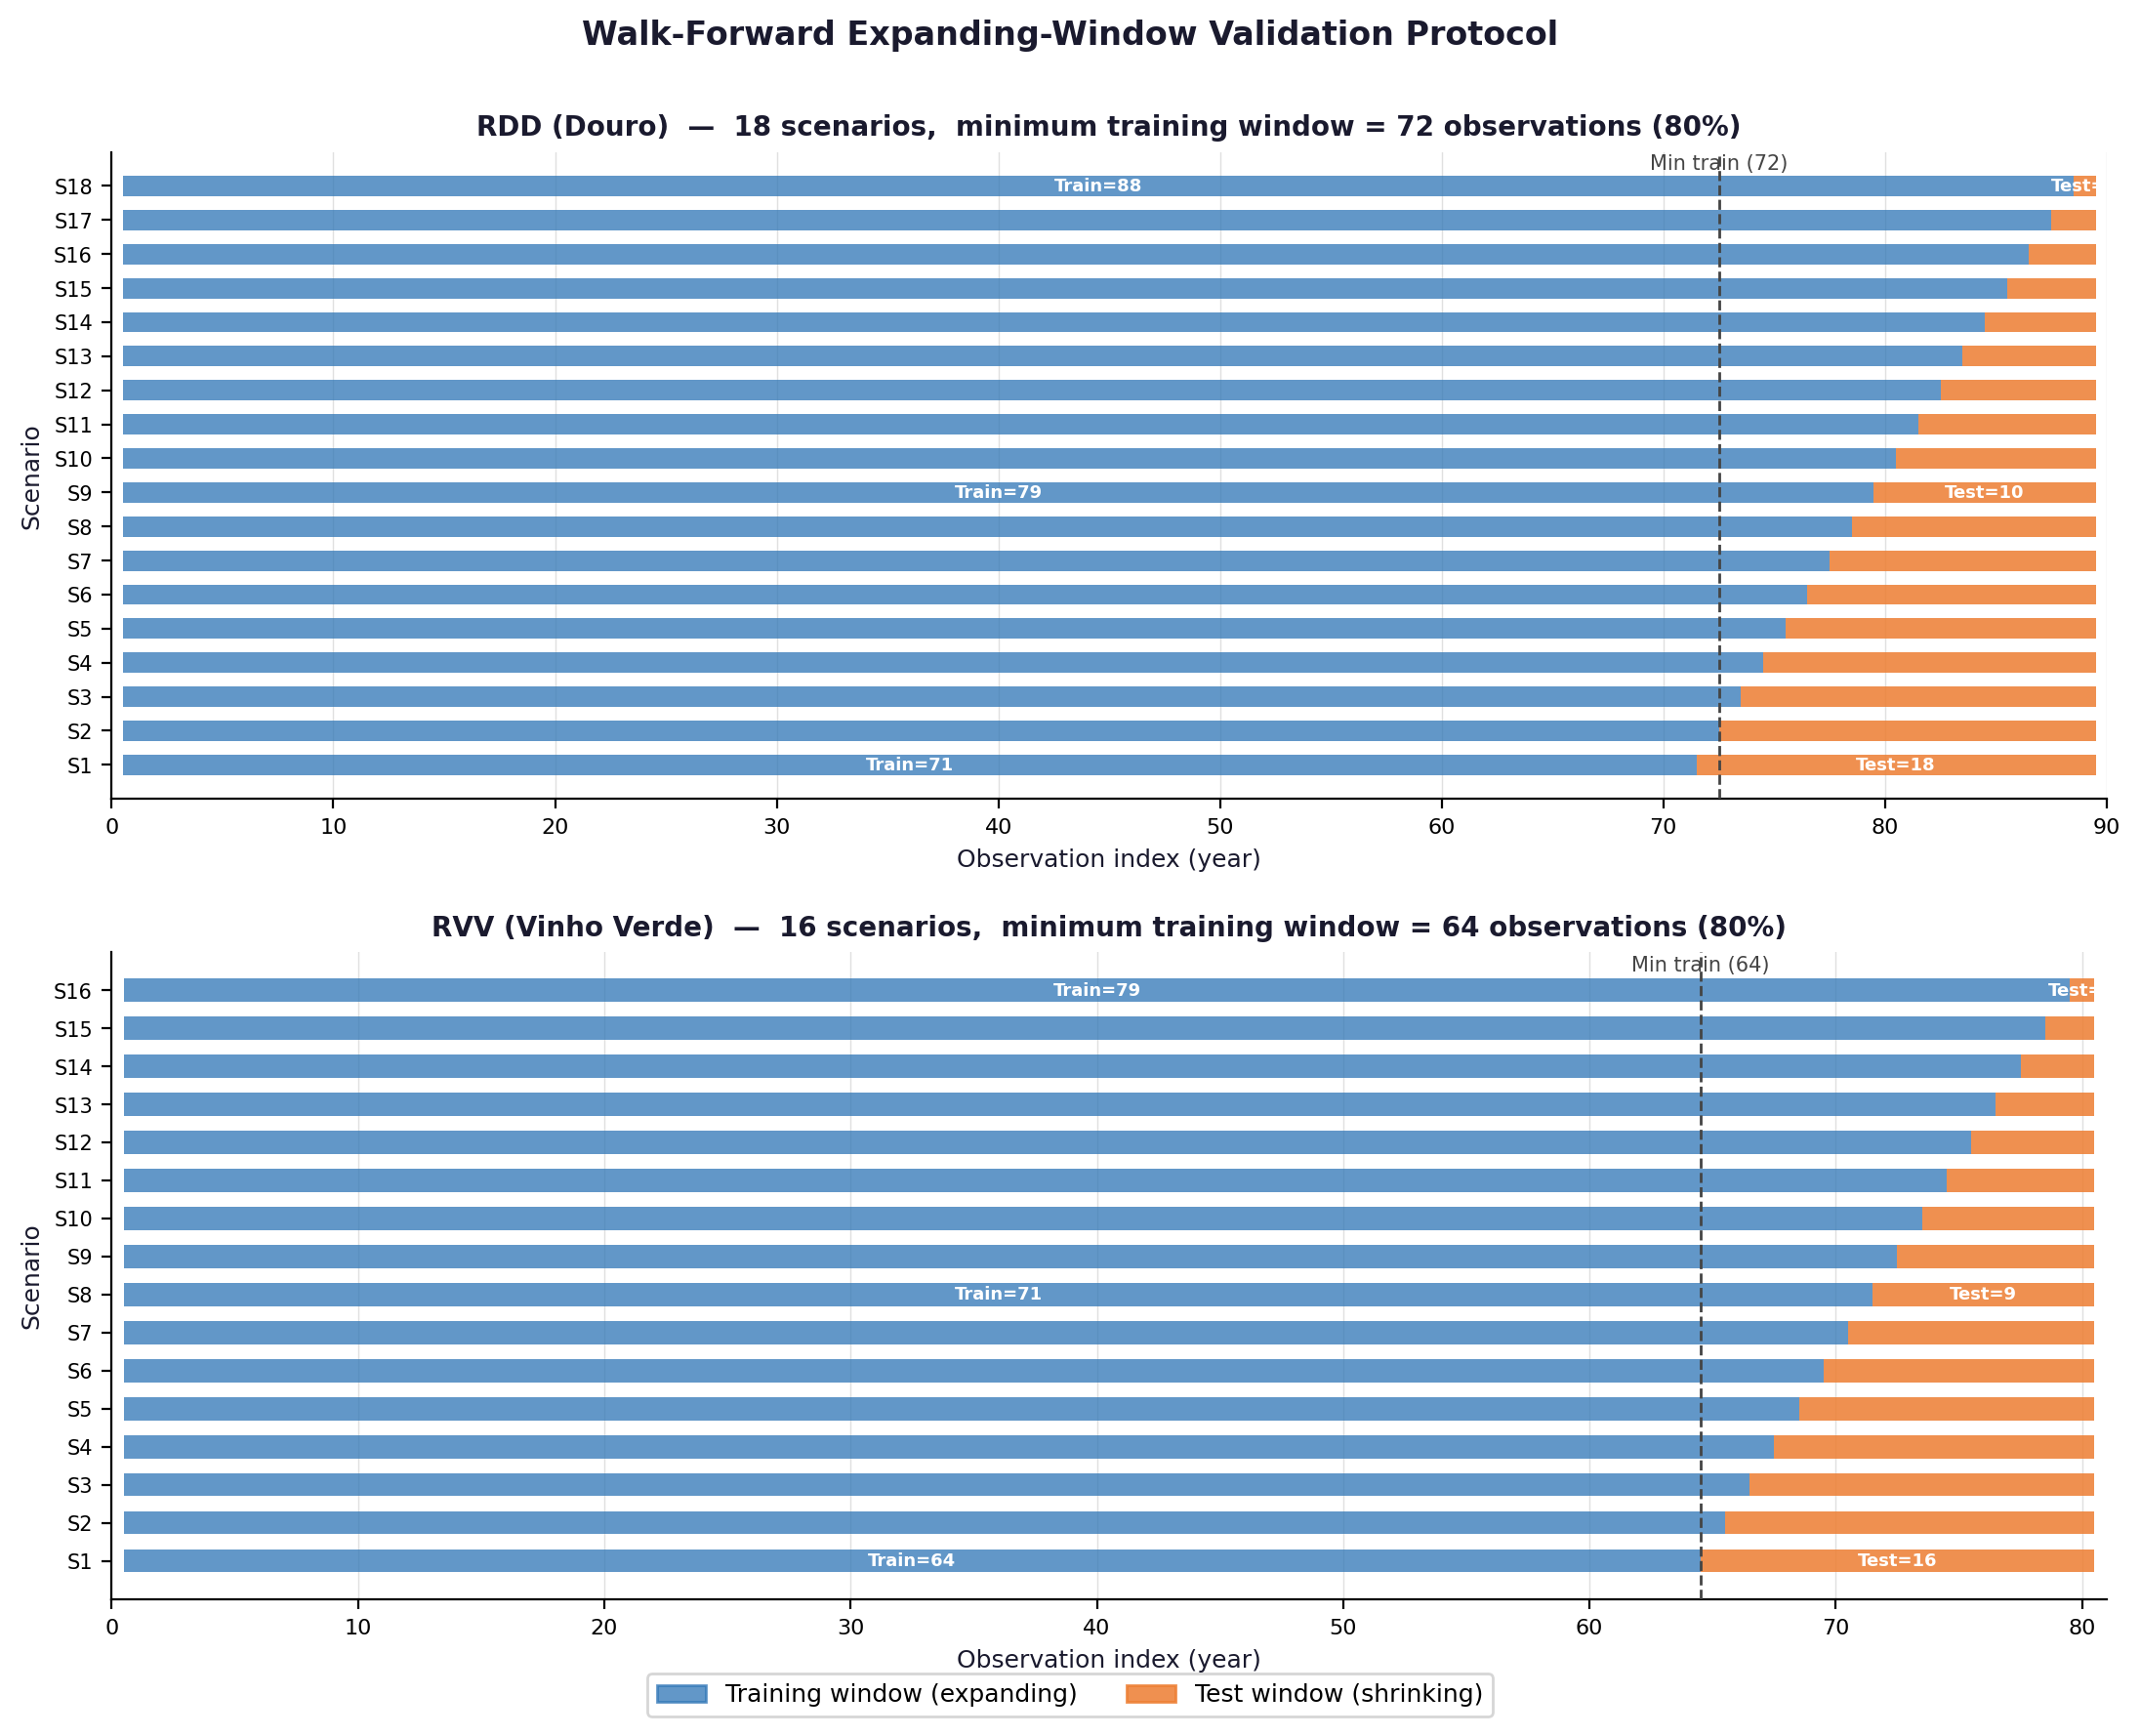
Figure 3.2. Walk-forward expanding-window validation for RDD (top, 18 scenarios) and RVV (bottom, 16 scenarios). Blue bars show the expanding training window; orange bars show the shrinking test window. The dashed vertical line marks the minimum training boundary (80% of observations). Scenario labels on y-axis: S1 has the shortest training set and largest test set.

Figure 3.3 — CarenR Algorithm: Step-by-Step
CarenR operates on the discretised-feature dataset and detrended production residuals. The algorithm first selects features (Step 2, optional), then searches for conjunctions of feature-bin conditions whose subgroup shows distributional shift in the target (Step 3). Candidate rules are filtered by KS-test significance (Step 4) and minimum support (Step 5). Retained rules predict the subgroup median residual; if no rule fires on a given test observation, the algorithm falls back to the training median — making it equivalent to Naive_Median by definition.
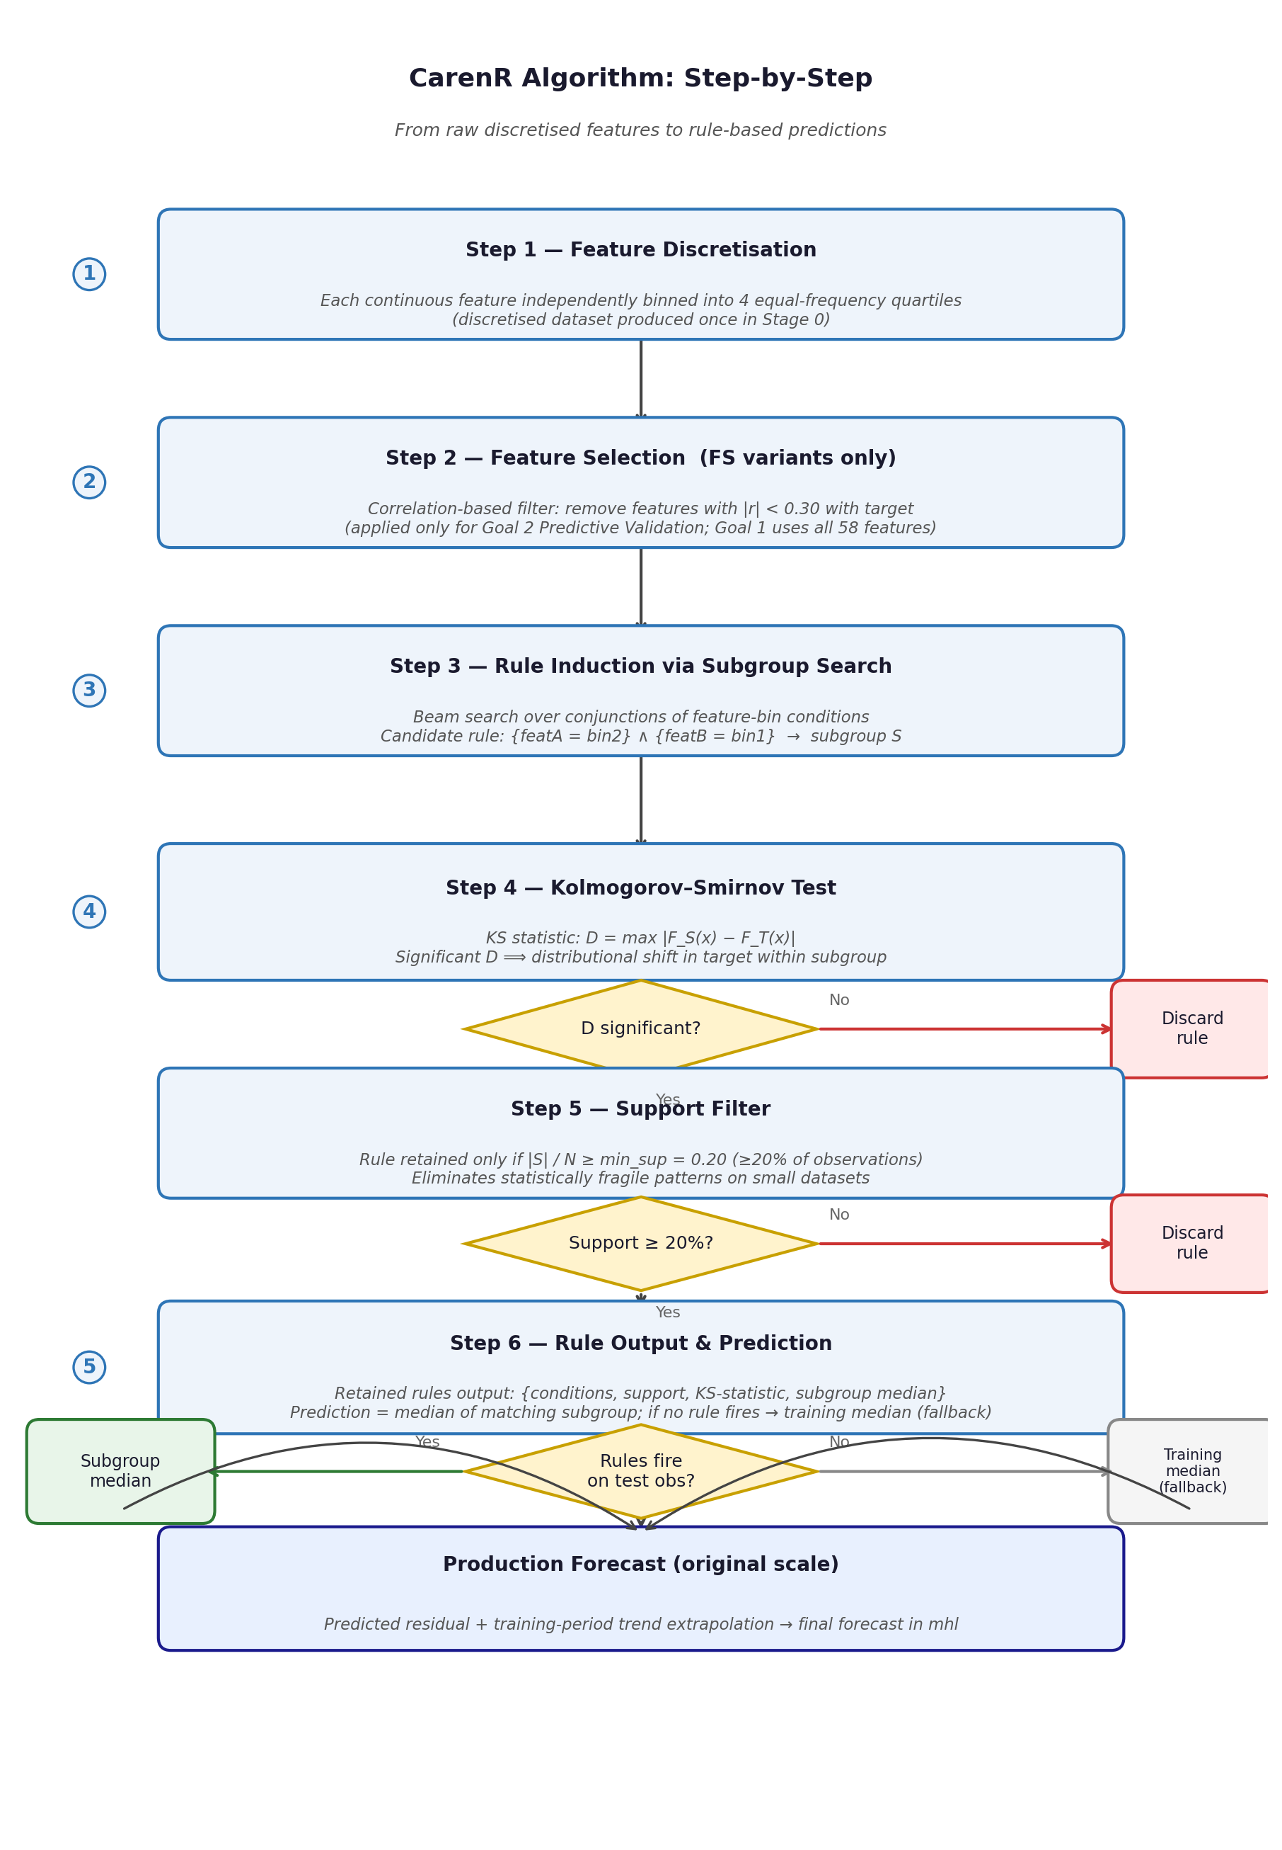
Figure 3.3. CarenR algorithm flowchart. Diamonds indicate filter decisions; red paths discard candidate rules; the green path retains rules with statistically significant distributional shift and sufficient support (min_sup = 0.20). The fallback branch (grey, right) activates when no retained rule matches the test observation, returning the training-period median.

Figure 3.4 — CarenR Variant Taxonomy
Eleven CarenR variants were evaluated, differing along two dimensions: (1) whether a correlation-based feature selection step is applied before rule induction (and which correlation variant: Eta1, Eta2, or the stricter FS selector), and (2) how the final prediction is derived from matched rules (subgroup MEDIAN, support-weighted average SUP, confidence-weighted CONF, or binary THRESHOLD). All variants share the same KS-test induction core and minimum support threshold.
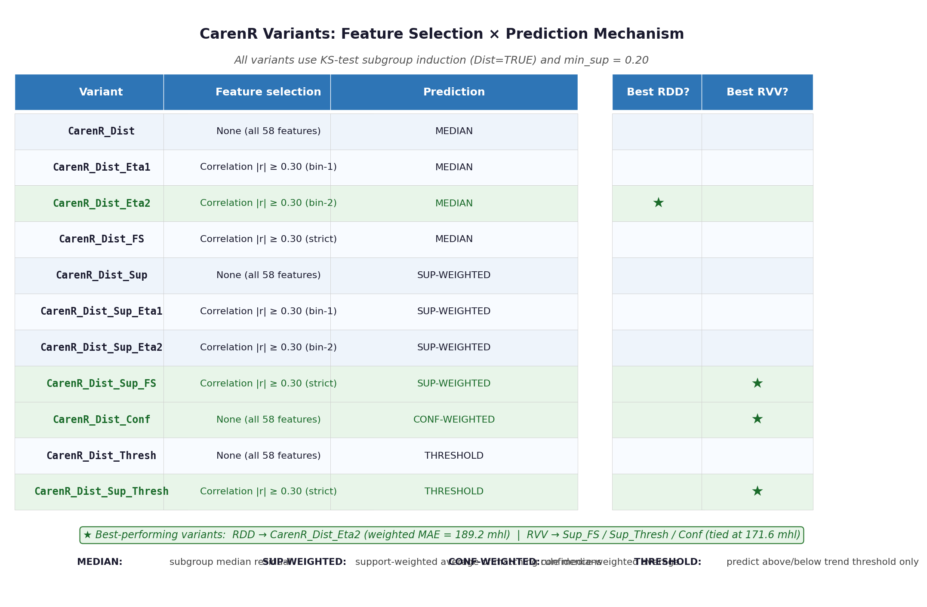
Figure 3.4. The 11 CarenR variants evaluated in this thesis. Feature selection variants (Eta1, Eta2, FS) apply a Pearson correlation filter before rule induction; the base variant uses all 58 features. Starred rows (green shading) indicate the best-performing variants: CarenR_Dist_Eta2 for RDD (weighted MAE = 189.2 mhl) and a three-way tie (Sup_FS, Sup_Thresh, Conf) for RVV (171.6 mhl).

